**Assignmnet:1**

**Twitter database schema**

Purpose: You need to create database schema for Twitter like application with below requirements. It must be normalized. You can use tool like draw.io to generate entity diagrams. It must also show relationships and its type between each entity if required.

Requirements:

* Users can register with their name, email and phone number
* Users can tweet any textual content
* Users can like another user’s tweet
* Users can retweet another user’s tweet
* Users can comment on another user’s Tweet(Comments are not separate entities in Twitter, when you click comment button on any tweet it will be posted as tweet only, check this once on Twitter platform).
* Users can follow other users.
* Submission:
* Use [https://draw.io (Links to an external site.)Links to an external site.](https://draw.io/) or  [https://www.dbdesigner.net (Links to an external site.)Links to an external site.](https://www.dbdesigner.net/) to draw diagram and upload exported image as submission. Your submission will look like below.

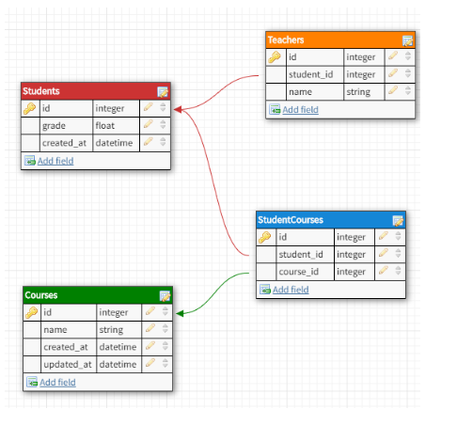

**Assignment:2**

**Twitter sample database**

Purpose: Based on your database schema, you need to populate below sample data into different tables with proper relationships maintained between them.

* System has three users. Vader, Leia and Obi-Wan.
* Vader posts tweets with content “I find your lack of faith disturbing.”
* Leia likes Vader’s tweet.
* Obi-Wan retweets Vader’s tweet.
* Leia follows Vader and Vader follows Obi-Wan.
* Obi-Wan tweets with content “The Force will be with you. Always.”
* Leia comments on Obi-Wan’s tweet with content “Help me, Obi-Wan Kenobi. You’re my only hope.”

Submission: Use excel to populate sample data with above requirements with all columns filled and upload screenshot as submission. Your submission will look like below.

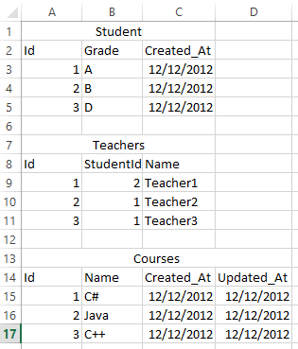

**Assignment:3**

**Twitter queries**

Purpose: Based on your Twitter database schema, you need to write below queries to perform required operation on database.

* Fetch all users name from database.
* Fetch all tweets of user by user id most recent tweets first.
* Fetch like count of particular tweet by tweet id.
* Fetch retweet count of particular tweet by tweet id.
* Fetch comment count of particular tweet by tweet id.
* Fetch all user’s name who have retweeted particular tweet by tweet id.
* Fetch all commented tweet’s content for particular tweet by tweet id.
* Fetch user’s timeline (All tweets from users whom I am following with tweet content and user name who has tweeted it)