WEEK 3 PROJECT REPORT
Statistical Analysis and Hypothesis Testing in Python
Student: Mohmmad Asharaf Harun Shaikh
Internship: Virtual Data Science with Python Apprentice Intern
Report Date: 05 September 2026

1. Objective
Test whether alcohol content differs significantly among the three wine classes.

2. Research Question
Is the mean alcohol content the same across all three wine classes?

3. Hypotheses
- H0: The mean alcohol content is equal across all three wine classes.
- H1: At least one class has a different mean alcohol content.
- Significance level: alpha = 0.05.

4. Methodology
A one-way ANOVA was used to compare the means of the three independent groups. A Welch t-test was also used as a pairwise follow-up between classes 0 and 1.

5. Results
- ANOVA F-statistic: 135.0776.
- ANOVA p-value: 0.00000000.
- Welch t-test p-value for class 0 vs class 1: 0.00000000.
- Because the ANOVA p-value is below 0.05, H0 is rejected. There is statistically significant evidence that mean alcohol content is not identical across all three classes.

6. Interpretation
Statistical significance supports further investigation of which class pairs differ and whether other chemical features show significant differences. Statistical significance does not establish causation.

7. Conclusion
The hypothesis test provides quantitative evidence that alcohol content differs across wine classes.

8. ANOVA Visualization
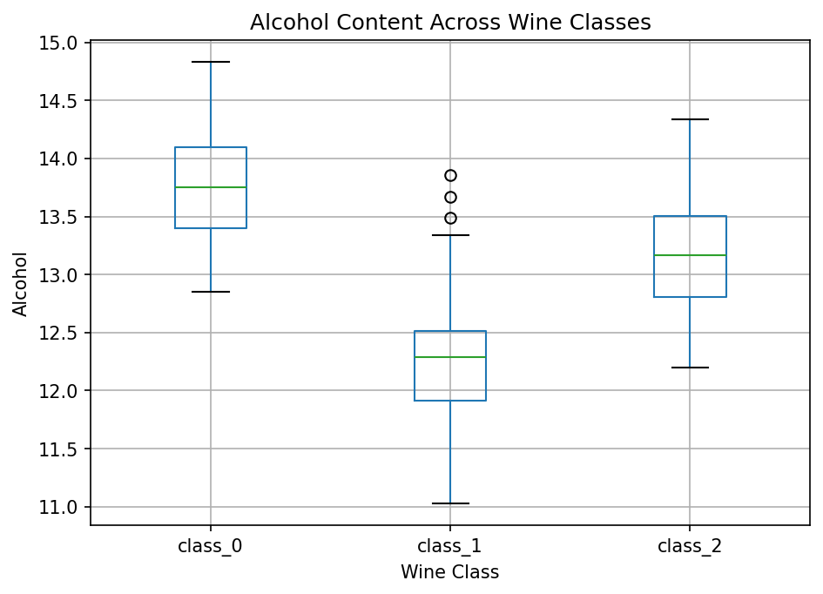
The box plot compares alcohol distributions across classes.

9. Pairwise Distribution
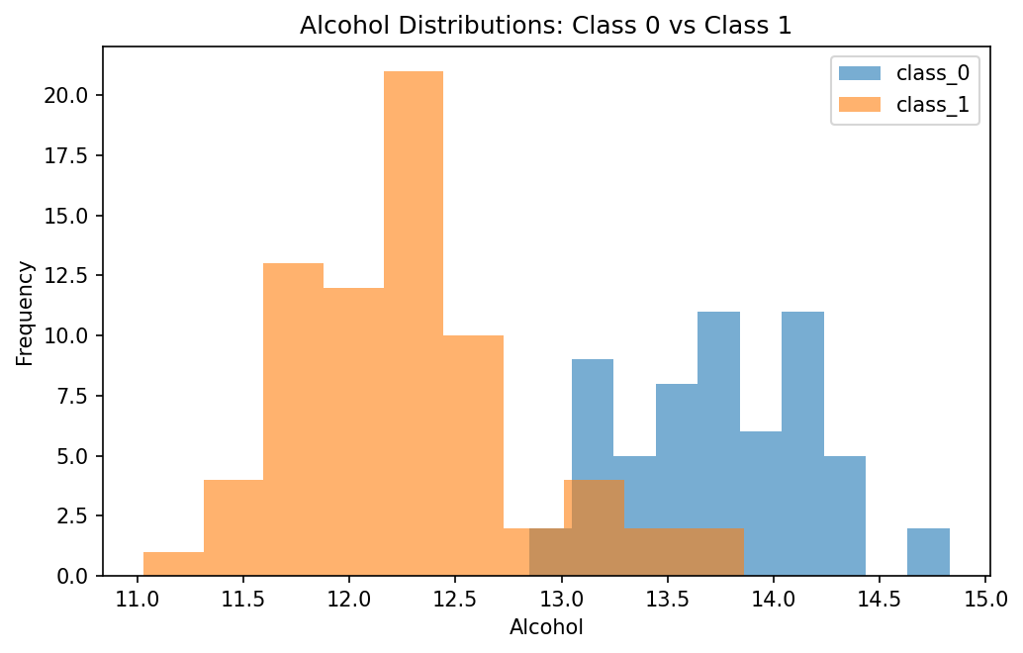
The histograms illustrate alcohol distributions for two classes used in the pairwise test.

