WEEK 4 PROJECT REPORT
Machine Learning Model Development and Evaluation
Student: Mohmmad Asharaf Harun Shaikh
Internship: Virtual Data Science with Python Apprentice Intern
Report Date: 08 September 2026

1. Objective
Build and evaluate a basic machine-learning classification model using the Wine Recognition dataset.

2. Problem Definition
Predict the wine class from 13 chemical measurements.

3. Model and Preprocessing
A Logistic Regression classifier was selected as an interpretable baseline. StandardScaler was included in a Pipeline so scaling parameters are learned only from training data.

4. Experimental Design
The data was split into 80% training and 20% test sets using stratification and random_state=42.

5. Results
- Accuracy: 0.9722.
- Weighted precision: 0.9741.
- Weighted recall: 0.9722.
- Weighted F1-score: 0.9720.
- Weighted one-vs-rest ROC AUC: 1.0000.

6. Error and Improvement Discussion
- The test set is relatively small, so performance estimates can vary.
- Cross-validation would give a more robust estimate.
- Alternative models could be compared.
- Hyperparameter tuning and feature-selection experiments could improve the analysis.

7. Conclusion
The baseline model demonstrates a complete preprocessing, training, and evaluation pipeline.

8. Confusion Matrix
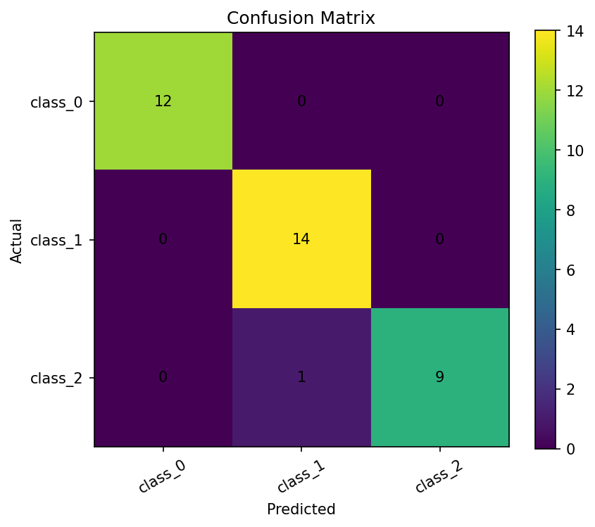
Actual versus predicted wine classes.

9. ROC Curves
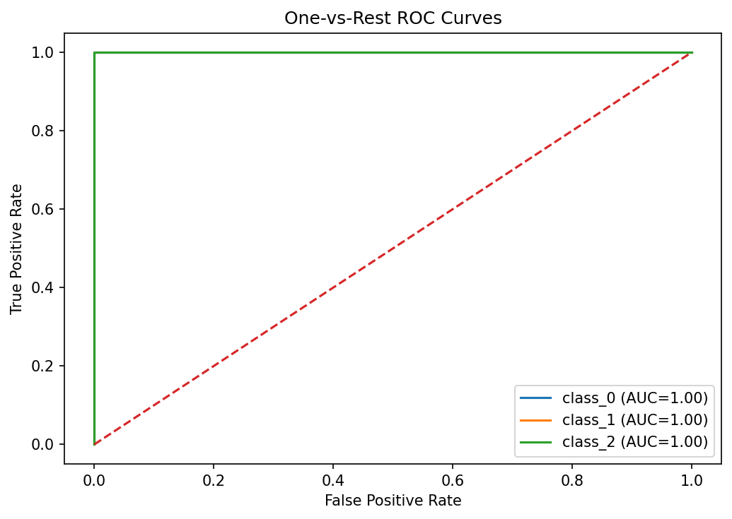
One-vs-rest ROC curves show discrimination performance.

10. Performance Metrics
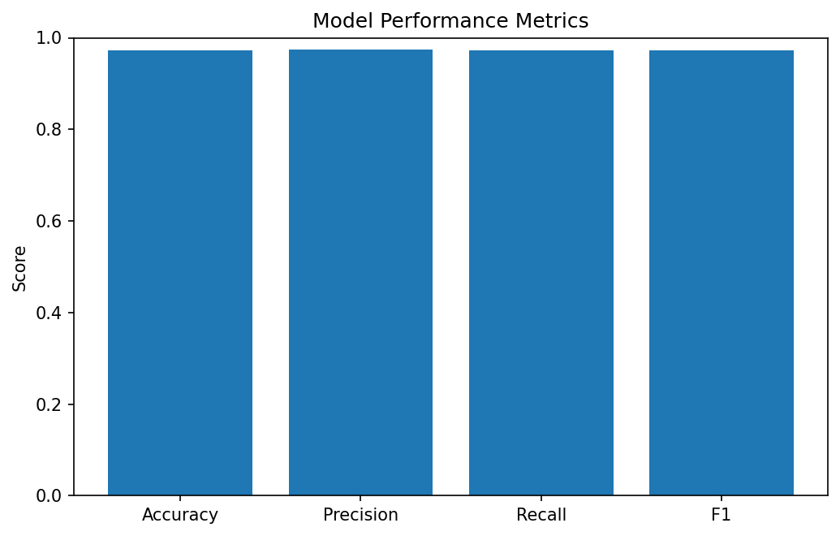
Accuracy, precision, recall, and F1 summarize performance.

