WEEK 5 PROJECT REPORT
Comprehensive Data Science Project Reporting and Strategic Recommendations
Student: Mohmmad Asharaf Harun Shaikh
Internship: Virtual Data Science with Python Apprentice Intern
Report Date: 10 September 2026

1. Executive Summary
This final report integrates the five-week project for the Virtual Data Science with Python Apprentice Intern. It covers acquisition, cleaning, visualization, statistical testing, classification modeling, evaluation, and strategic recommendations.

2. Project Methodology
- Week 1 established data quality and exploratory analysis.
- Week 2 developed a multi-chart visual narrative.
- Week 3 tested whether alcohol means differ across classes.
- Week 4 trained and evaluated a standardized Logistic Regression classifier.
- Week 5 consolidates findings, limitations, and recommendations.

3. Key Findings
- The dataset contains 178 observations, 13 numerical features, and three classes.
- No missing values or duplicate rows were detected.
- ANOVA p-value for alcohol across classes: 0.00000000.
- Logistic Regression test accuracy: 0.9722; weighted F1: 0.9720.
- Multiple chemical measurements show relationships useful for classification.

4. Strategic Recommendations
- Use multiple chemical attributes rather than a single measurement for classification.
- Use stratified validation and cross-validation for more reliable model comparisons.
- Compare several algorithms before selecting a final model.
- Track statistical significance and practical effect sizes.
- Document preprocessing and model parameters for reproducibility.

5. Potential Impact
The workflow can support analytical tasks where measurements are used to identify or categorize observations and can be adapted to other structured datasets.

6. Limitations
- The dataset is relatively small and is a benchmark dataset.
- The analysis does not establish causal relationships.
- Only a baseline Logistic Regression model was evaluated.
- There is no external validation dataset.

7. Future Improvements
- Add cross-validation and hyperparameter tuning.
- Compare tree-based and kernel-based models.
- Investigate feature importance and dimensionality reduction.
- Add confidence intervals and effect sizes.
- Package the analysis into a reproducible notebook or application.

8. Final Conclusion
The five-week project demonstrates an end-to-end Python data science workflow and provides a foundation for further data-driven analysis.

9. Project Summary Metrics
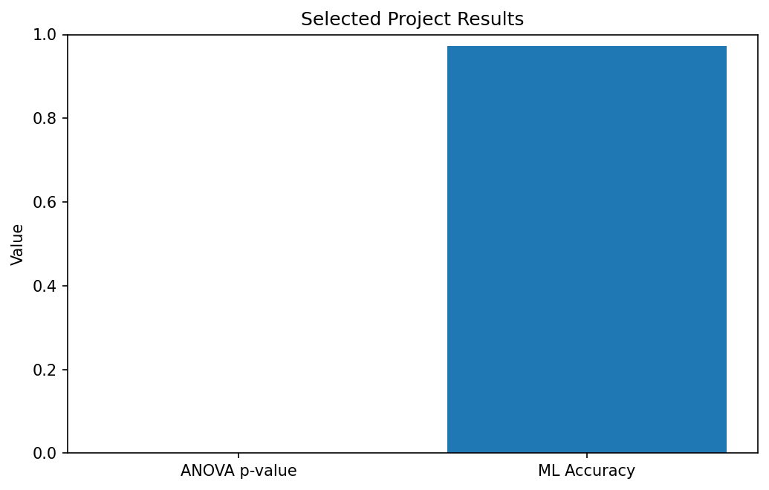
Selected results from statistical testing and machine-learning evaluation.

