WEEK 1 PROJECT REPORT
Data Acquisition, Cleaning, and Exploratory Analysis
Student: Mohmmad Asharaf Harun Shaikh
Internship: Virtual Data Science with Python Apprentice Intern
Report Date: 01 September 2026

1. Objective
Complete the data acquisition, cleaning, preprocessing, and exploratory analysis workflow using Python.

2. Dataset
The Wine Recognition dataset contains 178 observations, 13 numerical chemical features, and three target classes. It was loaded programmatically using Scikit-learn.

3. Data Cleaning
- Rows before cleaning: 178.
- Missing values: 0.
- Duplicate rows: 0.
- No rows required removal in this analysis.
- Data types and descriptive statistics were inspected.

4. Exploratory Analysis
Summary statistics and visualizations were used to understand class distribution, feature distributions, relationships, and correlations.

5. Key Insights
- The three wine classes have different sample counts.
- No missing values or duplicate rows were detected.
- Alcohol varies across observations and classes.
- Several chemical features show relationships useful for further analysis.

6. Conclusion
The dataset is suitable for downstream visualization, statistical testing, and classification modeling.

7. Class Distribution
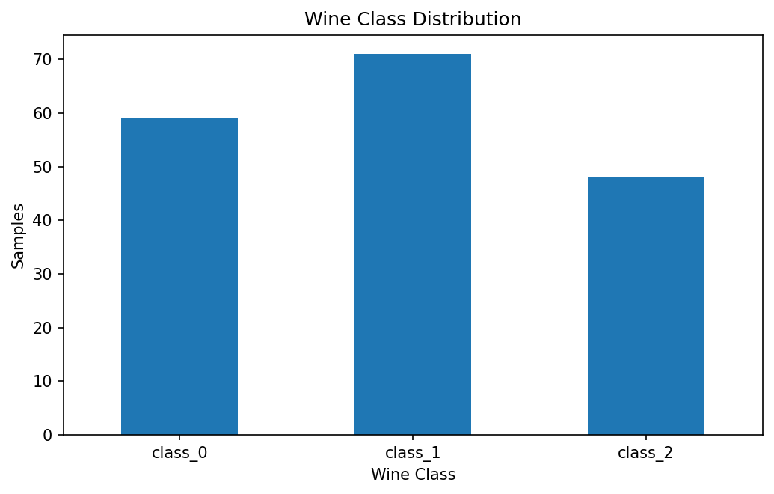
The chart shows the number of observations in each wine class.

8. Alcohol Distribution
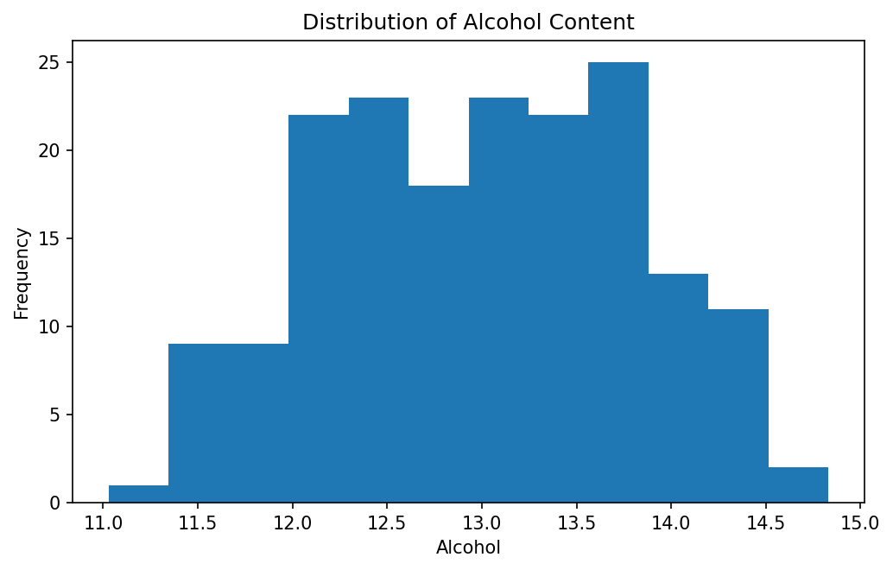
The histogram shows the distribution of alcohol content.

9. Alcohol vs Malic Acid
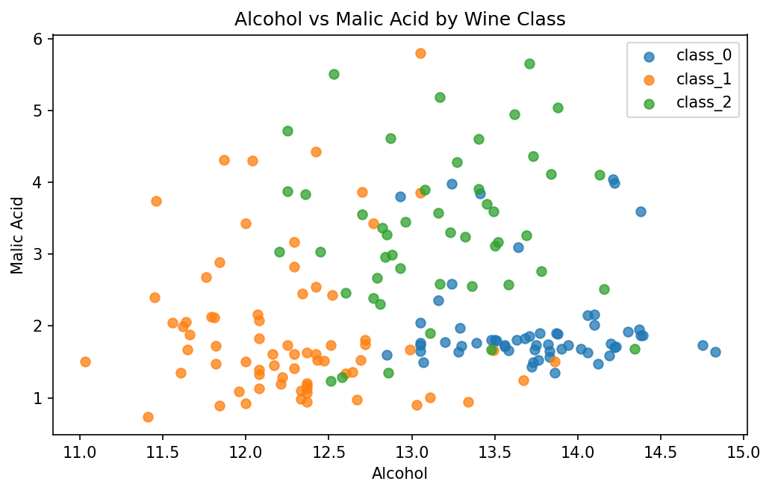
The scatter plot shows class-specific patterns in two chemical measurements.

10. Correlation Matrix
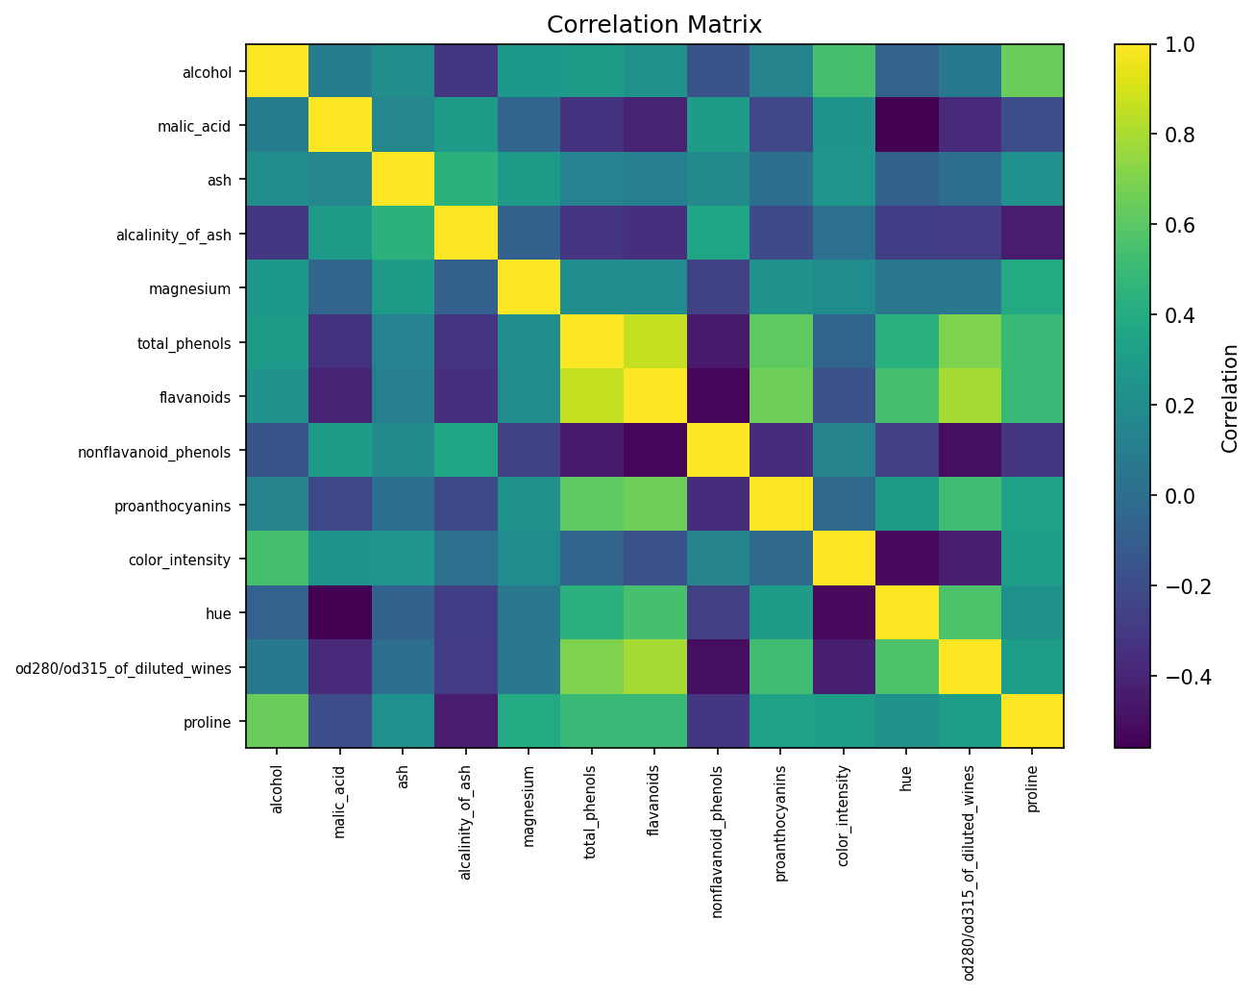
The matrix summarizes pairwise linear correlations.

