WEEK 2 PROJECT REPORT
Advanced Data Visualization and Storytelling with Python
Student: Mohmmad Asharaf Harun Shaikh
Internship: Virtual Data Science with Python Apprentice Intern
Report Date: 03 September 2026

1. Objective
Create a coherent visual narrative using at least five visualizations and explain how each contributes to understanding the dataset.

2. Approach
The cleaned Wine Recognition dataset was reused. Different chart types were selected to communicate distributions, comparisons, relationships, and correlations.

3. Visualization Strategy
- Box plots compare distributions across wine classes.
- Bar charts compare class sizes and feature means.
- Scatter plots show relationships between chemical measurements.
- A correlation-focused chart highlights relationships with proline.

4. Data Story
The visual evidence suggests that wine classes differ across multiple chemical attributes. Combining distributions, comparisons, and relationships provides a more complete narrative.

5. Implications
- Chemical measurements may support wine classification.
- Feature relationships can guide feature selection.
- Class proportions should be considered when evaluating predictive models.

6. Conclusion
The five-chart narrative makes the dataset easier to interpret and prepares the project for formal statistical testing and machine learning.

7. Alcohol by Class
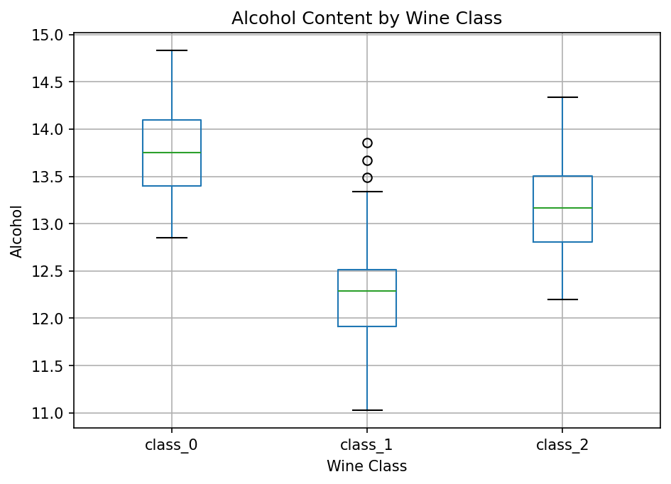
Box plots compare alcohol distributions.

8. Selected Feature Means
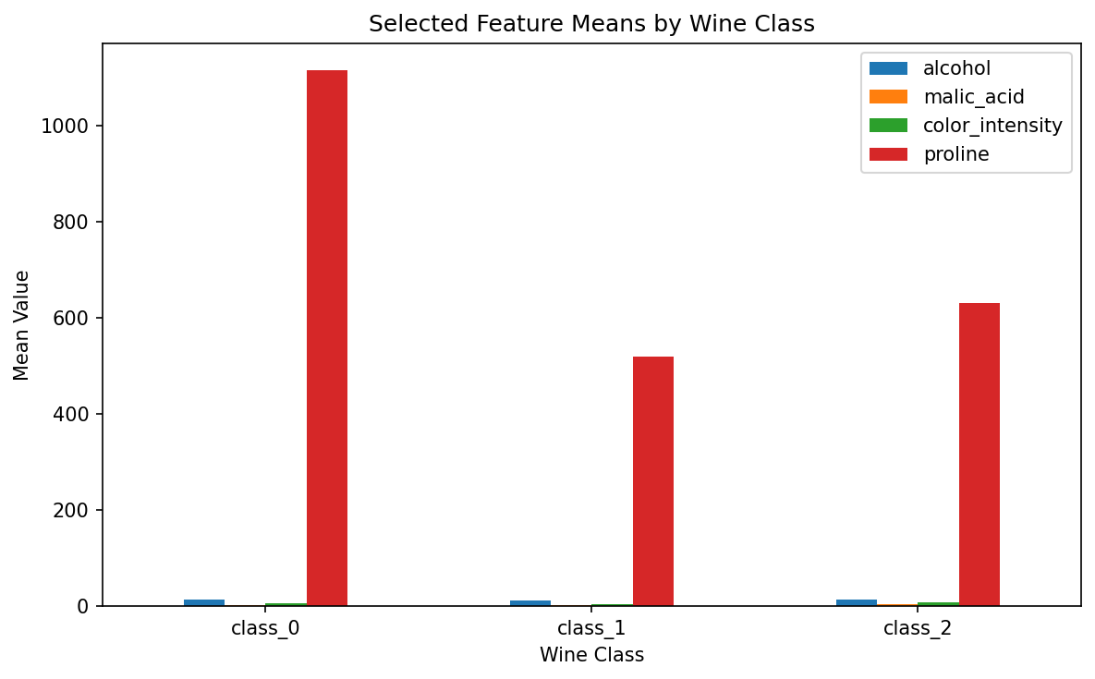
Mean values reveal differences across selected features.

9. Flavanoids vs Total Phenols
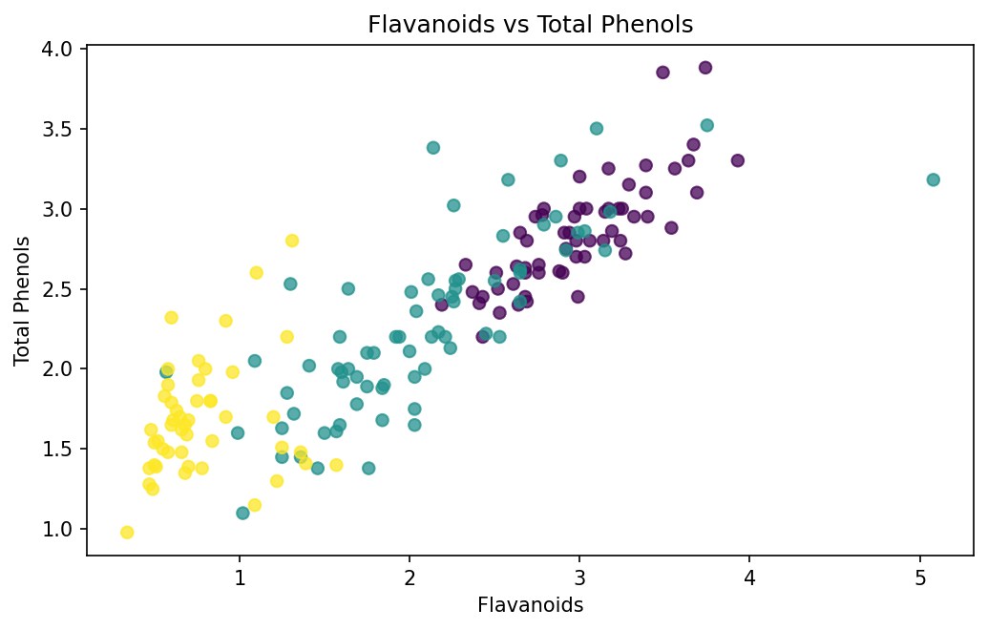
The scatter plot shows a relationship between two chemical measurements.

10. Class Counts
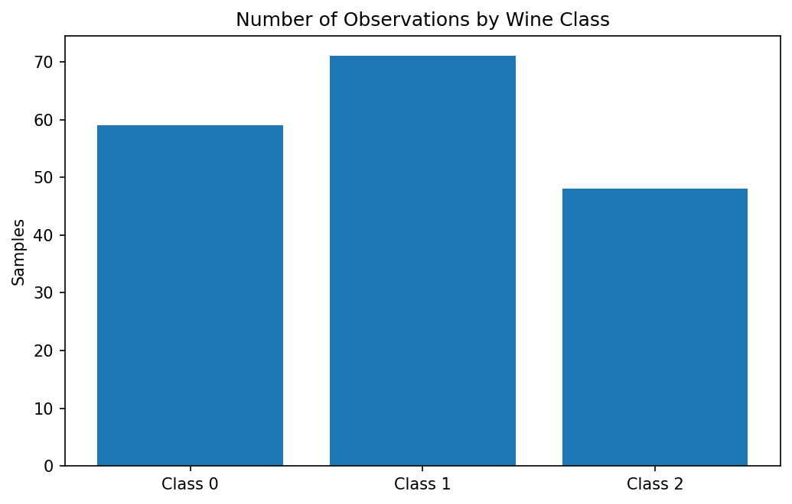
The bar chart communicates class sizes.

11. Correlations with Proline
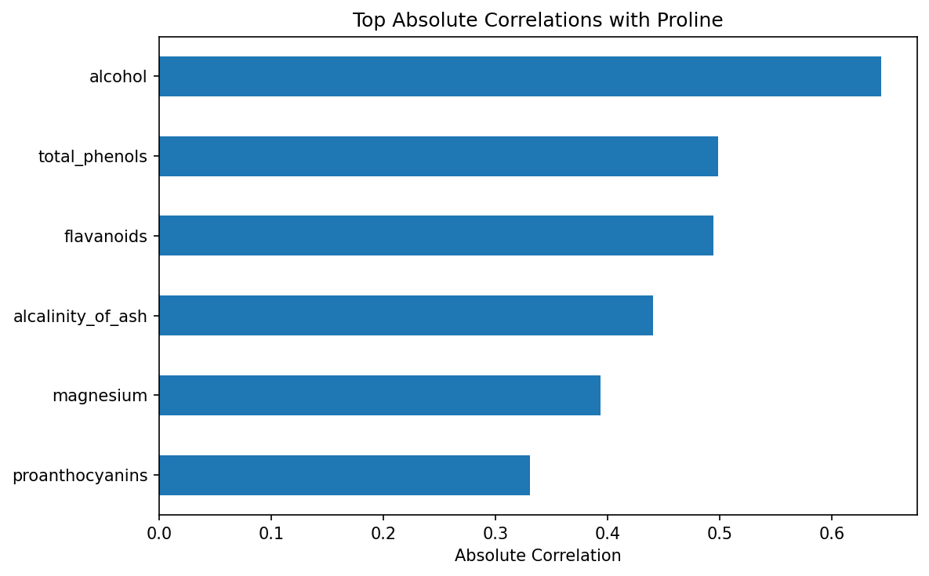
The chart highlights the strongest absolute correlations with proline.

