ITECH1104 - CLOUD AND ENTERPRISE COMPUTING

Laboratory/Tutorial for Topic 8 Task

**Task Description:**

In this lab we

1. create an Amazon Simple Storage Service (Amazon S3) bucket to host a static website.

A *static website* is fixed and displays the same content for each user. In contrast, a *dynamic website* uses advanced programming to provide user interaction and display different content depending on the user's selections.

1. create an AWS Lambda function by using the AWS Management Console. You will manually invoke the function by using sample event data. After Lambda runs the function and returns results, you will verify the function results. This will include reviewing the logs that the Lambda function created and examining various metrics in Amazon CloudWatch metrics.

(Go to next page)

**Access the AWS Management Console**

1. Open the module: AWS Academy Introduction to Cloud: Semester 1:

Select Modules / Module 4 - Virtual Servers / Lab 4.2 – S3

To start the lab session, choose  **Start Lab** in the upper-right corner of the page.

* + The lab session starts.
  + A timer displays in the upper-right corner of the page and shows the time remaining in the session.

**Tip:** To refresh the session length at any time, choose **Start Lab** again before the timer reaches 0:00.

1. Before continuing, wait until the lab environment is ready. The environment is ready when the lab details appear on the right side of the page and the circle icon next to the **AWS** link in the upper-left corner turns green.
2. To return to these instructions, choose the  **Readme** link in the upper-right corner.
3. To connect to the AWS Management Console, choose the **AWS** link in the upper-left corner, above the terminal window.

A new browser tab opens and connects you to the AWS Management Console.

**Tip:** If a new browser tab does not open, a banner or icon is usually at the top of your browser with the message that your browser is preventing the site from opening pop-up windows. Choose the banner or icon, and then choose **Allow pop-ups**.

**Note:** You are using the console through the lab environment, so you are not incurring any actual costs. However, in the real world, when using a personal or business account to access the console, users incur charges for use of specific AWS services.

**Continue with instructions from next page.** **Do not follow the instruction from the AWS page as they are not the same as the instructions from this lab.**

**A)** **Amazon S3**

**Task 1. Create an S3 bucket**

1. In the following **ignore any errors** you see, just continue.
2. Choose the **Services** menu, locate the **Storage** services, and select **S3**.
3. Select **Create bucket** on the right side of the page.
4. For **Bucket name**, enter a unique Domain Name System (DNS)-compliant name for your new bucket.

Follow these naming guidelines:

* + The name must be unique across all existing bucket names in Amazon S3.
  + The name must only contain lowercase characters.
  + The name must start with a letter or number.
  + The name must be between 3 and 63 characters long.
  + After you create the bucket, you cannot change the name, so choose wisely.
  + Choose a bucket name that reflects the objects in the bucket. This is because the bucket name is visible in the URL that points to the objects that you’re going to put in your bucket.

Choose as name your name followed by your student_ID:  
Take a note of your bucket name here: ____________  
e.g: christiantest01

1. For **Region**, choose the AWS Region where you want the bucket to reside.

Choose a Region close to you to minimize latency and costs, or to address regulatory requirements. Objects stored in a Region never leave that Region unless you explicitly transfer them to another Region.

1. Uncheck the **Block *all* public access** box because you want to be able to test if the website is working.

A warning message similar to **Turning off block all public access might result in this bucket and the objects within becoming public** appears below the security setting you deselected.

1. Below the warning, check the box next to **I acknowledge that...**.
2. Scroll to the bottom of the page, and select **Create bucket**.

Your new bucket appears in the **Buckets** list.

**Task 2. Add a bucket policy to make the content publicly available**

1. Choose the link for your bucket's name, and then select the **Permissions** tab.
2. In the **Bucket policy** section, choose **Edit**.
3. To grant public read access for your website, copy the following bucket policy, and paste it in the policy editor. (Copy/Paste from the Word Document!!)

{

   "Version":"2012-10-17",

   "Statement":[

      {

           "Sid":"PublicReadGetObject",

           "Effect":"Allow",

           "Principal":"*",

           "Action":[

               "s3:GetObject"

          ],

           "Resource":[

               "arn:aws:s3:::example-bucket/*"

          ]

      }

  ]

}

1. In the policy, replace **example-bucket** with the name of your bucket.
2. Ignore the error.
3. Select **Save changes**.

**Task 3. Upload an HTML document**

In this task, you upload an HTML document to your new bucket. You will just create a text file on your computer with the name “index.html”.

1. Open the context menu (right-click) for the following link, and then choose **Save link as**: [index.html](https://aws-tc-largeobjects.s3.us-west-2.amazonaws.com/CUR-TF-100-ACCAIC-1-35050/02-lab-4.2-S3/s3/index.html) or Copy Paste the following text into a file: index.html

<html>

<h1>Hello World. Take me to your leader.</h1>

</html>

1. Save the index.html file to your local computer.
2. In the console, choose the **Objects** tab.
3. Upload the index.html file to your bucket.
   * Choose **Upload**.
   * Drag and drop the index.html file onto the upload page.
   * As an alternative, choose **Add files**, navigate to the file, and choose **Open**.
4. Expand the **Properties** section.

This section lists the storage classes that are available in Amazon S3. You will learn more about storage classes later, but take a minute to review them now.

Ensure that the **Standard** storage class is selected.

1. At the bottom of the page, choose **Upload**.
2. Choose **Close**.

The index.html file appears in the **Objects** list.

**Task 4. Test your website**

1. Select the **Properties** tab, and scroll down to the **Static website hosting** section.
2. Choose **Edit**.
3. Select **Enable**.
4. In the **Index document** text box, enter index.html
5. Select **Save changes**.
6. Scroll down to the **Static website hosting** section again, and copy the **Bucket website endpoint** URL to your clipboard.
7. Open a new tab in your web browser, paste the URL you just copied, and press **Enter**.

The **Hello World** webpage should display. You have successfully hosted a static website using an S3 bucket!

**Task 5. Take Screen Shoots**

**Screen shot 01:** Take a screenshot of your **bucket having your name** and student ID in the bucket name. Save it, to be able to add it to your submission at the end of the lab.



**Screen shot 02:** Take a screenshot of the displayed web page having your name and student ID in the URL. The **screenshot must contain your name in in the URL**. Save it, to be able to add it to your submission at the end of the lab.

1. The displayed web page having your name and student ID in the URL:



**B)** **Lambda**

**Access the AWS Management Console**

1. Open the module: AWS Academy Learner Lab:   
   Select Modules / Learner Lab

To start the lab session, choose  **Start Lab** in the upper-right corner of the page.

* + The lab session starts.
  + This lab will use credit from your allocated $100.

1. Before continuing, wait until the lab environment is ready. The environment is ready when the lab details appear on the right side of the page and the circle icon next to the **AWS** link in the upper-left corner turns green.
2. To return to these instructions, choose the  **Readme** link in the upper-right corner.
3. To connect to the AWS Management Console, choose the **AWS** link in the upper-left corner, above the terminal window.

A new browser tab opens and connects you to the AWS Management Console.

**Tip:** If a new browser tab does not open, a banner or icon is usually at the top of your browser with the message that your browser is preventing the site from opening pop-up windows. Choose the banner or icon, and then choose **Allow pop-ups**.

**Note:** You are using the console through the lab environment, so you are not incurring any actual costs. However, in the real world, when using a personal or business account to access the console, users incur charges for use of specific AWS services.

**Continue with instructions from next page.** **Do not follow the instruction from the AWS page as they are not the same as the instructions from this lab.**

## Task 1. Create a Lambda function

1. Choose the **Services** menu, locate the **Compute** category, and choose **Lambda**.
2. Choose **Create function**, and configure the following:
   * For **Function name**, enter <your_name>-function e.g.: Christian-Kopp-Function
   * In the **Permissions** section, expand the **Change default execution role**.
   * For **Execution role**, choose **Use an existing role**.
   * For **Existing role**, choose **LabRole**.
   * Choose **Create function**.

Lambda creates a Node.js function that writes the text "Hello from Lambda!".

Add your name in the text: "Hello from Lambda, <your name>!"

**Note:** This lab uses Node.js, but Lambda is able to use several languages, including Python and C#.

## Task 2. Test the function

You can use the designer to test your function.

1. Go to the **Code source** section, and choose the **Test** tab.

Here you can create new test scripts or modify existing test scripts.

1. For **Event name**, enter mytestevent and then choose **Create**.
2. To run the test, choose **Test**.

The test results display in the **Code source** section. The status should display Succeeded. In the **Function logs** section of the results, you can see the **Duration**, which is how long it took the function to complete. Other information about the test is also displayed. 

**Screen shot 03:** Take a screenshot of the Test result. The **screenshot must contain your name**. Save it, to be able to add it to your submission at the end of the lab.

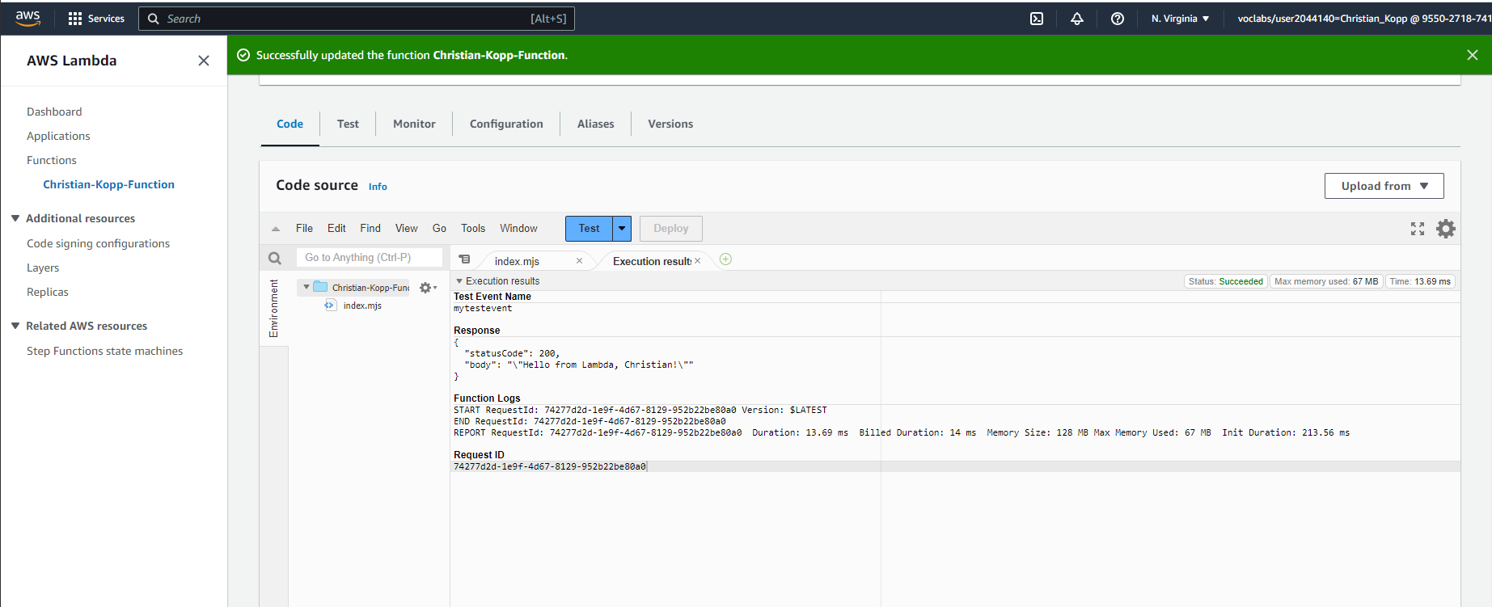



## Task 3. View CloudWatch metrics and logs

1. Choose the **Monitor** tab.

Metrics for the test you just ran display here. The **Invocations** graph shows that the function has been called one time. The **Duration** graph shows how long the function took to complete, and the **Error count and success rate** graph shows the success rate.

1. Choose **View logs in CloudWatch**.
   * The CloudWatch console opens in a new tab, and the log stream for the Lambda function displays.
   * Choose the log stream entry that displays.
   * In the **Log events** section, you can expand any of the events to see more detailed information.
   * For more information about monitoring in Lambda, see [Monitoring Functions in the AWS Lambda Console](https://docs.aws.amazon.com/lambda/latest/dg/monitoring-functions-access-metrics.html).

Create a Mahara (ePortfolio) Page “Task 8 – S3 Storage - Lambda”.

Add the following fields:

Text field: Describe in your own words the service S3 Storage.

Text field: Explain why and how the service S3 Storage is different to EBS storage.

Image field: Screenshot 01: Bucket

Image field: Screenshot 02: Web page

Text field: Describe Lambda Function.

Image field: Screenshot 03: Lambda Test result

**Lab complete**

Congratulations! You have completed the lab. **Make sure you have all your screen shoots for submission!! After ending the lab everything will be deleted!**

1. Log out of the AWS Management Console.
   * In the upper-right corner of the page, choose your user name. Your user name begins with **voclabs/user**.
   * Choose **Sign Out**.
2. Choose **End Lab** at the top of this page, and then select **Yes** to confirm that you want to end the lab.

**What and where to submit?**

Completion of the tasks 6 to 10 related to Topics 6-10 will be submitted after Topic 10 is delivered. The submission is via Moodle as a “Mahara Collection” (collection of pages where each page represents a topic task).

For submission exact date of the second collection (Part B) of the three (5) tasks see Assessment section in Moodle.