DAY 5: TESTING, ERROR HANDLING,BAKEND INTEGRATION REFINEMENT

STEP 1: FUNCTIONAL TESTING
STEP 2: ERROR HANDLING
STEP 3 : POSTMAN API

CATEGORIES
ALL:
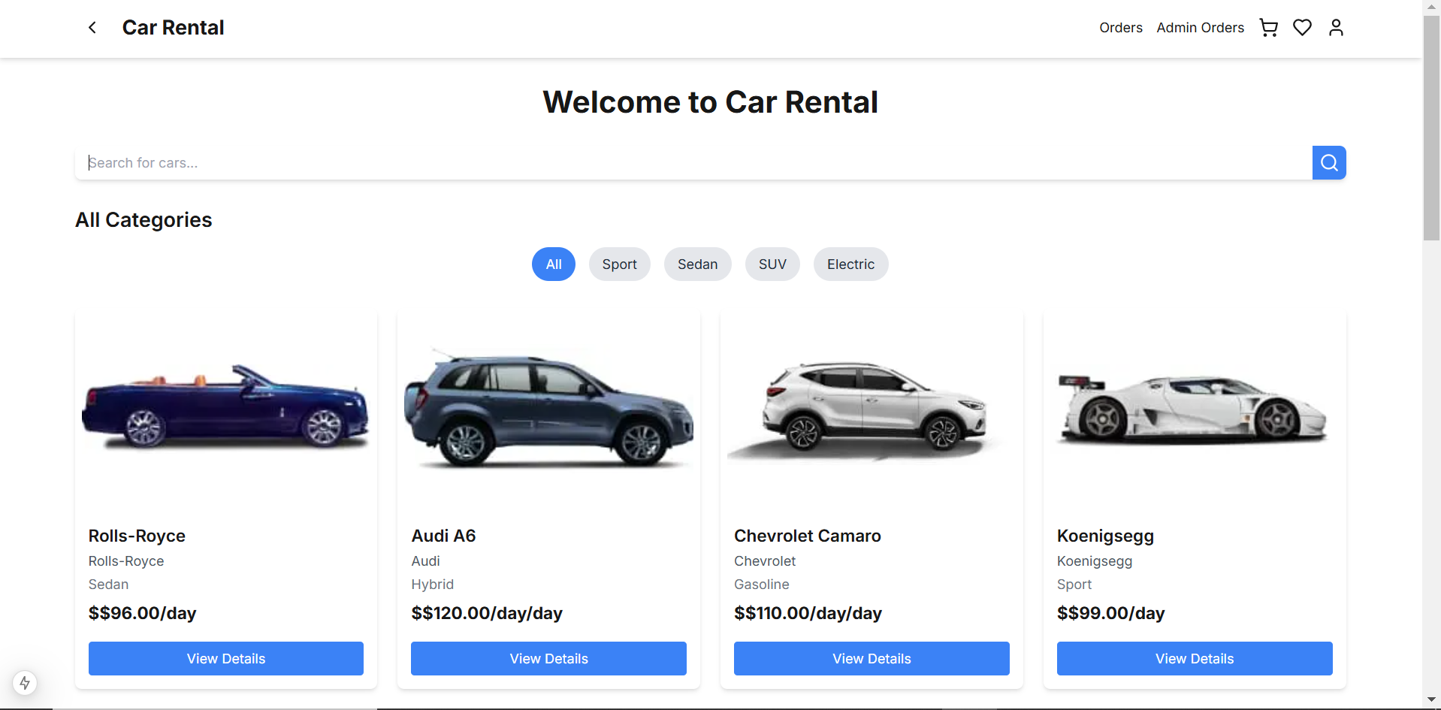
SPORTS :
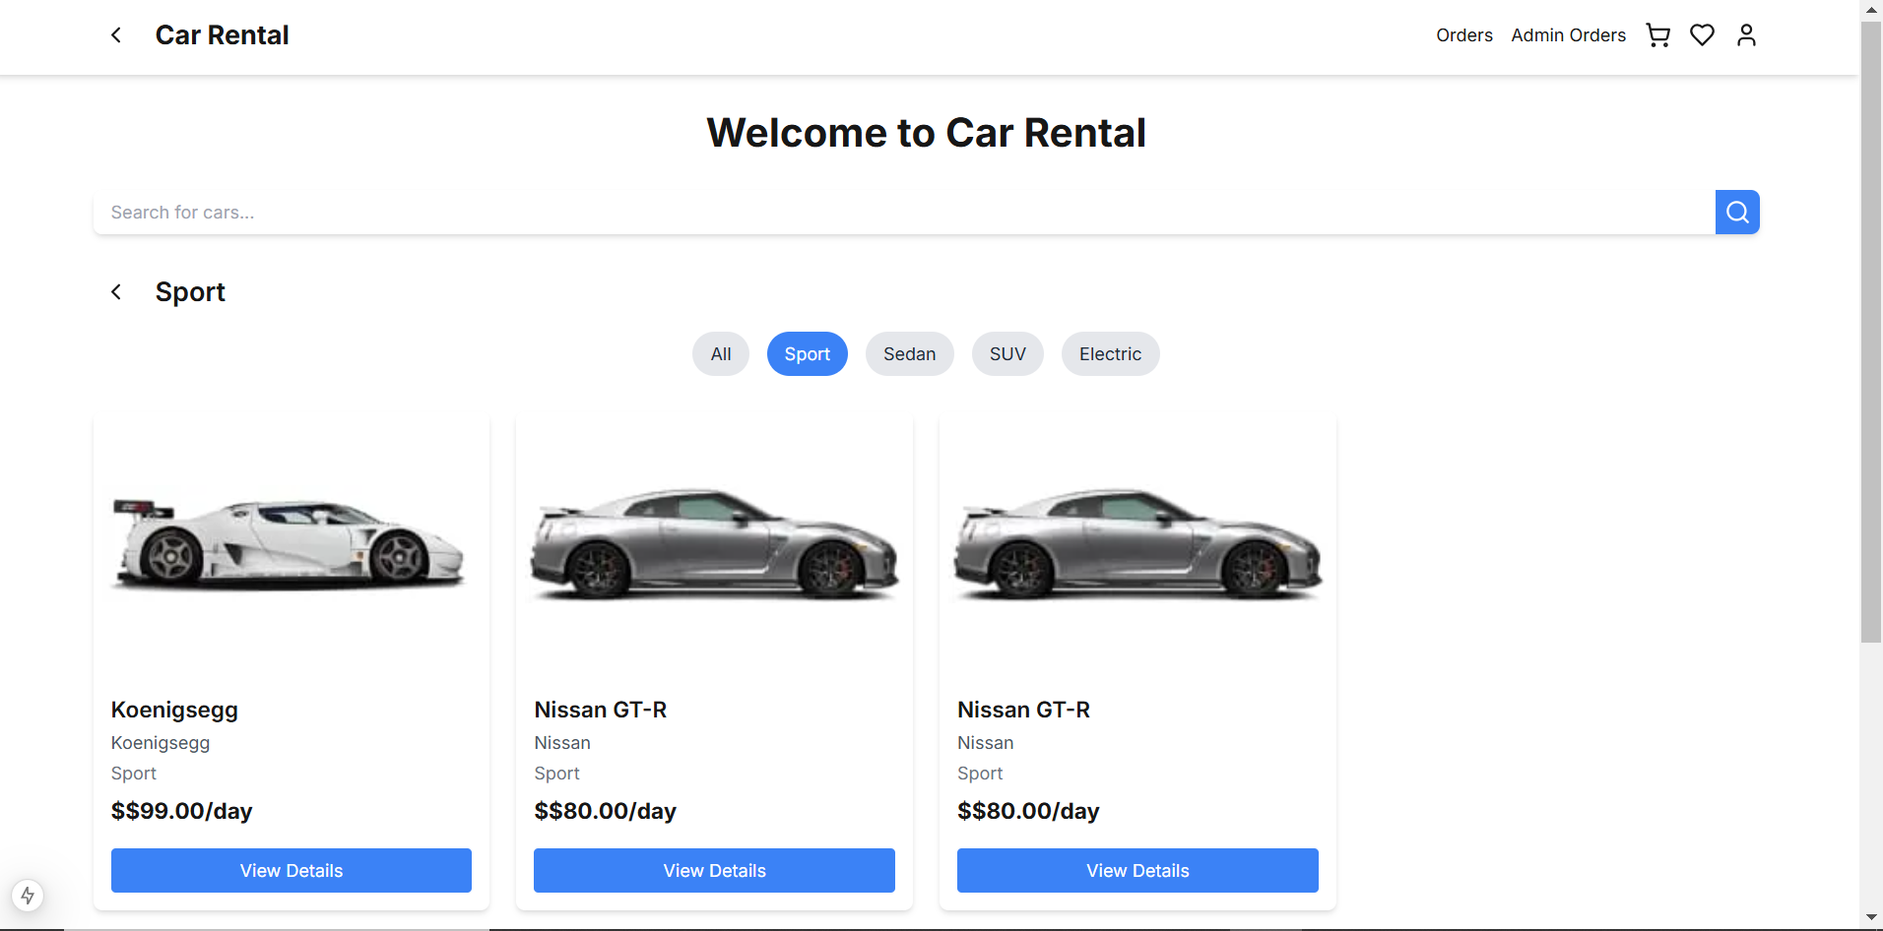

SUV:
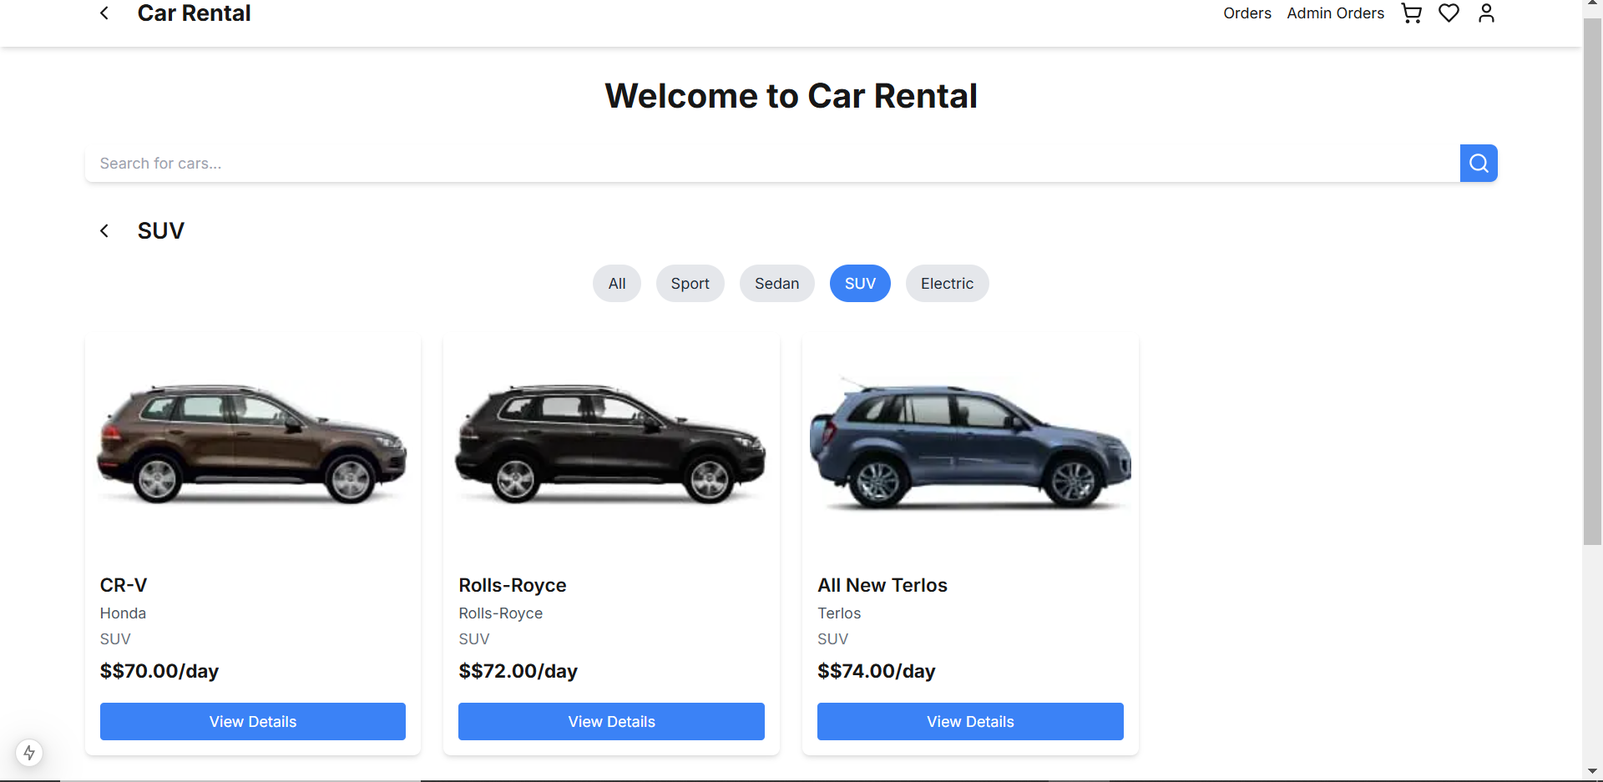
DYNAMIC NAVBAR:
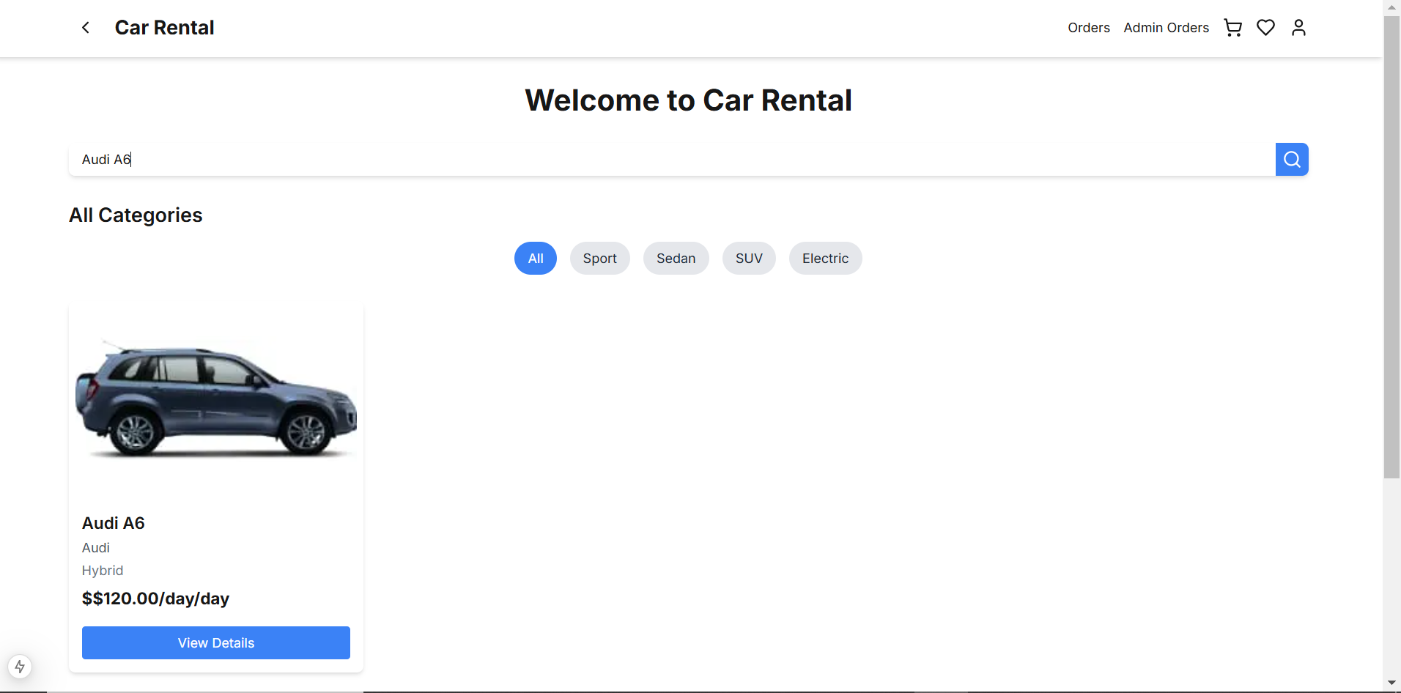
CAR DETAIL PAGE:
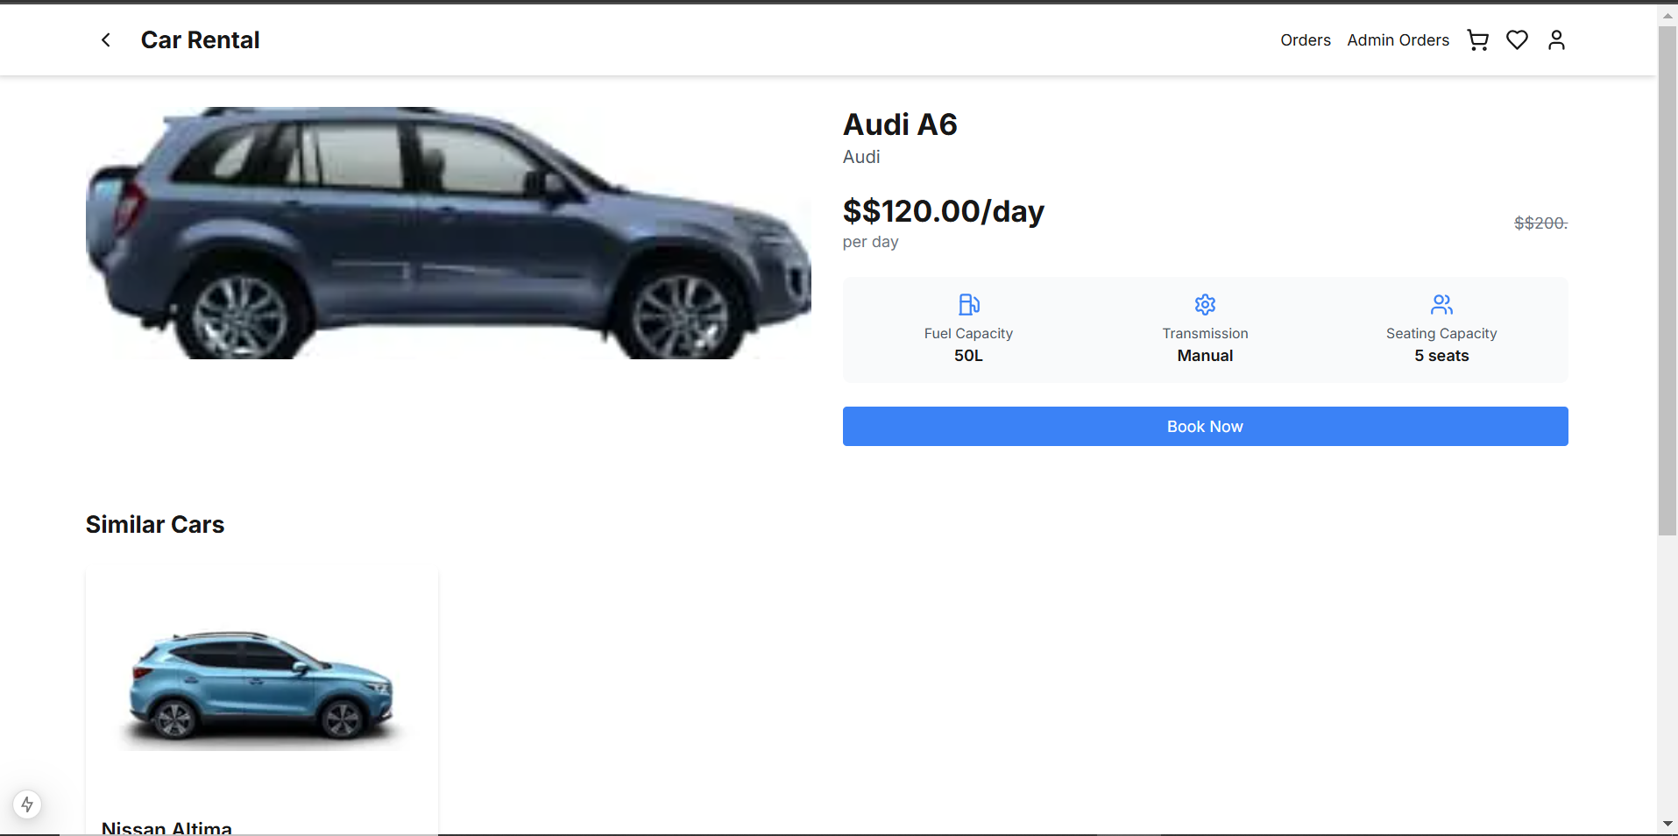
BOOK NOW FUNCTIONALITY:

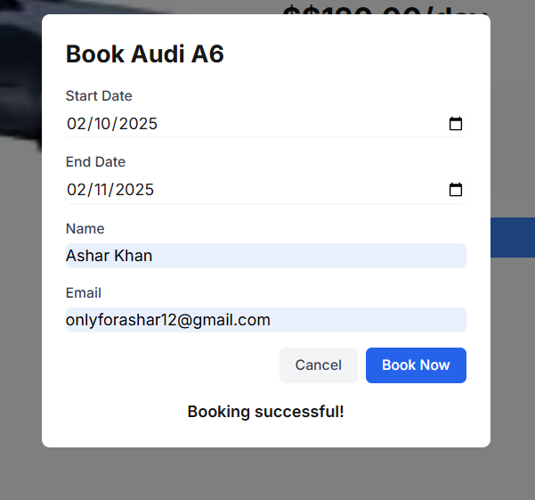

ORDER IS SHOWN AT ORDER PAGE:
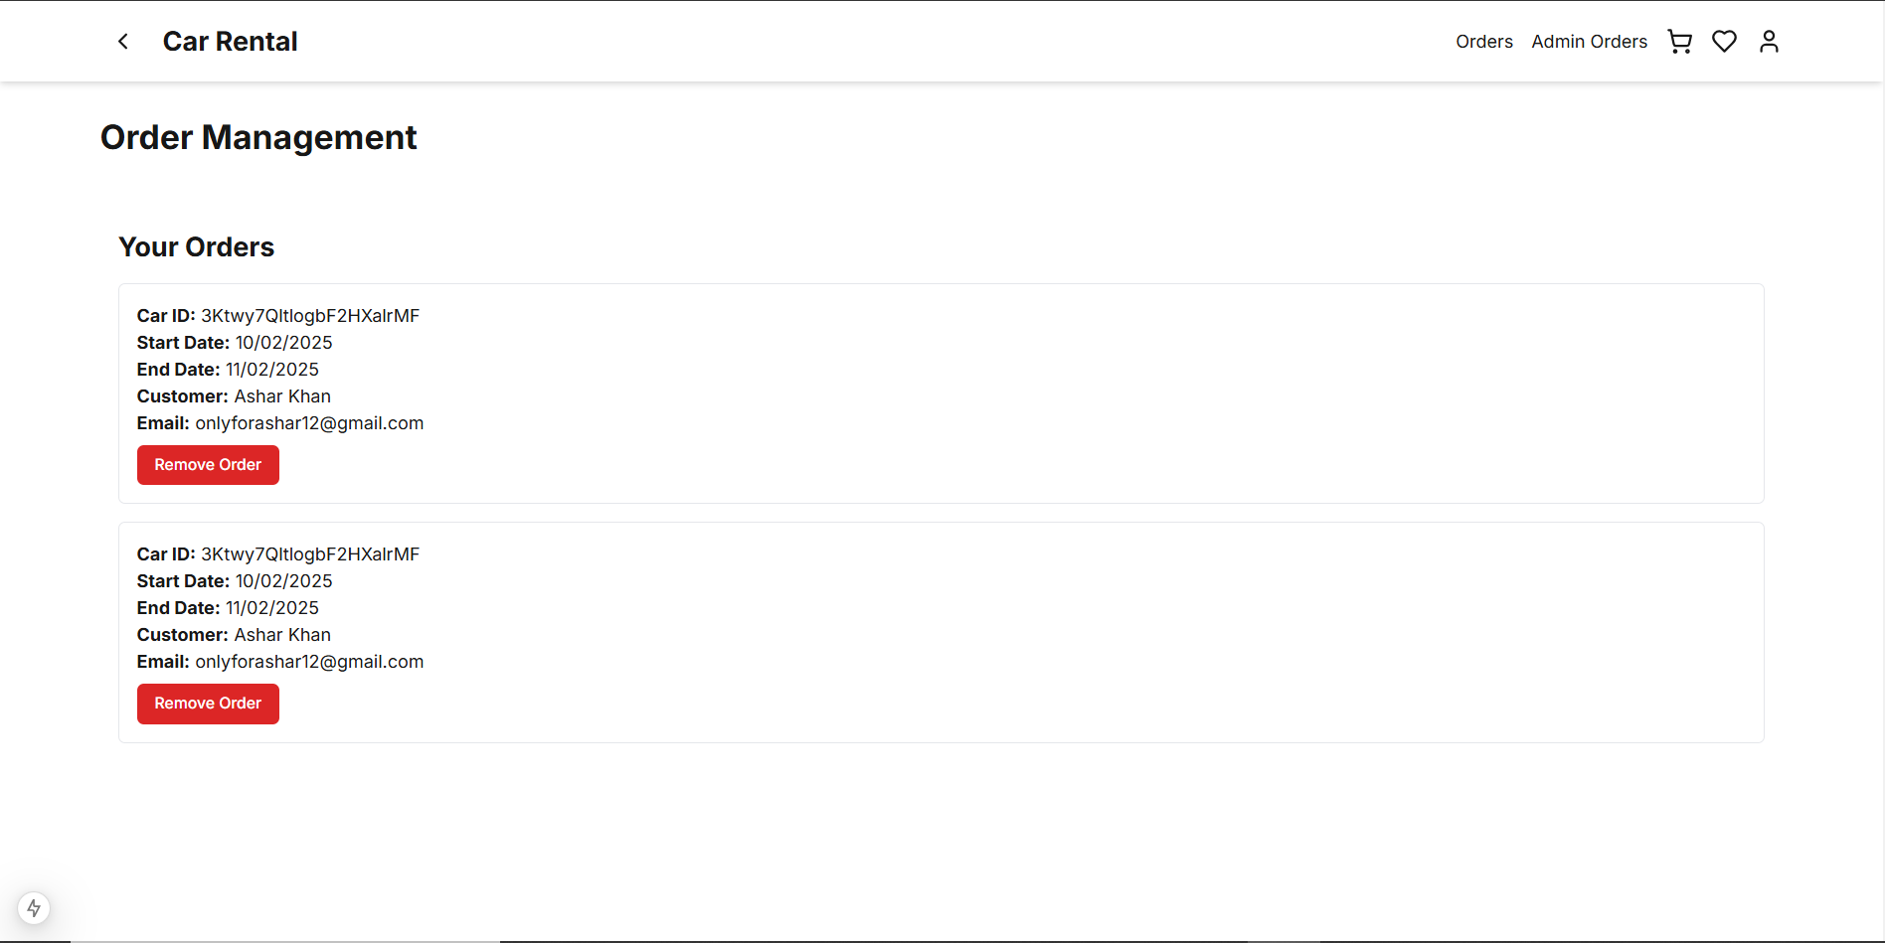
ORDER SHOWS TO ADMIN AT ADMIN ORDER PAGE:
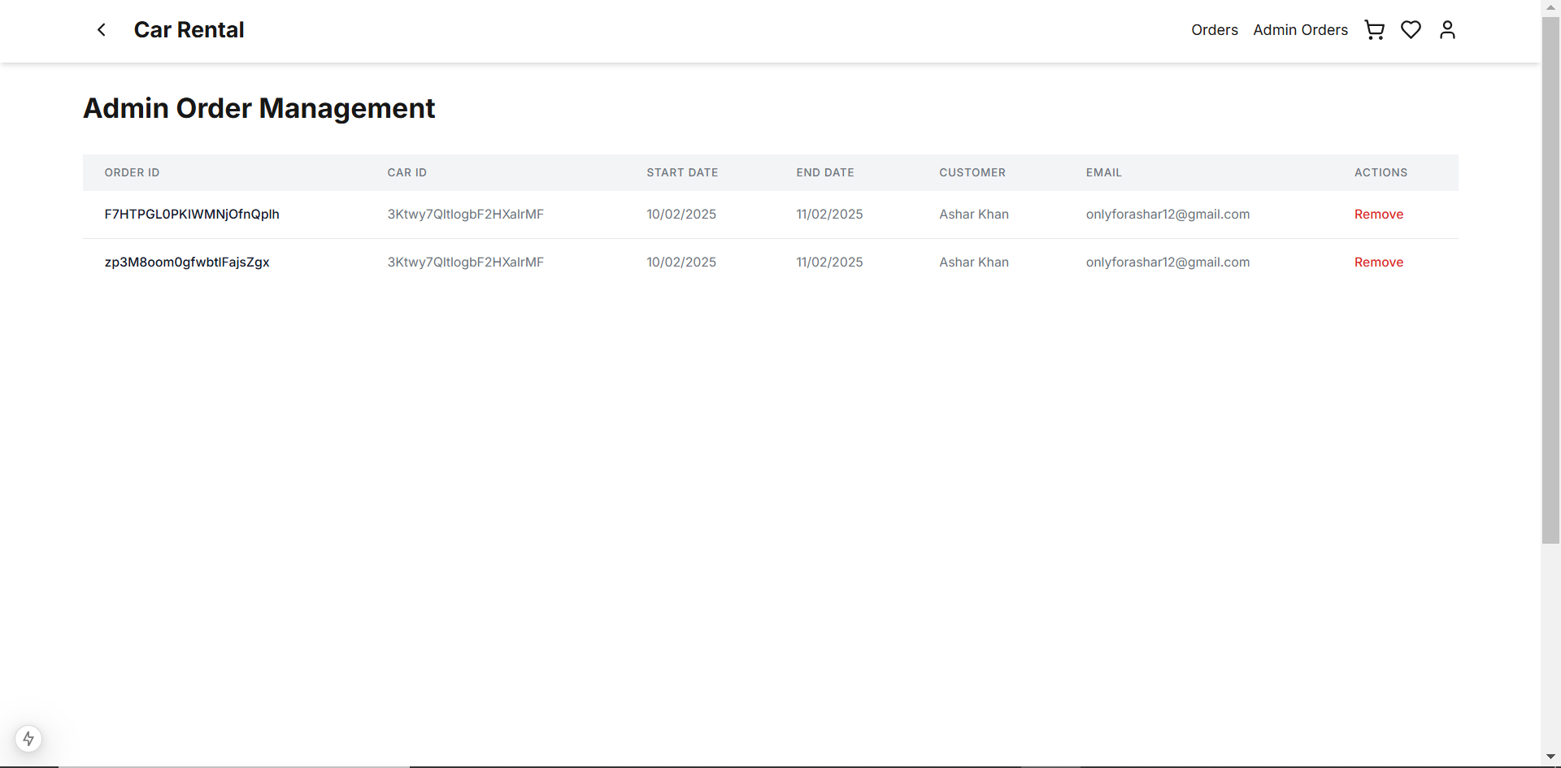

RESPONSIVENESS OF WEBSITE:
FULLY RESPONSIVE AT ALL DEVICES,
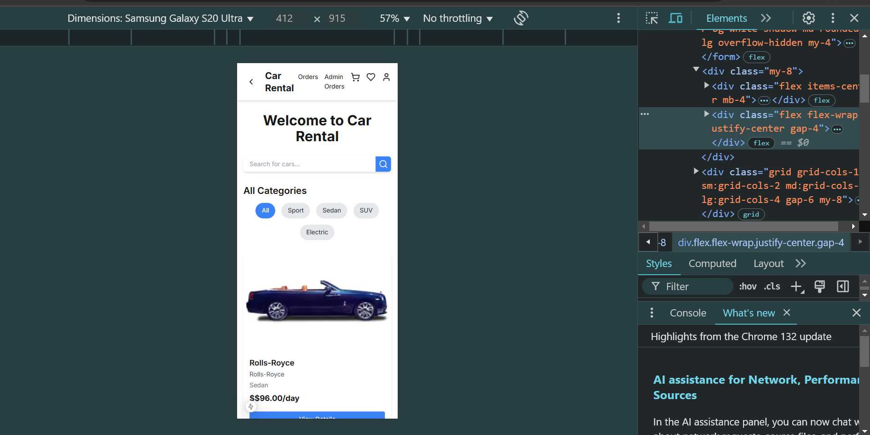
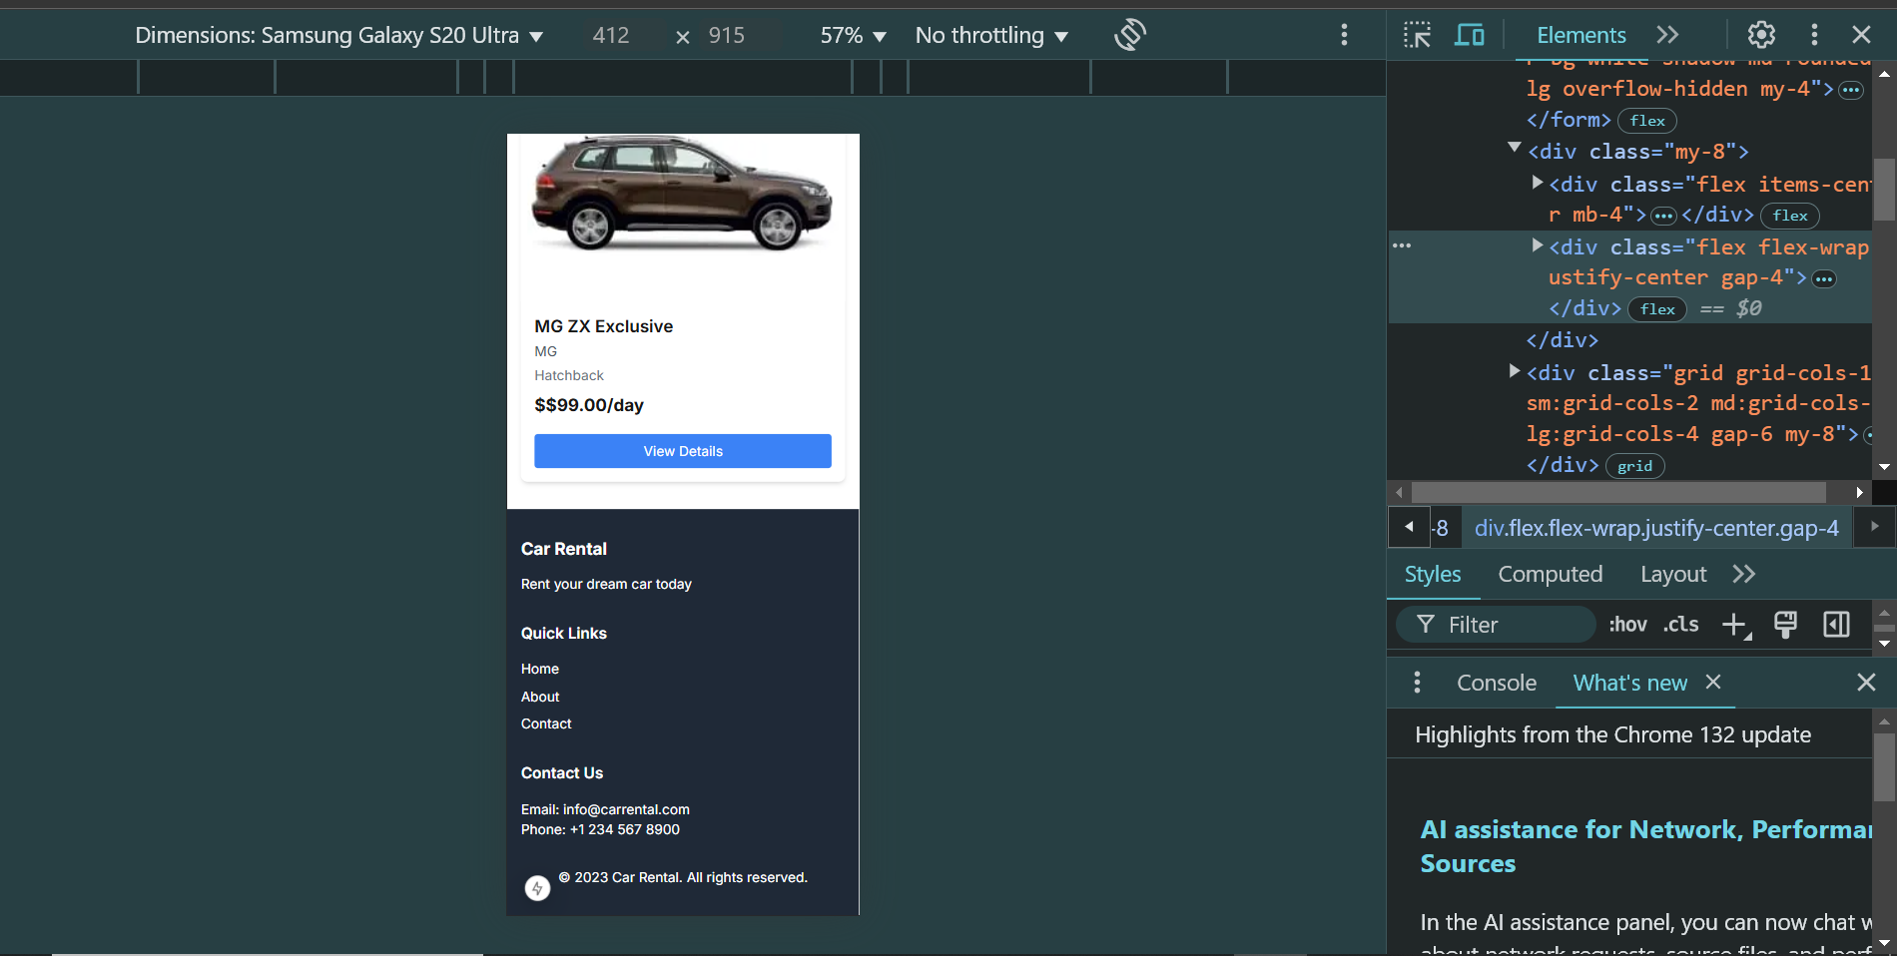
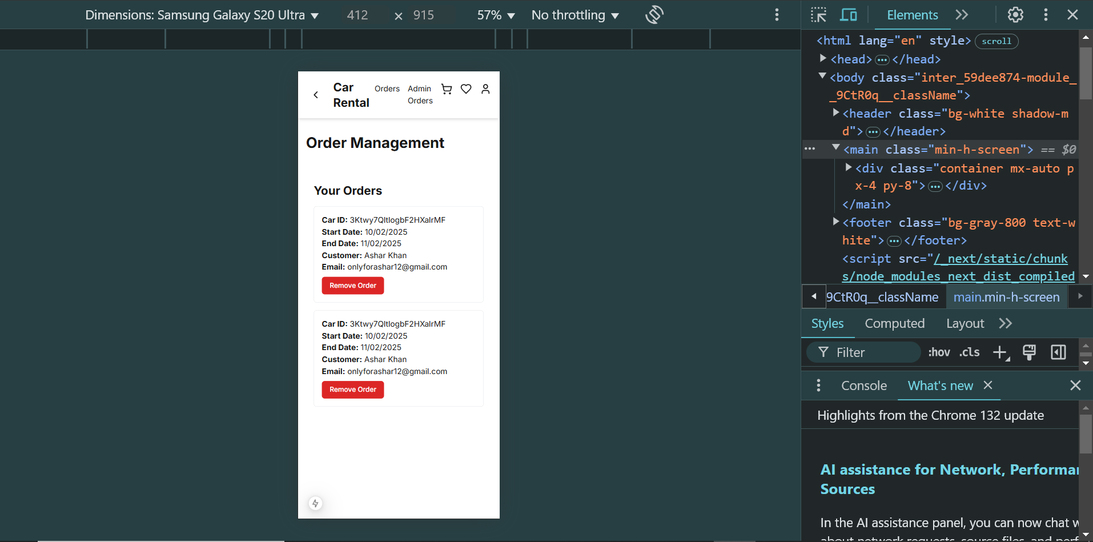
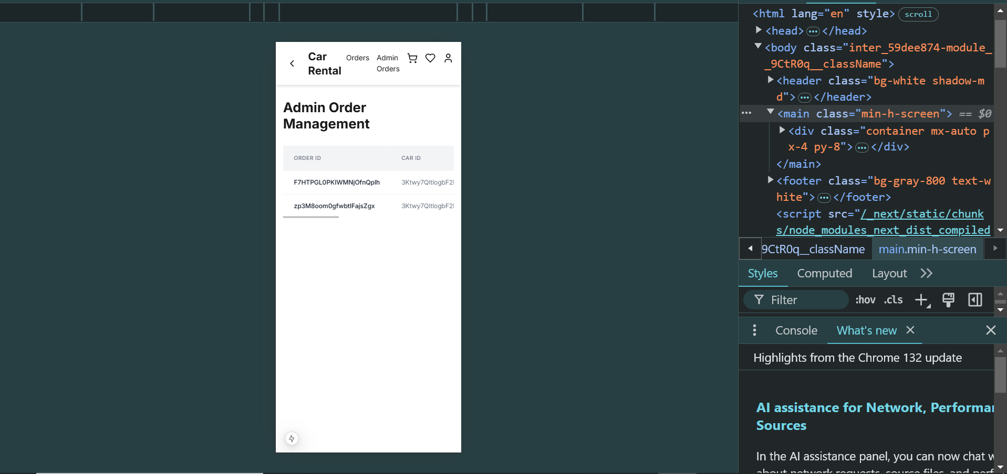

TESTING:
Test Case ID | Test Case Description | Test Steps | Expected Result | Actual Result | Status | Severity Level | Assigned To | Remarks
TC001 | Validate product listing page | Open product page > Verify products | Products displayed correctly | Products displayed correctly | Passed | high |  | No issues found
TC002 | Test API error handling | Disconnect API > Refresh page | Show fallback UI with error message | Error message shown | Passed | Medium |  | Handled gracefully
TC003 | Check cart functionality | Add product to cart > Verify cart contents | Cart updates with added product | Cart updates as expected | Passed | High |  | Works as expected
TC004 | Ensure responsiveness on mobile | Resize browser window > Check layout | Layout adjusts properly size | Responsive layout working as intended | Passed | high |  | Test successful
PERFORMANCE:
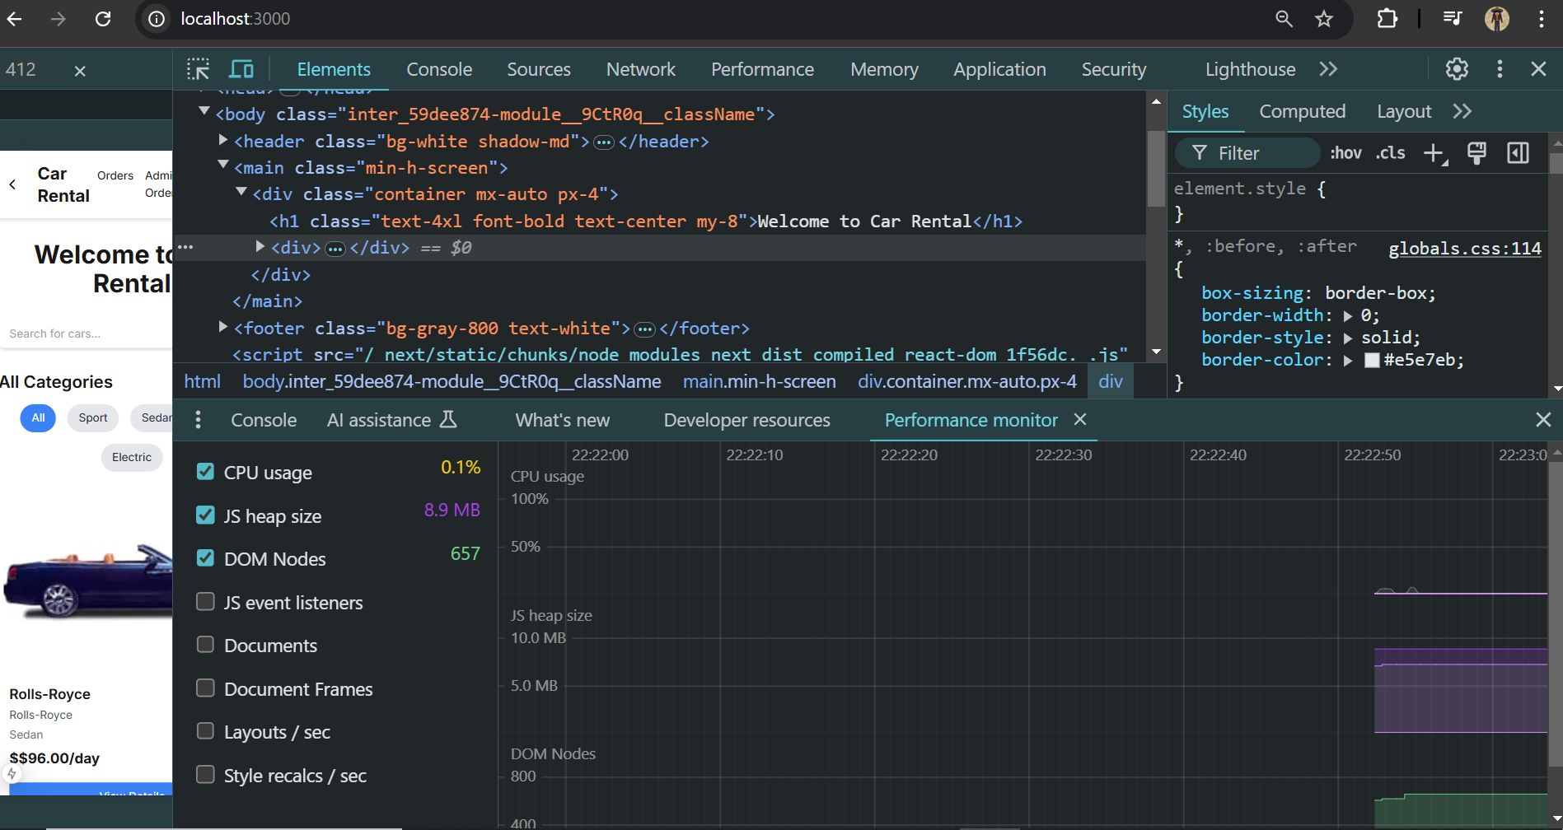
DEVELPER RESOURCES:
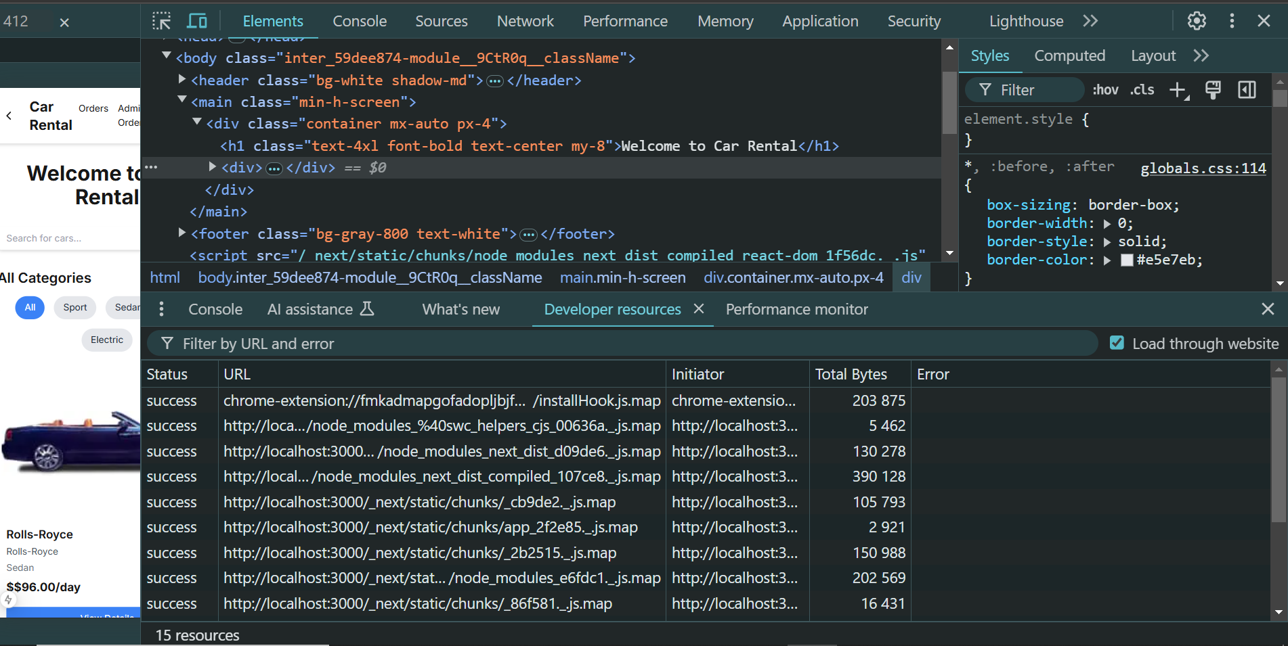
SECURITY:
