“**Development and Validation of an Integrated Modeling Approach to Reconstruct the Propagation of Fluvial Sediment Pulses After Dam Removals.**”

**Overview:**

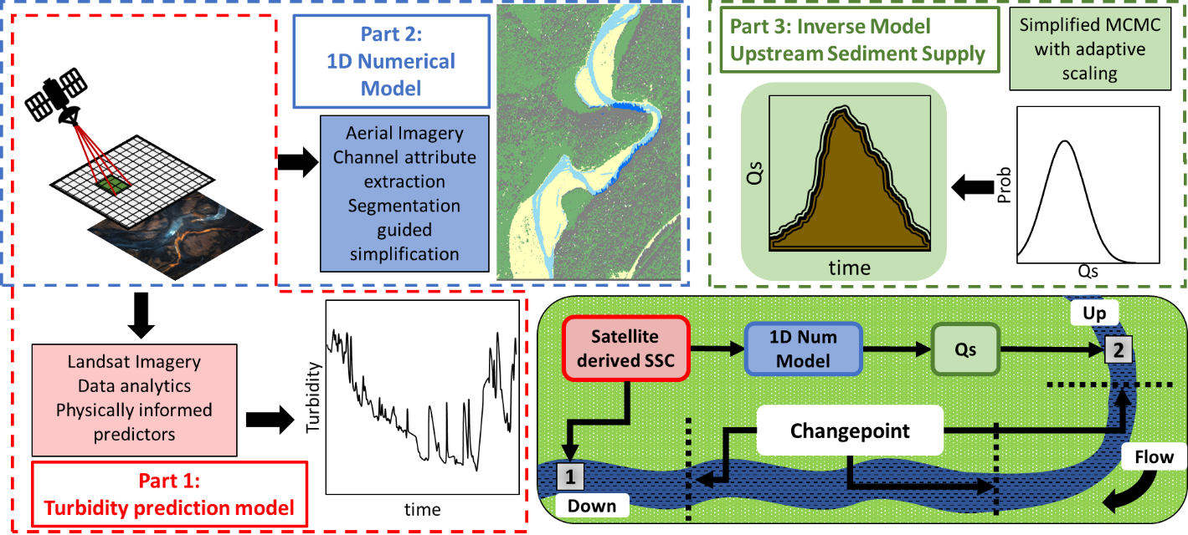

**Part 3A Description:**

Use Landsat-derived, spatially continuous suspended sediment concentration (SSC) data to optimize a one-dimensional hydro-morphodynamic numerical model for a model parameter Cs representing the upstream volumetric sediment supply concentration (m3/m3). Herein, Root Mean Squared Error (RMSE) was used as an objective function with Markov Chain Monte Carlo (MCMC) Inverse Modeling Framework

1. Model Input:
   1. Discharge Q extracted from “Q_h_list.rds”
   2. Flow Depth, h extracted from “Q_h_list.rds”
2. Model Calibration: Landsat based SSC (Part 1 + Part 2)
   1. Landsat based SSC:
      1. The number of SSC data extracted is scene specific and is dependent upon incident lighting conditions, cloud cover, and efficiency of water pixel extraction process (in this case thresholding using NDWI)
      2. The reflectance values are then used to derive SSC for water pixels throughout the study area using methods developed in Part 1 and Part 2
      3. Files “SSC_list.rds” contains spatially explicit SSC values, and “dgo_list.rds” matches the SSC values with the correct Finite volume location used for the Numerical model
3. Numerical Model:
   1. A well commented version of the 1D Numerical model is shared using the “Demo_w_desc.R” file
   2. Model Formulation and
      1. Governing equations:
         1. 1D unsteady St. Venant shallow water equations
         2. Exner equations for conservation of sediment mass
      2. Ability to simulate non-uniform bed load and suspended sediment transport rates
      3. Ability to simulate changes in bed gradation (Castro Bolinaga, 2016)
   3. Channel geometry:
      1. Extracted using publicly available NAIP imagery
      2. Simplified using changepoint analysis
      3. Calibrated for Water Surface Elevation (m), and SSC (m3/m3)
      4. Validated using remote sensing derived Erosion and Deposition amounts in m
4. Inverse Modeling Framework:
   1. Relies on the conceptual framework presented and validated for the Elwha Dam removals (Sharma, 2023)

* 1. A well commented version of the code available in “Demo_w_desc.R”
  2. Upstream sediment supply concentration (Cs in m3/m3) selected as the parameter to be optimized
  3. RMSE selected as the objective function
  4. MCMC used with adaptive scaling to ensure efficient exploration of Cs parameter space
  5. At each time step, Cs and its associated RMSE is saved
  6. Multiple scripts are run to spatiotemporally reconstruct sediment pulses throughout the evaluation period using remote sensing, numerical modeling, and machine learning.
  7. File “Parallel.R” demonstrates a simple method used to run multiple scripts in parallel

**References:**

Castro Bolinaga, C. F. (2016). *Numerical Simulation of the Propagation of Fine-Grained Sediment Pulses in Alluvial Rivers*. Virginia Tech.

Sharma, A. (2023). *Development and Validation of an Integrated Modeling Approach to Reconstruct the Propagation of Fluvial Sediment Pulses After Dam Removals.*