Decline in the running performances of lower-ranking participants in popular road races.

By
Ayush Sharma

A thesis submitted to the School of Graduate Studies
In partial fulfillment of the requirements for the degree of
Master of Science in Kinesiology School of Human Kinetics and Recreation
Memorial University of Newfoundland

Supervisor:
Dr. Fabien Basset
Co-Supervisor: Dr. Liam Kelly

April 2025

Table of Contents
1.1 Background of the Study 1
1.2 Purpose of the Study 5
2.1 Physical Fitness 8
2.1.1 General Fitness 11
2.1.2 Cardiorespiratory Fitness 12
2.2 Historical Background and Evolution of Physical Activity 17
2.2.1 The history of Distance Running 20
2.2.2 Evolution of Records 22
2.3 Physiological Response to Endurance Training 26
2.3.1 Cellular Response 28
2.3.2 Systemic Response 29
2.4 Sedentarism 33
2.5 Hypothesis 34
3.1 Abstract 36
3.2 Introduction 37
3.3 Methods 39
3.3.1 Data Collection Method 39
3.3.2 Programming Languages and Libraries 39
3.3.3 Data Cleaning 40
3.3.4 Exploratory Data Analysis 41
3.3.5 Attribute Information 41
3.3.6 Data Preparation 42
3.3.7 Calculation 43
3.3.8 Statistical Analysis 44
3.4.1 Participation and CRF trend 45
3.4.2 Participation by Age groups over the years 47
3.4.3 Average VO₂max by Age Groups for Males 49
3.4.4 Average VO₂max by Age Groups for Females 51
3.4.6 Analyzing the 50th Percentile for Tely 10 Road Race 55
3.4.7 Analyzing the 10th Percentile for Tely 10 Road Race 57
3.4.8 Analyzing the 10th Percentile for Tely 10 Road Race for Males 59
3.4.9 Analyzing the 10th Percentile for Tely 10 Road Race for Females 61
3.5 Discussion 63
3.6 Methodological Considerations 68
3.7 Conclusion 69
References 73
APPENDIX A: Full Ethics Clearance – Publicly Accessible Data 78
APPENDIX B: Tukey Table for 90th Percentile for Tely 10 79
APPENDIX C: Tukey Table for 50th Percentile for Tely 10 81
APPENDIX D: Tukey Table for 10th Percentile for Tely 10 83
APPENDIX E: ANOVA Table for 90th Percentile for Tely 10 85
APPENDIX F: ANOVA Table for 50th Percentile for Tely 10 86
APPENDIX G: ANOVA Table for 10th Percentile for Tely 10 87

List of Tables

Table 1 Average VO₂max by Age Group Across Time Periods for Males (1996–2024) ...................49
Table 2 Average VO₂max by Age Group Across Time Periods for Females (1996–2024) ................51
Table B1 Tukey HSD Table for 90th Percentile (Tely 10) ..................................................................79
Table C1 Tukey HSD Table for 50th Percentile (Tely 10) ..................................................................81
Table D1 Tukey HSD Table for 10th Percentile (Tely 10) ..................................................................83
Table E1 ANOVA Summary Table for 90th Percentile Results...........................................................85
Table F1 ANOVA Summary Table for 50th Percentile Results...........................................................86
Table G1 ANOVA Summary Table for 10th Percentile Results...........................................................87

List of Figures

Figure 1 Participation and predicted average VO₂max trends from 1978 to 2023..................45
Figure 2 Distribution of participant count by age group (1990–2023) ...................................48
Figure 3 Trend line graph for 90th percentile road race results (with standard deviation and 95% confidence interval) ................................................................................................................54
Figure 4 Trend line graph for 50th percentile road race results (with standard deviation and 95% confidence interval) ................................................................................................................56
Figure 5 Trend line graph for 10th percentile road race results (with standard deviation and 95% confidence interval) ................................................................................................................58
Figure 6 Trend line graph for 10th percentile for Males Road race results (with standard deviation and 95% confidence interval) ........................................................................................................60
Figure 7 Trend line graph for 10th percentile for Females Road race results (with standard deviation and 95% confidence interval) .................................................................................................62

CHAPTER 1
INTRODUCTION

1.1 Background of the Study
To understand how humans are designed for movement, it is essential to explore our evolutionary history. Studying the movement and nutrition patterns of ancestral populations provides valuable insights into how humans are naturally adapted for physical activity and dietary habits. This evolutionary perspective reveals physical adaptations that have influenced endurance, movement patterns, and overall capabilities. By examining the lifestyle of hunter-gatherers, we gain a deeper appreciation of the natural design and function of human movement. Notably, hunter-gatherer mobility was primarily driven by the distribution of food resources, which were often uneven across landscapes. As a result, these populations developed intricate movement patterns to acquire and transport food (Kelly, 2014). Although women rarely participated in large-game hunting, they were nonetheless highly physically active due to the demands of daily subsistence. Foraging involved gathering a wide variety of foods, including plants, vegetables, fruits, berries, nuts, tubers, and small animals. These activities required strenuous physical effort, such as digging, climbing, bending, stretching, and carrying heavy loads—often including children over long distances until the children reached around four years of age, sometimes totaling up to 4,800 kilometers. Other physically intensive tasks included constructing shelters, repairing tools, and preparing food. Communal dancing was also a frequent recreational activity, often lasting several hours across multiple nights each week (O’Keefe et al., 2010).
Among men, hunting was a fundamental routine activity. One particularly fascinating method was persistence hunting, which involved chasing prey over long distances during the hottest part of the day. This strategy leveraged the human advantage of thermoregulation through sweating, allowing hunters to exhaust prey over time (Ember, 2019; History, 2023; Lieberman et al., 2007; National Geographic Society, 2024; Attenborough, 2010). Hunters adapted their pace based on the movement of their quarry, alternating between walking and brief sprints across varied terrain. According to the Journal of Science in Sport and Exercise (2021), such ancestral activity patterns resulted in energy expenditures of 800–1,200 kilocalories per day—three to five times higher than the average modern American (Marlowe, 2005). Consequently, hunter-gatherer societies exhibited low rates of obesity and chronic diseases.
The endurance running hypothesis proposes that the human ability to sustain long-distance running may have significantly shaped evolutionary outcomes by enabling unique hunting strategies. Although most large animals can sprint faster than humans, few are capable of maintaining high speeds over extended periods. Persistence hunting enabled humans to outlast prey through thermal exhaustion, facilitating eventual capture (Crittenden & Schnorr, 2017; O’Keefe et al., 2010). In contemporary society, running remains a widely practiced form of physical activity. It offers numerous benefits for cardiovascular conditioning, longevity, and overall health. Regular runners typically exhibit lower resting heart rates and higher maximal oxygen uptake (VO₂ max), reflecting superior cardiovascular efficiency (Lee et al., 2014). Beyond physiological advantages, running also supports mental health by alleviating depression, reducing stress, and improving sleep quality. For instance, adolescents who engaged in daily morning runs demonstrated improved sleep efficiency and reduced symptoms of insomnia compared to non-runners (Mahindru et al., 2023).
However, modern lifestyles have diverged significantly from ancestral movement patterns. The Agricultural Revolution, approximately 10,000 years ago, marked a transition from foraging to farming. Although still physically demanding, agricultural work involved less dynamic movement and a narrower range of motion. Over time, as food availability increased and physical exertion declined, cardiorespiratory fitness began to deteriorate (Pontzer et al., 2012). Cardiorespiratory fitness (CRF)—
the body's ability to deliver and utilize oxygen during physical activity—is now recognized not only as a marker of physical activity levels but also as a powerful prognostic indicator for cardiovascular health and overall mortality.

1.2 Purpose of the Study
Modern technological advancements and mechanization have drastically altered physical activity patterns and diets compared to those of ancestral humans (Negishi, 2002). Research has shown that populations with higher physical activity levels, such as tribal communities, experience significantly lower rates of non-communicable diseases like diabetes and hypertension than their sedentary counterparts in industrialized nations (Booth et al., 2017).
Cardiorespiratory fitness (CRF) represents the integrated function of the cardiovascular and respiratory systems to supply oxygen during sustained physical activity. It is often measured by VO₂max and is closely linked with endurance performance and longevity. Declining CRF is associated with increased risks of illness and mortality (Burtscher et al., 2022).
While numerous studies have explored the long-term decline in CRF among the general population (Lamoureux et al., 2018b), this study specifically focuses on running performance in road races as a proxy. The aim is to determine whether race performance trends reflect the broader decline in CRF.
This thesis investigates the performance trends of lower-ranking (10th percentile) participants in the Tely 10 road race, analyzing data from 1995 to 2020. Performance is assessed by calculating speed and predicting VO₂max using a standard formula (VO₂max = 3.5 × speed). The central objective is to evaluate whether the decline in race performance among general participants mirrors the long-term decrease in population-level cardiorespiratory fitness.

1.3 Significance of the Study
Most studies in exercise science focus on elite or trained athletes, often overlooking the general population. However, the rise of chronic diseases due to physical inactivity and obesity calls for more inclusive research. Current physical activity guidelines appear ineffective for many, particularly younger individuals who struggle to adopt and maintain consistent exercise routines (Gardner et al., 2012). This study shifts the focus to lower-ranking race participants, offering a lens into CRF trends within the broader population.
Additionally, fitness trends on social media have popularized short-term, high-intensity workouts such as HIIT for aesthetic purposes rather than for long-term health (Dunlop et al., 2016). This emphasis on rapid transformations can undermine sustainable fitness behaviors. In contrast, this thesis advocates for a deeper understanding of aerobic fitness as a long-term health metric, emphasizing the importance of consistent, accessible movement patterns that support cardiovascular, metabolic, and mental well-being throughout the lifespan.

CHAPTER 2
LITERATURE REVIEW

2.1 Physical Fitness
Physical fitness is the ability of your body systems to work in harmony, allowing you to maintain health and perform daily activities effectively. It involves completing everyday tasks with minimal effort and energy. When your cardiovascular, respiratory, and muscular systems function efficiently, you can perform activities like walking, lifting, and climbing stairs with ease, reducing fatigue and the risk of injury. This efficiency not only supports your physical health but also enhances your overall well-being and quality of life (Warburton, 2006).
The World Health Organization (WHO) defines physical activity as “any bodily movement produced by skeletal muscles that requires energy expenditure.” This broad definition encompasses a wide range of activities beyond traditional sports. It includes everyday movements such as walking and running, as well as activities like swimming, gymnastics, dance, ball games, and martial arts. This perspective emphasizes that physical activity can take many forms, each contributing to overall health and fitness (Posadzki et al., 2020).
Exercise is a planned, structured, and repetitive form of physical activity specifically performed to improve or maintain various aspects of physical fitness and overall health. Exercise plays a crucial role in building healthy bones and strengthening muscles that support and protect joints. Regular physical activity helps prevent bleeds and joint damage by maintaining strong muscles, which can reduce the frequency and severity of bleeding episodes in joints and alleviate joint pain. Additionally, having strong muscles, good balance, and coordination decreases the likelihood of bleeds in both joints and muscles. Strong and flexible muscles are better able to withstand overexertion or overstraining, making them less susceptible to injuries or bleeds.
Training is a systematic, goal-oriented process that involves repeated and progressively challenging exercise or practice designed to improve specific physical, physiological, psychological, or skill-based capacities over time. Unlike a single bout of exercise, training follows a structured plan based on principles such as progressive overload, specificity, and periodization, aiming to induce long-term adaptations that enhance performance, fitness, or skill. According to (Kraemer & Ratamess, 2004), training requires a gradual increase in workload to continuously stimulate the body for adaptation, while (Hoffman, 2002) emphasizes its deliberate and organized nature tailored toward specific outcomes.
The distinction between exercise and training is fundamental in exercise science and sports physiology, as both serve different roles in physical development and health outcomes. Exercise refers to a single bout of physical activity that is typically structured and purposeful, aimed at immediate benefits such as burning calories, improving mood, or enhancing acute physiological responses like increased heart rate or blood flow. However, exercise, when performed in isolation or without a systematic plan, is unlikely to lead to long-term physiological adaptations. In contrast, training is a structured, repetitive, and goal-oriented process that employs principles such as progressive overload, specificity, and periodization to induce lasting adaptations in the body. Through consistent and progressive exposure to exercise stimuli, training leads to measurable improvements in strength, endurance, cardiovascular fitness, and other performance-related capacities.
Fitness comprises several key components, and the first is cardiorespiratory endurance. This aspect of fitness indicates how effectively the body’s circulatory and respiratory systems can supply fuel during prolonged physical activities. To boost your cardiorespiratory endurance, engage in activities that maintain an elevated heart rate at a safe level for an extended period, such as walking, running, jogging, swimming, or cycling. You don't need to start with strenuous exercises to see improvements. Begin with an activity you enjoy, and gradually increase the intensity over time.
The second component of fitness is muscular fitness, which refers to the ability of a muscle or group of muscles to exert force during a single maximal effort (contraction). To strengthen your muscles, it is essential to work them against resistance, whether that resistance comes from weights or gravity. To build muscle strength, consider exercises such as weight lifting, making sure to do so under proper supervision.
The third component is muscular endurance, which refers to a muscle or muscle group’s capacity to maintain force against a submaximal load over an extended period (or multiple repetitions) before becoming fatigued.
The fourth component is body composition, which refers to the ratio of lean body mass to body fat. This includes the amounts of muscle, fat, bone, and other essential parts of the body. Understanding body composition is vital for maintaining health and managing body fat effectively.
Finally, flexibility refers to the range of motion around a joint. Good joint flexibility can help prevent injuries throughout life. To enhance your flexibility, consider activities such as yoga, gymnastics, or basic stretching exercises.Regular exercise and physical activity are vital for the physical and mental well-being of nearly everyone, including older adults. Staying active can help you continue enjoying your favorite activities and maintain your independence as you age. Consistently engaging in physical activity over time can lead to substantial long-term health benefits. Therefore, health experts advise older adults to incorporate daily physical activity into their routines to sustain their health and well-being (CDC, 2024).

2.1.1 General Fitness
Cardiovascular fitness is widely considered the most essential form of physical fitness because of its numerous health benefits. These benefits are closely tied to the health of the lungs and heart, and they can significantly enhance both lifespan and quality of life. Cardiovascular fitness optimizes the muscles' ability to utilize oxygen efficiently, thereby producing the energy needed for movement. It positively impacts the heart, lungs, and vascular system, improving overall health, endurance, and reducing the risk of chronic diseases such as heart disease and hypertension.
Maintaining cardiovascular fitness involves engaging in regular activities like running, swimming, cycling, and other aerobic exercises that increase heart rate and improve respiratory efficiency (Haskell et al., 2007).
Anaerobic fitness pertains to short, powerful bursts of energy required for activities such as sprinting, powerlifting, and rapid, explosive movements (O’Leary et al., 2021). Flexibility fitness enhances a person's range of motion in various joints. It involves the lengthening of muscles across joints, allowing for a greater bending motion. While joint flexibility varies among individuals, it can be developed with the appropriate workout routine to improve their range of movement. Managing your fitness isn't just about choosing the type of exercise that suits you best, although some activities may be more suitable for you than others. Instead, it involves taking a holistic approach that balances all types of fitness equally. This approach ensures comprehensive development in strength, cardiovascular health, flexibility, and endurance, leading to overall better health and performance (Forte & Teixeira, 2023b).

2.1.2 Cardiorespiratory Fitness
Cardiorespiratory fitness (CRF) refers to the ability of the circulatory and respiratory systems to deliver oxygen to the mitochondria in skeletal muscles for energy production during physical activity. Cardiorespiratory endurance is the degree to which your heart, lungs, and muscles work together during prolonged exercise. This measure indicates the efficiency of your cardiorespiratory system and serves as a marker of your overall physical fitness and health (Umapathi & Nguyen, 2023).
Cardiorespiratory endurance exercises improve the body's overall efficiency, making it easier to tackle physical challenges in everyday life. They also lower the risk of many chronic diseases. Cardiovascular exercise increases cardiac output, blood pressure, breathing rate, and blood flow to skeletal muscles, all of which help the body meet the demands of physical activity. Moderate endurance exercise enhances immune function, whereas excessive training can suppress it. Physically fit individuals tend to experience fewer colds and upper respiratory infections. Exercise influences immune function by affecting levels of specialized cells and chemicals involved in the immune response. Additionally, endurance activities can reduce anxiety, depression, stress, and anger, thereby improving overall mood (Eske, 2019).
VO₂max refers to the maximum amount of oxygen your body can utilize during exercise. Oxygen is a crucial component in the respiratory process, essential for breathing. When you inhale, your lungs absorb oxygen and convert it into energy in the form of adenosine triphosphate (ATP). ATP powers your cells and facilitates the release of carbon dioxide (CO₂), which is produced during respiration and expelled when you exhale (Starritt et al., 1999).
VO₂max is commonly used to assess the aerobic endurance or cardiovascular fitness of athletes before and after a training cycle. It is measured in milliliters of oxygen consumed per minute per kilogram of body weight (mL/min/kg). This metric provides valuable insight into an athlete's ability to utilize oxygen during intense exercise, reflecting their cardiovascular efficiency and endurance capacity (Poole & Jones, 2017).
VO₂max can be estimated from running speed in endurance road races such as the Tely 10 using established physiological equations. For level-ground running, the American College of Sports Medicine (ACSM) provides a widely used formula: VO₂ (mL/kg/min) = (0.2 × speed in m/min) + 3.5. This equation accounts for the linear relationship between running velocity and oxygen consumption during steady-state exercise. Nonetheless, it provides a useful and accessible means of approximating aerobic fitness in endurance settings. The simplified formula VO₂max≈ 3.5 × speed (in km/h) is a practical approximation commonly used to estimate maximal oxygen uptake during steady-state running, which we will be using in this study.
High-intensity interval training (HIIT) involves alternating between short, intense bursts of aerobic exercise and periods of lower intensity for recovery. This approach is highly effective for increasing VO₂max. Additionally, low-intensity activities such as running, biking, hiking, or rowing can also help improve VO₂max. These low-intensity workouts are beneficial as they are less strenuous on the body while still offering cardiovascular benefits. Incorporating both HIIT and low-intensity training provides a balanced method for enhancing overall cardiovascular fitness (Schneider, 2022).
Repeated bouts of endurance exercise induce several changes within the cardiovascular system that enhance oxygen transport and exercise performance. These responses include structural changes in the heart that improve its capacity for pumping blood, an increase in the number of capillaries supplying blood to the skeletal muscles, and an increase in overall blood volume. The increase in internal ventricular volume, observed with endurance training, is attributed to an increase in the number of sarcomeres per cardiac muscle fiber and remodeling of connective tissue. This response, known as volume overload, occurs in response to the stretch imposed on the ventricular walls by greater-than-normal ventricular filling (Nystoriak & Bhatnagar, 2018). Essentially, as the heart accommodates a higher volume of blood, it undergoes structural changes to enhance its pumping capacity. Chronic endurance training leads to a reduction in resting heart rate, a condition known as bradycardia. This response is also observed during submaximal exercise, particularly when comparing pre- and post-training heart rates at the same absolute exercise intensity. While heart rates at the same exercise intensity are generally unaffected by training, there can be a slight reduction in maximal heart rate if the training period is prolonged (Hellsten & Nyberg, 2015).
Endurance training stimulates an increase in total blood volume through a two-phase process: an expansion of plasma volume followed by an increase in erythrocyte volume. The increase in plasma volume is an acute response, detectable within the first few days of starting a training program. In contrast, the increase in erythrocyte volume becomes evident only after 2-3 weeks. Because plasma volume and erythrocyte volume increase proportionally, hemoglobin concentration and hematocrit levels typically show little difference between trained and untrained states after about a month. Endurance training stimulates an increase in the number of capillaries in the trained muscles. One of the earliest longitudinal studies of peripheral responses involved muscle biopsy samples from the quadriceps taken before and after six months of intensive training. The study found that capillary density increased by approximately 26% following the training period. Additionally, the number of capillaries per muscle fiber increased by about 20%, indicating the formation of new capillaries in the trained muscle (MacDougall & Sale, 2014).
Training studies with previously sedentary subjects indicate that the upper limit for improvement in VO₂max is about 20%. In more physically active individuals, such as physical education students, the upper limit is closer to 10%. Maximal aerobic capacity, which refers to the total amount of ATP that can be generated through oxidative metabolic processes, is often indirectly measured by the maximal amount of work that can be performed aerobically in a given time or at a certain percentage of VO₂max before fatigue sets in. In endurance events, any increase in maximal aerobic capacity translates to improved athletic performance. With endurance training, the proportional improvement in maximal aerobic capacity is often greater than the improvement in VO₂max itself (MacDougall & Sale, 2014).
Training not only increases VO₂max but also enhances the capacity to tolerate and sustain exercise at higher intensities. This improved capacity for submaximal exercise is largely due to an elevation in the lactate threshold following endurance training. The increase in lactate threshold is primarily attributed to the increased density of muscle mitochondria and capillaries. Enhanced oxidative enzyme activity, resulting from the increased number of mitochondria, allows for more efficient oxidation of pyruvate, leading to less lactic acid production at a given exercise intensity. Additionally, increased capillary density improves blood flow distribution to type I muscle fibers, enabling them to dominate energy production and reduce the recruitment of type II fibers. These peripheral adaptations are significantly greater than the improvements in VO₂max and are closely correlated with improvements in maximal aerobic capacity (Joyner & Coyle, 2007).
Training studies with previously sedentary subjects indicate that the upper limit for improvement in VO₂max is about 20%. In more physically active individuals, such as physical education students, the upper limit is closer to 10%. Maximal aerobic capacity, which refers to the total amount of ATP that can be generated through oxidative metabolic processes, is often indirectly measured by the maximal amount of work that can be performed aerobically in a given time or at a certain percentage of VO₂max before fatigue sets in. In endurance events, any increase in maximal aerobic capacity translates to improved athletic performance. With endurance training, the proportional improvement in maximal aerobic capacity is often greater than the improvement in
VO₂max itself (MacDougall & Sale, 2014).
Training not only increases VO₂max but also enhances the capacity to tolerate and sustain exercise at higher intensities. This improved capacity for submaximal exercise is largely due to an elevation in the lactate threshold following endurance training. The increase in lactate threshold is primarily attributed to the increased density of muscle mitochondria and capillaries. Enhanced oxidative enzyme activity, resulting from the increased number of mitochondria, allows for more efficient oxidation of pyruvate, leading to less lactic acid production at a given exercise intensity. Additionally, increased capillary density improves blood flow distribution to type I muscle fibers, enabling them to dominate energy production and reduce the recruitment of type II fibers. These peripheral adaptations are significantly greater than the improvements in VO₂max and are closely correlated with improvements in maximal aerobic capacity.

2.2 Historical Background and Evolution of Physical Activity
Walking and running on two legs, is a defining trait of the human lineage, setting our ancestors apart from their ape-like predecessors. Since Darwin's era, the evolutionary advantages and disadvantages of adopting a two-legged stride have been a subject of debate (Darwin, 1874). To comprehend how humans are designed for movement, it is crucial to explore our evolutionary history. Investigating the movement and nutrition of our ancestors provides valuable insights into our natural adaptations for physical activity and dietary habits. This perspective uncovers the physical changes that have influenced our movement patterns, endurance, and overall capabilities (Kelly, R. L., 2014).
The impact of modern technology on physical activity can be evaluated by studying a group whose lifestyle has remained relatively unchanged over the past 150 years. One study on the Older Amish community reported that adults engaged in moderate physical activity, such as walking, for nearly eight hours a day (Science and Arbor, 2004). In a hunter-gatherer study, Forager women were very fit due to their daily routines, which involved hours of walking and carrying food and water. Their foraging efforts often required strenuous activities such as digging, climbing, bending, and stretching, along with frequently carrying heavy loads back to camp (O’Keefe et al., 2010).
From around age 5 to old age, hunter-gatherers consistently participated in moderate to challenging aerobic activities. They likely alternated between more demanding days and easier days whenever possible. This routine fostered aerobic endurance, flexibility, and strength, leading to well-rounded fitness. Additionally, this varied movement pattern-built resilience and reduced the risk of injury, enabling them to hunt and forage without significant interruptions due to incapacitation (O’Keefe et al., 2010).
According to heart rate measurements, Heart rate measurements show that Hadza adults engage in exceptionally high levels of daily physical activity, mostly at low and moderate intensities. They spend over 135 minutes each day in moderate to strenuous physical activities, which is significantly more than the average for adults in the United States and Europe (Raichlen et al., 2017).
In the mentioned studies, tribal populations with a higher level of low-intensity physical activity are more likely to be physically fit and healthy than industrialized nations whose populations are sedentary and believe high-intensity exercise makes people fit and healthy. In addition to being more immune to diseases such as hypertension, obesity, diabetes, etc., tribes also showed a lower rate of non-communicable diseases.
Inactivity and sedentarism, associated with chronic conditions in industrialized communities, have yet to be investigated in small-scale groups (Booth et al., 2017).
When indigenous populations renounced their traditional lifestyles and adopted western diets and exercise levels, they got the same metabolic and cardiovascular problems as modernity (O’Dea, 1991). However, because traditional lifestyles and diets are so diverse, it is challenging to draw straightforward conclusions that can be applied to industrialized cultures. In addition, hunter-gatherers have meager obesity rates and engage in many different physical activities. A high degree of physical activity is part of traditional lifestyles that protect against non-communicable diseases, and according to some fossil and archaeological evidence, physical activity and walking appear to be ancient in the human lineage (Garland, 1999).
According to some research, longer daily travel distances are associated with improved endurance. Compared to chimps and other wild animals, humans also possess greater endurance. This may lead to the conclusion that humans are born walkers, and we know that low-intensity physical activity and endurance are linked. To think of chimps as our forefathers, there is skeletal evidence for greater robusticity in the rear limbs (Bramble and Lieberman, 2004). Ecological evidence supports a shift in the diet to contain more meat and provides indirect proof of greater endurance. Also, in humans, increased brain size, a shift in diet to include meat, and advanced technical complexity and ecological flexibility are all indicators of high endurance (Pontzer, 2017). The economy and cost of transport for humans show that by increasing the speed, the economy rises to a point where the cost of transportation is the lowest, meaning that at a low-intensity walking activity, there is a speed at which humans may feel comfortable with optimal efficiency while departing from that point decreases locomotor efficiency. Also, the gait of humans appears to be adapted to minimize metabolic energy consumption (McNeill Alexander, 2002). Running is not unique to humans, but it seems to be a fundamental human capability. As socially cohesive predators, our lower-limb physical responses, which emerged around 2 million years ago, may have evolved to support long-term trotting while tracking prey (Schulkin, 2016). Although running and group running are not exclusive to humans, many paleoanthropologists now believe that long-distance running may be a specific evolutionary adaptation for group hunting over long distances that developed specifically in humans (Lieberman, 2011).
The evolution of human running practices has transitioned from persistence hunting in the hunter-gatherer era to modern-day road races. Persistence hunting involves tracking and chasing prey over long distances until the animal is exhausted. This method relies on human endurance and the ability to run long distances rather than speed (Lieberman & Bramble, 2007). Today, running has become a popular form of exercise and competition, with road races ranging from 5Ks to marathons. Unlike the utilitarian purpose of persistence hunting, modern running is often pursued for fitness, recreation, and personal achievement.
The journey from persistence hunting to running road races illustrates the adaptability and enduring nature of human physical activity. While the motivations and contexts have evolved, the fundamental human capacity for endurance running remains a significant aspect of our biology and culture.
Human inventions aimed at reducing physical labor have significantly decreased incidental physical activity, despite providing numerous benefits to society.

2.2.1 The history of Distance Running
Today, running is one of the world's most popular and accessible sports, attracting thousands of new enthusiasts each year due to its physical and mental health benefits. Historically, running was essential for early humans, evolving as a necessity for escaping predators and hunting prey. Competitive running began much later, with its origins tracing back to 632-1172 BC. The first recorded Olympic Games, which included running events, took place in 776 BC.
The tradition of running in the Olympic Games dates back to 776 B.C., where the first recorded event was a foot race. In 490 B.C., the Greek soldier Pheidippides is said to have run approximately 25 miles from Marathon to Athens to announce a military victory over the Persians at the Battle of Marathon. This legendary run inspired the modern marathon race (Bramble & Lieberman, 2004).
Running was a key aspect of Greek society and is often referenced in historical Greek texts. The Olympic Games included numerous running events, and the Greeks devised specialized training programs to prepare for these competitions. Foot racing was a popular pastime, with successful athletes frequently receiving gifts from wealthy patrons. The ancient Greeks were pivotal in developing running into a formal sport and advancing it as a field of scientific and philosophical study (Geoghegan, 2022).
Distances in track races are standardized to metric units, such as 100m, 200m, 400m, and so on for sprints, and up to 10,000m for long-distance events. In road races, distances are typically measured in kilometers or miles, depending on regional preferences. Common race distances include 5K (5 kilometers), 10K, half-marathon (21.0975 kilometers), and marathon (42.195 kilometers). Track races adhere to precise metric measurements, dictated by the geometry of the track. Road races, on the other hand, may use either kilometers or miles and adapt to the unique layouts of their courses (Haugen et al., 2019).
Running, typically a solo sport, can become highly competitive in a race setting. When selecting a running race, you should consider various categories, distances, event sizes, costs, and travel accommodations. One of the most popular race distances is the 5-kilometer (5K) race. These shorter distance races are widely accessible, available from local to international levels. A 5K race can focus on speed, support a theme, or raise funds for local charities, making it appealing to both beginners and experienced runners (APA PsycNet, n.d.).
A 10-kilometer (10K) race is a mid-level distance that provides runners with the opportunity to push into double-digit mileage. The increased distance means greater time and physical demand on the body. However, it is an excellent way to build endurance and can serve as a stepping stone towards achieving a personal best or preparing for a half marathon. This distance is ideal for runners looking to progress beyond shorter races and challenge their endurance and speed (Thibodeau, 2019).
10-mile races are long-distance road running events covering 16.1 kilometers (10 miles). They are popular for offering a challenging distance that bridges the gap between a 10K and a half marathon. These races often feature scenic or urban routes, attract both elite and recreational runners, and are known for their strong community support. Many 10-mile races, like the Tely 10 or Broad Street Run, have a long history and are annual highlights in their regions.
The half marathon, spanning 21 kilometers (13.1 miles), is the first of the long-distance races and is typically the most popular among them. These races are usually held in large towns and cities and attract a larger field size compared to 5K and 10K races. With more participants, there is often increased support along the course from volunteers and spectators.
The full marathon, covering 42 kilometers (26.2 miles), is considered the pinnacle of long-distance running. It is viewed as the ultimate achievement in endurance running, with only about 1% of the global population having participated in and completed this grueling distance. Training for a marathon typically requires a rigorous program lasting 12 to 20 weeks before race day. The average finishing time for most participants is around 4 hours and 30 minutes, while elite runners finish in just over 2 hours.
Trail runs can vary greatly in distance, ranging from single digits to over 100 kilometers. Unlike road runs, trail runs are typically performed on hilly or mountainous hiking trails. The technical difficulty of trail runs can vary based on factors such as weather, altitude, and Topography.
For extreme runners looking to push their limits, ultra runs offer an unparalleled challenge. These races range in distance from 50 kilometers to over 1000 kilometers and can last anywhere from one day to ten days. Ultra-running is designed for a select group of individuals who are in excellent health and possess a very strong running base.

2.2.2 Evolution of Records
Today, running is one of the world's most popular and accessible sports, attracting thousands of new enthusiasts each year due to its physical and mental health benefits. Historically, running was essential for early humans, evolving as a necessity for escaping predators and hunting prey. Competitive running began much later, with its origins tracing back to 632-1172 BC. The first recorded Olympic Games, which included running events, took place in 776 BC. In sports where performance can be quantified, it is possible to track the progression of records, with world records serving as benchmarks for the highest achievements at any given time. However, in some sports, changes in rules or equipment have made historical comparisons less valid. For instance, the length and weight of the javelin were modified when top throwers started achieving distances that exceeded the confines of an athletic stadium. Most sports events, however, have not undergone such fundamental changes, though some alterations have still impacted performance. For example, the introduction of synthetic running tracks and advancements in shoe design have influenced the simple act of running, potentially enhancing performance over time. Despite these changes, world records continue to represent the pinnacle of human capability in sports (Krauss, 2004).
In the 100-meter sprint, successful athletes must quickly respond to the starter's gun and generate significant power to accelerate out of the starting blocks. They then need to sustain their peak speed for as long as possible and minimize deceleration in the final stages of the race. This combination of rapid reaction, explosive power, and sustained speed is crucial for achieving top performance in this event. The 100-meter sprint has seen remarkable progress over the years, driven by advancements in athletic training, performance, and technology. In 1912, Donald Lippincott (USA) set the first official record at 10.6 seconds, followed by Jesse Owens (USA) who reduced it to 10.2 seconds during the 1936 Berlin Olympics. In 1968, Jim Hines (USA) became the first to break the 10-second barrier with a manual time of 9.9 seconds, later adjusted to 9.95 seconds with the introduction of fully automatic timing (FAT) in 1977. With the new timing system, Calvin Smith (USA) clocked 9.93 seconds in 1983, and Carl Lewis (USA) set a time of 9.92 seconds in 1988 after Ben Johnson’s disqualification. Lewis improved the record further to 9.86 seconds in 1991. Donovan Bailey (CAN) set a new record of 9.84 seconds in 1994, which stood until Usain Bolt (JAM) broke all expectations. Bolt ran 9.69 seconds at the 2008 Beijing Olympics and then set the current world record of 9.58 seconds at the 2009 World Championships in Berlin, solidifying his place in sprinting history (Martin et al., 2001).
At the other end of the spectrum in terms of distance covered in Olympic competition, marathon performances have improved significantly since the distance was standardized and records began being kept. Unlike short-distance events where strength and power are crucial, marathon success relies primarily on stamina—the ability to sustain effort over prolonged periods without succumbing to fatigue. This endurance capability is key to excelling in long-distance running events. The marathon world record has evolved significantly over time. Spyridon Louis of Greece set the first recorded marathon time of 2:58:50 in the 1896 Olympic Games. The standard marathon distance of 42.195 kilometers was established during the 1908 London Olympics, and by 1924, Harold Norcross (USA) set a record of 2:40:00. The 1950s saw the rise of athletes like Emil Zátopek of Czechoslovakia, who set a new record of 2:23:03 in 1952, followed by Amby Burfoot (USA), who broke the 2:20 barrier with a time of 2:19:36 in 1967. In the 1980s and 1990s, records continued to improve, with Robert De Castella (Australia) running 2:08:18 in 1981, and Dennis Kipruto Kimetto (Kenya) clocking 2:06:50 in 1998. The 2000s saw dominance from Kenyan and Ethiopian runners, with Paul Tergat (Kenya) setting a record of 2:04:55 in 2003 and Haile Gebrselassie (Ethiopia) lowering it further to 2:04:26 in 2007. In 2014, Dennis Kimetto set the world record at 2:02:57. A historic moment came in 2019 when Eliud Kipchoge (Kenya) became the first person to run a marathon in under 2 hours, finishing in 1:59:40 in a special event, though it was not officially recognized as a world record. Kipchoge solidified his place in history in 2022, setting the official world record of 2:01:09 at the Berlin Marathon (Sánchez et al., 2009).
Speed can be important in a finishing sprint for a marathon, but this is rare, and even then, the speed at the end of a marathon is relatively slow compared to shorter races. The key physiological characteristics that contribute to marathon success include the cardiovascular system's ability to supply
oxygen and nutrients to working muscles and the ability to regulate body temperature to prevent overheating. These factors are crucial for all endurance events, where maintaining energy and managing fatigue are more important than short bursts of speed (Sjödin & Svedenhag, 1985).
Energy metabolism is a critical factor in achieving successful athletic performances, particularly in endurance events. Carbohydrates play a crucial role as a primary fuel source during exercise. However, because the body's carbohydrate stores are limited, it is essential to conserve them by utilizing fat as an alternative fuel source whenever possible (Literacypages, 2018).

2.3 Physiological Response to Endurance Training
All sports activities necessitate muscular effort, and every individual has an upper limit to their ability to perform tasks involving such effort. When we exceed this limit, fatigue sets in, necessitating a reduction in activity or a complete stop, while skill and coordination deteriorate. This applies to activities requiring strength, speed, stamina, and skill. Differences in physical capacity among individuals form the basis of sports competitions, with each athlete striving to reach their limits. Despite various factors that can limit exercise performance, appropriate training can lead to improvement. The keys to success in sports are an individual’s innate abilities and their capacity to improve performance through training (Caspersen et al., 1985).
Both of these factors are fundamentally determined by our body's biochemical makeup. Our genetic material, composed of deoxyribonucleic acid (DNA), directs the formation of proteins, which in turn control the metabolism of all other chemical elements and compounds that constitute cells and tissues. Essentially, the human body is a complex collection of biochemicals interacting with each other to provide both structure and function (Knudson, 2003).
The structure of the body is crucial as it determines our height, weight, external appearance, and other physical characteristics. Function, however, is even more significant since it dictates our strength, speed, stamina, and skill. Although the nature of the mind, thought processes, and simpler human attributes like memory are not fully understood, it is believed that they all have a biochemical basis. Essentially, physiology and medicine are the physical manifestations of underlying biochemistry (Forte & Teixeira, 2023).
Habitual physical activity among humans is a complex trait influenced by the interplay of biological, psychosocial factors, and the physical environment Physical activity is defined as "any bodily movement produced by skeletal muscles that significantly increases energy expenditure above
the resting metabolic rate, encompassing leisure activities, exercise, sports, occupational tasks, and household chores." (Cesnaitiene et al., 2015).
The scientific investigation of activity explains that the hypothalamic appetite center regulates energy intake and emphasizes the recent discovery of leptin's role in this process. Leptin, a hormone produced by adipose tissue, significantly influences the brain's regulation of food intake and energy balance. Regarding energy expenditure, early starvation studies show a 30% decrease in basal metabolic rate. This decrease parallels the well-documented changes in physical activity and resting metabolic rate with age.
The evidence strongly suggests that a biological control center exists within the central nervous system, which partially governs an individual's level of regular physical activity. This control center influences how much physical activity a person engages in by integrating various biological signals and regulating energy expenditure accordingly (Eisenmann & Wickel, 2009b).

2.3.1 Cellular Response
Among runners, events ranging from 800 meters to 5000 meters are typically classified as middle-distance races, while events of 10,000 meters or longer are considered long-distance races. This classification is grounded in the physiological and biochemical demands specific to these events. Middle-distance races require a combination of speed and endurance, involving significant Fast glycolytic and slow glycolytic systems. In contrast, long-distance races rely more heavily on Fast glycolytic endurance and efficient energy metabolism. In longer distance events, lasting around 30 minutes or more, Fast glycolytic metabolism contributes minimally to energy supply. Success in middle- and long-distance events largely depends on the body's ability to generate energy through Fast glycolytic metabolism. In these longer races, successful athletes typically have a high capacity for using fat as a fuel source. This ability necessitates a highly developed cardiovascular system to deliver oxygen to the working muscles and high activity levels of enzymes involved in oxidative metabolism within the muscles (World's Marathons, 2016).
In longer duration events, the overall contribution of Fast glycolytic metabolism to energy production decreases, making a high Fast glycolytic capacity less critical. Most individuals cannot sustain exercise at an intensity corresponding to their VO₂max for more than a few minutes. However, elite athletes can maintain this intensity over the course of a 5000-meter race. The primary factor influencing the metabolic response to exercise is intensity: the higher the intensity, the greater the energy demand and the proportion of total energy turnover met by carbohydrate metabolism. When exercise intensity exceeds about 95% of VO₂max, the contribution of fat oxidation to energy metabolism becomes negligible. This is because high-intensity exercise requires quick energy production, which relies more heavily on Endogenous carbohydrates as they can be metabolized faster than fats (Brooks et al., 2000; Hargreaves et al., 2006).
Fat is a much more efficient storage form of energy compared to carbohydrates. The body has relatively large stores of fat, which serves as a highly concentrated energy reserve. When oxidized, fat, protein, and carbohydrates all release energy, but the energy yield per gram varies significantly. Fat provides about 9 calories per gram, while carbohydrates and proteins each provide about 4 calories per gram. Additionally, fat is stored in adipose cells that contain little water, making it a compact energy source. In contrast, glycogen (the storage form of carbohydrates in muscles) is stored with 2-3 grams of water per gram of carbohydrate, which makes it less efficient for long-term energy storage (Bhupathiraju & Hu, 2023).
Proteins can be broken down to provide energy, but all the protein in the body serves functional or structural roles, and there is no reserve of protein that can be degraded without compromising some aspect of bodily function. Thus, fat is the primary fuel that allows animals to accumulate large energy reserves, capable of sustaining them through prolonged periods of starvation. At marathon running pace, muscle glycogen can fuel about 80 minutes of exercise before it is depleted. However, the simultaneous utilization of body fat and liver glycogen enables continued ATP production, allowing the exercise to persist. Eventually, as muscle and liver glycogen stores become exhausted and fat oxidation cannot increase sufficiently to meet the energy demands, ATP production is compromised. The rate of ATP resynthesis from fat oxidation alone cannot sustain exercise intensities higher than about 50-60% of VO₂max. This limitation may be due to the rate of free fatty acid (FFA) uptake into the muscles from the blood or the transport of FFA into the mitochondria, rather than the rate of FFA oxidation within the mitochondria (Hargreaves & Spriet, 2020).

2.3.2 Systemic Response
Training is defined as the process of stimulating biological Acute and chronic responses that lead to improved performance in a specific task. For instance, when a muscle is repeatedly required to contract more forcefully than usual, it responds over time by becoming larger and stronger. The mechanisms behind this increase in muscle size are complex and not yet fully understood. The human body is an extraordinary system, capable of altering its structure and function to meet the demands placed on it. Unlike a machine, it can respond to various conditions that challenge its normal balance or homeostasis. Almost all tissues in the body have the potential to adjust to these challenges. Responses to exercise and training can be either acute or chronic. Acute adaptations occur immediately during or after exercise, while chronic adaptations develop over time with regular training (Hughes et al., 2017).
One of the most rapidly Acclimating tissues in the human body is the skin. For most athletes, however, it is the responses that occur in skeletal and cardiac muscle that have the greatest impact on performance. Muscle tissue is highly dynamic and has a remarkable capacity to adjust its structure and function in response to increased demands. For example, when a muscle is required to contract more forcefully than usual, it responds by becoming larger and stronger. This process, known as hypertrophy, involves complex mechanisms that are not yet fully understood (Schoenfeld, 2010).
The stimulus for most training adaptations is created by increasing the demands on the body, a concept known as functional overload. This involves adjusting the intensity of the training stimulus relative to the maximum performance capacity of the muscle or muscle group being targeted. Duration refers to the total time the stimulus is applied during a single training session and is typically measured in conjunction with intensity. Frequency refers to how often an athlete trains within a given time period. The product of intensity, duration, and frequency constitutes the volume of training (Armstrong et al., 2003). Volume is often quantified in terms of the distance covered per unit of time. Acute and chronic responses occur to protect the body and prepare it for the demands placed upon it. To ensure continued Remodeling and performance improvement, the magnitude of the training stimulus must be progressively increased. Without this progressive overload, performance will improve only to a certain level and then plateau. Additionally, there appears to be a critical threshold for many trainings Chronic responses, beyond which further improvements require significantly higher levels of stimulus (Vuaillat et al., 2008).
Most scientific investigations on endurance training have focused on specific training protocols. In studies involving human subjects, the training stimulus typically involves either continuous exercise at 65-80% of VO₂max for 30-60 minutes or higher intensity exercise at 90-100% of VO₂max performed in intervals of 1-4 minutes. Training frequency is generally three to five times per week, with the duration of the training period ranging from several weeks to five or six months. The most common mode of training in laboratory settings is cycle ergometry, though some studies have used running, swimming, or rowing as the exercise stimulus. Standard practice in these investigations includes obtaining measurements of exercise performance, VO₂max, and various muscle and blood parameters before and after the training periods (Scribbans et al., 2016). A common response to endurance training is an increase in the amount of glycogen stored in trained muscles. Depending on the intensity and duration of the training, glycogen concentration in humans may increase by as much as 100% or more, although increases in the 40-60% range are more typical. Endurance training also raises liver glycogen concentrations. Due to the technical difficulties in directly measuring liver glycogen levels, there have been relatively few studies on this in humans (MacDougall & Sale, 2014).
Endurance training may also lead to an increase in intermuscular fat content. This possibility has been suggested by a cross-sectional study comparing well-trained athletes and untrained subjects, though it has not yet been confirmed in a longitudinal investigation with humans. It is well established
that endurance training results in an increase in both the number and size of mitochondria in trained muscles. Additionally, there is a parallel increase in the total amount of various mitochondrial enzymes (Freyssenet et al., 1996). This rise in enzyme concentration enhances the oxidative reaction rate for a given concentration of pyruvic acid or free fatty acids (FFAs). Although in certain animal models, chronic low-frequency stimulation of skeletal muscle via implanted electrodes is known to convert fast-twitch muscle fibers to slow-twitch fibers, it is generally accepted that endurance training in humans has little or no effect on the proportions of slow-twitch (type I) fibers. However, endurance training can influence the proportions of type II fibers. Specifically, it can increase the proportion of type IIa fibers at the expense of type IIx fibers, which are less fatigue-resistant and more glycolytic (Yan et al., 2010).

2.4 Sedentarism
Compared to earlier generations, modern lifestyles have become significantly more sedentary, with increased time spent in environments that restrict physical activity and promote prolonged sitting. At work, many jobs now involve extended periods at desks or computers, replacing the more physically demanding roles of the past. At home, leisure activities often revolve around screen time, such as watching TV, gaming, or using digital devices, instead of the active pastimes and household chores that were once common. Additionally, the widespread reliance on cars for transportation has led to longer commutes and less walking or cycling. Urban and suburban development has also prioritized car-centric infrastructure over walkable communities, further reducing opportunities for incidental movement. These shifts collectively contribute to a lifestyle with reduced physical activity, increasing the risk of health issues such as cardiovascular disease, obesity, and mental health challenges. Addressing this trend requires systemic changes to promote more active living environments (Owen et al., 2010b).
Over the past several decades, societal shifts have highlighted reductions in human energy expenditure and a notable increase in sedentary behavior. In 1970, only 2 in 10 working Americans held jobs requiring minimal physical activity, such as desk work, while 3 in 10 were employed in high-energy occupations like construction, manufacturing, and farming. By 2000, over 4 in 10 Americans worked in light-activity roles, whereas high-energy jobs declined to just 2 in 10. This trend has been accompanied by a dramatic rise in total screen time over the last 20 years, including activities such as using computers, watching television, and playing video games. These changes underscore the increasing dominance of sedentary lifestyles across both professional and recreational domains (Owen et al., 2010).
2.5 Hypothesis
The hypothesis presented in this thesis is that there is a decline in the running performances of lower-ranking participants across different road races. This decline is attributed to the decrease in cardiorespiratory fitness, as documented in various studies over the years.

CHAPTER 3
MANUSCRIPT

3.1 Abstract
Numerous studies have indicated a decline in cardiorespiratory fitness (CRF) over the years. This study aims to examine whether this decline in CRF directly affects running performance, particularly in long-distance events. By analyzing running performance across different percentiles (90th, 50th, and 10th), this research seeks to offer insights into how CRF decline may influence performance in various competitive levels. Using data from major road race Tely 10, spanning 1995 to 2020, this study examines running speeds and calculates predicted VO₂max as a performance indicator.
The data for this study was collected through web scraping, utilizing publicly accessible information from the Tely 10 race. This method allowed for the extraction of relevant performance data over time, enabling an analysis of trends in running performance in relation to the decline in cardiorespiratory fitness (CRF).
The one-way ANOVA for both the 10th and 50th percentiles revealed a decline in performance across decade groups. The analysis showed a high R² value, indicating that the independent variable effectively explains the observed trends in the dataset, suggesting a clear relationship between the decline in performance and time.
The statistical analysis using ANOVA and post-hoc Tukey's test reveals a significant decline in VO₂max values among lower-ranking participants over the years. The data shows notable decreases in performance for these participants, indicating a broader trend of cardiorespiratory decline within the general population, which negatively impacts their running performance over time.

3.2 Introduction
From the dawn of humankind until around 10,000 BC, running was a natural and essential part of life. People ran out of necessity, driven by the practical demands of living in a wild environment and the need to avoid threats and seize survival opportunities. During this period, humans relied on running for hunting, escaping predators, and traveling long distances. However, technological advancements have significantly altered this dynamic. While these innovations have brought numerous benefits to society, they have also led to a substantial decrease in incidental physical activity. Today, most people lead predominantly sedentary, indoor lifestyles. This shift has resulted in a decline in natural physical activities like running, which were once essential for human survival and daily life.
Multiple studies have examined trends in cardiorespiratory fitness (CRF) over time (Harber et al., 2020; Lamoureux et al., 2018; Ekblom-Bak et al., 2018; Hemmingsson et al., 2021). These studies consistently reveal a decline in CRF in the general population from 1980 to 2020. CRF in adults tends to decrease with age and is influenced by lifestyle choices. In recent decades, several behavioral and environmental changes have occurred that may have negatively impacted physical activity levels, leading to a decline in cardiorespiratory fitness. Endurance running requires an efficient cardiorespiratory system to maintain activity for prolonged periods. During extended exercise, muscles need a steady supply of oxygen and nutrients (Drinkard et al., 2001). Consequently, cardiorespiratory fitness is crucial for successful endurance running, as both are closely linked and mutually supportive. Endurance road races, ranging from 5Ks to marathons, feature a wide variety of participants, from elite athletes to members of the general public.
While top athletes continuously seek to improve their performance, this study focuses on the lower-ranking participants. Our aim is to understand the experiences, motivations, and challenges faced by these runners, who make up a significant portion of race participants. Endurance road races, from 5Ks to marathons, include a wide range of participants, from elite athletes to the general public. While top athletes continuously strive for improvement, this study focuses on the lower-ranking participants. The primary goal of this paper is to analyze the trends in cardiorespiratory fitness (CRF) among lower-ranking participants from 1980 to 2020. We hypothesize that the CRF of these participants has declined over recent decades.

3.3 Methods

3.3.1 Data Collection Method
The data collection method employed in this study is web scraping, a process that involves automatically extracting data from web pages. This technique allows for the efficient gathering of large volumes of data from websites. The extracted data, initially unstructured and in HTML format, is subsequently converted into structured data in a spreadsheet or database. Web scraping can capture all data from a website or target specific information as needed by the user. Some websites explicitly prohibit users from scraping data. This is because scraping can slow down the website or potentially overload the server, causing the website to become unresponsive.
Web scraping mimics the behavior of a person browsing different pages of a website and manually copying content. When the web scraping code is executed, it sends a request to the server, and the data is included in the response. It is essential to respect the terms of service of websites to avoid legal issues and ensure ethical data collection.

3.3.2 Programming Languages and Libraries
Python includes a wide array of libraries, such as NumPy, Matplotlib, and Pandas, which offer a range of methods and functions for diverse applications. These libraries make Python highly effective for web crawling and data manipulation. The Requests library provides a straightforward API for handling HTTP operations, such as GET and POST requests. The methods implemented in this library facilitate the execution of HTTP operations against a specified web server, identified by its URL.
BeautifulSoup is a widely used Python library for parsing data from XML and HTML documents. It organizes the parsed content into more accessible trees, making it easier to navigate and search through large amounts of data. This functionality makes it a preferred tool for many data analysts. Pandas is a versatile Python library used for data manipulation and indexing. It can be effectively used in conjunction with BeautifulSoup for web scraping tasks. One of the main advantages of using Pandas is that it allows analysts to perform the entire data analytics process within Python, eliminating the need to switch to other languages such as R. This streamlines the workflow and enhances efficiency in data analysis.

3.3.3 Data Cleaning
Data cleaning involves preparing data for analysis by removing or correcting incorrect, incomplete, irrelevant, duplicate, or poorly formatted information. Such data is often unnecessary or problematic for analysis, potentially causing errors or inaccuracies. The methods used for data cleaning depend on how the data is stored and the specific objectives of the analysis. Data cleaning is not just about deleting information to make room for new data; it's about enhancing the accuracy of a dataset without necessarily removing information. It encompasses more than just data removal, including correcting spelling and syntax errors, standardizing datasets, and resolving issues such as empty fields, missing codes, and duplicate data points. As a core aspect of data science, data cleaning is essential for the analytical process and for uncovering reliable insights.

3.3.4 Exploratory Data Analysis
Exploratory Data Analysis (EDA) is a data analytics process designed to gain an in-depth understanding of data and its characteristics, often through visual methods. This approach helps you better grasp the data and identify useful patterns. EDA involves analyzing data to uncover trends, patterns, and validate assumptions using statistical summaries and graphical representations.

3.3.5 Attribute Information
The dataset includes the following attributes:
• Name – The participant's name in the road race (text).
• Time – The time taken by the participant to complete the road race (numerical, in hours).
• Sex – The participant's gender category (text).
• Age_Cat – The participant's age category (text).
• Year – The year in which the road race was held (numerical).
• Time_sec – The time taken by the participant to complete the road race (numerical, in seconds).
• Speed – The participant's speed during the road race (numerical).
• VO₂max – The predicted maximum oxygen uptake of the participant, measured in milliliters per minute per kilogram (numerical).
• Year_group – The decade category of the race year (text).
• Residence – The participant’s town and state of residence (text).
• Distance – The distance completed by the participant (numerical, in kilometers).

3.3.6 Data Preparation
Before performing statistical analysis and visualization, the data needs to be prepared and cleaned. The "Name" column, the middle names of participants were causing issues by merging into the next column. This was corrected by removing the middle names to standardize the names into First Name and Last Name.
To standardize the "Time" column, which originally contained hours, minutes, and seconds, we converted it into hours using Pandas. This involved extracting the hours’ part and multiplying it by 3600 (seconds in an hour), extracting the minutes part and multiplying it by 60, and then adding the seconds’ part. Finally, to convert the total seconds into hours, we divided by 3600.
The "Sex" column had values "Males" and "Female," which were standardized to "M" for males and "F" for females.
The "Speed" column was calculated from the race distance, which is 10 miles or 16.09 km, and the time taken by the participant. Using the formula speed = distance/time, the speed was determined.
The "VO₂max" or predicted VO₂max was calculated by multiplying 3.5 by the participant's speed, measured in mL/min/kg. Based on the categorization of participants by performance percentile, the calculation of VO₂max is adjusted using specific multipliers to account for differences in fitness levels. Top 10 Percentile: The VO₂max is multiplied by 0.85 to reflect the higher efficiency and fitness of elite athletes. Middle 50 Percentile: The VO₂max is multiplied by 0.75, representing average fitness levels. Bottom 10 Percentile: The VO₂max is multiplied by 0.65, indicating lower fitness levels typical of this group.
These adjustments help to normalize the VO₂max values and provide a more accurate representation of relative fitness across different performance categories, ensuring meaningful comparisons and trend analyses.

3.3.7 Calculation
Speed was calculated by dividing the distance run by each participant (in kilometers) by the time taken (in seconds). VO₂max, expressed in mL/min/kg, was then estimated by multiplying the calculated speed by a constant factor of 3.5.

Equations:

VO₂max = 3.5 Speed Eq.1

Speed = Distance (Km)/Time(hr) Eq.2

3.3.8 Statistical Analysis
All statistical analyses were performed using open-source python programming language (version 3.6.0) and the Integrated development environment used Visual Studio Code (version 1.91). Shapiro Wilk and Mauchly’s tests were run to test the normality of values and homogeneity of variance (sphericity), respectively.
One-way ANOVA was utilized to examine variations in the predicted mean VO₂max across different decade groups, followed by Tukey’s HSD test to identify specific differences among the mean VO₂max values among these groups.
Data were reported as means ± standard deviations (SD), and statistical significance was set at p < 0.05. Analysis of variance (ANOVA) is a statistical technique used to check if the means of two or more groups are significantly different from each other.

3.4 Results

3.4.1 Participation and CRF trend
Figure 1
Participation and predicted average VO₂max trends from 1978 to 2023.
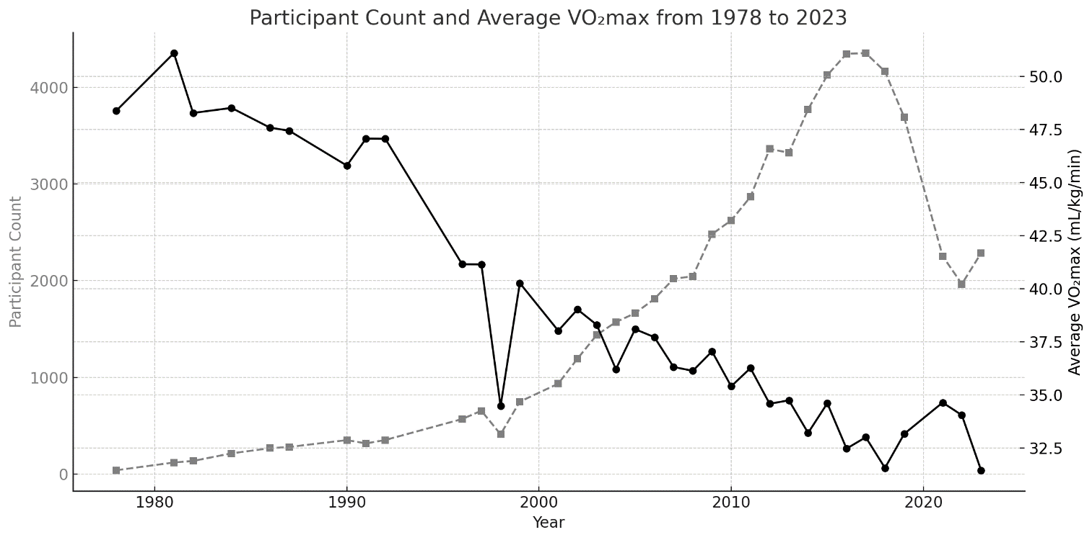
The figure presents a dual-axis trend analysis of participant count and average VO₂max spanning from 1978 to 2023.
A clear upward trajectory in participant numbers is observed over the decades, particularly from the early 2000s onward. The number of participants increased from just 38 in 1978 to a peak of 4,356 in 2017. Despite minor fluctuations, the overall growth trend suggests increasing interest, accessibility, and inclusivity in the event or activity being measured. However, post-2019, a noticeable decline in participation likely reflects the global impact of the COVID-19 pandemic, which disrupted organized events and public gatherings.
Conversely, the average predicted VO₂max, an indicator of aerobic fitness, shows a steady
decline across the same period. From values consistently above 45 mL/kg/min in the early years—representing a fitness level comparable to a well-trained individual—the mean VO₂max progressively fell to approximately 31 mL/kg/min by 2023, a value closer to that of a sedentary or moderately active adult. This trend indicates a substantial decline in population-level cardiorespiratory fitness (CRF).
The inverse relationship between participant count and average VO₂max is particularly striking from the early 2000s onward. As broader demographic groups participated, including more recreational runners and non-athletes, average fitness levels decreased. This shift reflects not only a physiological decline but also a change in participant composition—suggesting greater inclusivity but potentially reduced physical performance standards.
Broader societal factors likely contribute to this trend. Technological advancements, increasing urbanization, and shifts toward sedentary lifestyles have been associated with declining CRF across multiple populations. Lower average VO₂max is a known predictor of increased cardiovascular disease risk and all-cause mortality, making these trends concerning from a public health perspective.
Collectively, these findings highlight the importance of promoting structured physical activity interventions and lifestyle modifications aimed at improving CRF at the community and population levels.

3.4.2 Participation by Age groups over the years
The chart provides a comprehensive overview of age-wise participation trends from 1990 to 2023. Early in the timeline (1990–1999), participation was relatively low, with fewer than 1,000 participants per year, and the largest contributions came from the 30–39 and 40–49 age brackets. During this period, younger (<20) and older (60+) participants made up a very small portion of the total.
From the early 2000s onward, especially post-2005, a significant increase in total participation is observed, with numbers surpassing 2,000 participants annually. This upward trend peaks between 2011 and 2016, where total counts exceed 4,000 per year. In these peak years, the 30–39 and 40–49 groups dominate, jointly making up more than half of the total sample in many years. The 50–59 group also shows substantial growth in this period, reflecting aging cohorts who continue to participate.
Interestingly, the 20–29 group steadily grows but never surpasses the middle-aged groups, suggesting either lower participation interest or lower eligibility in this demographic. Post-2016, a slight decline in overall participation is noted, though the age distribution pattern remains consistent.
The inclusion of the U20 and 70+ groups remain minimal throughout the years, though they show slight growth post-2010, likely due to better outreach or broader data collection. The graph effectively illustrates both demographic engagement trends and the expansion of the participant base over time, which may reflect increased program popularity, improved data infrastructure, or greater public health interest in the studied phenomenon.
Meanwhile, participation among older adults (60–69, 70–79, and 80+) shows gradual improvement after 2010, indicating rising engagement in physical activity among seniors, possibly due to increased health awareness, preventive healthcare programs, and broader outreach efforts. Despite this growth, the U20 group consistently remains the smallest demographic across all years, contributing marginally to the overall participant pool.
Overall, the graph effectively illustrates both demographic engagement trends and external influences on participation dynamics over three decades.

Figure 2
*Distribution of Participant Count by Age Group (1990–2023)*
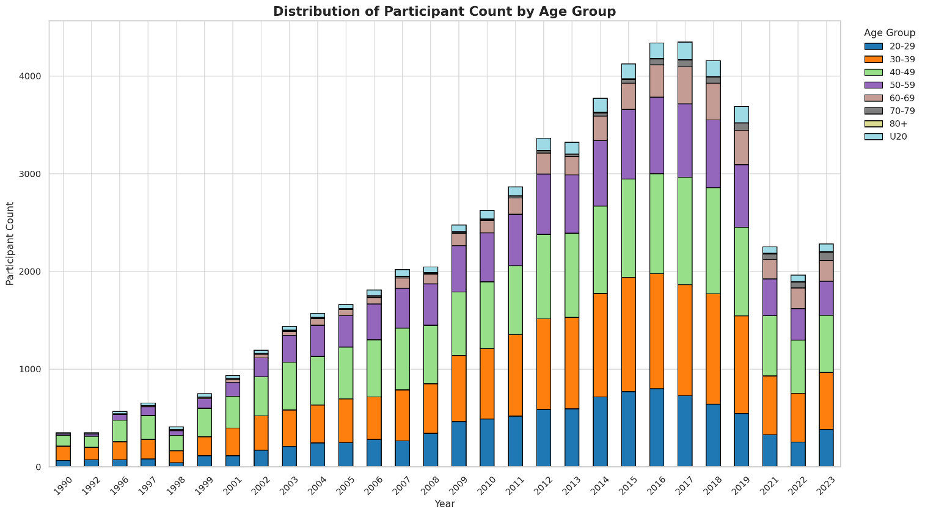
Note. Participation peaked between 2011 and 2016 across most age groups, with middle-aged adults (30–49) dominating the sample. A sharp decline occurred around 2020–2021, likely reflecting COVID-19 disruptions.

3.4.3 Average VO₂max by Age Groups for Males
Table 1
Average VO₂max by Age Group Across Time Periods for Males (1996–2024)
Years | U20 | 20-29 | 30-39 | 40-49 | 50-59 | 60-69 | 70-79 | 80+
1996-2000 | 41.41 | 45.07 | 44.99 | 44.16 | 42.15 | 34.76 | 23.75 | —
2001-2005 | 40.65 | 42.82 | 42.54 | 41.79 | 39.42 | 34.65 | 27.28 | 21.40
2006-2010 | 37.92 | 41.46 | 40.87 | 40.42 | 38.76 | 35.05 | 29.14 | 21.74
2011-2015 | 37.65 | 40.38 | 40.14 | 38.77 | 37.40 | 34.04 | 31.12 | 21.96
2016-2020 | 37.23 | 37.37 | 38.16 | 37.06 | 35.53 | 32.01 | 29.32 | 24.21
2021-2024 | 36.75 | 37.23 | 38.84 | 38.28 | 35.69 | 33.26 | 29.50 | 24.53
Note. Dashes (—) indicate missing or unavailable data for the respective age group and period. Values represent average VO₂max for male participants only.
The data in Table 1 reflect a consistent decline in average VO₂max among male participants across most age groups from 1996 to 2024. Young adult males aged 20–29 and 30–39 exhibited the highest VO₂max levels during 1996–2000 (45.07 and 44.99, respectively), but experienced a gradual decline over time, reaching 37.23 and 38.84 by 2021–2024. Middle-aged groups (40–49 and 50–59) followed a similar trajectory, dropping from VO₂max values above 44 and 42 in the late 1990s to the mid-30s in recent years. These patterns are consistent with broader literature showing that physical activity intensity tends to decrease with age and across successive cohorts, often due to increased sedentary lifestyles, occupational shifts away from manual labor, and decreased participation in structured exercise (Booth et al., 2012; Hallal et al., 2012).
Interestingly, the data also reveal a notable improvement in VO₂max values among older males
(70–79 and 80+), with the 70–79 age group rising from 23.75 in 1996–2000 to 29.50 in 2021–2024, and the 80+ group increasing from 21.40 in 2001–2005 to 24.53 by 2021–2024. These increases may reflect growing awareness of the benefits of physical activity in later life, coupled with advances in preventive healthcare and fitness programs targeting seniors (Chodzko-Zajko et al., 2009). They may also indicate survivorship bias, wherein more active older adults are overrepresented in health datasets due to greater longevity (Nelson et al., 2007).
The overall declining trend in VO₂max, particularly among young and middle-aged males, aligns with concerns raised in global physical activity surveillance studies. These studies have documented substantial reductions in vigorous physical activity, despite increased awareness of its health benefits (Ng & Popkin, 2012; Reiner et al., 2013). Given that higher VO₂max are associated with improved cardiorespiratory fitness, lower all-cause mortality, and reduced risk for chronic disease (Kodama et al., 2009), the data highlight the need for gender- and age-specific interventions aimed at promoting not only activity participation but also sufficient exercise intensity.

3.4.4 Average VO₂max by Age Groups for Females
Table 2
Average VO₂max by Age Group Across Time Periods for Females (1996–2024)
Years | U20 | 20-29 | 30-39 | 40-49 | 50-59 | 60-69 | 70-79 | 80+
1996-2000 | 31.44 | 37.44 | 35.72 | 30.72 | 30.36 | 25.28 | 18.02 | —
2001-2005 | 30.92 | 35.85 | 35.42 | 34.30 | 30.78 | 27.95 | 21.96 | —
2006-2010 | 32.31 | 34.96 | 34.30 | 33.66 | 30.95 | 28.33 | 25.39 | 21.12
2011-2015 | 31.61 | 32.82 | 32.73 | 32.12 | 30.19 | 27.38 | 25.92 | 17.83
2016-2020 | 29.28 | 30.82 | 31.03 | 30.60 | 28.86 | 26.78 | 23.85 | 23.23
2021-2024 | 32.26 | 31.86 | 31.62 | 31.23 | 29.27 | 27.56 | 24.77 | 33.23
Note. Dashes (—) indicate missing or unavailable data for the respective age group and period. Values represent average VO₂max for Female participants only.
The data presented in Table 2 show longitudinal trends in average VO₂max among female participants across various age groups from 1996 to 2024. Overall, younger women (ages 20–29 and 30–39) consistently exhibit the highest VO₂max values, starting at 37.44 and 35.72, respectively, during 1996–2000. However, both groups experience a gradual decline over time, with average VO₂max falling to 31.86 and 31.62 by 2021–2024. This decline aligns with established findings that physical activity levels in women tend to decrease with age and across generations due to factors such as occupational shifts, caregiving burdens, and sociocultural norms limiting vigorous physical activity (Bauman et al., 2012; Troiano et al., 2008).
Middle-aged groups (40–49 and 50–59) show relatively stable VO₂max levels in the early 30s, though they too reflect modest declines over time. Interestingly, VO₂max among older women (ages
70–79 and 80+) demonstrate notable improvement, especially in the most recent years. The 70–79 group increased from a baseline of 18.02 to 24.77 by 2021–2024, while the 80+ group jumped from 21.12 (2006–2010) to a peak of 33.23 in 2021–2024—the highest value recorded in that age bracket across all observed periods. This unexpected surge may be attributed to the “healthy survivor effect,” wherein more active and fit individuals are increasingly represented in aging populations due to medical advancements, active aging programs, and selective participation in data collection studies (Chodzko-Zajko et al., 2009; Nelson et al., 2007).
Furthermore, the Under-20 (U20) category shows minimal variability, maintaining VO₂max in the range of 30.9–32.3. This pattern reflects a relatively stable activity level among adolescent females, although it still points to consistently lower VO₂max compared to earlier generations of young adults. These findings support the broader epidemiological concerns that female participation in high-intensity physical activity remains limited despite increased awareness, with implications for cardiovascular health, metabolic disease risk, and quality of life (Reiner et al., 2013; Guthold et al., 2018). The data reinforce the importance of targeted physical activity promotion initiatives that consider gender-specific barriers and life-stage transitions across the lifespan.

3.4.5 Analyzing the 90th Percentile for Tely 10 Road Race
The ANOVA results show significant differences between the group means. The F-ratio is 42.7, with an extremely small p-value (9.859E-201), confirming strong statistical significance. The R2 value for this new ANOVA is approximately 0.981, which means that approximately 98.1% of the variance in the dependent variable is explained by the differences between the groups in your dataset. This suggests a strong relationship between the groups.
The Tukey HSD post-hoc analysis (Appendix D) reveals significant differences in mean values between various time periods. Notable significant differences include the 1978-1989 group compared to the 1996-2000, 2011-2015, and 2016-2020 groups, as well as the 1990-1995 group with the 1996-2000 and 2001-2005 groups. The 1996-2000 group shows the largest positive differences when compared to later periods, such as 2001-2005, 2006-2010, and 2011-2015, reflecting a trend of higher means in more recent years. However, several comparisons, such as between 1978-1989 and 1990-1995, and between 2006-2010 and 2021-2024, show no significant differences, indicating periods with similar or stable means. In conclusion, while there are clear upward trends in mean values in more recent decades, many comparisons do not yield significant differences, suggesting some stability between certain time periods.

Figure 3
*Trend Line Graph for 90th Percentile Road Race Results (with Standard Deviation and 95% Confidence Interval)*
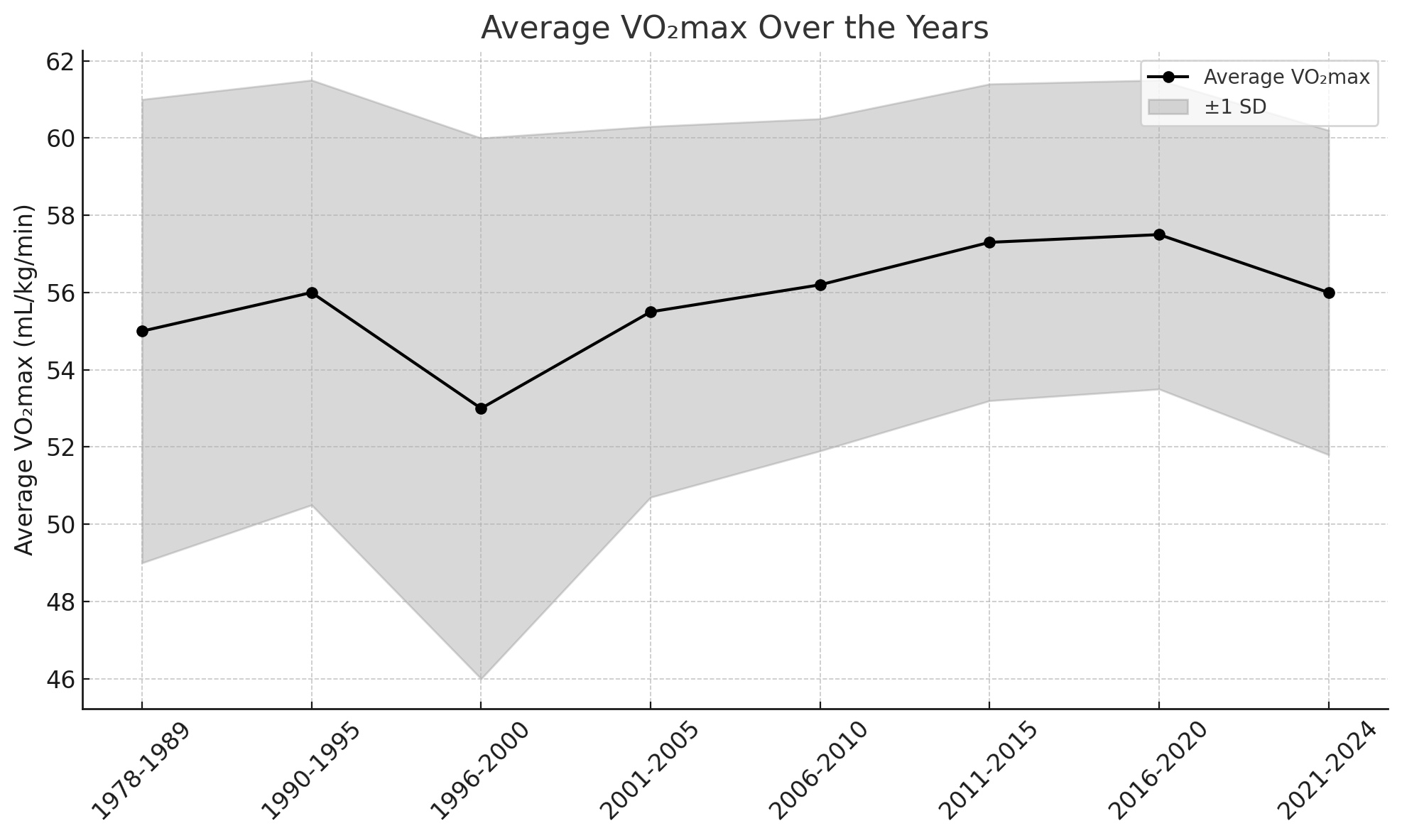
Note. The trend line shows cardiorespiratory fitness (CRF) changes across year groups for the 90th percentile, including standard deviations and 95% confidence intervals.

3.4.6 Analyzing the 50th Percentile for Tely 10 Road Race
The one-way ANOVA results reveal significant differences between the means of the seven groups. The analysis revealed a statistically significant effect of decade, with an F-statistic of 6545.02 (df = 6, 214) and a p-value of less than 0.001. These results indicate that the null hypothesis of equal population means across the decades can be rejected at the 5% significance level. The observed variation suggests that VO₂max values have changed significantly over time, reflecting notable shifts in cardiorespiratory fitness trends within the studied demographic. From the ANOVA table, The R2 value of 0.9954 indicates that approximately 99.54% of the total variability in the data is explained by the differences between the groups. This is an extremely high value, showing that the group differences account for nearly all the variation in the data.
The Tukey HSD test results (Appendix C) confirm significant differences between all pairwise group comparisons. The mean differences ("meandiff") are statistically significant for all pairs, as indicated by adjusted p-values of 0 and rejection of the null hypothesis for each comparison. The 95% confidence intervals for the mean differences do not include zero, further supporting the significance of these differences. These results align with the ANOVA findings, highlighting meaningful disparities in means across all groups. All comparisons show adjusted p-values of 0, indicating extremely strong evidence against the null hypothesis, which assumes no difference between group means. The Tukey test results show a significant decline in means over time, with all comparisons between different time periods showing statistically significant differences (p-value = 0.0). The largest mean differences are observed between the 1978-1989 group and the 2016-2020 group, with a mean difference of -16.1976, indicating the most substantial decline in values. Smaller, but still significant, differences are seen in more recent years, such as between 2001-2005 and 2006-2010, where the mean difference is -1.5925. Overall, the trend indicates a steady decrease in means from 1978-1989 to 2021-2024, with the 2016-2020 group showing a slightly higher mean than 2021-2024. The confidence intervals for all mean differences are narrow and negative, reinforcing the conclusion that later time periods generally have lower means. This analysis highlights a clear and consistent decline across the decades.

Figure 4
*Trend Line Graph for 50th Percentile Road Race Results (with Standard Deviation and 95% Confidence Interval)*
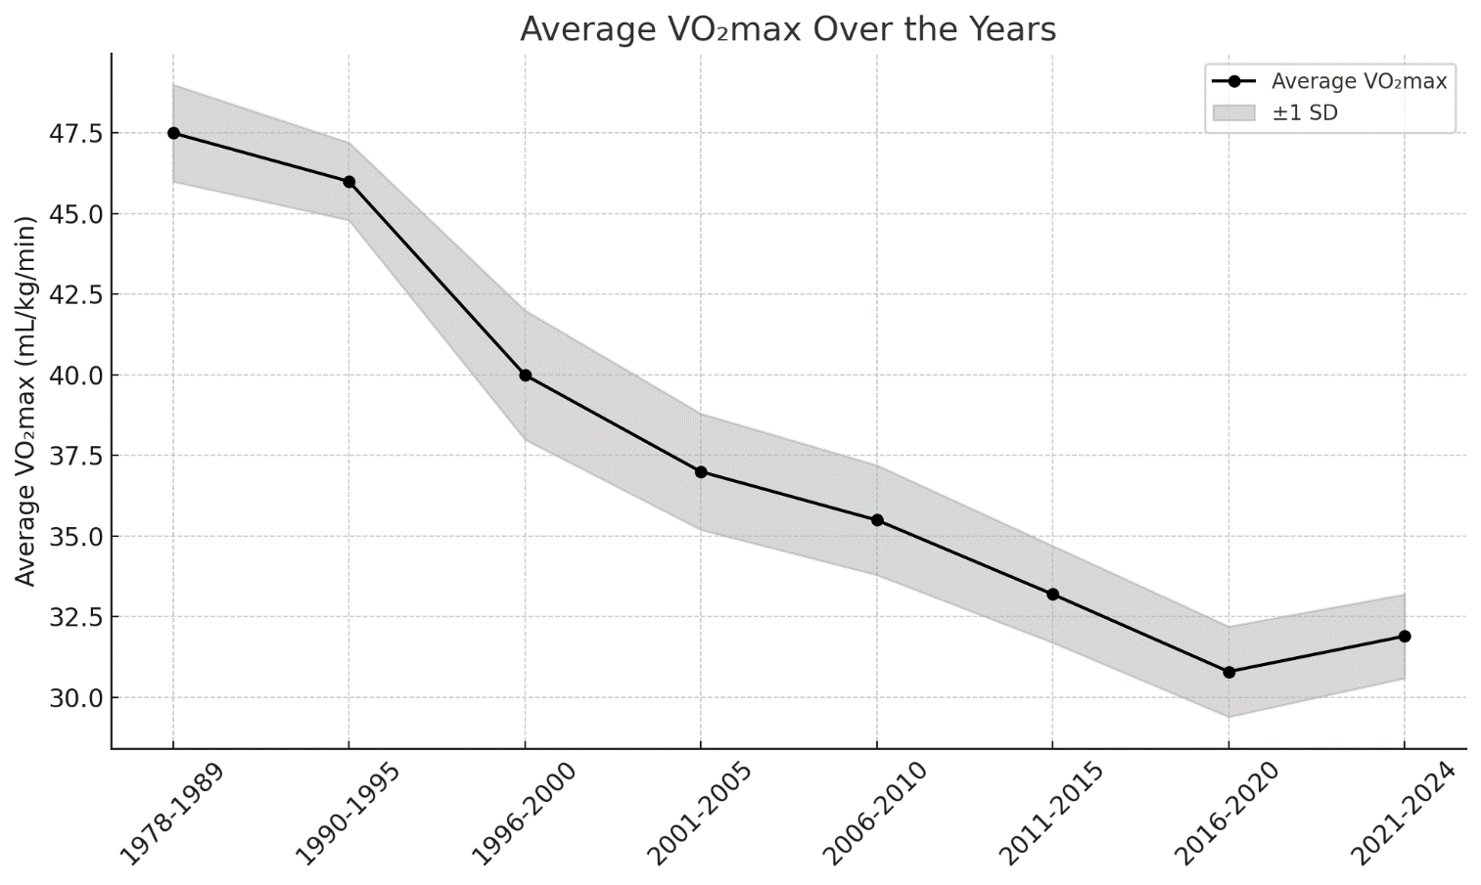
Note. The trend line shows cardiorespiratory fitness (CRF) changes across year groups for the 50th percentile, including standard deviations and 95% confidence intervals.

3.4.7 Analyzing the 10th Percentile for Tely 10 Road Race
A one-way analysis of variance (ANOVA) was conducted to examine differences in VO₂max across decades for participants in the 10th percentile. The analysis revealed a statistically significant effect of years, with an F-statistic of 392.8 (df = 6, 250) and a p-value of less than 0.001. These results indicate that the null hypothesis of equal population means across the decades can be rejected at the 5% significance level. The observed variation suggests that VO₂max values have changed significantly over time, reflecting notable shifts in cardiorespiratory fitness trends within the studied demographic. From the ANOVA table the coefficient of determination (R2) was calculated to be approximately 0.8617. This indicates that 86.17% of the variation in the data is explained by the model, demonstrating a strong fit.
The Tukey HSD test (Appendix B) compares the mean differences between various group pairs. All the comparisons listed have a p-value less than the significance threshold of 0.05, indicating that the differences between the compared groups are statistically significant. The "lower" and "upper" columns provide the 95% confidence interval for the mean difference. The "reject" column indicates whether the null hypothesis (no difference between group means) is rejected. The post-hoc analysis reveals a clear and statistically significant decline in mean values across time periods, particularly when comparing earlier years (1978–1995) to more recent ones. The groups from 1978–1989 and 1990–1995 consistently show significantly higher means than all subsequent periods, with large mean differences and adjusted p-values effectively equal to zero. As we move into later decades, the differences become less pronounced. Comparisons among adjacent groups from 1996 to 2024 show smaller mean differences, with a mix of statistically significant and non-significant results. Notably, comparisons between 1996–2000 vs 2001–2005, 1996–2000 vs 2006–2010, and 2016–2020 vs 2021–2024 are not statistically significant, suggesting a relative stabilization in recent years. Overall, the data indicates a strong downward trend in means over time, with the sharpest declines occurring between the earliest and mid-range periods, and a plateauing effect in the most recent decade.
Figure 5
*Trend Line Graph for 10th Percentile Road Race Results (with Standard Deviation and 95% Confidence Interval)*
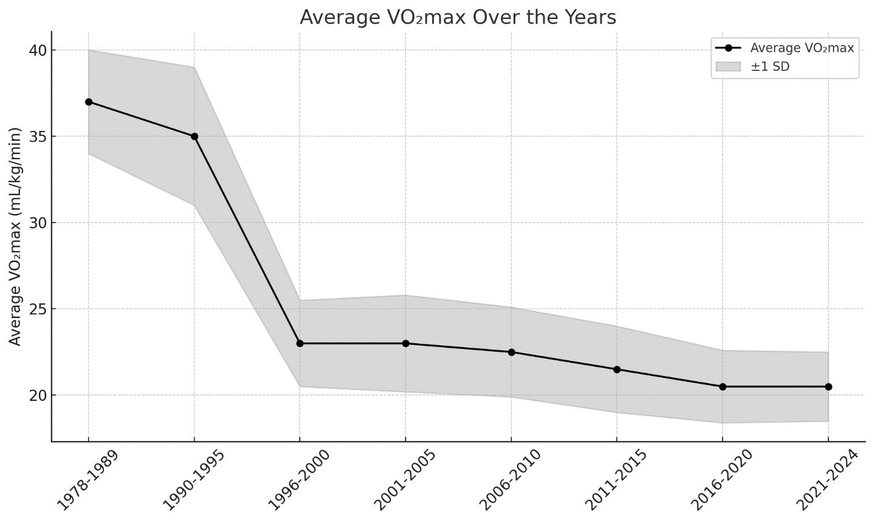
Note. The trend line shows cardiorespiratory fitness (CRF) changes across year groups for the 10th percentile, including standard deviations and 95% confidence intervals.

3.4.8 Analyzing the 10th Percentile for Tely 10 Road Race for Males
The graph illustrates the trend in average VO₂max for males across various time periods from 1978 to 2024, with a shaded band representing ±1 standard deviation (S.D.) to show variability within each time range. The data reveals a significant decline in male cardiorespiratory fitness since 1978–1989, where average VO₂max were highest (≈37.3), followed by a sharp drop in the 1996–2000 period (≈22.9). After this initial decline, the trend shows a gradual and consistent decrease over the subsequent decades, reaching the lowest average of approximately 20.1 VO₂max in 2021–2024. The narrow confidence bands in later periods suggest reduced variability in VO₂max values, possibly indicating uniformly lower fitness levels in recent male participants. This long-term downward trend highlights a concerning decline in population-level fitness, likely influenced by lifestyle changes such as increased sedentary behavior, reduced physical activity, and broader public health shifts.

Figure 6
*Trend Line Graph for 10th Percentile Road Race Results for Males (with Standard Deviation and 95% Confidence Interval)*
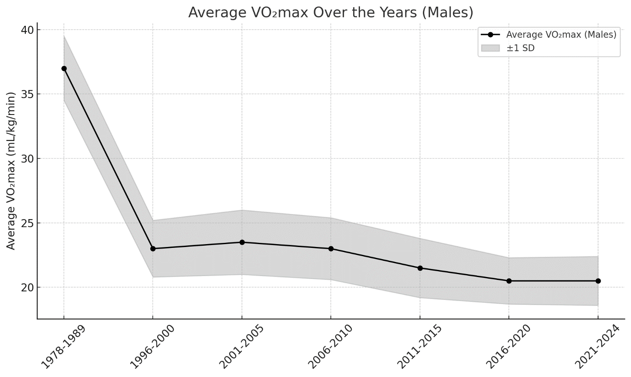
Note. The trend line shows cardiorespiratory fitness (CRF) changes across year groups for the 10th percentile for males, including standard deviations and 95% confidence intervals.

3.4.9 Analyzing the 10th Percentile for Tely 10 Road Race for Females
The graph illustrates the long-term decline in average VO₂max among females from 1978 to 2024, with a shaded region indicating ±1 standard deviation to represent variability. In the earliest period (1978–1989), female VO₂max were substantially higher, averaging 35.36, reflecting superior cardiorespiratory fitness levels. However, this sharply declined to 22.84 in the 1996–2000 period, marking a significant reduction in female fitness. Following this drop, the trend continued on a gradual downward slope, stabilizing around 20 VO₂max in the most recent periods (2016–2020 and 2021–2024). The narrowing of the shaded region in recent years indicates decreasing variability in fitness levels, suggesting a more consistently lower performance across the population. This pattern mirrors that of males and points toward widespread societal shifts—such as increased sedentary lifestyles, technological dependency, and reduced physical activity—as major contributors to the decline in female cardiorespiratory fitness over the decades.

Figure 7
*Trend Line Graph for 10th Percentile Road Race Results for Females (with Standard Deviation and 95% Confidence Interval)*
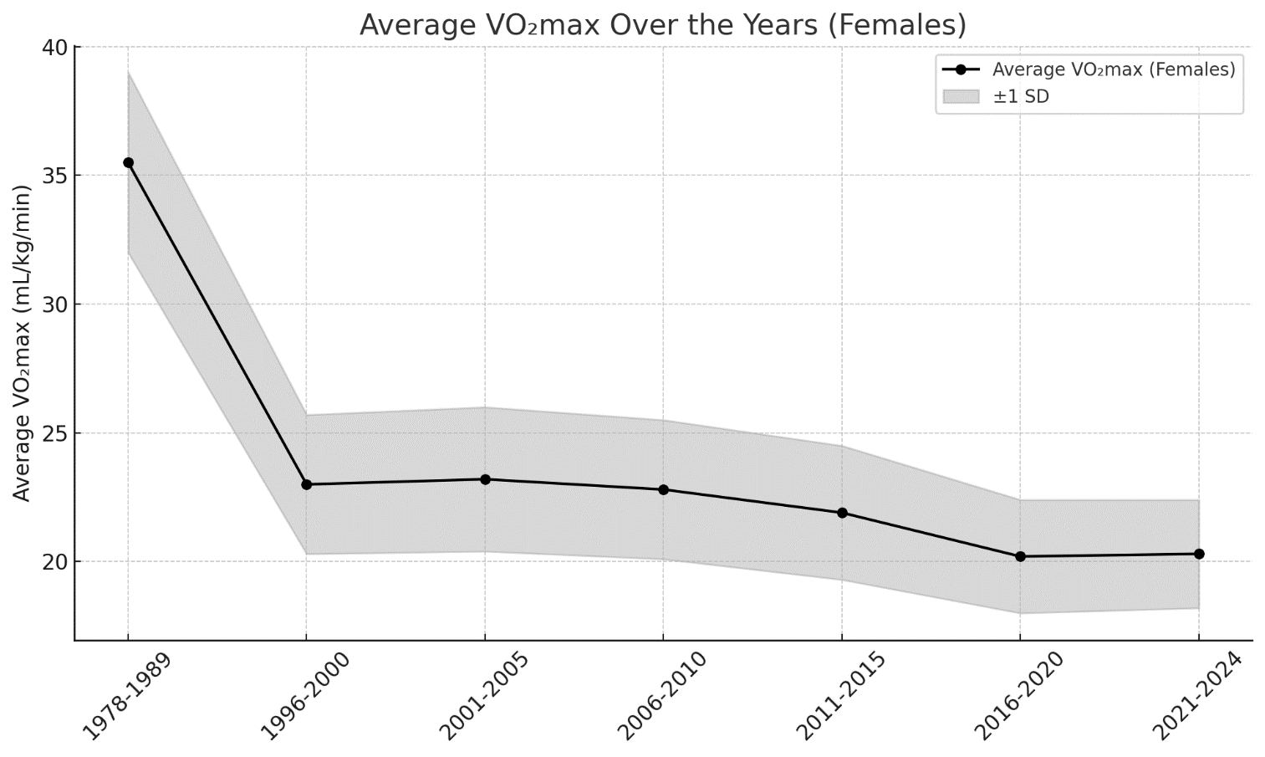
Note. The trend line shows cardiorespiratory fitness (CRF) changes across year groups for the 10th percentile for females, including standard deviations and 95% confidence intervals.

3.5 Discussion
The 90th percentile data reflect performance among the top tier of participants—presumably highly trained and highly motivated individuals. These values provide a meaningful glimpse into the physiological capacity of elite or near-elite performers over time. Although a noticeable dip in VO₂max occurs during the 1996–2000 period, the overall trend from 2001 onward shows a steady and sustained rise, reaching its peak in 2016–2020 before experiencing a slight decline in 2021–2024. Despite fluctuations in certain time frames, the broader upward trajectory indicates that these top-performing individuals have successfully maintained or even enhanced their cardiorespiratory fitness over the decades. The 50th percentile represents the median level of cardiorespiratory fitness among participants, offering insight into the typical fitness capacity of the general population. From 1978–1989 to 2015–2020, the data show a clear and consistent decline in average VO₂max values, falling from approximately 47.5 mL/kg/min to just above 30 mL/kg/min. This sustained downward trend reflects a gradual but substantial reduction in overall fitness levels, likely influenced by long-term shifts in lifestyle, physical activity patterns, and increasing sedentary behavior over the decades. The 10th percentile, illustrates a significant decline in cardiorespiratory fitness from 1978–1989 to 2021–2024. Average VO₂max began at approximately 37 mL/kg/min in the late 1970s and 1980s, followed by a sharp decline during the 1996–2000 period. This was then followed by a more gradual decrease, with values stabilizing around 21 mL/kg/min in the most recent years. This consistent downward trend reflects a substantial reduction in aerobic capacity among the broader population, likely driven by long-term changes in lifestyle, declining physical activity levels, and increasing sedentary behavior.
In this study, we utilized automated web scraping techniques as the primary method of data collection to retrieve historical performance records from the official Tely 10 road race website. Web scraping enabled the efficient extraction of large volumes of publicly available race data spanning multiple decades, including participant finishing times, age categories, gender, and year-wise registration details. This approach allowed us to build a robust, structured dataset without manual entry, ensuring accuracy and completeness in capturing race trends over time. The Tely 10, a prominent 10-mile (16 km) endurance road race held annually in Newfoundland and Labrador, Canada, draws a wide demographic of participants, making it an ideal population sample to study trends in aerobic performance. Given the growing body of evidence pointing to a decline in cardiorespiratory fitness (CRF) within the general population, race performance data serve as a practical and scalable proxy for assessing longitudinal shifts in CRF. By applying percentile-based analyses (e.g., 10th, 50th, and 90th), we were further able to stratify fitness trends across different segments of the population—from general participants to top-tier athletes—thus providing deeper insight into the changing landscape of population fitness over time.
Over recent decades, cardiorespiratory fitness (CRF) has declined significantly in the general population, a trend attributed to reduced physical activity, increased sedentary behavior, and rising obesity rates. CRF is a critical indicator of health, with low levels associated with elevated risk of all-cause and cardiovascular mortality (Kodama et al., 2009). Longitudinal studies, such as the Aerobics Center Longitudinal Study, have shown that declining fitness levels correspond with increased mortality, even in previously healthy individuals (Blair et al., 1995). Surveillance data from national health programs have further supported these findings. Among youth, global trends demonstrate a notable reduction in aerobic capacity over the last several decades, reflecting broader lifestyle shifts (Tomkinson et al., 2018). Collectively, this body of research underscores the urgency of addressing the long-term decline in CRF to improve public health outcomes.
The VO₂max values for the 10th percentile—representative of the general population—reveals a clear and sustained decline in cardiorespiratory fitness from 1978–1989 to 2021–2024, with average VO₂max decreasing from approximately 37 mL/kg/min to 21 mL/kg/min. This mirrors the trends observed in epidemiological studies, which have consistently documented a reduction in population-level CRF over the past several decades. For instance, Tomkinson et al. (2018) conducted a global analysis of aerobic fitness among children and adolescents, reporting a significant decline of roughly 0.43% per year from 1981 to 2014 across 19 high- and middle-income countries. Similarly, Lahart et al. (2016) highlighted a 10–15% reduction in adult CRF levels since the 1970s, largely attributed to increased sedentary behavior, urbanization, and declining physical activity.
Analyzing road race data such as from the Tely 10 provides valuable insights into population fitness trends, but it comes with several limitations. First, there is a strong self-selection bias, as only individuals who are sufficiently motivated, trained, or have the means to participate are represented, potentially overestimating average cardiorespiratory fitness (CRF) relative to the general population. Second, environmental variability—including changes in weather, temperature, wind, and course conditions across years—can influence performance outcomes, reducing consistency in trend interpretation. Third, the absence of direct physiological measurements such as VO₂max, heart rate, or the precision of CRF estimates, which must instead rely on finishing times as indirect proxies. Additionally, demographic shifts over time—such as an increase in recreational runners or changes in age and gender composition—can influence race results independently of actual changes in CRF. Finally, data quality issues, especially for older races, may include missing, inconsistent, or incomplete records, introducing uncertainty into longitudinal analyses. Despite these limitations, road race data remains a practical and scalable model for estimating long-term fitness trends when interpreted with appropriate caution.
Road races such as the Tely 10 provide a valuable model for estimating cardiorespiratory fitness (CRF) at the population level. These events attract a broad range of participants and offer a standardized endurance setting, making them ideal for assessing aerobic capacity through field performance data. Prior research has demonstrated a strong correlation between distance running performance and maximal oxygen uptake (VO₂max), a primary indicator of CRF (Bassett & Howley, 2000). Endurance race results have been used as reliable proxies for CRF in epidemiological studies, offering an ecologically valid alternative to laboratory-based testing (Noakes, 2003). Furthermore, such data enable long-term surveillance of aerobic fitness trends, particularly useful in understanding how aging, lifestyle changes, and physical activity levels influence health outcomes (Thompson et al., 2010). As concerns grow around the global decline in CRF, road race datasets like those from the Tely 10 present a practical, accessible, and scalable tool for monitoring fitness trends in the general population.
Despite its limitations, analyzing road race data—such as that from the Tely 10—remains a valid and practical approach to inferring cardiorespiratory fitness (CRF) trends in the general population. Road races offer a large, real-world dataset that captures endurance performance across a broad demographic, enabling researchers to track fitness levels over time without the need for expensive laboratory testing. When complemented with appropriate statistical methods and contextual understanding of race conditions and participant demographics, road race data can provide meaningful insight.

3.6 Methodological Considerations
One notable limitation of this study is the geographic and demographic specificity of the sample, as it is restricted to participants of the Tely 10 road race, held annually in Newfoundland and Labrador (NL), Canada. As a result, the dataset primarily reflects the behaviors, fitness levels, and participation trends of individuals residing in or connected to the island population of Newfoundland. While the data still offer valuable insights into long-term fitness trends, caution must be exercised in extrapolating the results to the general population beyond the NL context without supporting data from other regions or races.
Integrating external data into the analysis of Tely 10 road race results adds important contextual depth and allows for more robust interpretation of cardiorespiratory fitness (CRF) trends. By linking race data with variables such as race-day weather conditions (e.g., temperature, humidity, wind), regional demographic shifts, socioeconomic indicators, and physical activity surveillance data from sources like Statistics Canada or the Canadian Health Measures Survey (CHMS), researchers can assess whether external factors are influencing observed VO₂max trends.
Another important limitation in analyzing long-term road race data lies in the inconsistencies in race timing methods and event organization over the years. Earlier editions of the Tely 10—especially in the 1970s through the 1990s—were often timed manually using stopwatches or basic clock systems, which lacked the precision and consistency of modern chip-based electronic timing systems now standard in contemporary races. These manual methods were more prone to human error, rounding, and delays in recording, especially in large fields with closely packed finishers.

3.7 Conclusion
Based on the statistical analysis using ANOVA and post-hoc Tukey’s test, we observe trends in VO₂max among participants over the years. Based on the statistical analysis, it is evident that lower-ranking participants are experiencing a significant decline in VO₂max values over the years. The absolute mean differences in VO₂max are particularly pronounced among these participants, indicating substantial decreases in performance. This decline reflects a broader trend of cardiorespiratory decrement within the general population, affecting the performance of lower-ranking participants negatively over time.

CHAPTER 4
OVERALL SUMMARY OF STUDY

For decades, public health campaigns and guidelines from organizations such as the American College of Sports Medicine (ACSM) and the Canadian Medical Association Journal (CAMJ) have promoted regular participation in moderate to vigorous exercise, targeting at least 150 minutes per week (Yang, 2019). Despite these efforts, there has been a notable decline in cardiorespiratory fitness over time (Harber et al., 2020). One of the main contributing factors to this decline is the increasing prevalence of new technology and sedentary lifestyles.
The contemporary sedentary lifestyle, heavily influenced by technological advancements, has substantial public health consequences. Studies indicate that increased sedentary behavior from technology use, including extended screen time on computers, tablets, and smartphones, has led to reduced physical activity and a surge in related health problems. The COVID-19 pandemic has intensified this trend by further restricting physical activity opportunities through the promotion of remote work and virtual interactions (The Impact of Sedentary Behavior and Virtual Lifestyles on Physical and Mental Wellbeing, n.d.).
Incorporating more non-exercise activities into our daily routines can effectively address the lack of commitment to regular exercise by increasing light physical activities. These can include tasks like household chores or taking daily walks. Researchers are exploring methods to boost daily energy expenditure that are both widely acceptable and effective at enhancing cardiorespiratory fitness and reducing chronic diseases. These strategies involve modifying the built environment and promoting active transportation (Chung et al., 2018).
In this study, we analyzed the trend in running performances over the years across various road races of different distances. The findings indicate a decline in running performances, supporting the observed decrease in cardiorespiratory fitness (Lamoureux et al., 2018). Although there are certain years where performances improved, the overall trend shows a decline. In some years, this decline is sharp, while in others, it is more moderate.
In the present study, several variables were controlled, including distance, route, and type of physical activity, which was running. The study included a wide variety of participants in terms of age, sex, and performance levels. Each participant completed the road race based on their physical capabilities. After the initial start, participants chose their pace strategy, opting for either a steady or faster pace. Following the initial surge, most participants settled into a comfortable, sustainable pace until the final phase, where some increased their speed again, depending on their preparation, until they reached the finish line.
A key practical takeaway from this study is that fitness advertisements should be redesigned to encourage individuals to create an active work-life balance and make their surrounding environment more conducive to physical activity. By doing so, society can better achieve its goals of reducing the prevalence of non-communicable diseases and increasing cardiorespiratory fitness.
Future research can explore additional variables that may influence the trend, such as location, to determine if they correlate with the observed trends. This could provide a more comprehensive understanding of the factors affecting running performances and cardiorespiratory fitness.

References
Attenborough, D. (2010). First life: A journey back in time with David Attenborough. BBC Books.
Bauman, A. E., Reis, R. S., Sallis, J. F., Wells, J. C., Loos, R. J., & Martin, B. W. (2012). Correlates of physical activity: Why are some people physically active and others not? The Lancet, 380(9838), 258–271. https://doi.org/10.1016/S0140-6736(12)60735-1
Booth, M. L., Bauman, A. E., Owen, N., & Gore, C. J. (2012). Physical activity preferences, preferred sources of assistance, and perceived barriers to increased activity among physically inactive Australians. Preventive Medicine, 26(1), 131–137. https://doi.org/10.1006/pmed.1996.9982
Agha, M., & Agha, R. (2017). The rising prevalence of obesity: Part A: Impact on public health. International Journal of Surgery: Oncology, 2(7), e17. https://doi.org/10.1097/IJ9.0000000000000017
Ambrústolo, P., & Zubimendi, M. (2015). New approaches to the study of hunter-gatherers of the north coast of Santa Cruz (Argentina): The use of rockshelters. ResearchGate. https://www.researchgate.net/publication/277233547_New_approaches_to_the_study_of_hunter-gatherers
Ariew, A., & Lewontin, R. C. (2004). The confusions of fitness. British Journal for the Philosophy of Science, 55(2), 347–363. https://doi.org/10.1093/bjps/55.2.347
Attenborough, D. (2010). First life: A journey back in time with David Attenborough. BBC Books.
Baar, K. (2014). Nutrition and the adaptation to endurance training. Sports Medicine, 44(S1), 5–12. https://doi.org/10.1007/s40279-014-0146-1
Bauman, A. E., Reis, R. S., Sallis, J. F., Wells, J. C., Loos, R. J., & Martin, B. W. (2012). Correlates of physical activity: Why are some people physically active and others not? The Lancet, 380(9838), 258–271. https://doi.org/10.1016/S0140-6736(12)60735-1
Bensimhon, D. R., Kraus, W. E., & Donahue, M. P. (2006). Obesity and physical activity: A review. American Heart Journal, 151(3), 598–603. https://doi.org/10.1016/j.ahj.2005.03.005
Biddle, S., Mutrie, N., & Gorely, T. (2015). Psychology of physical activity: Determinants, well-being and interventions (3rd ed.). Routledge. http://site.ebrary.com/id/11023171
Blair, S. N., LaMonte, M. J., & Nichaman, M. Z. (2004). The evolution of physical activity recommendations: How much is enough? The American Journal of Clinical Nutrition, 79(5), 913S–920S. https://doi.org/10.1093/ajcn/79.5.913s
Booth, F. W., & Shanely, R. A. (2004). The biochemical basis of the health effects of exercise: An integrative view. Proceedings of the Nutrition Society, 63(2), 199–203. https://doi.org/10.1079/pns2004337
Booth, M. L., Bauman, A. E., Owen, N., & Gore, C. J. (2012). Physical activity preferences, preferred sources of assistance, and perceived barriers to increased activity among physically inactive Australians. Preventive Medicine, 26(1), 131–137. https://doi.org/10.1006/pmed.1996.9982
Brand, R. (2019, August 23). The history of running: A brief introduction. Rockay. https://rockay.com/blogs/blog/the-history-of-running-a-brief-introduction
Burkule, N. (2016). Marathon running for amateurs: Benefits and risks. Journal of Clinical and Preventive Cardiology, 5(4), 113. https://doi.org/10.4103/2250-3528.192681
Carbone, S., Ozemek, C., & Lavie, C. J. (2020). Sedentary behaviors, physical inactivity, and cardiovascular health: We better start moving! Mayo Clinic Proceedings: Innovations, Quality & Outcomes, 4(6), 627–629. https://doi.org/10.1016/j.mayocpiqo.2020.09.013
Caspersen, C. J., Powell, K. E., & Christenson, G. M. (1985). Physical activity, exercise, and physical fitness: Definitions and distinctions for health-related research. Public Health Reports, 100(2), 126–131.
Chodzko-Zajko, W. J., Proctor, D. N., Singh, M. A. F., Minson, C. T., Nigg, C. R., Salem, G. J., & Skinner, J. S. (2009). Exercise and physical activity for older adults. Medicine & Science in Sports & Exercise, 41(7), 1510–1530. https://doi.org/10.1249/MSS.0b013e3181a0c95c
Crittenden, A. N., & Schnorr, S. L. (2017). Current views on hunter-gatherer nutrition and the evolution of the human diet. American Journal of Physical Anthropology, 162(S63), 84–109. https://doi.org/10.1002/ajpa.23148
Dishman, R. K., Sui, X., Church, T. S., Hand, G. A., Trivedi, M. H., & Blair, S. N. (2012). Decline in cardiorespiratory fitness and odds of incident depression. American Journal of Preventive Medicine, 43(4), 361–368. https://doi.org/10.1016/j.amepre.2012.06.011
Eaton, S. B., Strassman, B. I., Nesse, R. M., Neel, J. V., Ewald, P. W., Williams, G. C., ... & Cordain, L. (2002). Evolutionary health promotion. Preventive Medicine, 34(2), 109–118. https://doi.org/10.1006/pmed.2001.0876
Ember, C. R. (2019). Human evolution and culture: Highlights of anthropology (9th ed.). Pearson.
Eske, J. (2019, June 18). What to know about cardiorespiratory endurance. Medical News Today. https://www.medicalnewstoday.com/articles/325487
Franklin, B. A., Eijsvogels, T. M., Pandey, A., Quindry, J., & Toth, P. P. (2022). Physical activity, cardiorespiratory fitness, and cardiovascular health. American Journal of Preventive Cardiology, 12, 100424. https://doi.org/10.1016/j.ajpc.2022.100424
Getchell, B. (n.d.). Physical fitness: A way of life (2nd ed.). ERIC. https://eric.ed.gov/?id=ED166166
Grove, M. (2009). Hunter–gatherer movement patterns: Causes and constraints. Journal of Anthropological Archaeology, 28(2), 222–233. https://doi.org/10.1016/j.jaa.2009.01.003
Guthold, R., Stevens, G. A., Riley, L. M., & Bull, F. C. (2018). Worldwide trends in insufficient physical activity from 2001 to 2016. The Lancet Global Health, 6(10), e1077–e1086. https://doi.org/10.1016/S2214-109X(18)30357-7
Haskell, W. L. (2012). Physical activity by self-report: A brief history and future issues. Journal of Physical Activity & Health, 9(s1), S5–S10. https://doi.org/10.1123/jpah.9.s1.s5
History. (2023). Persistence hunting: How humans hunted before weapons. History.com. https://www.history.com/topics/pre-history/persistence-hunting
History of Running. (n.d.). Health and Fitness History. https://healthandfitnesshistory.com/explore-history/history-of-running/
Haugen, T., Sandbakk, Ø., Seiler, S., & Tønnessen, E. (2022). The training characteristics of world-class distance runners: An integration of scientific literature and results-proven practice. Sports Medicine - Open, 8(1). https://doi.org/10.1186/s40798-022-00438-7
Hawkes, K., O’Connell, J., & Jones, N. B. (2018). Hunter-gatherer studies and human evolution: A very selective review. American Journal of Physical Anthropology, 165(4), 777–800. https://doi.org/10.1002/ajpa.23403
Kelly, R. L. (2014). The lifeways of hunter-gatherers: The foraging spectrum (2nd ed.). Cambridge University Press.
Kodama, S., Saito, K., Tanaka, S., Maki, M., Yachi, Y., Asumi, M., Sugawara, A., & Sone, H. (2009). Cardiorespiratory fitness as a quantitative predictor of all-cause mortality and cardiovascular events: A meta-analysis. JAMA, 301(19), 2024–2035. https://doi.org/10.1001/jama.2009.681
Lavie, C. J., Lee, D., Sui, X., Arena, R., O’Keefe, J. H., Church, T. S., Milani, R. V., & Blair, S. N. (2015). Effects of running on chronic diseases and cardiovascular and all-cause mortality. Mayo Clinic Proceedings, 90(11), 1541–1552. https://doi.org/10.1016/j.mayocp.2015.08.001
Lee, D.-C., Pate, R. R., Lavie, C. J., Sui, X., Church, T. S., & Blair, S. N. (2014). Leisure-time running reduces all-cause and cardiovascular mortality risk. Journal of the American College of Cardiology, 64(5), 472–481. https://doi.org/10.1016/j.jacc.2014.04.058
Lieberman, D. E., Bramble, D. M., Raichlen, D. A., & Shea, J. J. (2007). Endurance running and the evolution of Homo. Nature, 432(7015), 345–352. https://doi.org/10.1038/nature03052

APPENDIX A: Full Ethics Clearance – Publicly Accessible Data
According to the Tri-Council Policy Statement: Ethical Conduct for Research Involving Humans (TCPS 2, 2018), information that is legally accessible to the public and appropriately protected by law does not require ethics review. As stated in the TCPS 2 (p. 17), "publicly available information is any existing stored documentary material, records, or publications, which may or may not include identifiable information."
Research that uses exclusively publicly available information, even if it contains identifiable information, does not require ethics review provided there is no reasonable expectation of privacy. Examples of such publicly accessible information include identifiable information disseminated through print or electronic publications, film or digital recordings, exhibitions, or events open to public attendance.
The data used in this study were collected from a publicly accessible source, the Tely 10 Road Race website, and involved no intervention, interaction with individuals, or collection of private or sensitive information. As such, the use of these data does not require ethics board review.

The websites used to collect the data are listed below.
• https://www.nlaa.ca/tely10/results/#gsc.tab=0.
• https://github.com/asharma21mun/Tely10.

APPENDIX B: Tukey Table for 90th Percentile for Tely 10
Table B1
(Tukey Post-Hoc Test for 90th Percentile Comparisons — Tely 10 Road Race Results)
Group1  Year Group | Mean1  (CRF) | Group2  Year Group | Mean2  (CRF) | MeanDiff | p-adj | Lower | Upper | Rject
1978-1989 | 56.03566847 | 1990-1995 | 57.05874284 | 1.0231 | 0.2672 | -0.2981 | 2.3443 | False
1978-1989 | 56.03566847 | 1996-2000 | 52.95089247 | -3.0848 | 0.0 | -4.2925 | -1.877 | True
1978-1989 | 56.03566847 | 2001-2005 | 55.2955184 | -0.7402 | 0.4956 | -1.8744 | 0.3941 | False
1978-1989 | 56.03566847 | 2006-2010 | 56.15762606 | 0.122 | 1.0 | -1.0123 | 1.2562 | False
1978-1989 | 56.03566847 | 2011-2015 | 57.20743718 | 1.1718 | 0.0371 | 0.0375 | 2.306 | True
1978-1989 | 56.03566847 | 2016-2020 | 57.34020218 | 1.3045 | 0.0237 | 0.0968 | 2.5123 | True
1978-1989 | 56.03566847 | 2021-2024 | 55.99537371 | -0.0403 | 1.0 | -1.3615 | 1.2809 | False
1990-1995 | 57.05874284 | 1996-2000 | 52.95089247 | -4.1079 | 0.0 | -5.5251 | -2.6906 | True
1990-1995 | 57.05874284 | 2001-2005 | 55.2955184 | -1.7632 | 0.0021 | -3.1184 | -0.4081 | True
1990-1995 | 57.05874284 | 2006-2010 | 56.15762606 | -0.9011 | 0.4699 | -2.2563 | 0.454 | False
1990-1995 | 57.05874284 | 2011-2015 | 57.20743718 | 0.1487 | 1.0 | -1.2065 | 1.5038 | False
1990-1995 | 57.05874284 | 2016-2020 | 57.34020218 | 0.2815 | 0.9989 | -1.1358 | 1.6987 | False
1990-1995 | 57.05874284 | 2021-2024 | 55.99537371 | -1.0634 | 0.3959 | -2.5785 | 0.4517 | False
1996-2000 | 52.95089247 | 2001-2005 | 55.2955184 | 2.3446 | 0.0 | 1.0998 | 3.5894 | True
1996-2000 | 52.95089247 | 2006-2010 | 56.15762606 | 3.2067 | 0.0 | 1.9619 | 4.4515 | True
1996-2000 | 52.95089247 | 2011-2015 | 57.20743718 | 4.2565 | 0.0 | 3.0118 | 5.5013 | True
1996-2000 | 52.95089247 | 2016-2020 | 57.34020218 | 4.3893 | 0.0 | 3.0772 | 5.7014 | True
1996-2000 | 52.95089247 | 2021-2024 | 55.99537371 | 3.0445 | 0.0 | 1.6272 | 4.4617 | True
2001-2005 | 55.2955184 | 2006-2010 | 56.15762606 | 0.8621 | 0.3346 | -0.3115 | 2.0357 | False
2001-2005 | 55.2955184 | 2011-2015 | 57.20743718 | 1.9119 | 0.0 | 0.7383 | 3.0855 | True
2001-2005 | 55.2955184 | 2016-2020 | 57.34020218 | 2.0447 | 0.0 | 0.7999 | 3.2895 | True
2001-2005 | 55.2955184 | 2021-2024 | 55.99537371 | 0.6999 | 0.77 | -0.6553 | 2.055 | False
2006-2010 | 56.15762606 | 2011-2015 | 57.20743718 | 1.0498 | 0.1188 | -0.1238 | 2.2234 | False
2006-2010 | 56.15762606 | 2016-2020 | 57.34020218 | 1.1826 | 0.0767 | -0.0622 | 2.4274 | False
2006-2010 | 56.15762606 | 2021-2024 | 55.99537371 | -0.1623 | 1.0 | -1.5174 | 1.1929 | False
2011-2015 | 57.20743718 | 2016-2020 | 57.34020218 | 0.1328 | 1.0 | -1.112 | 1.3775 | False
2011-2015 | 57.20743718 | 2021-2024 | 55.99537371 | -1.2121 | 0.1189 | -2.5672 | 0.1431 | False
2016-2020 | 57.34020218 | 2021-2024 | 55.99537371 | -1.3448 | 0.0774 | -2.7621 | 0.0724 | False

APPENDIX C: Tukey Table for 50th Percentile for Tely 10
Table C1
(Tukey Post-Hoc Test for 50th Percentile Comparisons — Tely 10 Road Race Results)
Group1  Year Group | Mena1  (CRF) | Group2  Year Group | Mean2  (CRF) | MeanDiff | p-adj | Lower | Upper | Rject
1978-1989 | 47.150664 | 1990-1995 | 45.603647 | -1.547 | 0.0 | -2.0626 | -1.0315 | True
1978-1989 | 47.150664 | 1996-2000 | 39.981679 | -7.169 | 0.0 | -7.6028 | -6.7351 | True
1978-1989 | 47.150664 | 2001-2005 | 37.08463 | -10.066 | 0.0 | -10.4552 | -9.6769 | True
1978-1989 | 47.150664 | 2006-2010 | 35.492172 | -11.6585 | 0.0 | -12.0378 | -11.2792 | True
1978-1989 | 47.150664 | 2011-2015 | 33.354848 | -13.7958 | 0.0 | -14.169 | -13.4226 | True
1978-1989 | 47.150664 | 2016-2020 | 30.953088 | -16.1976 | 0.0 | -16.5714 | -15.8238 | True
1978-1989 | 47.150664 | 2021-2024 | 32.037912 | -15.1128 | 0.0 | -15.503 | -14.7225 | True
1990-1995 | 45.603647 | 1996-2000 | 39.981679 | -5.622 | 0.0 | -6.0588 | -5.1851 | True
1990-1995 | 45.603647 | 2001-2005 | 37.08463 | -8.519 | 0.0 | -8.9115 | -8.1265 | True
1990-1995 | 45.603647 | 2006-2010 | 35.492172 | -10.1115 | 0.0 | -10.4942 | -9.7287 | True
1990-1995 | 45.603647 | 2011-2015 | 33.354848 | -12.2488 | 0.0 | -12.6255 | -11.8721 | True
1990-1995 | 45.603647 | 2016-2020 | 30.953088 | -14.6506 | 0.0 | -15.0278 | -14.2733 | True
1990-1995 | 45.603647 | 2021-2024 | 32.037912 | -13.5657 | 0.0 | -13.9594 | -13.1721 | True
1996-2000 | 39.981679 | 2001-2005 | 37.08463 | -2.897 | 0.0 | -3.1736 | -2.6205 | True
1996-2000 | 39.981679 | 2006-2010 | 35.492172 | -4.4895 | 0.0 | -4.752 | -4.227 | True
1996-2000 | 39.981679 | 2011-2015 | 33.354848 | -6.6268 | 0.0 | -6.8805 | -6.3732 | True
1996-2000 | 39.981679 | 2016-2020 | 30.953088 | -9.0286 | 0.0 | -9.2831 | -8.7741 | True
1996-2000 | 39.981679 | 2021-2024 | 32.037912 | -7.9438 | 0.0 | -8.2219 | -7.6656 | True
2001-2005 | 37.08463 | 2006-2010 | 35.492172 | -1.5925 | 0.0 | -1.7717 | -1.4132 | True
2001-2005 | 37.08463 | 2011-2015 | 33.354848 | -3.7298 | 0.0 | -3.8958 | -3.5638 | True
2001-2005 | 37.08463 | 2016-2020 | 30.953088 | -6.1315 | 0.0 | -6.2988 | -5.9643 | True
2001-2005 | 37.08463 | 2021-2024 | 32.037912 | -5.0467 | 0.0 | -5.2482 | -4.8452 | True
2006-2010 | 35.492172 | 2011-2015 | 33.354848 | -2.1373 | 0.0 | -2.2787 | -1.996 | True
2006-2010 | 35.492172 | 2016-2020 | 30.953088 | -4.5391 | 0.0 | -4.6819 | -4.3963 | True
2006-2010 | 35.492172 | 2021-2024 | 32.037912 | -3.4543 | 0.0 | -3.636 | -3.2726 | True
2011-2015 | 33.354848 | 2016-2020 | 30.953088 | -2.4018 | 0.0 | -2.5276 | -2.2759 | True
2011-2015 | 33.354848 | 2021-2024 | 32.037912 | -1.3169 | 0.0 | -1.4856 | -1.1483 | True
2016-2020 | 30.953088 | 2021-2024 | 32.037912 | 1.0848 | 0.0 | 0.9149 | 1.2547 | True

APPENDIX D: Tukey Table for 10th Percentile for Tely 10
Table D1
(Tukey Post-Hoc Test for 10th Percentile Comparisons — Tely 10 Road Race Results)
Group1 Year Group | Mean1 (CRF) | Group2 Year Group | Mean2 (CRF) | MeanDiff | p-adj | Lower | Upper | Reject
1978-1989 | 36.91 | 1990-1995 | 35.07 | -1.8395 | 0.0 | -2.6742 | -1.0048 | True
1978-1989 | 36.91 | 1996-2000 | 22.85 | -14.0598 | 0.0 | -14.7615 | -13.3582 | True
1978-1989 | 36.91 | 2001-2005 | 23.09 | -13.825 | 0.0 | -14.4522 | -13.1978 | True
1978-1989 | 36.91 | 2006-2010 | 22.65 | -14.2616 | 0.0 | -14.8724 | -13.6507 | True
1978-1989 | 36.91 | 2011-2015 | 21.68 | -15.2324 | 0.0 | -15.8331 | -14.6317 | True
1978-1989 | 36.91 | 2016-2020 | 20.22 | -16.6966 | 0.0 | -17.2983 | -16.0949 | True
1978-1989 | 36.91 | 2021-2024 | 20.25 | -16.6619 | 0.0 | -17.2911 | -16.0327 | True
1990-1995 | 35.07 | 1996-2000 | 22.85 | -12.2203 | 0.0 | -12.9337 | -11.5069 | True
1990-1995 | 35.07 | 2001-2005 | 23.09 | -11.9855 | 0.0 | -12.6259 | -11.3451 | True
1990-1995 | 35.07 | 2006-2010 | 22.65 | -12.4221 | 0.0 | -13.0464 | -11.7977 | True
1990-1995 | 35.07 | 2011-2015 | 21.68 | -13.3929 | 0.0 | -14.0074 | -12.7785 | True
1990-1995 | 35.07 | 2016-2020 | 20.22 | -14.8571 | 0.0 | -15.4725 | -14.2417 | True
1990-1995 | 35.07 | 2021-2024 | 20.25 | -14.8224 | 0.0 | -15.4647 | -14.1801 | True
1996-2000 | 22.85 | 2001-2005 | 23.09 | 0.2348 | 0.7683 | -0.2186 | 0.6882 | False
1996-2000 | 22.85 | 2006-2010 | 22.65 | -0.2017 | 0.8479 | -0.6322 | 0.2288 | False
1996-2000 | 22.85 | 2011-2015 | 21.68 | -1.1726 | 0.0 | -1.5886 | -0.7566 | True
1996-2000 | 22.85 | 2016-2020 | 20.22 | -2.6368 | 0.0 | -3.0542 | -2.2194 | True
1996-2000 | 22.85 | 2021-2024 | 20.25 | -2.6021 | 0.0 | -3.0582 | -2.1459 | True
2001-2005 | 23.09 | 2006-2010 | 22.65 | -0.4366 | 0.0002 | -0.7305 | -0.1426 | True
2001-2005 | 23.09 | 2011-2015 | 21.68 | -1.4074 | 0.0 | -1.6798 | -1.1351 | True
2001-2005 | 23.09 | 2016-2020 | 20.22 | -2.8716 | 0.0 | -3.1461 | -2.5972 | True
2001-2005 | 23.09 | 2021-2024 | 20.25 | -2.8369 | 0.0 | -3.1673 | -2.5065 | True
2006-2010 | 22.65 | 2011-2015 | 21.68 | -0.9709 | 0.0 | -1.203 | -0.7387 | True
2006-2010 | 22.65 | 2016-2020 | 20.22 | -2.4351 | 0.0 | -2.6697 | -2.2004 | True
2006-2010 | 22.65 | 2021-2024 | 20.25 | -2.4003 | 0.0 | -2.6985 | -2.1022 | True
2011-2015 | 21.68 | 2016-2020 | 20.22 | -1.4642 | 0.0 | -1.671 | -1.2573 | True
2011-2015 | 21.68 | 2021-2024 | 20.25 | -1.4295 | 0.0 | -1.7063 | -1.1527 | True
2016-2020 | 20.22 | 2021-2024 | 20.25 | 0.0347 | 0.9999 | -0.2442 | 0.3136 | False

APPENDIX E: ANOVA Table for 90th Percentile for Tely 10
Table E1
(ANOVA for 90th Percentile Comparisons — Tely 10 Road Race Results)
ANOVA Table
 | sum_sq | df | F | PR(>F)
C(Year) | 562.8235 | 34 | 42.77469 | 9.9E-201
Distance | 53959.65 | 1 | 139432.1 | 0
Time_sec | 20141.62 | 1 | 52046.07 | 0
Residual | 658.6672 | 1702

APPENDIX F: ANOVA Table for 50th Percentile for Tely 10
Table F1
(ANOVA for 50th Percentile Comparisons — Tely 10 Road Race Results)
ANOVA Table
 | sum_sq | df | F | PR(>F)
C(Year) | 1782.485 | 34 | 6545.192 | 0
Distance | 7757.226 | 1 | 968460.3 | 0
Time_sec | 1816.63 | 1 | 226799.4 | 0
Residual | 49.77324 | 6214

APPENDIX G: ANOVA Table for 10th Percentile for Tely 10
Table G1
(ANOVA for 10th Percentile Comparisons — Tely 10 Road Race Results)
ANOVA Table
 | sum_sq | df | F | PR(>F)
C(Year) | 22148.03874 | 34 | 392.8010405 | 0
Distance | 6872.934486 | 1 | 4144.36957 | 0
Time_sec | 12354.76709 | 1 | 7449.906714 | 0
Residual | 10364.86728 | 6250

