Algorithm Brief Description

There are two main parts of algorithm: Project/Lecturer-Student assignment and Grouping of students.

Project-Student Assignment or Lecturer-Student Assignment

1. Find project score according to their ranking/preference given by students.
Sort it in ascending order to find which project is preferred by most of students.

2. Assigning projects to students by preference
Loop through preference ‘pref’ from (1-4)
Loop through project in ascending order of score
Extract students who preferred this project at ‘pref’
Extract lecturer who offers this project (as one lecturer supervise only one project ,groups can be more, so there is only one lecturer for one project)
Assign students to lecturer until lecturer’s limit is reached.

3. Find projects which have spare seats after above assignment.
4. Find students which are not allocated.
5. Find projects, for un-allocated students, in already assigned projects and if found, find new projects for students, who are allocated to this project, in spare seats projects and if found, then assign both students(already allocated and un-allocated) to found projects and their lecturers until limits are reached.

-----------------------------------------------------------------------------------------------------------------------

Grouping of Students

Students assignments to lecturers/projects are done here, every student got projects according to their preference. Now we will make groups according to min and max limits of lecturers.
Now you know, which students are assigned to which lecturers (e.g l1=[s1,s2,s3], l2=[s4,s5],..)

1. Divide students groups of lecturers into three types:
Perfect groups, which do not need to change.
Unbalanced groups, which need to change because they have more of less number of students than it should have to make a group (not in min-max limit).
Spare seats groups, which are fine without changing but they have spare seats, which we can utilize to give students of unbalanced groups.

2. Give a chance to unbalanced groups to adjust themselves: make groups among themselves according to lecturers limits and their(students) preference. If both conditions become true, remove themselves from unbalanced and add themselves to perfect groups.
To make this work, divide unbalanced groups into giver and taker groups.
Giver groups are those groups which can give less students and make itself perfect group.
Taker groups are those groups which can take less students and make itself perfect group.
Giver gives students to taker and both becomes perfect groups.

3. Find the spare seats groups and what are their limits: how many students we can add to them.
4. Adjust rest of the students of giver and taker groups (which could not adjust themselves to make perfect groups) into spare seats groups according to spare seats groups limit and giver, taker students’ preferences.
5. Merge same meta groups, now we have two main category, one is consist of perfect and spare seat groups (which is now almost perfect) and second is giver, taker groups, which is still unbalanced.
6. Loop through perfect groups and if any seats available in lecturer’s project for giver taker groups students according to their preference, just add them into it.
7. Now, in most of the cases all the groups will be made with their respective preference(99%). But in some worst cases there are students which will not have partners in their preferred projects to make a group so in this last step they will be assigned to any popular projects who have seats available.

------------------------------------------------------------------------------------------------------------------------

How Testing of algorithm is performed?

Students: total students – 140
Projects: total projects – 41
Lecturer: total lecturer – 41 (as one lecturer will have only one project)
Lecturers_offering: it contains lecturers and project, they will supervise
Project_lecturer: it is mirror of ‘lecturer_offering’: projects and their lecturer/supervisor
Lecturers_limit: It is randomly assigned, some lecturers is given two group, some is given one group. It stores limits in perspective of students not groups. For example, to divide 140 students in 41 lecturer there will be roughly 3-4 students each group. Thus, min limit of group is 3 and max limit is 4. Thus, if lecturer supervise one group, then its limit would be 4 and if it supervise two groups, then its limit would be 8 and so on.
s_pref: students preference – 4 preferences of every student is taken. Preferences are assigned randomly between 1 to 41, as there are 41 topics so random generator picks 4 preferences randomly and it is done for all 140 students.

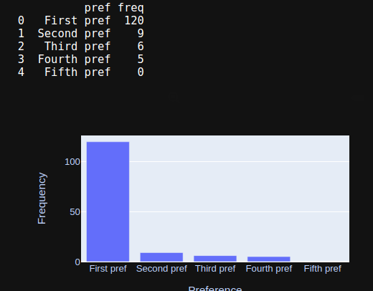
After making data set randomly by aforementioned process, we test our algorithm on it many times. In almost all cases, above 115 students got their first preference, around 12 students got second preference, around 9 students got third preference and 4 students got fourth preference. Results of 10 tests are also attached as test-1,test-2,….,test-10 etc It looks like this:

