This report explains the implementation of an Access Control List (ACL) on the Layer 3 switch within Autonomous Systems : AS100 , AS200 , AS300 and AS400.
The purpose of the ACL is to restrict unauthorized communication between hosts in the local network to enhance overall security.
Blocking PC14 (IP: 192.168.1.5) from accessing the Server (IP: 192.168.1.100).
Allowing all other devices to communicate normally with the server
Blocking PC24 (IP: 192.168.2.5) from accessing the Server (IP: 192.168.2.100).
Allowing all other devices to communicate normally with the server
Blocking PC14 (IP: 192.168.3.5) from accessing the Server (IP: 192.168.3.100).
Allowing all other devices to communicate normally with the server
Blocking PC14 (IP: 192.168.4.5) from accessing the Server (IP: 192.168.4.100).
Allowing all other devices to communicate normally with the server

- Configuration
- AS100
<LW1> system-view

# -------- ACL Configuration --------
[LW1] acl number 3000
[LW1-acl-3000] rule 5 deny ip source 192.168.1.5 0.0.0.0 destination 192.168.1.100 0.0.0.0
[LW1-acl-3000] rule 10 permit ip
[LW1-acl-3000] quit

# -------- Apply ACL on Vlan Gateway --------
[LW1] interface Vlanif10
[LW1-Vlanif10] traffic-filter inbound acl 3000
[LW1-Vlanif10] quit
<LW1> save

- AS200
<LSW4> system-view
[LSW4] acl number 3001
[LSW4-acl-3001] rule 5 deny ip source 192.168.2.5 0.0.0.0 destination 192.168.2.100 0.0.0.0
[LSW4-acl-3001] rule 10 permit ip
[LSW4-acl-3001] quit

[LSW4] interface Vlanif30
[LSW4-Vlanif30] traffic-filter inbound acl 3001
[LSW4-Vlanif30] quit
< LSW4> save

- AS300
<LSW14> system-view
[LSW14] acl number 3002
[LSW14-acl-3002] rule 5 deny ip source 192.168.3.5 0.0.0.0 destination 192.168.3.100 0.0.0.0
[LSW14-acl-3002] rule 10 permit ip
[LSW14-acl-3002] quit
[LSW14] interface Vlanif50
[LSW14-Vlanif50] traffic-filter inbound acl 3002
[LSW14-Vlanif50] quit
< LSW14> save
- AS400
<LSW17> system-view
[LSW17] acl number 3003
[LSW17-acl-3003] rule 5 deny ip source 192.168.4.5 0.0.0.0 destination 192.168.4.100 0.0.0.0
[LSW17-acl-3003] rule 10 permit ip
[LSW17-acl-3003] quit

[LSW17] interface Vlanif70
[LSW17-Vlanif70] traffic-filter inbound acl 3003
[LSW17-Vlanif70] quit
< LSW17> save

- Test
AS100
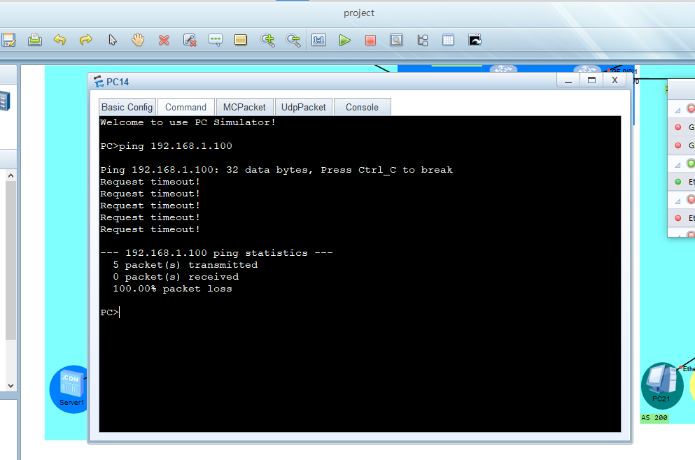
AS200
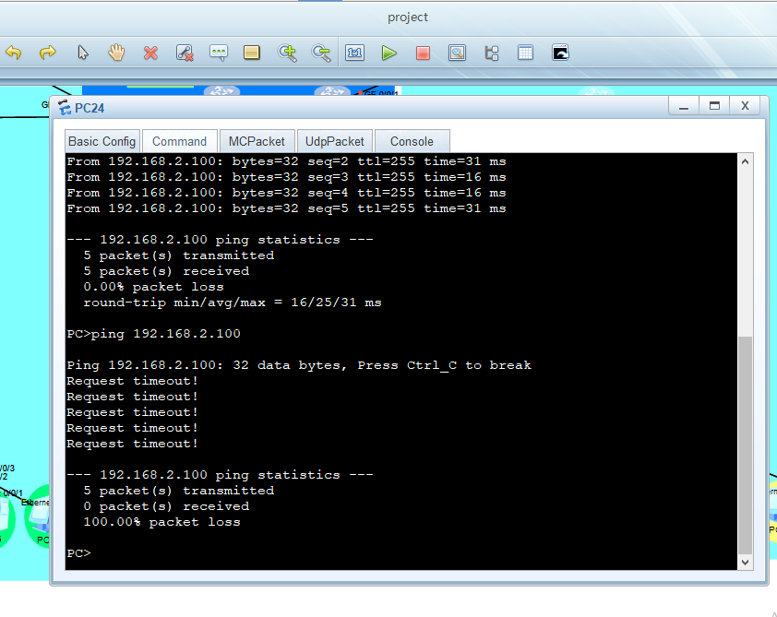
AS300
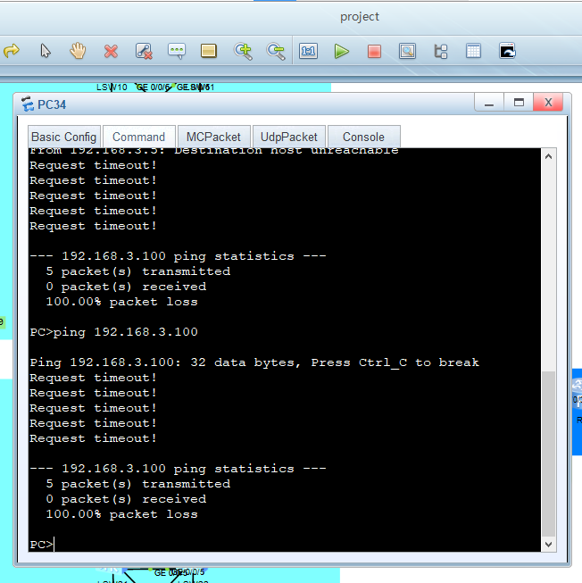

AS400
