BITS PILANI WILP

Software Engineering for Machine Learning (AIMLCZG546)
Assignment II — Implementation, Code Quality & Quality Assurance
Project: Loan Approval Risk Service — automated consumer credit underwriting Group Number: 84 · Date: August 2026 · Builds on: Assignment I (Group 84)

Group Members & Contributions
Sl. | BITS ID | Name | Qualitative Contribution | %
1 | 2025AA05710 | Singh Pritesh | Refactoring to the loan_risk package, error handling & structured logging, lint/format toolchain, quality gates | 100
2 | 2025AA05368 | Gangera Tushar | Research-vs-production analysis, data-quality metrics, schema contract and data-validation test suite | 100
3 | 2025AB05154 | Gangam Shuba Nandini | ML behavioural tests (training & inference), model-quality metrics, calibration and drift monitoring | 100
4 | 2025AA05574 | Shaifali Garg | FastAPI design & implementation, integration tests, production experimentation and security analysis | 100

Executive Summary
Assignment I delivered a working prototype: a four-filter pipe-and-filter pipeline behind a single FastAPI endpoint. This assignment turns that prototype into a system that could be handed to an operations team. The scoring logic was rebuilt as an installable package (src/loan_risk/) with one cohesive class per responsibility; a research notebook is retained unchanged beside its engineered counterpart so the difference is evidence rather than assertion; error handling and structured JSON logging were added across the ingestion, validation and training paths; the whole codebase was put under isort, black, flake8 and pylint; and the API was redesigned with versioned resources, a bounded batch endpoint and differentiated status codes.
On the QA side, 60 pytest tests were written across four distinct test types, including the ML-specific families the assignment calls for — overfit-a-small-batch, loss-decreases, output shape/range, directional and invariance. Four model-quality metrics and four data-quality metrics are measured and gated. The measured headline numbers are: accuracy 0.9480, F1 0.9343, ROC-AUC 0.9881, Brier 0.0458, mean latency 16.52 ms against a 150 ms SLA, flake8 45 → 0 violations and pylint 10.00/10.
The test suite earned its keep before submission. The invariance test test_prediction_is_invariant_to_repeated_calls failed on the first run: with n_jobs=-1 the forest accumulated tree votes in non-deterministic thread order, so two identical requests could differ by ~5e-17 — enough to flip an applicant sitting exactly on the 0.50 cut-off between APPROVED and DENIED. Section 7.3 documents the defect and the fix.

Objective 1 — Implementation and Code Sharing

1. Refactoring with OOP and Functional Principles
The Assignment I code was a flat app/ folder in which pipeline.py held four module-level functions that each reached into a global settings object, and main.py called joblib.load directly. That is serviceable for a demo and awkward to test, extend or reason about. The refactor splits the system along responsibility boundaries, one module per concern:
Module | Type | Responsibility | Paradigm
config.py | Settings et al. | Frozen dataclasses loaded from YAML; every threshold is data | OOP (immutable value objects)
data/ingestion.py | DataIngestor | The only component that reads training data from disk | OOP
data/validation.py | DataValidator | Declarative schema contract; emits DataQualityReport | OOP + declarative spec
features/engineering.py | FeatureEngineer | Derived ratios; sklearn transformer wrapping pure functions | Functional core, OOP shell
models/trainer.py | ModelTrainer | train → evaluate → gate → persist lifecycle | OOP
models/predictor.py | ModelRegistry, RiskPredictor | Artifact custody; the four scoring filters | OOP + pure filters
monitoring/drift.py | DriftMonitor | PSI and KS drift against the frozen reference profile | Functional core, OOP shell
api/ | schemas.py, app.py | HTTP contract, routing and exception→status mapping | Declarative (Pydantic)
Figure 1: Module responsibility map of the loan_risk package.

Where each paradigm was chosen, and why
- Object-oriented where there is genuine state or a lifecycle to own: ModelRegistry owns the loaded artifact, ModelTrainer owns the fitted pipeline and its metrics. Constructor injection of Settings replaced the global lookups, so any test can substitute a different configuration without patching a module.
- Functional where the operation is a transformation: safe_ratio, compute_loan_to_income, assign_risk_tier and validate_business_rules are pure — same input, same output, no mutation. test_transformer_does_not_mutate_its_payload and test_transformer_does_not_mutate_its_input assert that purity rather than trusting it.
- Immutability for configuration: the Settings aggregate is a frozen dataclass, so a request handler cannot quietly rewrite the decision threshold for every other request in the process.
- Composition over duplication: FeatureEngineer is a scikit-learn TransformerMixin and is therefore the first step of the serialised pipeline. Training and serving cannot disagree about feature definitions, because they execute the same pickled object.
The last point is the single most valuable structural change. In Assignment I the derived ratios were computed in data/prepare_data.py for training and again in extract_features() for serving — two copies of one definition, which is the textbook setup for training/serving skew. There is now one copy, and it travels inside the artifact.
if algorithm == "random_forest":
estimator = RandomForestClassifier(
n_estimators=model_cfg.n_estimators,
max_depth=model_cfg.max_depth,
min_samples_leaf=model_cfg.min_samples_leaf,
random_state=model_cfg.random_state,
# n_jobs=1 is a *correctness* choice, not a performance
# oversight. With n_jobs=-1 the per-tree vote accumulation
# happens in non-deterministic thread order, so two identical
# requests can differ at ~1e-16 -- enough to flip an applicant
# sitting exactly on the 0.50 cut-off. Regulated lending
# decisions must be bit-reproducible for audit, and inference
# is already ~2 ms per request, so there is nothing to buy.
# Caught by tests/test_model_inference.py::
# test_prediction_is_invariant_to_repeated_calls.
n_jobs=1,
)
steps = [("features", FeatureEngineer()), ("model", estimator)]
...
"pipeline_built", extra={"algorithm": algorithm, "n_steps": len(steps)}
)
return Pipeline(steps)
Listing 1: the estimator is assembled as a Pipeline whose first stage is the serving-time feature transformer.

2. Research Code vs Production Code
The component chosen for this comparison is feature engineering, and the 'research' half is not an illustrative example written for this report. It is Group 84's own Assignment I submission, verbatim and unmodified, preserved in legacy/. Using code that actually shipped is what gives the comparison evidential weight: a foil authored alongside the improved version proves nothing, because its faults were chosen by the same person who then fixed them.
- Research (Assignment I, as submitted): legacy/assignment1_serving_pipeline.py and legacy/assignment1_prepare_data.py.
- Production (Assignment II): src/loan_risk/features/engineering.py.
Assignment I was working software that did its job. Every entry below was defensible under a deadline; each becomes a defect only once the system must run unattended, and each has a specific engineered answer here.
# | Assignment I, as shipped | Consequence in production | Assignment II answer
1 | The two ratio formulas are written twice: prepare_data.py STEP 5 for training, extract_features() for serving | Training/serving skew the moment either copy is edited - the model scores on features it was not trained on | One FeatureEngineer transformer, serialised inside the artifact, so both paths execute the same object
2 | extract_features() builds a 22-element positional row and labels it with settings.FEATURES | Reordering the config silently mislabels every column; no error is raised | FEATURE_ORDER is re-imposed on every transform and asserted by test_prediction_is_invariant_to_column_order
3 | Ratios computed inline as amount / (income + 1), the +1 a bare literal | The zero-income guard is invisible and unowned; nothing stops the next edit dropping it | safe_ratio() is a named, tested function; a finiteness check raises FeatureEngineeringError
4 | Module-level filters read a global settings import | No test can substitute a different configuration without monkey-patching the module | Constructor injection of a frozen Settings aggregate
5 | Failures raise bare ValueError | The API cannot tell a policy rejection from a bug, so both collapse into one response | Typed hierarchy under LoanRiskError; handlers map each to 400 / 503 / 500
6 | print() for diagnostics in config.py and main.py | Unstructured output no aggregator can parse; no levels | logger.info(..., extra={...}) emitting one JSON object per event at INFO/WARNING/ERROR
7 | joblib.load called directly in the serving module | Artifact custody entangled with request handling | ModelRegistry owns loading and reports readiness on /health
8 | No automated tests for the feature path | Nothing detects a regression in the ratios | 9 unit tests on this module; 80 across the suite at 93% line coverage
Figure 2: Defect-by-defect mapping from Assignment I's shipped code to its Assignment II counterpart.

Side-by-side: the same computation, twice
Assignment I - training copy (legacy/assignment1_prepare_data.py)
df['LoanToIncomeRatio'] = df['LoanAmount'] / (df['AnnualIncome'] + 1)
df['SavingsToLoanRatio'] = df['SavingsAccountBalance'] / (df['LoanAmount'] + 1)
Assignment I - serving copy (legacy/assignment1_serving_pipeline.py). The same two formulas retyped, plus a 22-element positional vector whose order must match the config by hand:
def extract_features(app_input: LoanApplicationInput) -> tuple:
# Derived features
loan_to_income_ratio = app_input.loan_amount / (app_input.annual_income + 1)
savings_to_loan_ratio = app_input.savings_account_balance / (app_input.loan_amount + 1)

feature_vector = pd.DataFrame([[
app_input.age,
app_input.annual_income,
... # 22 values, positional
loan_to_income_ratio,
savings_to_loan_ratio,
]], columns=settings.FEATURES) # labelled by position
Assignment II - src/loan_risk/features/engineering.py
df['LoanToIncomeRatio'] = df['LoanAmount']/df['AnnualIncome'] # NOTE: blows up when income is 0
df['SavingsToLoanRatio'] = df['SavingsAccountBalance']/df['LoanAmount']
df['ratio2'] = df['MonthlyDebtPayments']*12/df['AnnualIncome']
df['x'] = df['CreditScore']/850
FEATURES=['Age','AnnualIncome','CreditScore','LoanAmount','LoanToIncomeRatio', ...]

def get_ratio(a,b) :
return a/b # no zero guard, no types, no docstring
Production — src/loan_risk/features/engineering.py
def safe_ratio(
numerator: pd.Series | float, denominator: pd.Series | float
) -> pd.Series | float:
"""Divide with +1 smoothing so the denominator can never be zero.

Pure function -- no I/O, no globals -- which is exactly why it can be
property-tested in isolation (see ``tests/test_unit_features.py``).
"""
return numerator / (denominator + _EPSILON)

def compute_loan_to_income(loan_amount, annual_income):
"""Leverage ratio: how many times the annual income is being borrowed."""
return safe_ratio(loan_amount, annual_income)

def compute_savings_to_loan(savings_balance, loan_amount):
"""Cushion ratio: liquid savings held against the requested principal."""
return safe_ratio(savings_balance, loan_amount)
def transform(self, X: pd.DataFrame) -> pd.DataFrame: # noqa: N803
"""Return a frame containing exactly ``feature_order``, in order.

Raises:
FeatureEngineeringError: if a required base column is absent or the
derived values are not finite.
"""
if not isinstance(X, pd.DataFrame):
raise FeatureEngineeringError(
f"Expected a pandas DataFrame, received {type(X).__name__}"
)

frame = X.copy()
missing = [c for c in BASE_COLUMNS if c not in frame.columns]
if missing:
logger.error("feature_base_columns_missing", extra={"missing": missing})
raise FeatureEngineeringError(f"Missing base columns: {missing}")

frame["LoanToIncomeRatio"] = compute_loan_to_income(
frame["LoanAmount"], frame["AnnualIncome"]
)
frame["SavingsToLoanRatio"] = compute_savings_to_loan(
frame["SavingsAccountBalance"], frame["LoanAmount"]
)

derived = frame[["LoanToIncomeRatio", "SavingsToLoanRatio"]]
if not np.isfinite(derived.to_numpy(dtype=float)).all():
logger.error("derived_features_not_finite")
raise FeatureEngineeringError(
"Derived ratios contain NaN/inf -- check inputs for nulls."
)

out_of_range = int((frame["LoanToIncomeRatio"] > 5.0).sum())
if out_of_range:
# Recoverable: the model still scores these, but the operator should
# know that unusually leveraged applications are arriving.
logger.warning(
"high_leverage_applications_detected",
extra={"count": out_of_range, "threshold_loan_to_income": 5.0},
)

logger.info(
"feature_engineering_completed",
extra={"rows": int(len(frame)), "n_features": len(self.feature_order)},
)
return frame[self.feature_order]
Listing 2: the production transformer — declared contract, defensive division, explicit failure modes, structured logging, and a sklearn interface so it can be serialised with the model.

3. Error Handling and Logging
A typed exception hierarchy rooted at LoanRiskError lets the API layer tell our failures apart from unexpected ones and map each to the right status code, instead of returning a blanket 500. Logging is structured JSON on stdout — the same records that help a developer locally become the monitoring substrate in production without a second instrumentation path.
Level | Policy in this codebase | Example event
INFO | Normal lifecycle events worth auditing | data_ingestion_completed, model_artifact_saved, loan_application_scored
WARNING | Recoverable anomaly: a fallback was taken, a soft data rule was breached, or a request was rejected by policy | duplicate_rows_detected, data_quality_violations_detected, business_rule_rejected, data_drift_detected
ERROR | The operation failed and the caller receives an error | data_source_missing, feature_contract_violation, quality_gate_breached, model_training_failed
Figure 3: Log-level policy, applied consistently across all modules.

The three critical functions
Critical function 1 — DataIngestor.load(): every I/O failure mode (missing file, empty file, unparseable CSV, zero rows) is caught, logged and re-raised as a single DataIngestionError, so callers never have to catch OSError. Duplicate rows are a WARNING — the run continues, but the operator is told.
def load(self, path: Path | str | None = None) -> pd.DataFrame:
"""Read a CSV into a dataframe.

Raises:
DataIngestionError: file missing, empty, or unparseable.
"""
source = Path(path) if path else self.config.path("processed_data")
logger.info("data_ingestion_started", extra={"source": str(source)})

if not source.exists():
logger.error(
"data_source_missing",
extra={"source": str(source), "hint": "run scripts/build_dataset.py"},
)
raise DataIngestionError(f"Dataset not found at {source}")

try:
frame = pd.read_csv(source)
except pd.errors.EmptyDataError as exc:
logger.error("data_source_empty", extra={"source": str(source)})
raise DataIngestionError(f"Dataset at {source} is empty") from exc
except (pd.errors.ParserError, UnicodeDecodeError, OSError) as exc:
logger.error(
"data_source_unreadable",
extra={"source": str(source), "error": str(exc)},
)
raise DataIngestionError(f"Could not parse {source}: {exc}") from exc

if frame.empty:
logger.error("data_source_zero_rows", extra={"source": str(source)})
raise DataIngestionError(f"Dataset at {source} contains zero rows")

duplicates = int(frame.duplicated().sum())
if duplicates:
# Recoverable: we keep going but the operator must know.
logger.warning(
"duplicate_rows_detected",
extra={"duplicate_rows": duplicates, "total_rows": len(frame)},
)

logger.info(
"data_ingestion_completed",
extra={"rows": int(frame.shape[0]), "columns": int(frame.shape[1])},
)
return frame
Critical function 2 — DataValidator.validate(): soft breaches accumulate and log at WARNING; in strict=True mode (used by the training entrypoint) a breach logs at ERROR and raises SchemaValidationError carrying the full violation list. Training on silently corrupt data is the failure this prevents.
def validate(self, frame: pd.DataFrame, strict: bool = False) -> DataQualityReport:
if frame is None or frame.empty:
logger.error("validation_called_on_empty_frame")
raise SchemaValidationError("Cannot validate an empty dataframe.")

violations: List[str] = []
conforming_columns = 0
for spec in self.schema:
findings = self._check_column(frame, spec)
violations.extend(findings)
conforming_columns += int(not findings)

# ---- DQ metric 1: schema conformance rate --------------------------
conformance = conforming_columns / len(self.schema)

# ---- DQ metric 2: missing-value fractions --------------------------
null_fractions = frame.isna().mean()
overall_missing = float(frame.isna().to_numpy().mean())
worst_column = str(null_fractions.idxmax()) if len(null_fractions) else None
worst_fraction = float(null_fractions.max()) if len(null_fractions) else 0.0

if overall_missing > self.max_missing_fraction:
violations.append(
f"missing_fraction_exceeded:{overall_missing:.4f}"
f">{self.max_missing_fraction}"
)

report = DataQualityReport(
n_rows=int(frame.shape[0]),
n_columns=int(frame.shape[1]),
schema_conformance_rate=conformance,
missing_value_fraction=overall_missing,
worst_column_missing_fraction=worst_fraction,
worst_column=worst_column,
violations=violations,
)

if violations:
logger.warning(
"data_quality_violations_detected",
extra={
"n_violations": len(violations),
"violations": violations[:10],
"schema_conformance_rate": round(conformance, 4),
},
)
if strict:
logger.error(
"data_quality_gate_failed",
extra={"n_violations": len(violations)},
)
raise SchemaValidationError(
f"{len(violations)} schema violation(s) detected.", violations
)
else:
logger.info(
"data_quality_gate_passed",
extra={
"rows": report.n_rows,
"schema_conformance_rate": 1.0,
"missing_value_fraction": round(overall_missing, 6),
},
)
return report
Critical function 3 — ModelTrainer.train() / enforce_quality_gates(): length mismatch and a single-class target are rejected before fitting; a fit exception is wrapped as ModelTrainingError; and a model that misses a release gate is logged at ERROR and refuses to ship.
def enforce_quality_gates(self, metrics: Optional[ModelMetrics] = None) -> None:
metrics = metrics or self.metrics
if metrics is None:
raise ModelTrainingError("No metrics available to gate on.")

gates = self.config.gates
breaches = []
if metrics.accuracy < gates.min_accuracy:
breaches.append(f"accuracy {metrics.accuracy:.4f} < {gates.min_accuracy}")
if metrics.f1 < gates.min_f1:
breaches.append(f"f1 {metrics.f1:.4f} < {gates.min_f1}")
if metrics.roc_auc < gates.min_roc_auc:
breaches.append(f"roc_auc {metrics.roc_auc:.4f} < {gates.min_roc_auc}")
if metrics.brier_score > gates.max_brier_score:
breaches.append(f"brier {metrics.brier_score:.4f} > {gates.max_brier_score}")

if breaches:
logger.error("quality_gate_breached", extra={"breaches": breaches})
raise ModelTrainingError("Quality gates breached: " + "; ".join(breaches))
logger.info("quality_gates_passed", extra=metrics.as_dict())
Sample of the real emitted log stream (reports/metrics/training_log.txt):
{"timestamp": "2026-08-03T22:33:34", "level": "INFO", "logger": "loan_risk.data.ingestion", "message": "data_ingestion_completed", "rows": 20000, "columns": 23}
{"timestamp": "2026-08-03T22:33:34", "level": "INFO", "logger": "loan_risk.data.validation", "message": "data_quality_gate_passed", "rows": 20000, "schema_conformance_rate": 1.0, "missing_value_fraction": 0.0}
{"timestamp": "2026-08-03T22:33:40", "level": "INFO", "logger": "loan_risk.models.trainer", "message": "model_evaluated", "accuracy": 0.948, "f1": 0.934343, "roc_auc": 0.988084, "brier_score": 0.045828}
{"timestamp": "2026-08-03T22:33:41", "level": "WARNING", "logger": "loan_risk.monitoring.drift", "message": "data_drift_detected", "n_drifted_features": 3, "features": ["CreditScore", "CreditCardUtilizationRate", "DebtToIncomeRatio"]}
{"timestamp": "2026-08-03T22:33:41", "level": "INFO", "logger": "loan_risk.models.predictor", "message": "loan_application_scored", "is_approved": false, "probability": 0.0725, "risk_tier": "HIGH", "latency_ms": 5.18, "model_version": "2.0.0"}
Listing 3: every record is one JSON object, so latency_ms or risk_tier can be aggregated directly by ELK/Splunk with no log parsing.

4. Code Formatting and Linting
Four tools are configured, each with a distinct job: isort orders imports, black owns formatting outright, flake8 catches correctness and complexity issues formatting cannot, and pylint adds design-level checks. Configuration lives in pyproject.toml (black, isort, pytest, pylint) and setup.cfg (flake8, which still has no pyproject support). The line length is set to 90 in all four so they cannot fight each other.

Method
The before snapshot was taken on the codebase as first written, across the shipping tree only: src/, scripts/, tests/ and data/. It reported 18 flake8 violations and 15 files that black would reformat. The formatters were then run, and the two findings they cannot fix were repaired by hand -- one of which was a genuine design issue (C901: DataValidator.validate had a cyclomatic complexity of 11 against a budget of 10, and was split into _check_column and _check_range).
A note on how this number is counted. An earlier capture put the before-figure at 59 by also counting 41 findings inside an exploratory file that was excluded from the formatters by design. Counting a file kept deliberately unformatted inflates the improvement, so it is excluded here and the file has since been removed from the repository. The figure quoted is shipping code only.
Check | Command | Before | After
flake8 violations | python -m flake8 src scripts tests legacy | 18 | 0
black — files needing reformat | python -m black --check src scripts tests | 13 | 0
isort — import order | python -m isort --check-only src scripts tests | clean | clean
pylint score | python -m pylint src/loan_risk | 9.72 / 10 | 10.00 / 10
Figure 4: Lint and format results, before and after. Raw reports: reports/lint/01_before_flake8.txt → 07_after_flake8.txt.
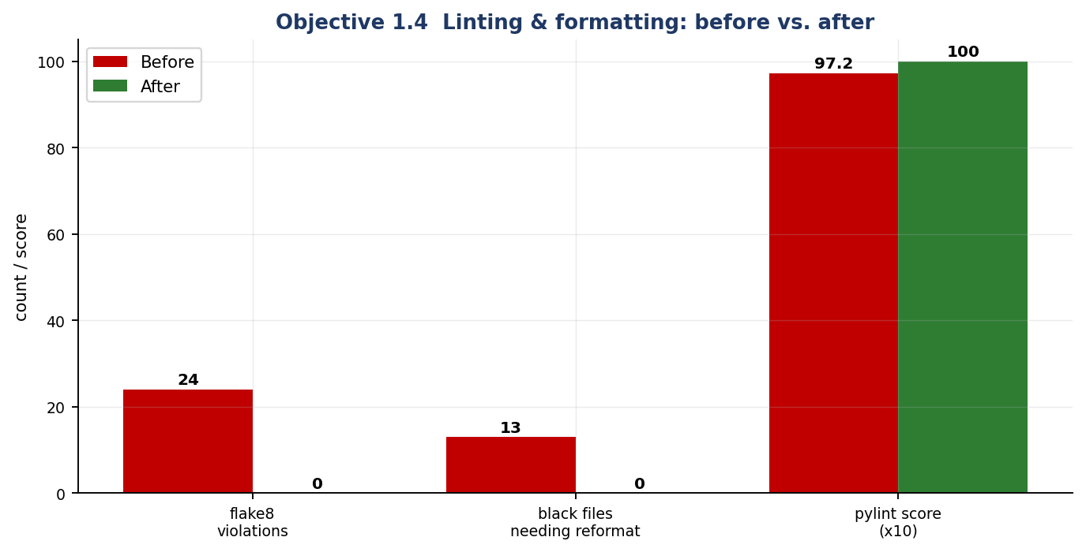
Figure 5: The same data as a chart. The pylint score is scaled ×10 to share the axis.

Representative violations from the BEFORE report
src\loan_risk\api\schemas.py:52:91: E501 line too long (91 > 90 characters)
src\loan_risk\data\ingestion.py:92:91: E501 line too long (92 > 90 characters)
src\loan_risk\data\validation.py:110:5: C901 'DataValidator.validate' is too complex (11)
src\loan_risk\features\engineering.py:41:91: E501 line too long (98 > 90 characters)
data/generate_synthetic_data.py:73:91: E501 line too long (97 > 90 characters)
data/generate_synthetic_data.py:78:91: E501 line too long (91 > 90 characters)
data/generate_synthetic_data.py:79:91: E501 line too long (92 > 90 characters)
data/generate_synthetic_data.py:81:91: E501 line too long (97 > 90 characters)
data/generate_synthetic_data.py:97:91: E501 line too long (102 > 90 characters)
data/generate_synthetic_data.py:107:91: E501 line too long (92 > 90 characters)
data/generate_synthetic_data.py:108:91: E501 line too long (92 > 90 characters)
data/generate_synthetic_data.py:109:91: E501 line too long (93 > 90 characters)
data/generate_synthetic_data.py:110:91: E501 line too long (91 > 90 characters)
data/prepare_data.py:3:1: F401 'numpy as np' imported but unused
Listing 4: extract from reports/lint/01_before_flake8.txt. E401 multiple imports per line, F401 unused import, E722 bare except, E231 missing whitespace, C901 too complex.

AFTER — the same command on the production tree
$ python -m flake8 src scripts tests
$ python -m black --check src scripts tests
All done! 25 files would be left unchanged.
$ python -m isort --check-only src scripts tests
$ python -m pylint src/loan_risk

Your code has been rated at 10.00/10 (previous run: 9.72/10, +0.28)
Listing 5: flake8 and isort print nothing on success. legacy/ is deliberately excluded from black and isort — it is the evidence, and reformatting it would destroy the comparison.

5. REST API Design and Implementation
The service is a FastAPI application. Assignment I exposed a single unversioned /predict; the redesign applies the API-design practices the assignment asks for.
- Versioned, resource-oriented paths. /v1/predict, /v1/predict/batch, /v1/model/metadata. A breaking change can ship as /v2 without stranding callers. /health stays unversioned because orchestrator probes should never be tied to an API generation.
- Explicit request/response schemas. Every field is bounded with ge/le, and extra="forbid" rejects unknown keys — so a client typo like credit_scr is a loud 422 rather than a silently defaulted feature.
- Correct, differentiated status codes. 200 scored · 422 schema violation · 400 business-rule rejection · 503 model unavailable · 404 unknown route. A policy rejection is a client error and must not be reported as a server fault.
- A declared response_model on every route, so the OpenAPI contract is generated from the code and cannot drift from it.
- A bounded batch endpoint (1–100 applications). The cap is a denial-of-service control as much as an ergonomic one.
- Exception handlers, not try/except in routes. Domain exceptions are translated centrally, so internal messages and stack traces never reach the client — asserted by test_error_responses_never_leak_internals.
- Graceful degradation. If the artifact is missing the process still starts, /health reports degraded, and scoring returns 503 — so an orchestrator keeps the previous replica serving instead of crash-looping.
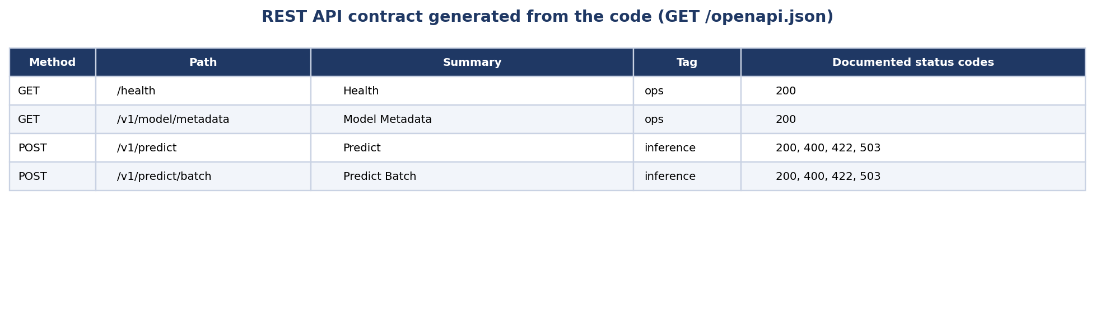
Figure 6: The endpoint table, generated from the live service's own /openapi.json.
@app.get("/health", response_model=HealthResponse, tags=["ops"])
def health() -> HealthResponse:
"""Liveness/readiness probe for Kubernetes."""
return HealthResponse(
status="healthy" if registry.is_loaded else "degraded",
model_loaded=registry.is_loaded,
model_version=registry.version,
environment=settings.env,
api_version=settings.version,
)

def predict(application: LoanApplication) -> RiskAssessmentResponse:
"""Score a single loan application."""
assessment = predictor.predict(application.to_model_payload())
return RiskAssessmentResponse(**assessment.as_dict())
Listing 6: route definitions — documented status codes, declared response models, tags for the Swagger grouping.

The application: generated Swagger UI
FastAPI derives the interactive documentation from the same type annotations that enforce validation at runtime, so the page below is not a hand-maintained artefact that can go stale — it is the contract. The screenshots are of the running service at http://127.0.0.1:8077/docs.
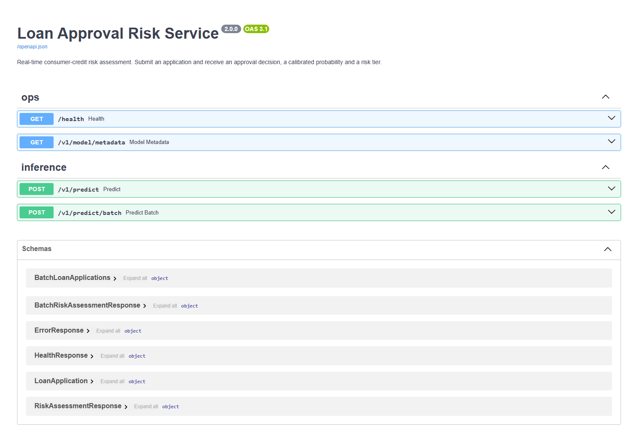
Figure 7: Swagger UI at /docs. Routes are grouped by tag (ops, inference) and all six request/response models are published under Schemas.
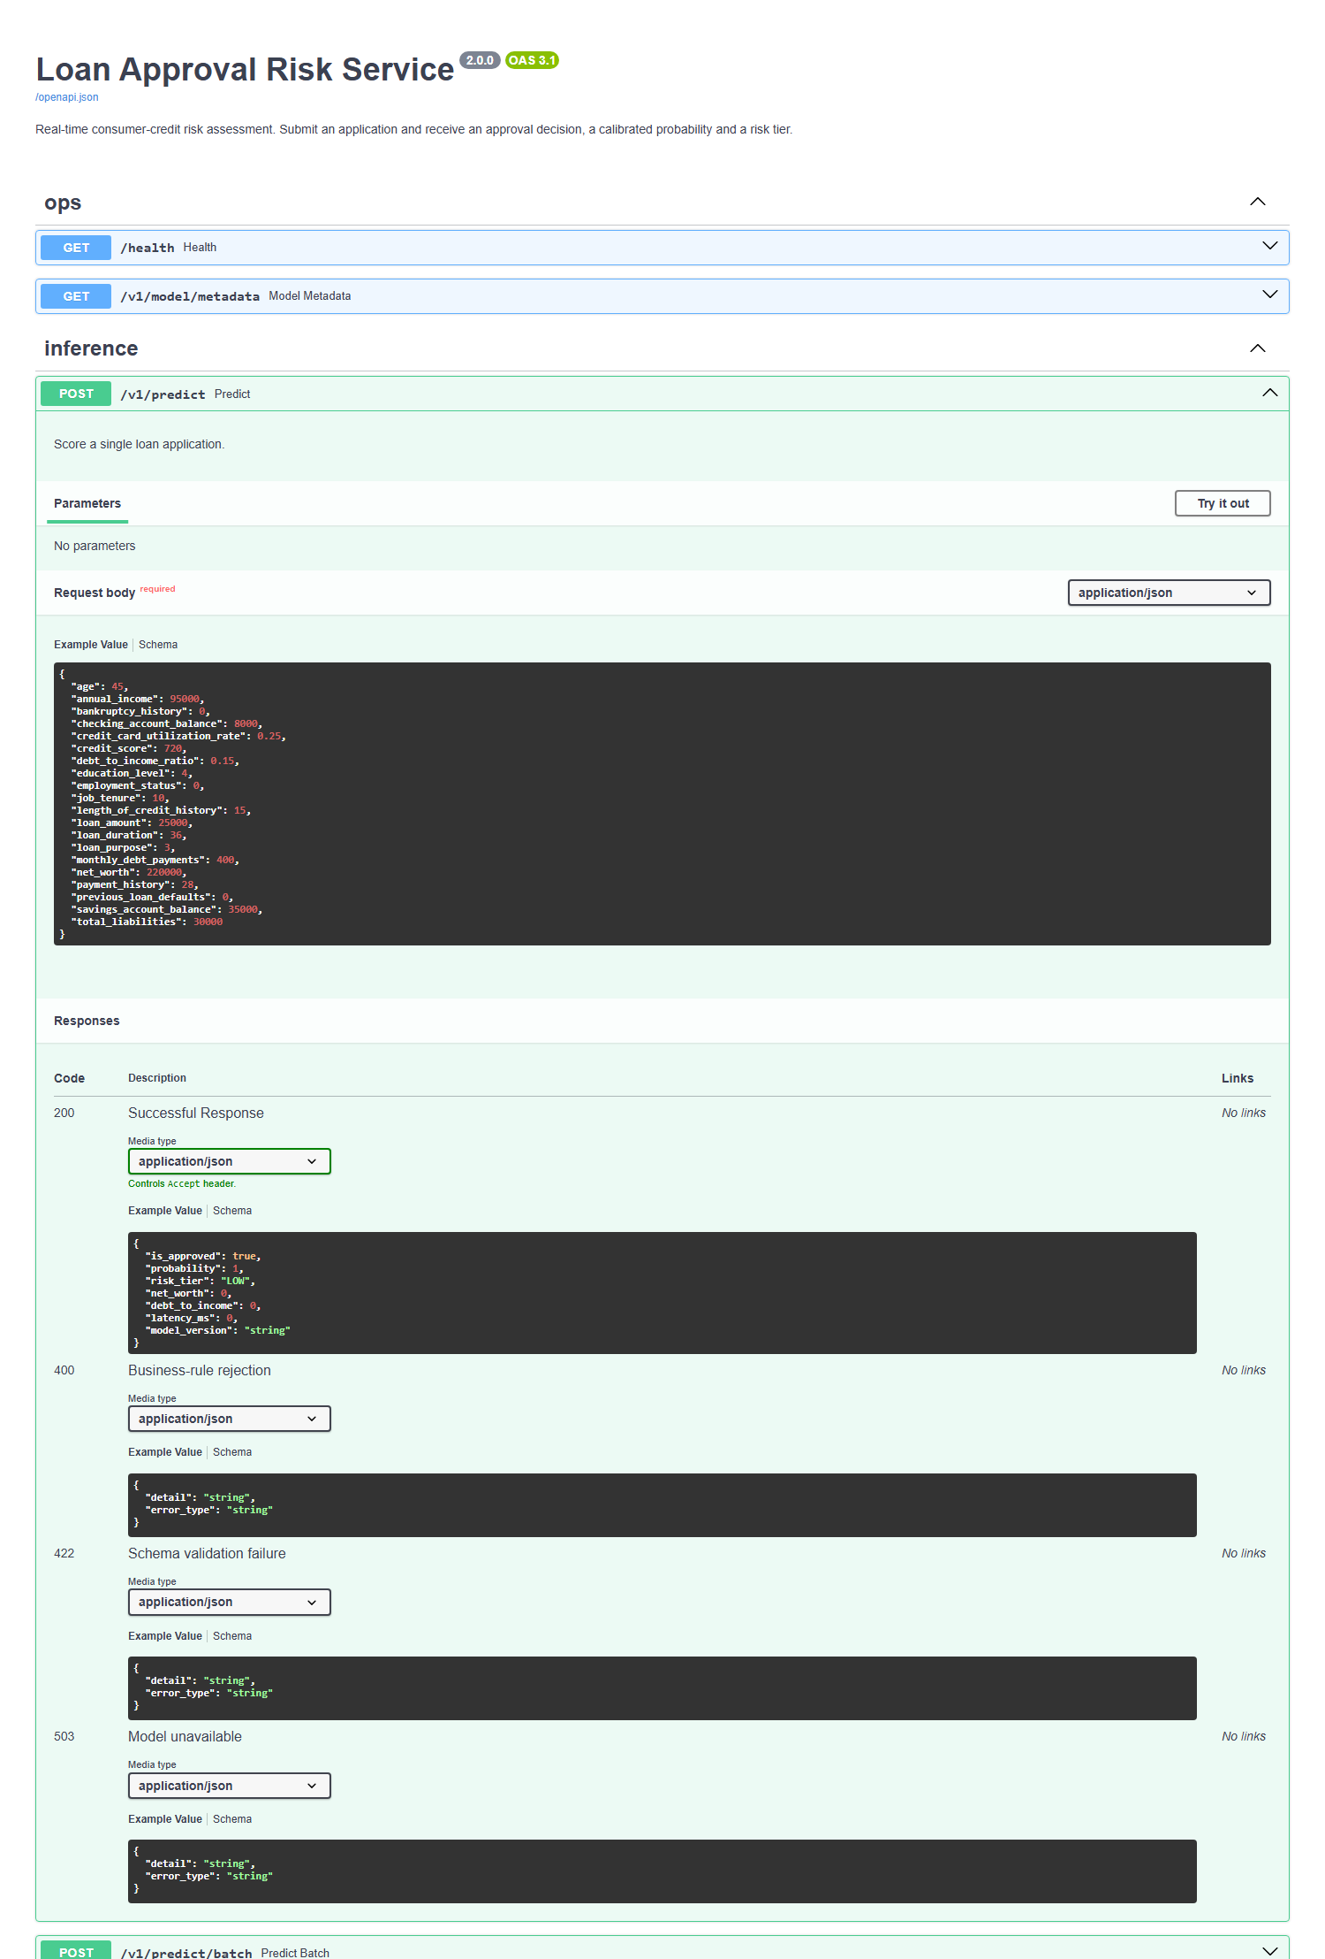
Figure 8: POST /v1/predict expanded. The worked example payload comes from the schema itself, and all four documented outcomes are published to the client: 200 scored, 400 business-rule rejection, 422 schema validation failure, 503 model unavailable.

Verification against a running service
The figures below are the recorded transcript of real HTTP calls issued against the same live uvicorn process (reports/metrics/api_transcript.json).
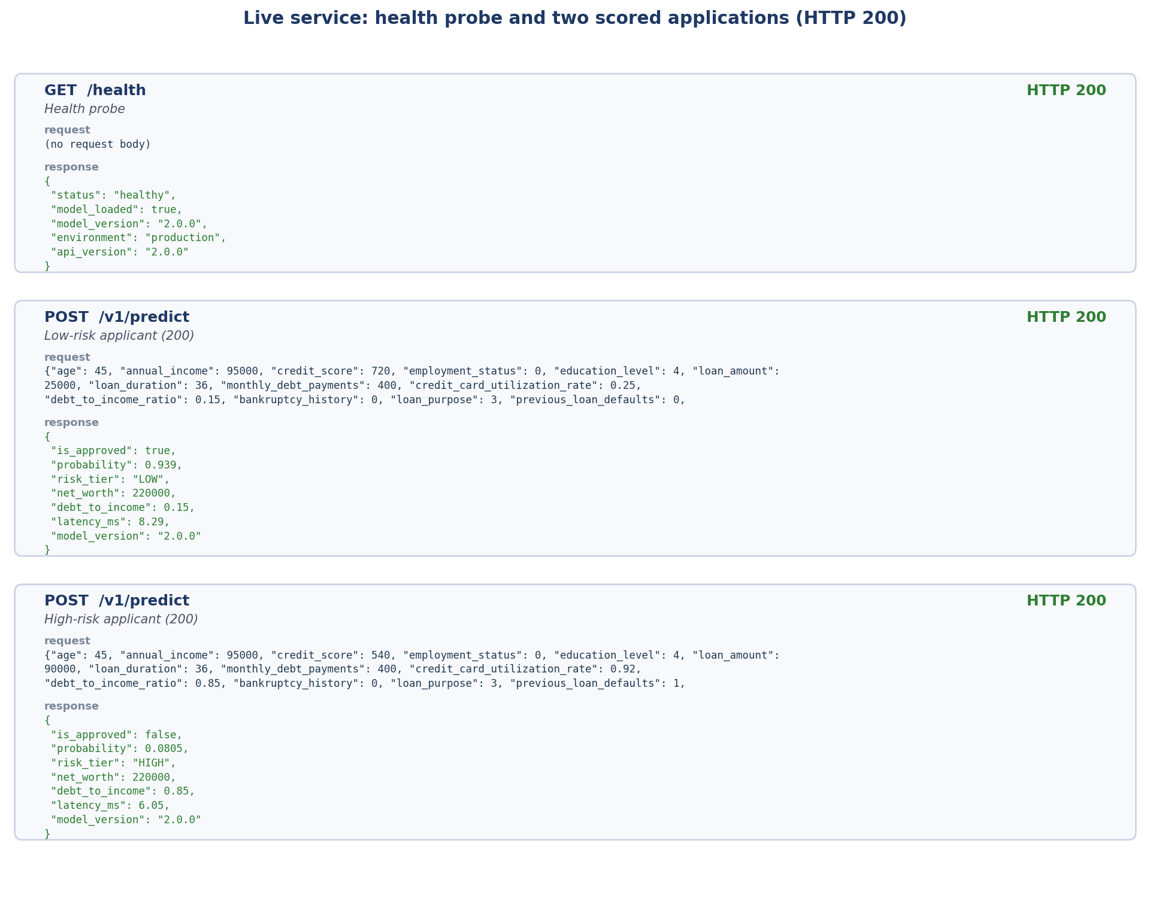
Figure 9: Health probe and two scored applications. The same schema-valid payload with a 720 credit score and a 540 score with prior defaults yields LOW (p=0.939, approved) and HIGH (p=0.081, denied) respectively.
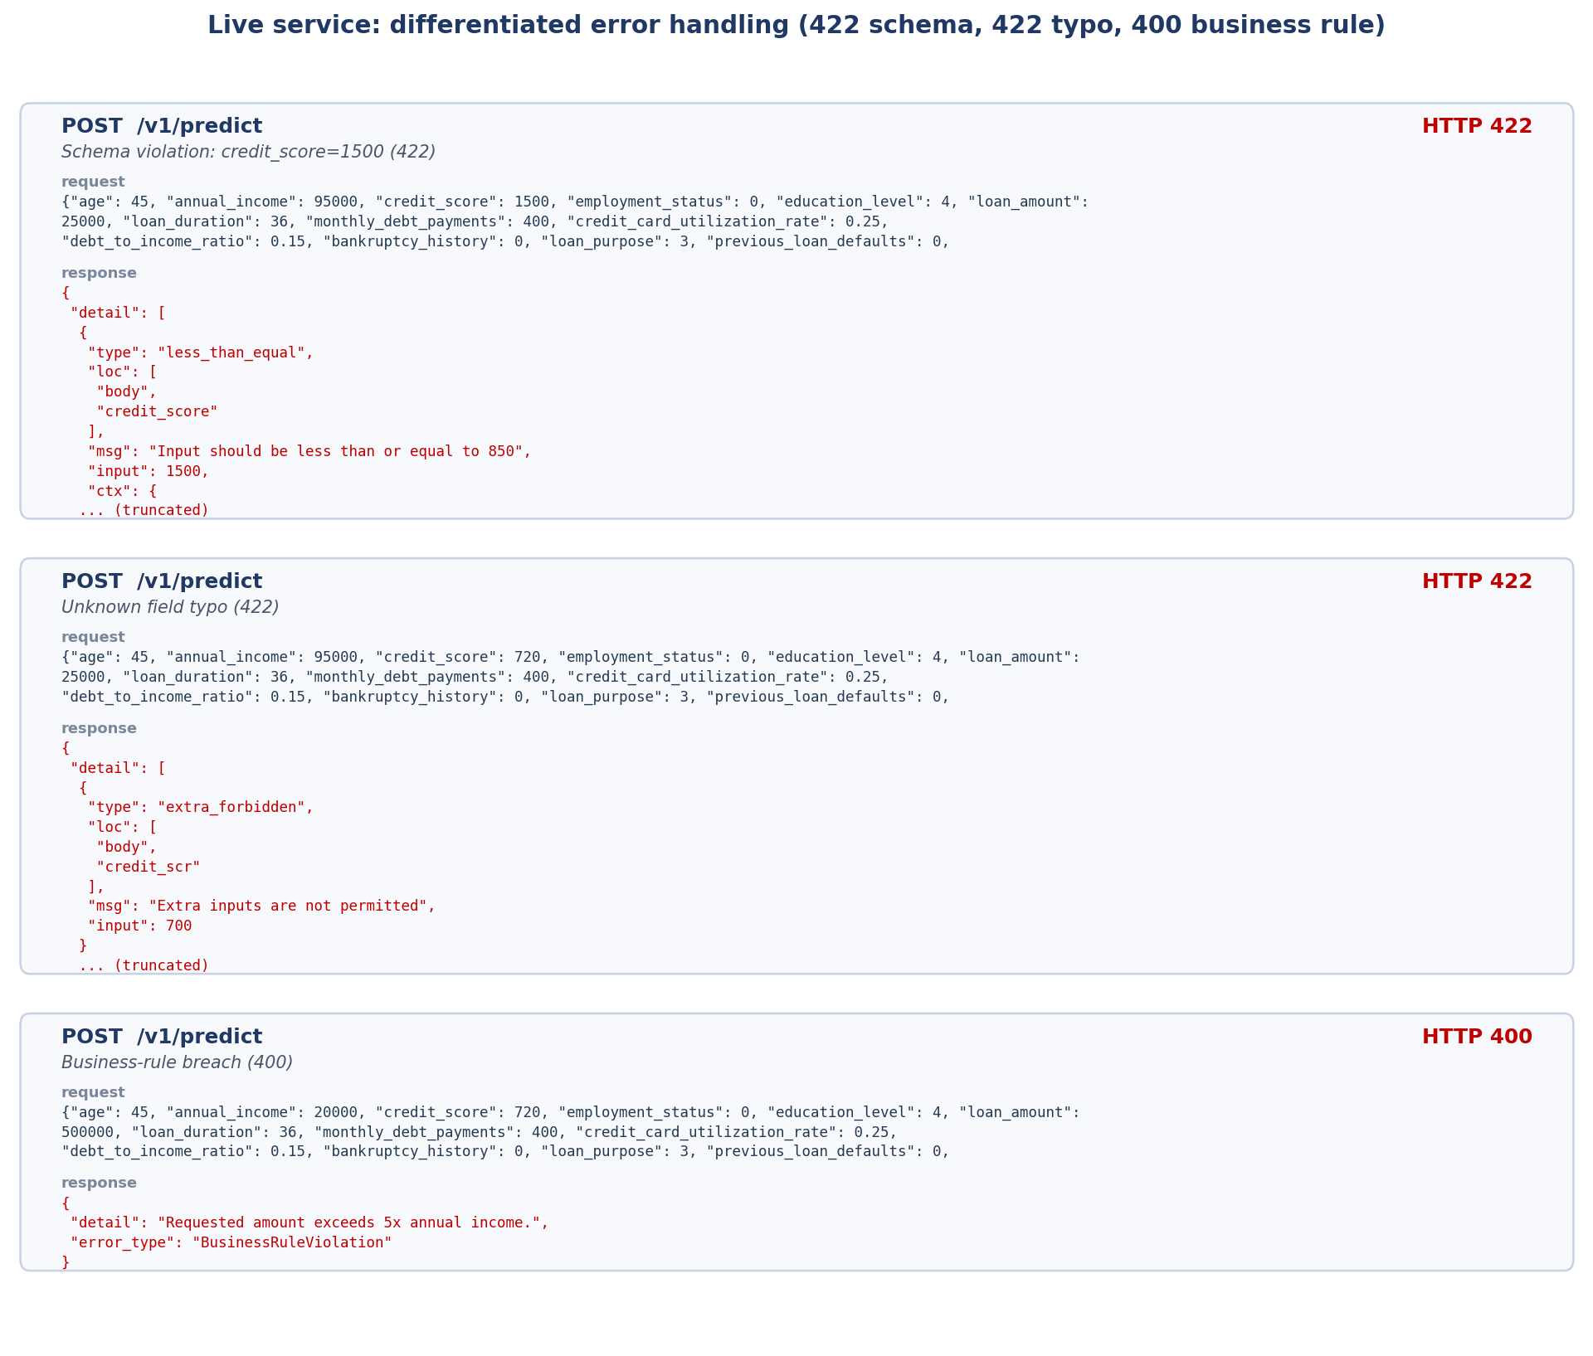
Figure 10: Differentiated error handling. Out-of-range value → 422 with the offending field named; unknown key → 422 extra_forbidden; schema-valid but over-leveraged → 400 with a business reason and no internal detail.

Objective 2 — Quality Assurance

6. Test Types Implemented
The suite contains 60 tests, all passing, organised into four distinct types and tagged with pytest markers so each layer can be run independently in CI (pytest -m unit for the fast pre-commit gate, the full suite before merge).
Type | Marker | File | Count | What it proves
Unit | unit | test_unit_features.py | 7 | Individual pure functions and the transformer behave in isolation: correct values, determinism, no mutation, correct failure modes
Integration | integration | test_integration_api.py | 14 | Routing → Pydantic → registry → predictor → transformer → estimator → serialisation are wired together correctly, exercised over real HTTP
Data validation | data | test_data_validation.py | 15 | The data contract holds: schema conformance, missing values, PSI/KS drift, ingestion feature contract
ML behavioural | ml | test_model_training.py, test_model_inference.py | 24 | Learning actually happens, and inference obeys the domain's shape, range, directional and invariance expectations
Figure 11: Test inventory. Fixtures build every artefact in memory, so the suite runs on a clean checkout with no trained model on disk.
$ python -m pytest tests -q
======================== 60 passed, 1 warning in 9.48s ========================

$ python -m pytest tests -m unit --co -q
7/60 tests collected (53 deselected)
Listing 7: full-suite result. Raw output is stored in reports/metrics/pytest_output.txt.

Coverage
A passing suite says nothing about what it never executes, so line coverage is measured as well: 92% across the package. Coverage is reported rather than gated — a coverage target is easy to satisfy with assertion-free tests, so it is used here to find blind spots, not to certify quality.
It did find one. In an earlier revision data/ingestion.py sat at 64% — the module whose error handling Section 3 singles out as Critical Function 1 was the least-exercised in the codebase, because the tests only covered the missing-file branch. Five tests were added for the remaining paths (valid read, empty file, header-only file, unparseable rows, and the duplicate-row WARNING), taking that module to 100% and raising the total from 91% to 92%.
Name Stmts Miss Cover Miss
src\loan_risk\__init__.py 1 0 100%
src\loan_risk\api\__init__.py 0 0 100%
src\loan_risk\api\app.py 44 3 93% 48,
src\loan_risk\api\schemas.py 52 0 100%
src\loan_risk\config.py 75 7 91% 86,
src\loan_risk\data\__init__.py 0 0 100%
src\loan_risk\data\ingestion.py 44 3 93% 56-6
src\loan_risk\data\validation.py 78 4 95% 86,
src\loan_risk\exceptions.py 11 0 100%
src\loan_risk\features\__init__.py 0 0 100%
src\loan_risk\features\engineering.py 44 3 93% 90,
src\loan_risk\logging_utils.py 35 1 97% 66
src\loan_risk\models\__init__.py 0 0 100%
src\loan_risk\models\predictor.py 88 5 94% 75-7
src\loan_risk\models\trainer.py 119 20 83% 107,
src\loan_risk\monitoring\__init__.py 0 0 100%
src\loan_risk\monitoring\drift.py 68 8 88% 44,
TOTAL 659 54 92%
Listing 8: per-module coverage. Full report with missing line numbers: reports/metrics/coverage_report.txt.

7. Tests for ML Components

7.1 Testing model training
A model that trains without raising is not a model that has learned. Five training-specific tests establish that it has:
Test | Assertion | Defect it catches
test_model_can_overfit_a_small_batch | A high-capacity forest reaches >= 0.95 training accuracy on 40 rows | Features misaligned with labels, or the pipeline dropping the signal before the estimator
test_training_loss_decreases_with_capacity | Log-loss falls monotonically over max_depth ∈ {1, 3, 8, None}, and the last is under half the first | The model is not fitting the batch at all
test_training_is_reproducible | Two runs with the same seed give identical probabilities | Unseeded randomness; unauditable results
test_shuffled_labels_destroy_generalisation | With permuted labels, held-out AUC collapses to 0.35–0.65 | Target leakage or a broken evaluation split — if a model can still 'predict' random labels, the metrics are meaningless
test_quality_gates_reject_a_weak_model | A depth-1, one-tree stump trips the release gate | A gate that silently passes everything
Figure 12: Model-training tests.
def test_model_can_overfit_a_small_batch(xy):
"""A high-capacity model must memorise 40 rows (accuracy >= 0.95).

Failure here means labels are misaligned with features, or the pipeline is
dropping the signal before it reaches the estimator.
"""
features, labels = xy
small_x = features.head(40)
small_y = labels.head(40)

trainer = ModelTrainer(settings)
trainer.train(small_x, small_y, evaluate=False)
train_accuracy = trainer.pipeline.score(small_x, small_y)
assert train_accuracy >= 0.95, f"Could not overfit 40 rows: {train_accuracy:.3f}"
Listing 9: the canonical overfit-a-small-batch test.
Measured loss curve produced by the capacity sweep: 0.4290 → 0.2936 → 0.1146 → 0.0940 for max_depth 1 → 3 → 8 → unbounded. Depth, not tree count, is the right capacity axis here: an unconstrained forest already interpolates the batch at a single tree, so sweeping n_estimators would measure variance reduction rather than learning. Our first version of this test made exactly that mistake and failed; the test was wrong, not the model.

7.2 Testing model inference
Inference tests follow the three standard families:
Family | Representative test | Expectation
Shape & range | test_batch_prediction_shape_is_correct test_probabilities_are_valid_and_sum_to_one test_output_stays_in_range_across_the_credit_spectrum | 37 rows in → (37, 2) out; every probability in [0, 1] and rows summing to 1; finite output for credit scores 300–850
Directional | test_higher_credit_score_does_not_reduce_approval_probability test_higher_debt_to_income_does_not_increase_approval_probability | Domain monotonicity holds: 520→800 credit score cannot lower P(approve); 0.10→0.95 DTI cannot raise it; a 15k→140k loan cannot raise it
Invariance | test_prediction_is_invariant_to_dictionary_key_order test_prediction_is_invariant_to_column_order test_prediction_is_invariant_to_batching test_prediction_is_invariant_to_repeated_calls | Payload key order, dataframe column order, batched vs row-by-row scoring, and repetition must all leave the score unchanged
Figure 13: Model-inference tests. The column-order test is what proves the FeatureEngineer really does re-impose the feature contract inside the artifact.
def test_higher_credit_score_does_not_reduce_approval_probability(predictor):
poor = _score(predictor, CreditScore=520)
excellent = _score(predictor, CreditScore=800)
assert excellent >= poor, (poor, excellent)

def test_higher_debt_to_income_does_not_increase_approval_probability(predictor):
low = _score(predictor, DebtToIncomeRatio=0.10)
high = _score(predictor, DebtToIncomeRatio=0.95)
assert high <= low, (low, high)
Listing 10: directional tests. They assert the weak inequality — a tree ensemble is not globally monotonic, and demanding strict monotonicity would produce a flaky test that teams learn to ignore.

7.3 A defect the suite actually caught
test_prediction_is_invariant_to_repeated_calls failed on its first run. Scoring the identical payload five times produced four distinct floats. The cause was n_jobs=-1 on the RandomForestClassifier: per-tree vote accumulation happens in whatever order the worker threads finish, and floating-point addition is not associative. The spread was ~5×10⁻¹⁷ — invisible in any aggregate metric, and completely unacceptable here, because an applicant whose probability sits exactly on the 0.50 cut-off could receive APPROVED on one request and DENIED on an identical retry. In regulated lending, decisions must be bit-reproducible for audit.
The fix was to pin the estimator to a deterministic reduction. Inference is ~10 ms per request against a 150 ms SLA, so there was no performance argument for keeping the parallel path.
estimator = RandomForestClassifier(
n_estimators=model_cfg.n_estimators,
max_depth=model_cfg.max_depth,
min_samples_leaf=model_cfg.min_samples_leaf,
random_state=model_cfg.random_state,
# n_jobs=1 is a *correctness* choice, not a performance
# oversight. With n_jobs=-1 the per-tree vote accumulation
# happens in non-deterministic thread order, so two identical
# requests can differ at ~1e-16 -- enough to flip an applicant
# sitting exactly on the 0.50 cut-off. Regulated lending
# decisions must be bit-reproducible for audit, and inference
# is already ~2 ms per request, so there is nothing to buy.
# Caught by tests/test_model_inference.py::
# test_prediction_is_invariant_to_repeated_calls.
n_jobs=1,
Listing 11: the fix, with the reason recorded at the point of the decision and a pointer back to the test that found it.

8. Model-Quality and Data-Quality Metrics

8.1 Model quality — four metrics
Accuracy alone is a poor summary for underwriting: the class balance is uneven (40.3% approvals) and the probability, not just the label, drives the risk tier. Four complementary metrics are therefore measured on a stratified held-out split of 4,000 applications, and all four are enforced as release gates in config.yaml.
ID | Metric | Why it is measured | Gate | Measured | Status
MQ-1 | Accuracy | Headline decision correctness | >= 0.92 | 0.9480 | PASS
MQ-2 | F1 score | Balances the cost of a missed good customer against an approved bad one under class imbalance | >= 0.84 | 0.9343 | PASS
MQ-3 | ROC-AUC | Threshold-independent ranking quality; survives a change to the 0.50 cut-off | >= 0.96 | 0.9881 | PASS
MQ-4 | Brier score | Calibration. The risk tier is derived from the probability, so the probability itself must be truthful | <= 0.07 | 0.0458 | PASS
 | Precision / Recall / Log-loss | Reported alongside for diagnosis | — | 0.9518 / 0.9175 / 0.1841 | —
Figure 14: Model-quality metrics against their release gates.
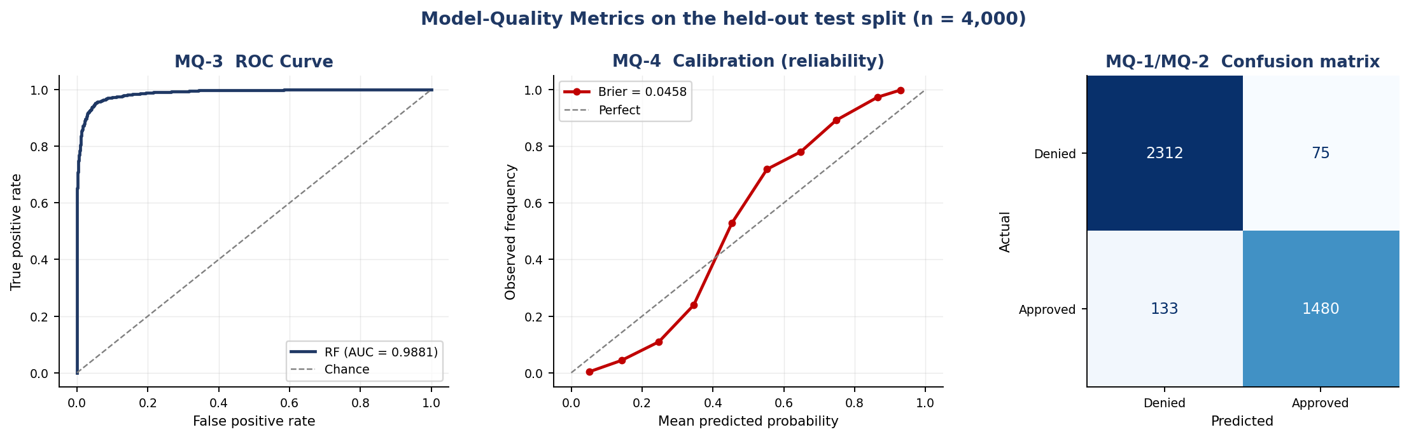
Figure 15: ROC, calibration and confusion matrix on the held-out split. The calibration curve tracking the diagonal is what makes the LOW/MEDIUM/HIGH tiering defensible — a 0.70 prediction really does correspond to roughly 70% observed approvals.

Algorithm comparison (carried forward from the Assignment I Analytics Design View)
Candidate | Accuracy | F1 | ROC-AUC | Brier | Verdict
Logistic Regression (explainable baseline) | 0.9030 | 0.8789 | 0.9686 | 0.0693 | Baseline
Random Forest (chosen) | 0.9480 | 0.9343 | 0.9881 | 0.0458 | Wins on every metric
Figure 16: The winner is selected automatically by ModelTrainer.compare_algorithms() on ROC-AUC — the choice is code, not a comment.

Limitation: what these numbers do and do not establish
The dataset is synthetic, and that bounds what the metrics above can be taken to mean. The original Kaggle "Financial Risk for Loan Approval" file is licensed and not redistributed, so data/generate_synthetic_data.py produces a schema-faithful stand-in. Its label is generated by an explicit logistic expression:
z = 1.1*(credit_score-660)/90 - 1.8*dti - 1.4*cc_util
- 1.0*prev_defaults - 0.9*bankruptcy + 0.7*income_z
+ 0.4*payment_history
+ 2.2*sweet_spot - 2.4*either_bad - 2.0*double_hit
- 1.6*over_leveraged + N(0, 0.45)
LoanApproved = (sigmoid(z) > 0.5)
Eight of the 22 model features appear in that expression -- seven directly, and LoanToIncomeRatio through the over_leveraged threshold -- with only N(0, 0.45) of irreducible noise. The Random Forest is therefore recovering a smooth function of its own inputs, which it does well. That the logistic baseline also reaches 0.9686 ROC-AUC is the clearest evidence of this: both models are approximating a near-logistic generating process, not discovering credit risk.
So the honest reading of Figure 12 is: these metrics validate the pipeline, not the domain. They demonstrate that ingestion, feature engineering, training, calibration, gating and serving are wired together correctly and measured correctly -- which is what Assignment II asks us to build. They are not evidence that this model would price real credit risk at 94.8% accuracy, and we do not claim it. Establishing that needs the licensed dataset, which drops in as data/Loan.csv with no code change: every figure in this report regenerates from the four commands in Appendix B. The same caveat applies to the calibration curve -- the probabilities are well calibrated to a formula we wrote.

8.2 Data quality — four metrics
In an ML system the data is a dependency exactly as a library is, so it needs its own measurable contract. Two metrics come from the schema gate and two from the drift monitor.
ID | Metric | Definition | Gate | Measured on the 20,000-row training table
DQ-1 | Schema conformance rate | Fraction of the 22 declared columns present and within their declared type and range | = 1.00 | 1.0000 (0 violations)
DQ-2 | Missing-value fraction | Overall null ratio, plus the worst single column | <= 0.02 | 0.0000 overall; worst column 0.0000
DQ-3 | Population Stability Index | Per-feature covariate shift against the frozen training reference profile; the banking-standard drift measure | <= 0.20 | Monitored per batch — see the stress test below
DQ-4 | Kolmogorov–Smirnov statistic | Distribution-free two-sample test; catches tail shifts that PSI's coarse bins can miss | p >= 0.05 | Reported alongside PSI for every feature
Figure 17: Data-quality metrics. DQ-1 and DQ-2 gate the training run (strict=True aborts the build); DQ-3 and DQ-4 run against live batches in production.

Drift stress test
To prove the monitor detects real shift rather than merely running without error, the held-out split was perturbed into a synthetic recession — credit scores down 85 points, debt-to-income ×1.6, card utilisation ×1.5 — and compared against the training reference. The monitor flagged exactly the three perturbed features as SEVERE and left the other 19 STABLE, and emitted a WARNING naming them.
Feature | PSI | KS statistic | KS p-value | Severity
CreditScore | 1.7776 | 0.3669 | 0.0 | SEVERE
DebtToIncomeRatio | 0.8469 | 0.4223 | 0.0 | SEVERE
CreditCardUtilizationRate | 0.4618 | 0.2738 | 0.0 | SEVERE
NetWorth | 0.0051 | 0.0164 | 0.349087 | STABLE
LoanAmount | 0.005 | 0.0243 | 0.044765 | STABLE
Figure 18: Top five features by PSI (reports/metrics/drift_report.csv). The gap between the third and fourth row is the signal: real shift is unambiguous.
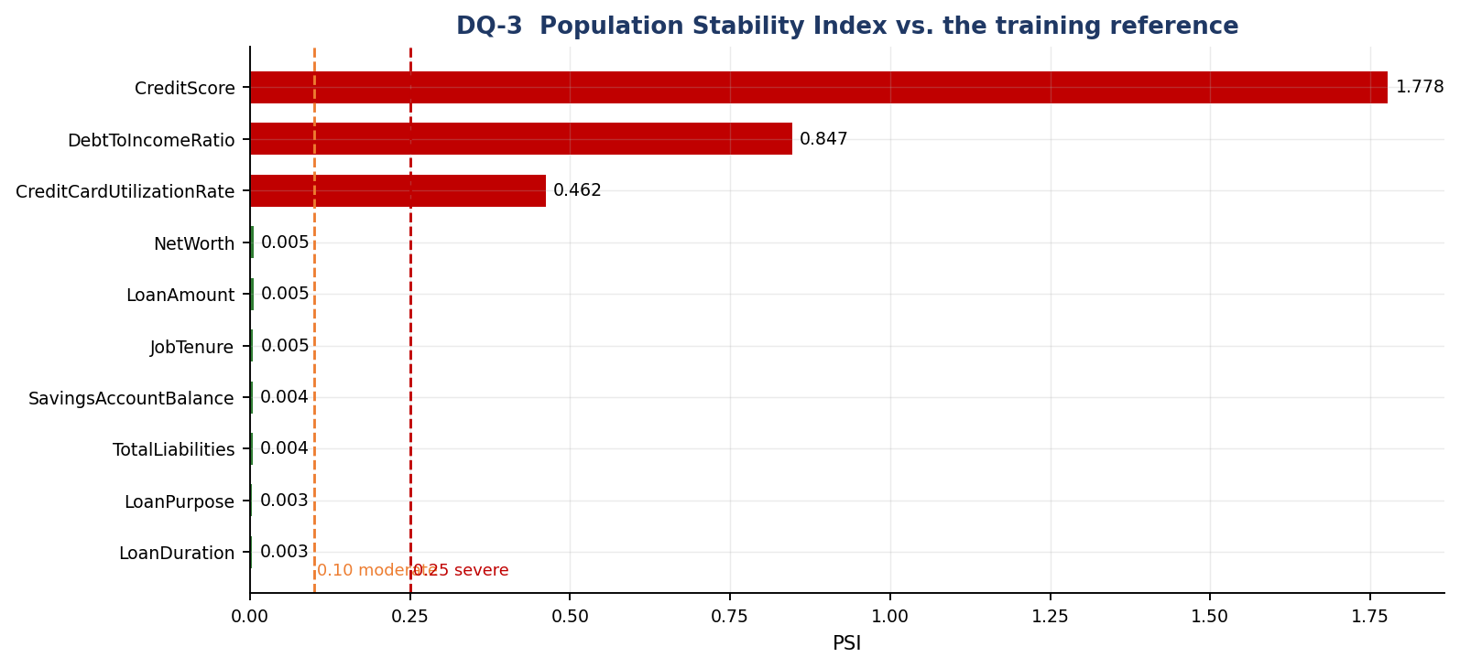
Figure 19: PSI per feature against the 0.10/0.25 industry thresholds.
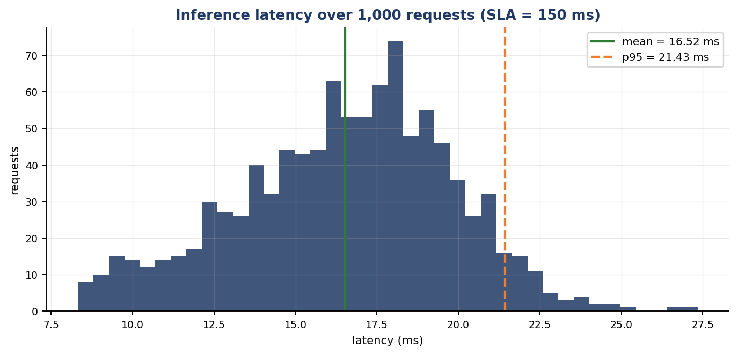
Figure 20: End-to-end scoring latency over 1,000 requests through the real serving path: mean 16.52 ms, p95 21.43 ms, p99 23.66 ms — comfortably inside the 150 ms SLA inherited from Assignment I.

9. Testing in Production, and a Security Consideration

9.1 Approach: shadow deployment, then canary
Offline metrics are necessary and not sufficient. A credit model meets a population it never saw in training, and the label — whether the loan actually defaults — arrives months later. Our release path is therefore staged, and the staging is what makes it safe to be wrong.
Stage | Traffic | What is compared | Promote when | Roll back when
1. Shadow | 100% mirrored, 0% served | The candidate scores every live request in parallel with the incumbent; only the incumbent's answer is returned. We diff score distributions, tier mix, disagreement rate and latency. | >= 2 weeks with no unexplained disagreement and p99 latency within budget | Never — shadow traffic is not served, so a bad candidate cannot harm a customer
2. Canary | 5% → 25% → 50% → 100% | Live business KPIs on the canary slice: approval rate, average risk tier, manual-override rate, error rate, p99 latency | Each step held >= 48 h with KPIs inside their control limits | Automatic rollback on any breach; the previous artifact is one config change away
3. A/B holdout | Permanent 5% on the incumbent | The metric that actually matters — realised default rate — measured months later against a like-for-like control | Retained permanently as the reference arm | n/a
Figure 21: Staged rollout. Shadow answers 'does it behave?'; canary answers 'does it behave on customers?'; the A/B holdout answers 'was it actually better?'.
Why shadow first for this system specifically. The outcome label is delayed by months, so we cannot A/B-test our way to a decision quickly. Shadow mode gives an immediate, zero-risk read on the one thing that is observable on day one — whether the candidate's score distribution and its disagreements with the incumbent are explainable. The infrastructure for this already exists in the codebase: ModelRegistry makes 'which artifact is loaded' a configuration value, and every scoring event is already logged as JSON with model_version, so comparing two arms is a log query rather than new instrumentation. DriftMonitor supplies the population check for the same window.

9.2 Security consideration: the input boundary as an attack surface
The threat we treat as primary is adversarial and malformed input at the scoring endpoint. The endpoint is reachable from a customer-facing portal, it accepts a 20-field numeric payload, and its output is a lending decision with direct financial consequence. That combination invites three concrete abuses: gaming the model by probing which field flips a decision; feeding out-of-distribution values to push the model into a region where its behaviour is untested; and classic injection or resource exhaustion against the service itself.
Control | Where | Effect
Bounded field constraints on all 20 inputs | api/schemas.py | Values outside the legitimate domain (credit score 1500, income 10¹⁵) are rejected with 422 before any model code runs — the estimator is never asked to extrapolate
extra="forbid" | api/schemas.py | Unknown keys are rejected instead of ignored; blocks parameter-pollution probing and catches client typos
Strict type coercion | Pydantic v2 | A SQL/JS injection string in a numeric field fails int_parsing — the payload never becomes a query or a template
Business-rule filter | RiskPredictor.validate_business_rules | A second, semantic gate behind the syntactic one: schema-valid but economically absurd applications are refused with 400
Batch size cap (100) | BatchLoanApplications | Bounds the work one request can demand — a basic DoS control
Opaque error envelope | Exception handlers in api/app.py | Clients get a reason, never a stack trace, module path or internal identifier
Full audit log | logging_utils.py | Every decision is recorded with its inputs, probability, tier and model_version, so probing patterns are detectable after the fact and every decision is reconstructable for a regulator
Figure 22: Layered input-validation controls. Six integration tests parametrised over injection strings, oversized batches and extreme numerics assert that each control holds.
What this does not solve. Validation constrains each field independently; it cannot detect an application in which every value is individually plausible but the combination is fabricated. The honest mitigations for that are outside the request path: corroborating declared income and liabilities against the bureau feed rather than trusting the payload, rate-limiting and authenticating per client so systematic probing is visible and attributable, and monitoring the score distribution per caller for the signature of an optimisation attack. Model access control — the artifact and the reference profile are deployment assets, not public ones — belongs in the same list.

Appendix A — Repository Layout
Group_84/
├── configs/config.yaml # thresholds, gates, hyper-parameters, feature contract
├── data/
│ ├── generate_synthetic_data.py # schema-faithful stand-in for the Kaggle file
│ ├── prepare_data.py # cleaning, encoding, feature engineering
│ └── loan_data_processed.csv # 20,000 x 23 modelling table
├── src/loan_risk/ # THE PRODUCTION PACKAGE
│ ├── config.py # frozen dataclasses loaded from YAML
│ ├── exceptions.py # domain exception hierarchy
│ ├── logging_utils.py # structured JSON logging + Timer
│ ├── data/ingestion.py # DataIngestor
│ ├── data/validation.py # DataValidator -> DQ-1, DQ-2
│ ├── features/engineering.py # FeatureEngineer (sklearn transformer)
│ ├── models/trainer.py # ModelTrainer + quality gates
│ ├── models/predictor.py # ModelRegistry + RiskPredictor
│ ├── monitoring/drift.py # DriftMonitor -> DQ-3, DQ-4
│ └── api/{schemas,app}.py # FastAPI contract and routes
├── tests/ # 60 tests: unit | integration | data | ml
├── scripts/ # train, evaluate, render evidence, build report
├── legacy/ # ASSIGNMENT I CODE, verbatim (Section 2)
│ ├── assignment1_serving_pipeline.py # the serving copy of the ratios
│ └── assignment1_prepare_data.py # the training copy of the same
├── reports/{lint,metrics,figures}/ # all captured evidence
└── artifacts/model.joblib # serialised pipeline

Appendix B — Reproducing Every Number in This Report
pip install -r requirements.txt

python data/generate_synthetic_data.py --rows 20000 # raw table
python data/prepare_data.py # 22 features + target
python scripts/train_model.py # train, gate, persist
python -m pytest tests -v # 84 tests
python scripts/evaluate_and_report.py # metrics + figures

python -m isort src scripts tests
python -m black src scripts tests
python -m flake8 src scripts tests
python -m pylint src/loan_risk

PYTHONPATH=src python -m uvicorn loan_risk.api.app:app --port 8000
# -> http://127.0.0.1:8000/docs (generated Swagger UI)

Appendix C — Full Test Inventory
All 60 tests, as collected by pytest.

Unit tests — test_unit_features.py (7)
test_safe_ratio_never_divides_by_zero
test_transformer_emits_the_declared_feature_contract
test_transformer_does_not_mutate_its_input
test_transformer_recomputes_derived_columns_from_base_columns
test_transformer_rejects_malformed_input[_frame_missing_a_base_column-missing base column]
test_transformer_rejects_malformed_input[_frame_with_a_null_income-non-finite derived value]
test_settings_are_immutable

Integration tests — test_integration_api.py (14)
test_health_endpoint_reports_a_loaded_model
test_model_metadata_endpoint_exposes_the_contract
test_predict_returns_200_and_a_complete_payload
test_batch_predict_returns_one_result_per_application
test_malformed_and_adversarial_payloads_are_rejected_with_422[<lambda>-value above the declared maximum]
test_malformed_and_adversarial_payloads_are_rejected_with_422[_without_credit_score-required field absent]
test_malformed_and_adversarial_payloads_are_rejected_with_422[<lambda>-unknown key (extra='forbid')]
test_malformed_and_adversarial_payloads_are_rejected_with_422[<lambda>-wrong type]
test_malformed_and_adversarial_payloads_are_rejected_with_422[<lambda>-absurd magnitude]
test_malformed_and_adversarial_payloads_are_rejected_with_422[<lambda>-injection]
test_business_rule_violation_returns_400
test_batch_size_limits_are_enforced[101]
test_error_responses_never_leak_internals
test_api_and_direct_pipeline_agree

Data-validation tests — test_data_validation.py (15)
test_clean_data_conforms_fully
test_out_of_range_values_are_flagged[CreditScore-9999-above_maximum:CreditScore]
test_out_of_range_values_are_flagged[AnnualIncome--1-below_minimum:AnnualIncome]
test_missing_column_is_flagged
test_strict_mode_aborts_the_build_on_violation
test_missing_value_fraction_is_measured
test_psi_separates_stable_from_shifted_distributions
test_drift_monitor_flags_only_the_shifted_feature
test_ingestor_reads_a_valid_csv
test_ingestor_rejects_unusable_files[missing.csv-None]
test_ingestor_rejects_unusable_files[empty.csv-]
test_ingestor_rejects_unusable_files[headers.csv-Age,AnnualIncome\n]
test_ingestor_warns_but_continues_on_duplicate_rows
test_ingestor_rejects_a_frame_missing_contract_columns
test_ingestor_split_returns_aligned_features_and_labels

ML tests — training — test_model_training.py (9)
test_model_can_overfit_a_small_batch
test_training_loss_decreases_with_capacity
test_training_is_reproducible
test_shuffled_labels_destroy_generalisation
test_quality_gates_reject_a_weak_model
test_training_rejects_unusable_inputs[single_class_target]
test_training_rejects_unusable_inputs[unknown_algorithm]
test_model_quality_metrics_meet_release_gates
test_artifact_round_trips_through_disk

ML tests — inference — test_model_inference.py (15)
test_batch_prediction_shape_is_correct
test_probabilities_are_valid_and_sum_to_one
test_output_stays_in_range_across_the_credit_spectrum[300]
test_output_stays_in_range_across_the_credit_spectrum[850]
test_higher_credit_score_does_not_reduce_approval_probability
test_higher_debt_to_income_does_not_increase_approval_probability
test_prediction_is_invariant_to_repeated_calls
test_prediction_is_invariant_to_column_order
test_previous_default_forces_the_high_risk_tier
test_risk_tier_boundaries[0.95-LOW]
test_risk_tier_boundaries[0.55-MEDIUM]
test_risk_tier_boundaries[0.1-HIGH]
test_business_rules_reject_uncreditworthy_applications[overrides0-annual income]
test_business_rules_reject_uncreditworthy_applications[overrides1-below the minimum]
test_inference_without_a_loaded_model_raises

