**Third Party API Documentation**

**1) Xero API**

**Url:-** <https://www.xero.com/>

after login into xero go to [https://my.xero.com/!0qhv1/Organisation/Add#](https://my.xero.com/!0qhv1/Organisation/Add)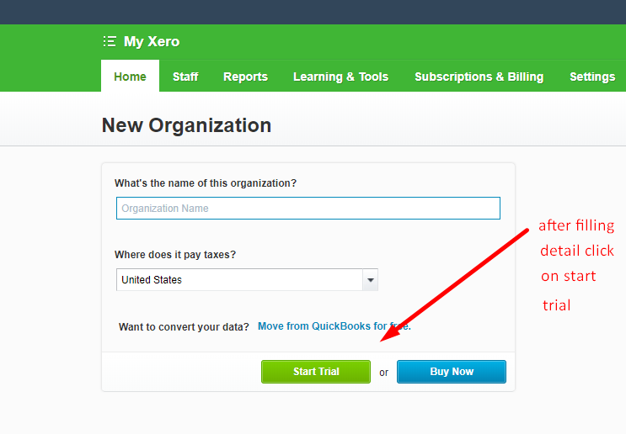

after clicking on start trial you will get screen like this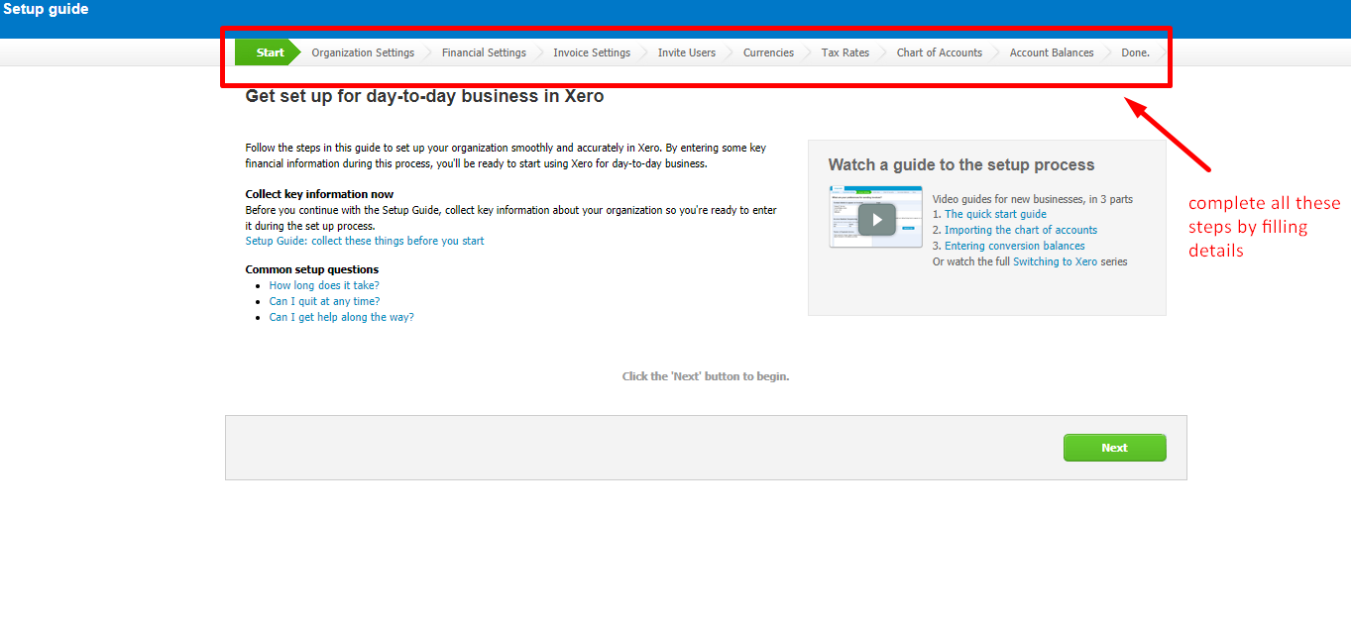

after completion of all the steps as in above screenshot open this link .

<https://developer.xero.com/myapps/>

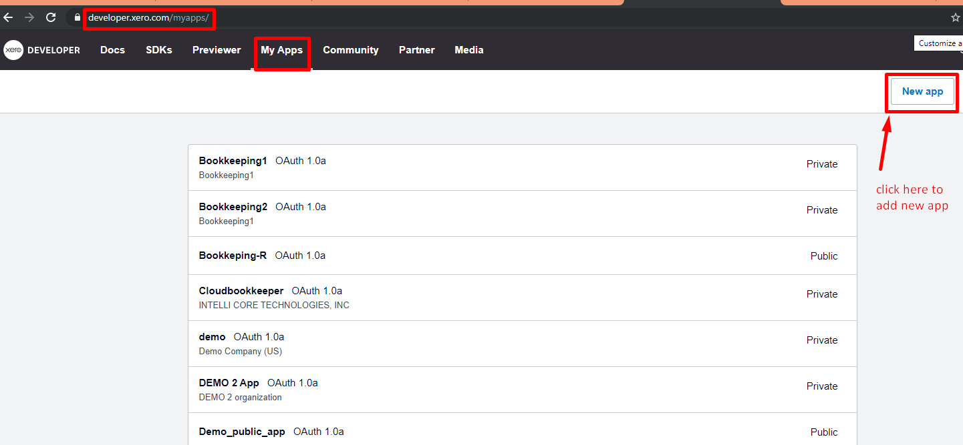

after clicking on new app you will get popup like this

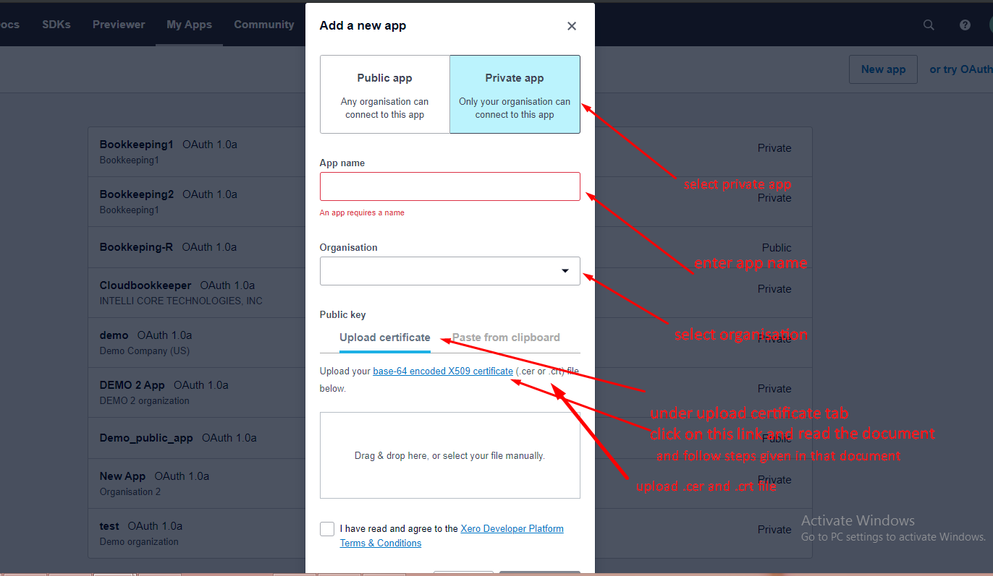

after filling required information click on create app button.

now click on my apps tab and click on app and open popup like this.

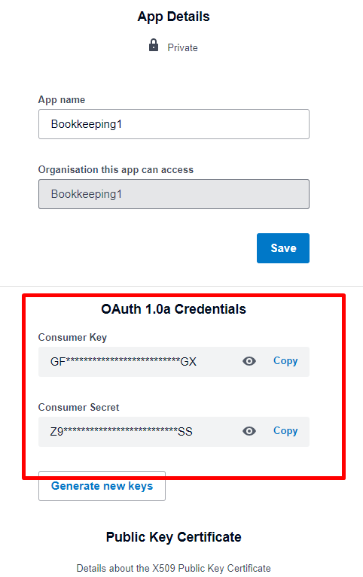

copy consumer key and consumer secret and paste under xero tools

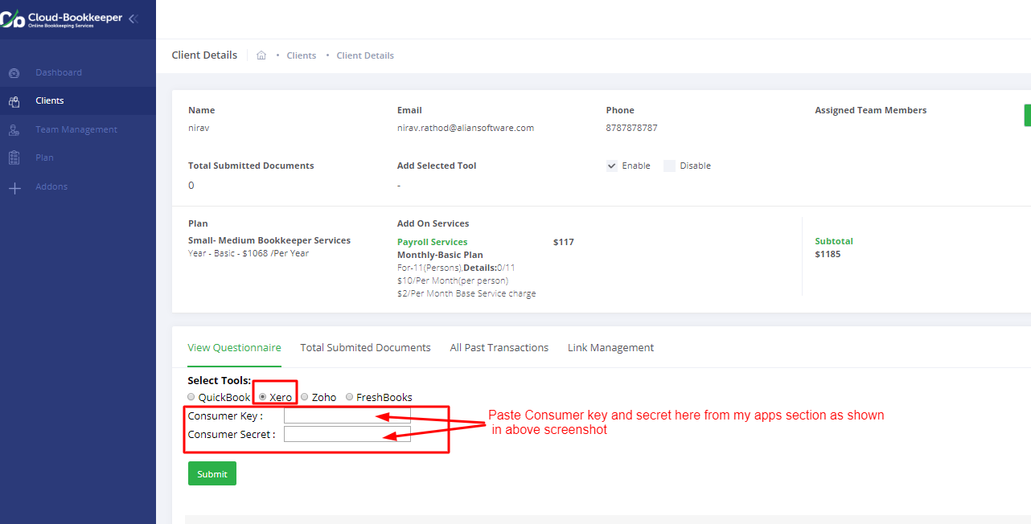

after filling consumer key and secret key click on submit button.

**2) Zoho API**

**Url:-** <https://www.zoho.com/>

click on login

after login

open this url- <https://accounts.zoho.com/developerconsole> (For get client id and client secret)

* Create Zoho Client ID

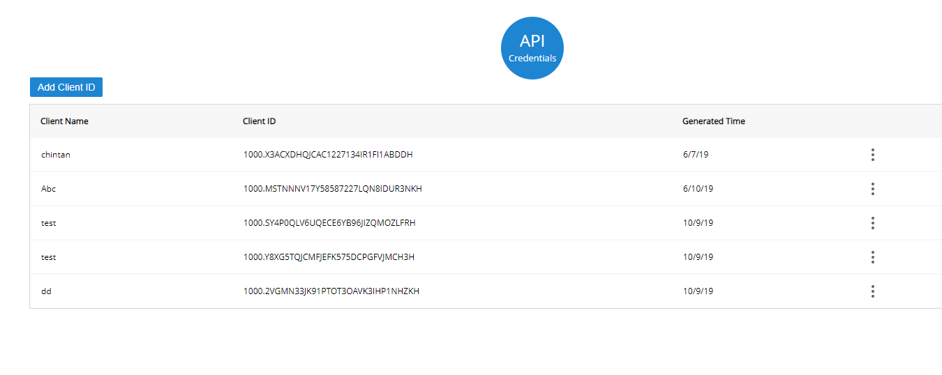

Onclick add client id open popup

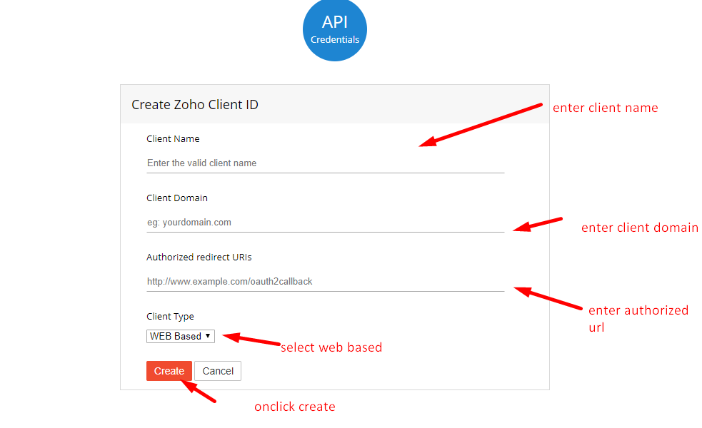

Authorized redirect URLs

http://bookkeeper.aliansoftware.net/zoho_callback

Onclick create buton open popup

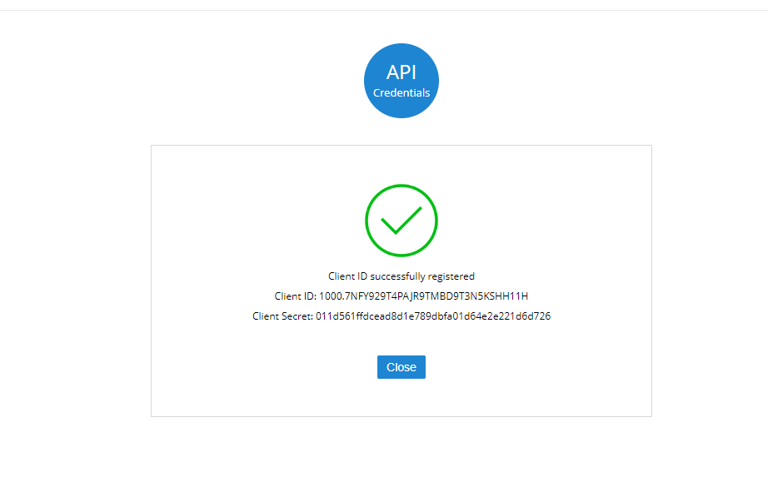

copy client id and client secret and paste in consumer key and consumer secret

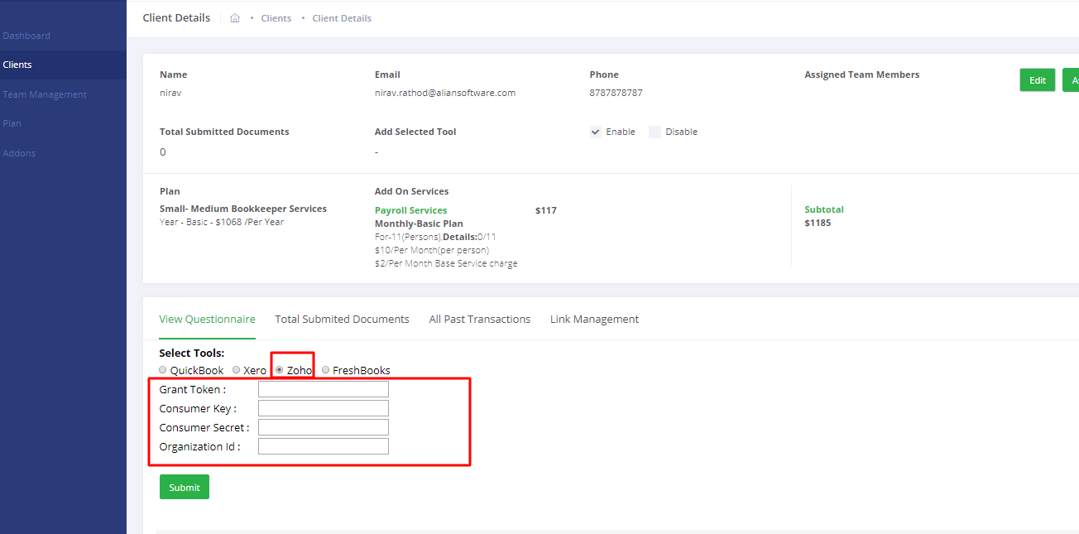

* Create Self client

URL- <https://accounts.zoho.com/developerconsole> (For get grant token)

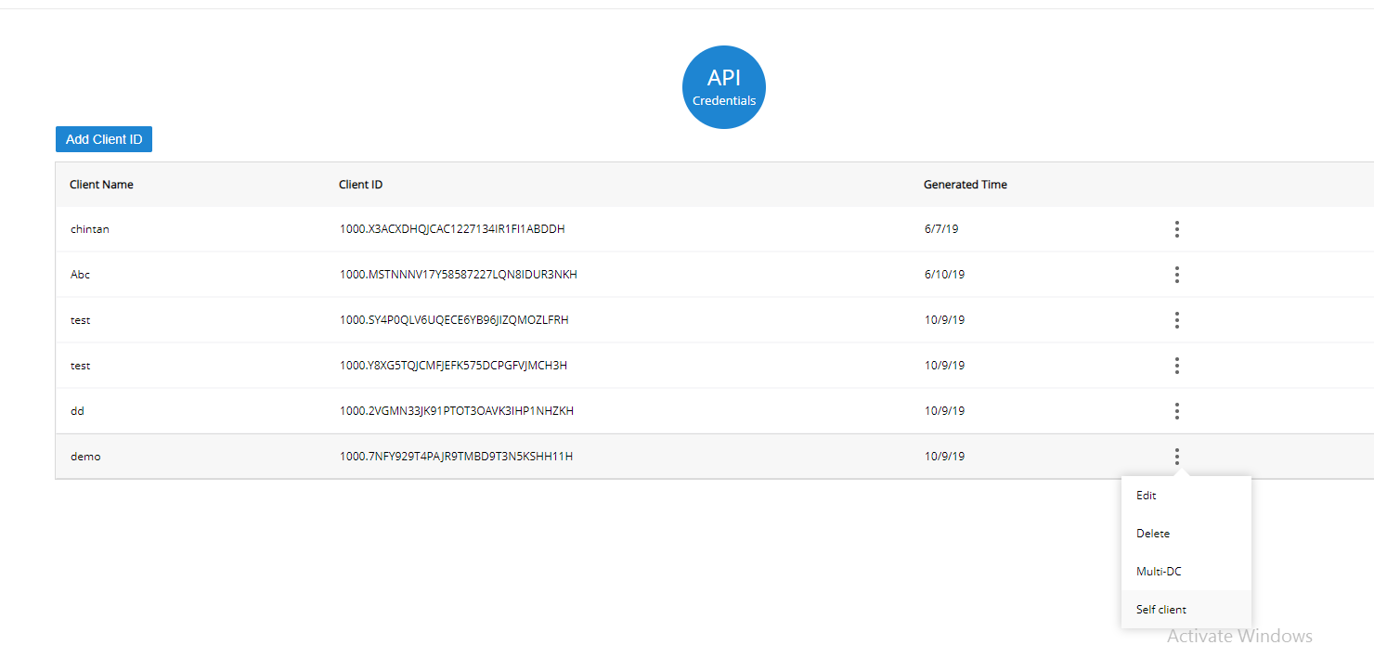

Select self client

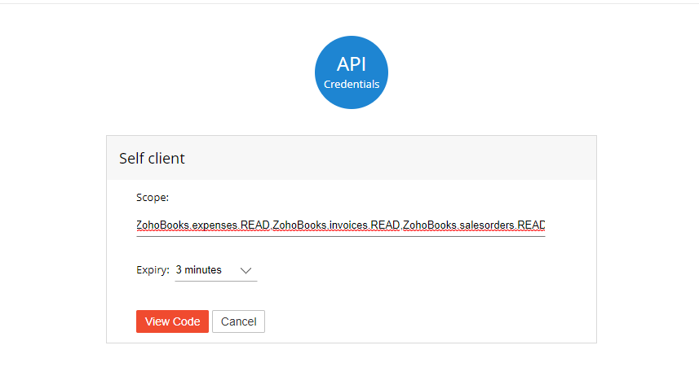

Scope- ZohoBooks.expenses.READZohoBooks.invoices.READZohoBooks.salesorders.READ

Onclick view code

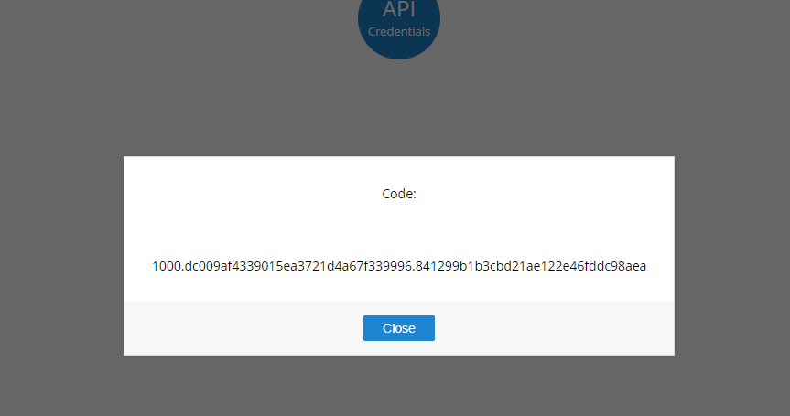

Copy code and paste in grant token.



Now open

url- <https://accounts.zoho.com/developerconsole> (For get organization)

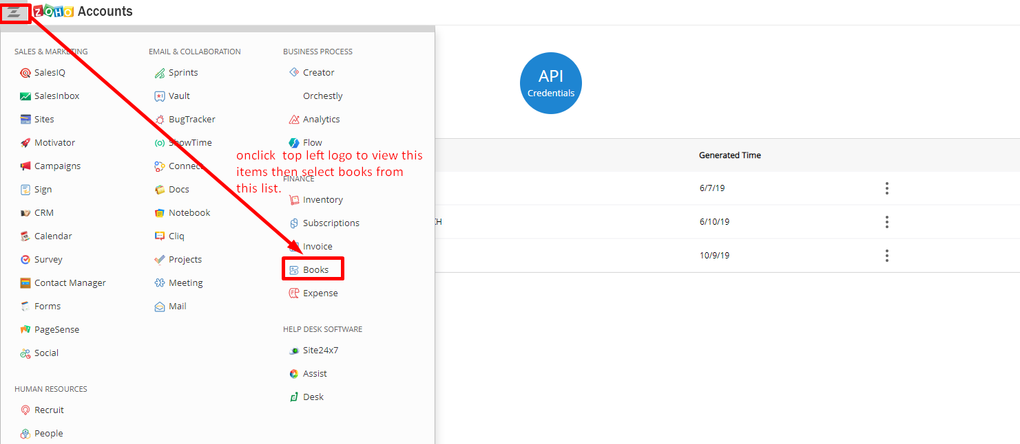

after select books open popup

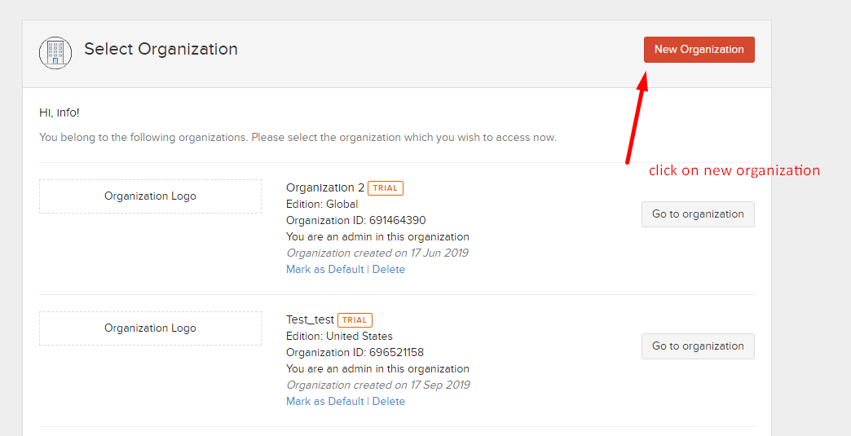

onclick new organization open popup

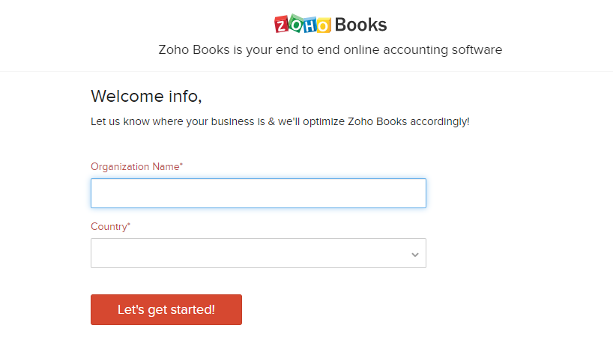

filled all details and click on button then open popup like

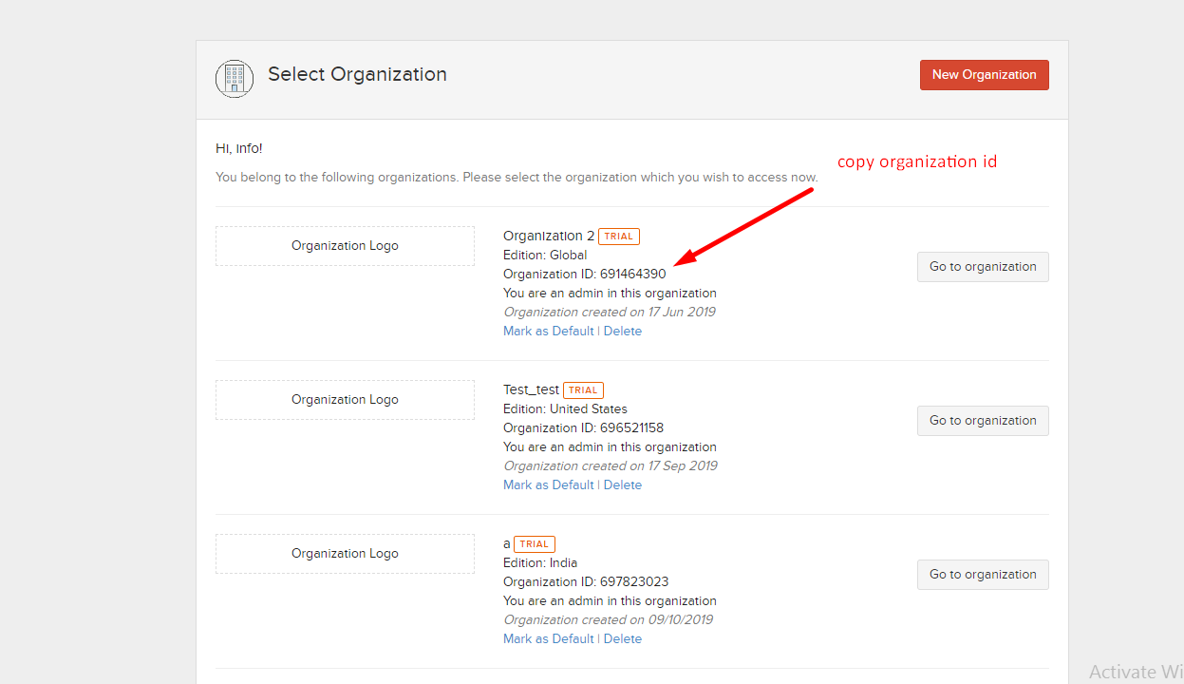

copy organization and paste in organization id.



**3)Quick Book API**

**Login URL-**<https://c25.qbo.intuit.com/c25/v1921.174/0/login?redirect=true>

after login open dashboard

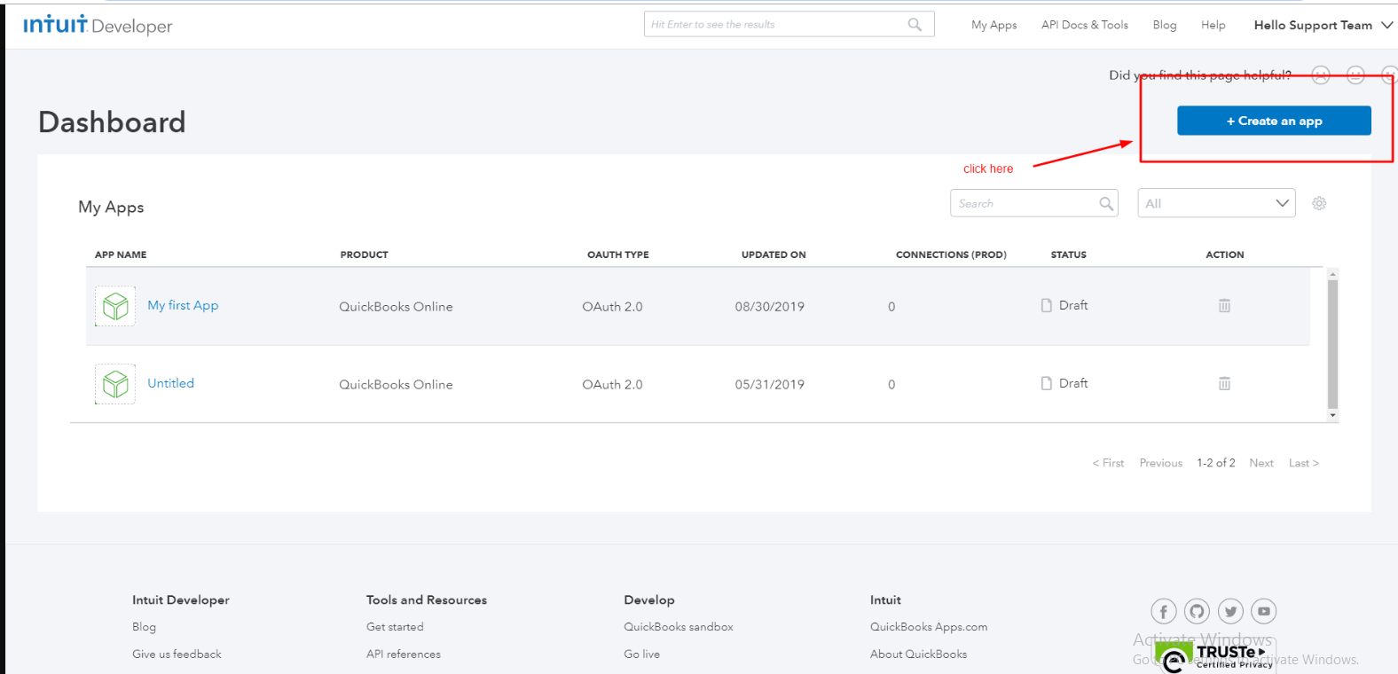

then open popup

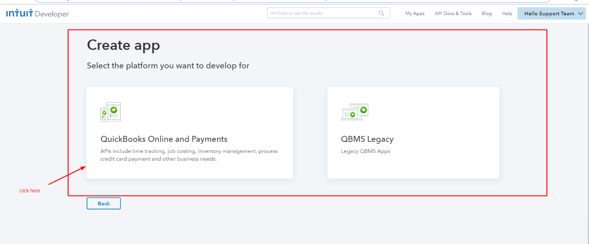

then open

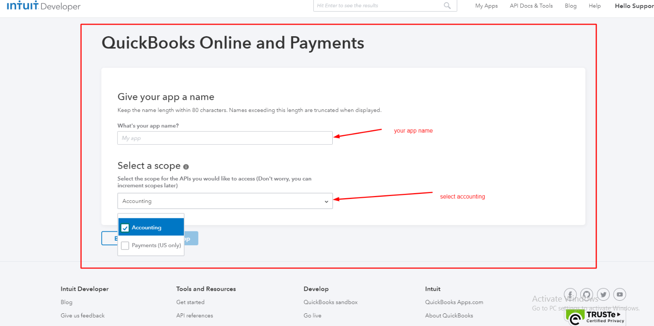

then open

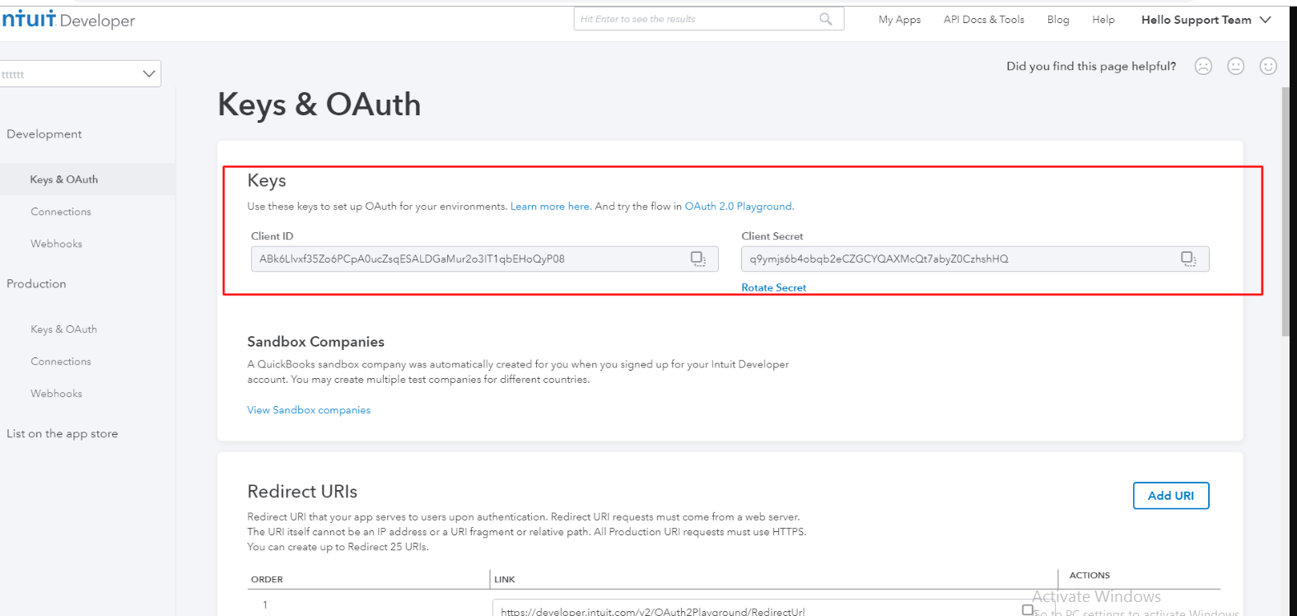

add redirct urls

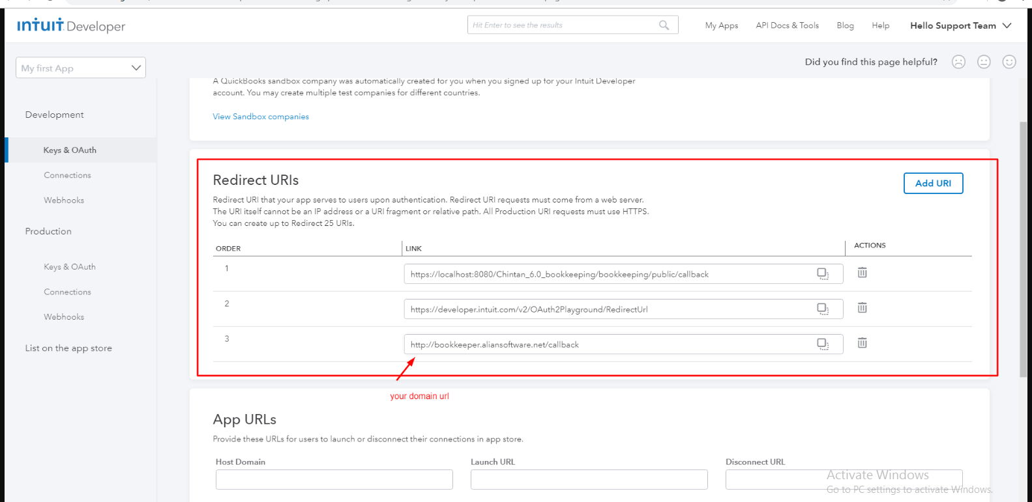

add your domain url.

**Link Management Documents**

1)**zoho**

URL- <https://www.zoho.com/>

after login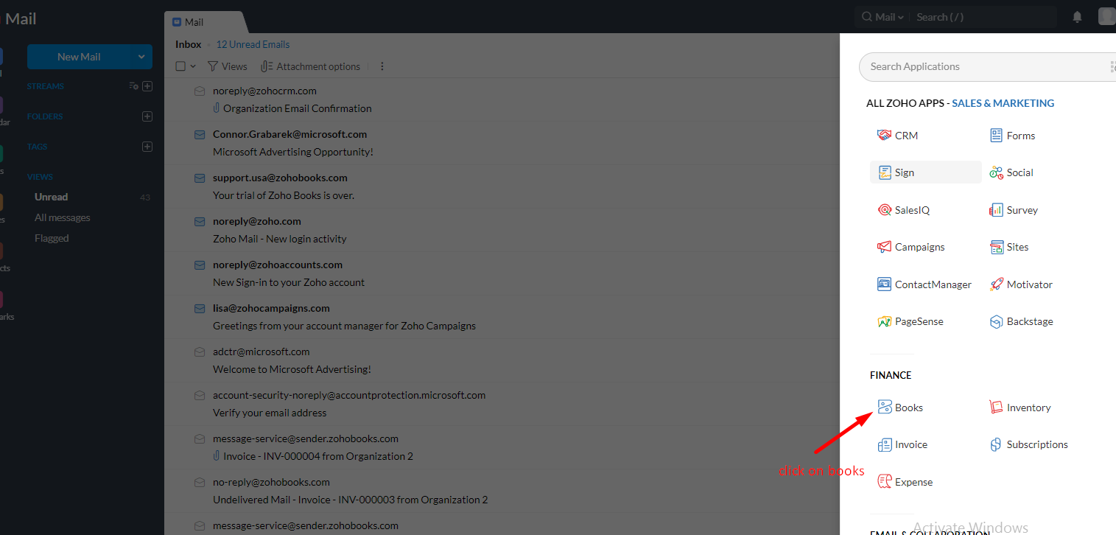

onclick books open below page

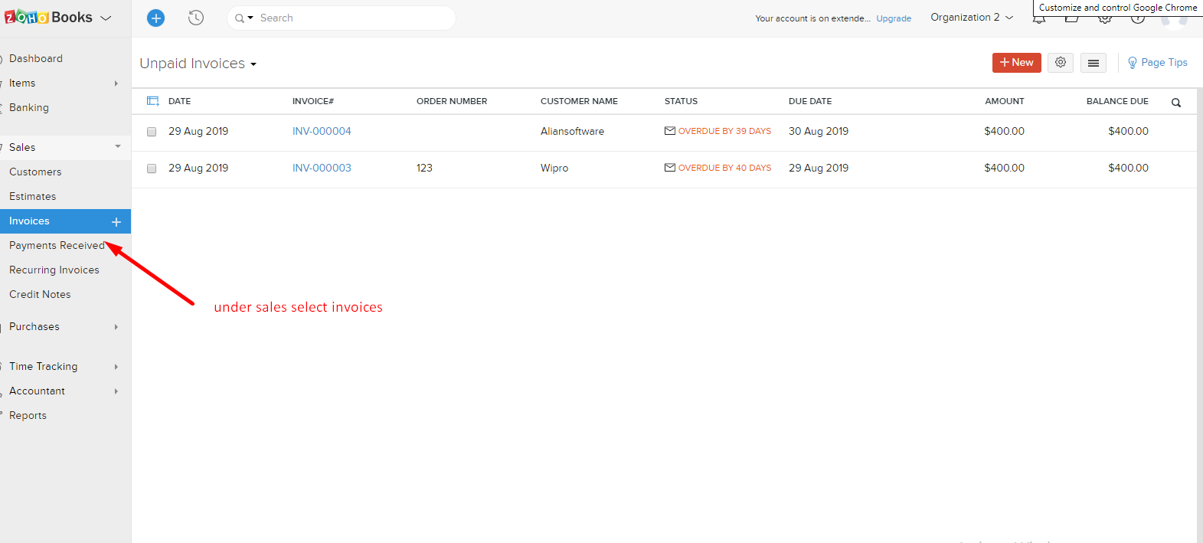

copy above page url and place in sales/invoices

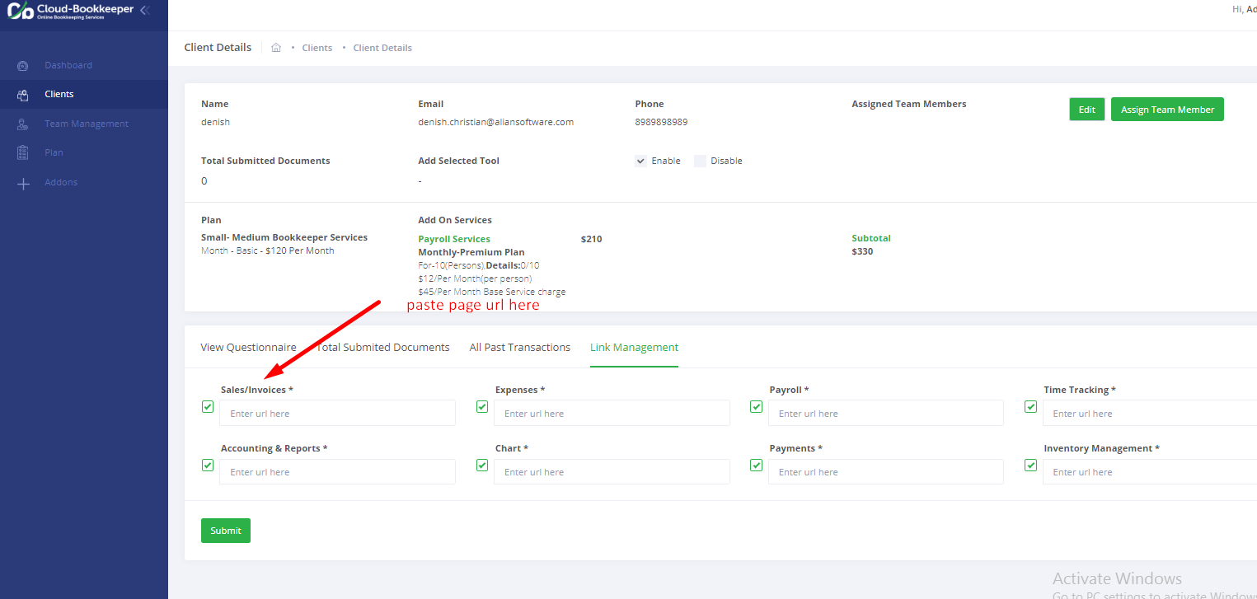

copy page url (for expenses)

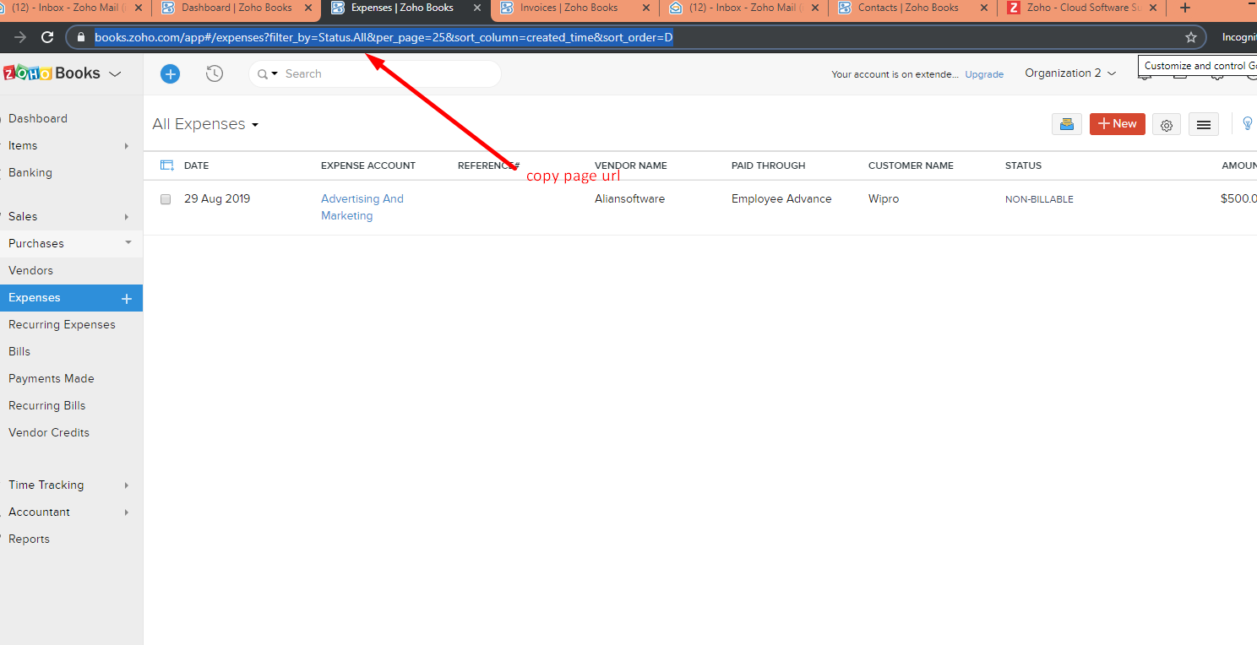

paste page url in expenses

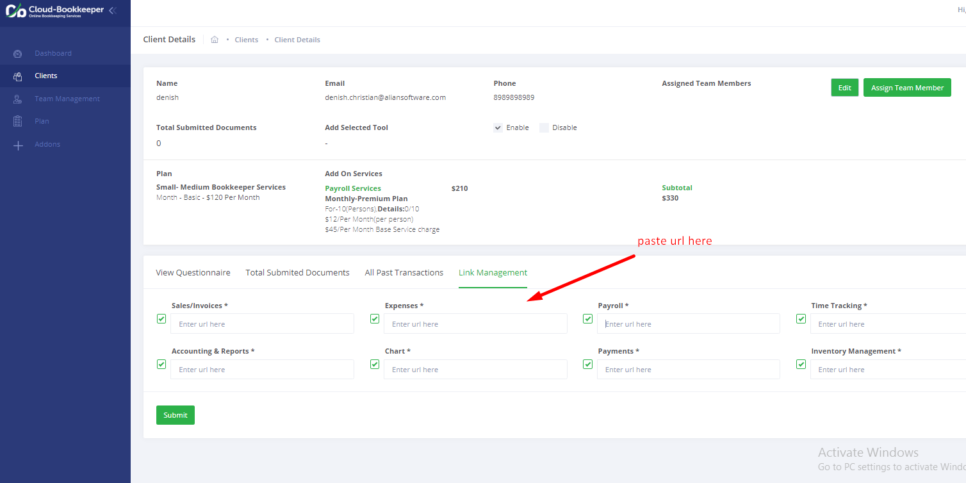

**for payments**

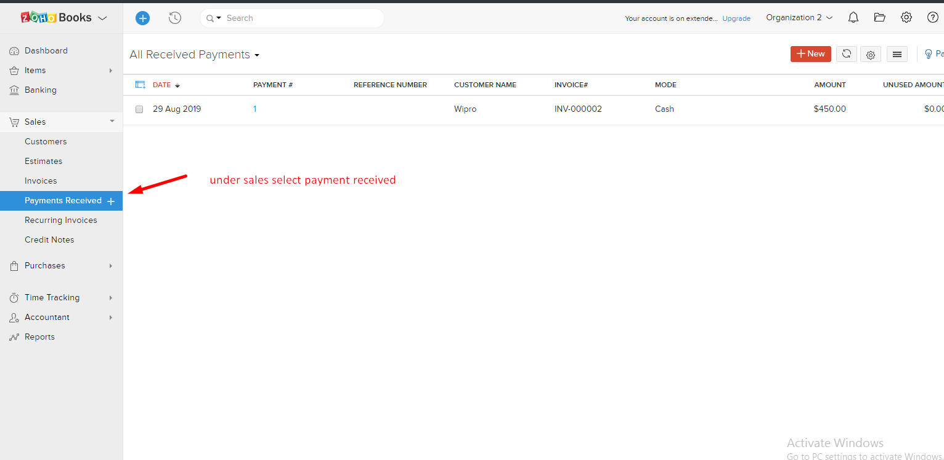

copy above page url and paste in payments

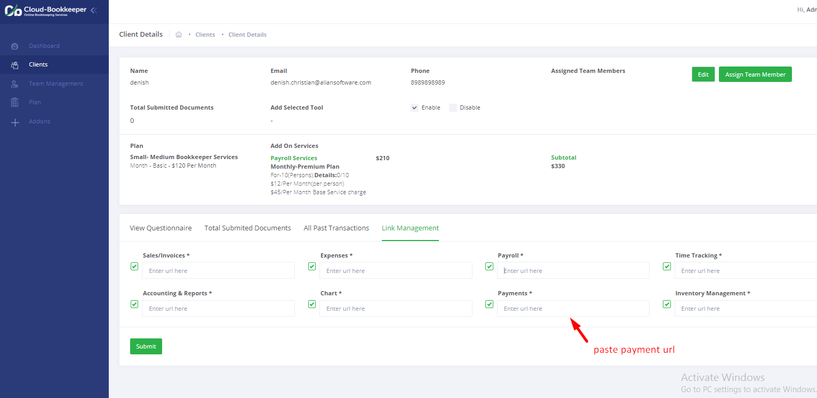

2)**Xero**

URL-[http://xero.com](http://xero.com/)

after login open dashboard

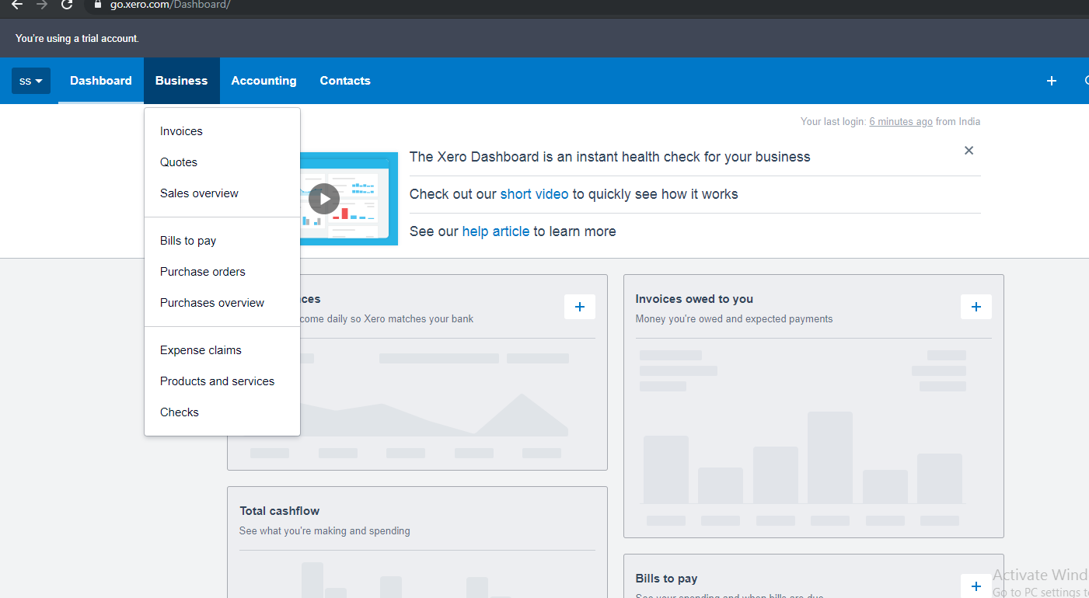

Onclick invoice open invoices copy this site url and paste in sales/invoices.

Onclick expenses claim open expenses claim copy this site url and paste in expenses

