
PHASE 2: DESIGN
Coursework Deliverable — AI-Augmented SDLC
Project: SoleStep — Shoe Store Application (MVP Stage)
Target Stack: Python (Flet)

0. Scope of This Deliverable
This document covers Phase 2 (Design) of the SDLC, following directly from the Functional, Non-Functional, and System Requirements defined in the Phase 1 Analysis deliverable, rebranded to the SoleStep shoe store. Design is split into three parts, as specified in the course framework: Front End (UI/UX, wireframes, logo, color palette, look & feel), Logic (algorithms, data structures, workflow), and Backend (API, data access layer, database).

1. Front End Design

1.1 Logo
The SoleStep mark pairs a minimal sneaker-silhouette icon with a two-tone wordmark, reused at icon-only scale (square, navy background) for the seller dashboard sidebar. Both assets ship with the app under assets/ and are loaded via Flet's assets_dir.

1.2 Information Architecture
Five core screens cover the buyer and seller journeys defined by the Phase 1 functional requirements (FR-1 to FR-7):
- Home / Shoe Catalog — buyer browse & search (FR-2)
- Product Detail — buyer shoe view & add to cart (FR-2, FR-3)
- Cart — buyer review & quantity management (FR-3)
- Checkout — buyer order placement (FR-4)
- Seller Dashboard — catalog & order management (FR-1, FR-5, FR-7)

1.3 Wireframes (Low-Fidelity)
Wireframes below are intentionally low-fidelity — layout and hierarchy only, no final styling — to keep this an Analysis→Design handoff artifact rather than a pixel-perfect mockup. In Flet, each screen maps to a View / set of Controls (Row, Column, GridView, Card). The header carries the SoleStep wordmark; catalog items reflect the shoe product set seeded in Phase 3.
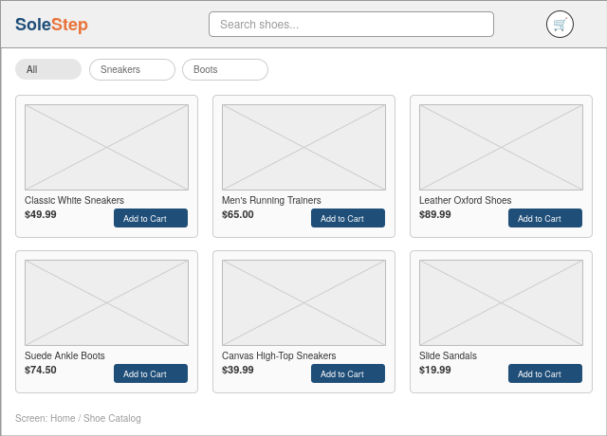
Fig 1. Home / Shoe Catalog — grid of shoe listings, search bar, category filter
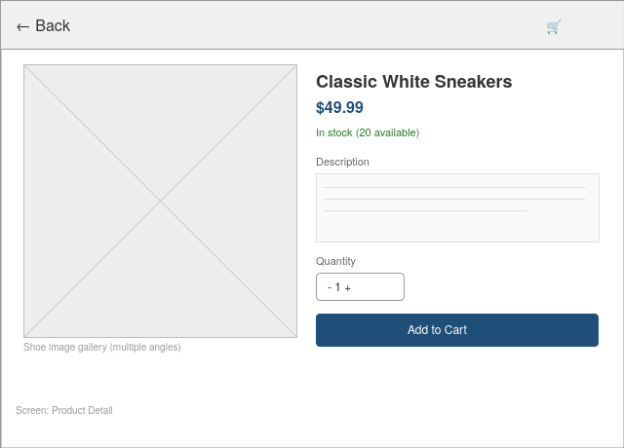
Fig 2. Product Detail — image, price, stock, quantity selector, add-to-cart
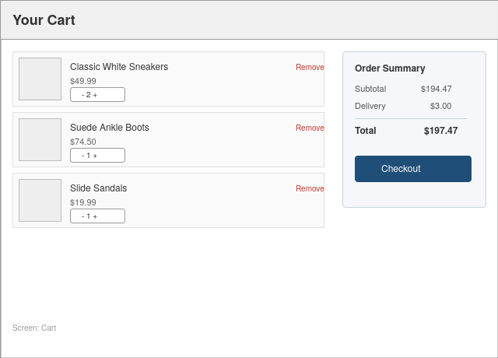
Fig 3. Cart — line items with quantity control, order summary panel
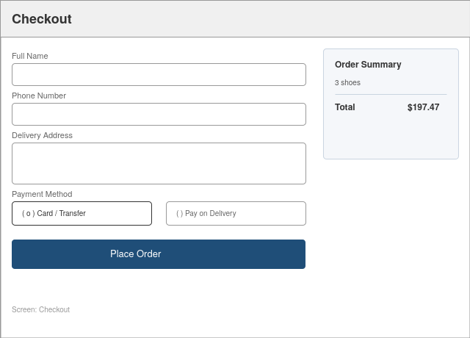
Fig 4. Checkout — shipping form, payment method, order summary
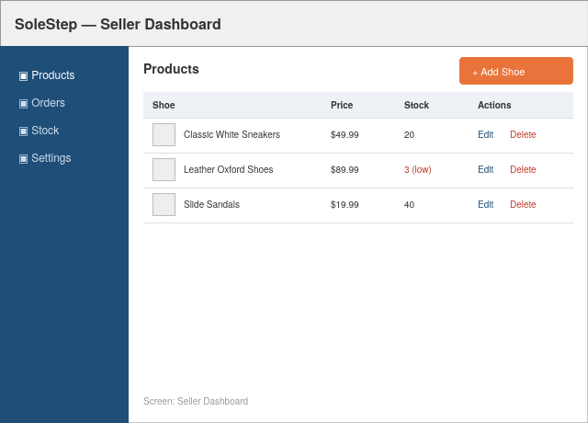
Fig 5. Seller Dashboard — sidebar nav with logo icon, shoe inventory table with edit/delete/add actions

1.4 Color Palette
The SoleStep brand palette extends the original neutral MVP palette with a warm accent (orange) drawn from the logo, used for primary call-to-action emphasis and the logo's sole/heel accent.
Swatch | Role | Hex
 | Primary (logo, headers, CTAs) | #1F4E78
 | Brand accent (logo sole, highlights) | #E8743B
 | Panel / card background | #F5F7FA
 | Success / in-stock indicator | #2A7A2A
 | Destructive actions (remove/delete) | #C0392B
 | Base background | #FFFFFF

1.5 Look & Feel
- Card-based layout for the shoe catalog; generous whitespace over dense tables on buyer-facing screens.
- Sidebar navigation for the seller dashboard (data-dense, desktop-first use case), topped with the icon-only logo mark.
- Consistent 4px corner radius on cards/buttons; flat design, no heavy shadows — keeps custom rendering simple in Flet.
- System font stack for MVP (no custom font loading) to reduce build complexity; the wordmark is the one custom-styled text element.

2. Logic Design

2.1 Core Data Structures
Modeled as plain Python dataclasses in the MVP (ORM models are introduced only if/when the backend moves to a hosted DB — see NFR-4 in Phase 1). Product fields are unchanged from the generic schema; a per-size/variant structure is noted as a production follow-up, not part of this MVP.
Entity | Key Fields
Product | id, name, description, price, stock_qty, image_path, seller_id
User | id, name, email, password_hash, role (buyer/seller)
CartItem | product_id, quantity (held in session/local state until checkout)
Order | id, buyer_id, status (pending/shipped/delivered), created_at, total
OrderItem | order_id, product_id, quantity, unit_price (price snapshot at purchase time)

2.2 Core Algorithms

Cart total calculation
total = Σ (unit_price × quantity) for each CartItem, computed client-side on every quantity change for instant UI feedback (supports NFR-1, 2-second response target), then re-validated server-side at checkout against live stock and price.

Stock validation on checkout
For each CartItem: if quantity > Product.stock_qty → reject the item and prompt the buyer to adjust, rather than failing the whole order silently. On successful order creation, stock_qty is decremented atomically per item to avoid overselling under concurrent orders — notably relevant for the seeded low-stock item (Leather Oxford Shoes, qty 3).

Order status workflow
A simple linear state machine: pending → shipped → delivered (with a cancelled branch from pending only). Sellers can only move status forward, preventing accidental reversion and keeping the MVP logic simple.

2.3 Buyer Workflow
- 1. Browse/search the shoe catalog (Home)
- 2. View shoe detail, select quantity
- 3. Add to cart → Cart screen
- 4. Adjust quantities / remove items
- 5. Checkout → enter shipping + payment method
- 6. Place order → stock validated → order created → confirmation shown

2.4 Seller Workflow
- 1. Log in → Seller Dashboard
- 2. Add/edit/delete shoe listings (name, price, stock, image)
- 3. View incoming orders
- 4. Update order status as items are shipped/delivered

3. Backend Design

3.1 Application/API Layer
Flet apps run as a single Python process — 'API' here refers to the internal service layer (callable functions/classes) that the UI layer calls, structured so it can be lifted behind a real HTTP API later without rewriting business logic (supports NFR-4).
Service Function | Purpose | Maps To
auth_service.register(name, email, password) | Create a user, hash password | FR-1
auth_service.login(email, password) | Authenticate, start session | FR-1
catalog_service.list_products(filter) | Browse/search the shoe catalog | FR-2
catalog_service.upsert_product(seller_id, data) | Create/edit a shoe listing | FR-1
cart_service.add_item / update_qty / remove_item | Manage in-session cart | FR-3
order_service.checkout(buyer_id, cart, shipping) | Validate stock, create order | FR-4
order_service.update_status(order_id, status) | Seller updates order status | FR-5

3.2 Data Access Layer
A thin repository layer (e.g., ProductRepository, OrderRepository) wraps all database reads/writes, so the service layer above never issues raw queries directly. For the MVP this sits on top of SQLite (file-based, zero-config, ships with Python); the repository interface is designed so the underlying engine can be swapped for a hosted Postgres/MySQL instance at the production-ready stage without touching service or UI code.

3.3 Database Schema (Relational)
Table | Columns | Notes
users | id (PK), name, email (unique), password_hash, role | role = buyer | seller
products | id (PK), seller_id (FK → users.id), name, description, price, stock_qty, image_path | Shoe listings
orders | id (PK), buyer_id (FK → users.id), status, total, created_at | status: pending/shipped/delivered/cancelled
order_items | id (PK), order_id (FK → orders.id), product_id (FK → products.id), quantity, unit_price | unit_price snapshot at purchase time
Relationships: one seller (users) → many products; one buyer (users) → many orders; one order → many order_items; each order_item references one product. This normalized structure directly supports FR-1 through FR-5 and keeps stock/price history auditable (order_items.unit_price is never overwritten by later price changes).

4. Next Phase
This design maps directly into Phase 3 (Development): each wireframe becomes a Flet View, each service function becomes a Python module, the schema above becomes the SQLite table definitions created at build time, and the logo assets ship in assets/ for the UI to reference. Non-functional and system requirements from Phase 1 (security, performance, compliance) are addressed in the corresponding development tasks — e.g., password hashing in auth_service, response-time targets in the cart/checkout UI handlers.

