I took a look at tidal range, on the basis that sites with more extreme tidal ranges might be more vertically mixed (of course more goes into that).

Hobo Cumulative GDD predicted by LEO L3S ACSPO SST:
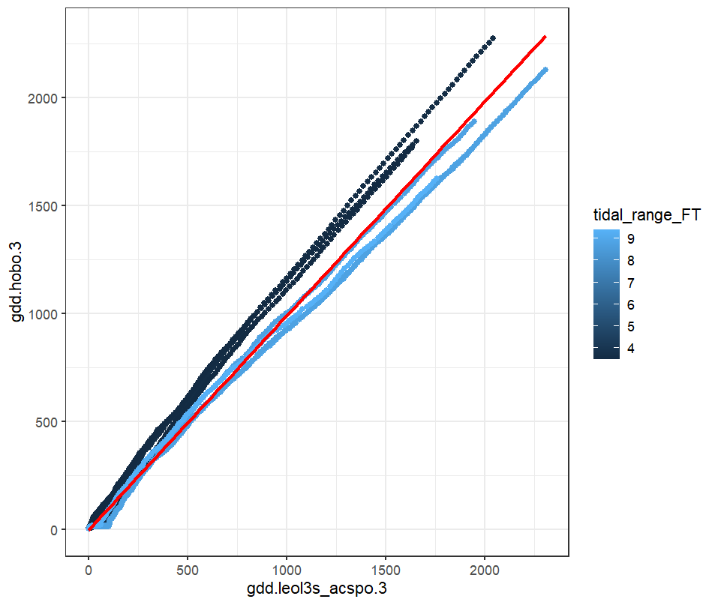
Above the cape the tidal ranges are wider and the satellite sst underestimates the cumulative hobo gdd, while below the cape the tidal ranges are narrower and the satellite sst over estimates the hobo temperatures.

Left Plots: gdd.hobo.3 ~ gdd.leol3s_acspo.3
Right Plots: gdd.hobo.3 ~ gdd.leol3s_acspo.3 + tidal_range_FT
