A Shawn Bandy

5671

Economics 420

Final Project – Construction Employment Forecast

## Introduction

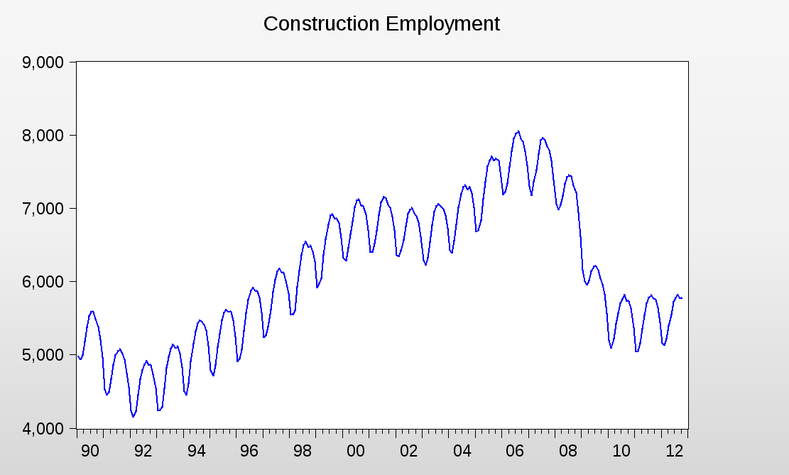

The data set is the time series of monthly US construction employment from January 1990 to October 2012. Following the recession in the early 1990s, employment trended steadily upward until the recession around 2008. The construction industry is highly seasonal with peak employment generally occurring in August and the trough in February.

The correlogram for the series suggests both auto-regressive and moving average processes and possibly a unit-root, as well. The Augmented Dickey-Fuller test shows that we cannot reject the hypothesis that the series has a unit-root at the 95% confidence level, although we can at 90%.

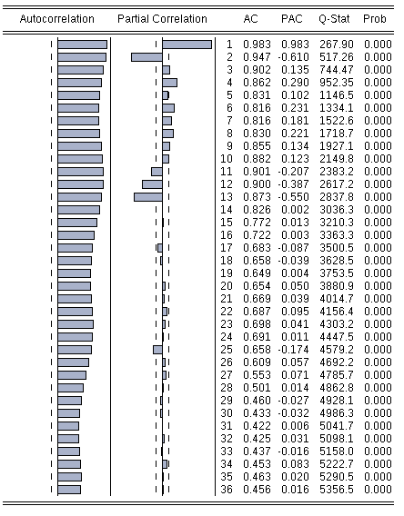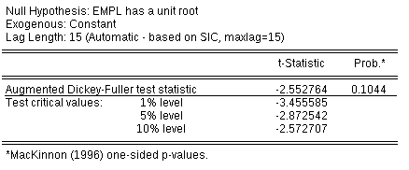

## Leading Indicators

Using data from the United States Census Bureau, I chose and examined time series data from seven economic indicators I believed may lead construction employment. In eViews, I created an equation for each with the dependent variable ‘empl’, a constant ‘c’ and the indicator as the independent variable. In order to maximize the explanatory power of the variable, I found the lag time that maximized ‘adjusted R-Squared’. The table below shows key criteria from the estimation output for each of these indicators.



‘Total Construction Spending’ (TCS) and new orders for ‘Consumer Durable Goods’ seemed to have the most explanatory power and the lowest out-of-sample forecast errors of the group. The reason for including TCS as a leading indicator is fairly direct: spending on construction will increase in tandem with increases in labor, with labor trailing slightly as finding and contracting labor can take longer to fulfill than other purchases made. Consumer durable goods includes refrigerators, washers , dryers and other large appliances. In the retail market consumer durable goods is a trailing indicator of construction as new homes create demand for these products. The logic here is that new orders from manufacturers are made with anticipation of future construction. The PPI price measures price levels at the manufacturing level and was included out of curiosity. Building permits and housing starts are included for the same reason as they generally measure impending construction activity for which construction workers would be needed. The national unemployment rate was included simply because employment is a key criteria in securing a home mortgage and new housing is a significant portion of the construction industry. New orders for construction machinery had little explanatory power. My assumption then is most machinery is purchased independently of changes in demand for the construction industry’s products.

## Model 0: ARMA

For the first model, I used none of the leading indicators above and instead used only auto-regression and moving average terms. It was important to have both an experimental control against which to measure the other model and also to have a “back-up” in case the other models were total failures. In this case, by trial-and-error I added and removed AR and MA terms until I was satisfied with the estimation output and the correlogram.

|  |  |  |  |  |
| --- | --- | --- | --- | --- |
| **Variables** | **Adjusted R-Squared** | **Prob(f-Stat)** | **AIC** | **Durbin-Watson** |
| ar(1), sar(12), sma(3), sma(12) | 0.998328871 | 0 | 10.23723 | 1.567252498 |

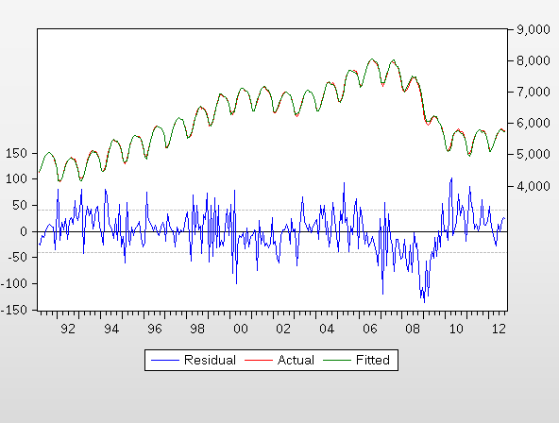 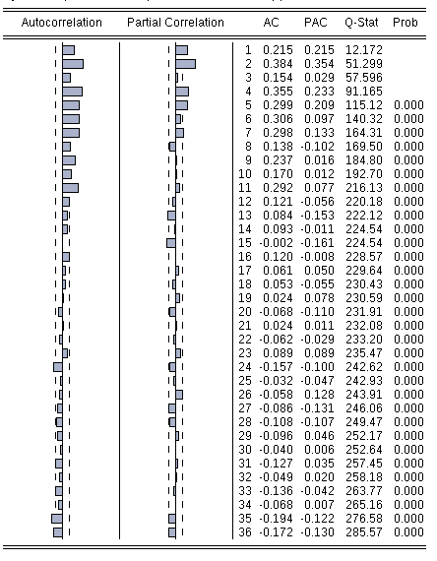

## Model 1

For this model, I chose the two indicators, TCS and DUR, that had the better overall estimation output (see above) and then added and removed ARMA terms until I was satisfied with overall performance of the model.

|  |  |  |  |  |
| --- | --- | --- | --- | --- |
| **Variables** | **Adjusted R-Squared** | **Prob(f-Stat)** | **AIC** | **Durbin-Watson** |
| TCS, DUR | 0.836702474 | 3.30E-95 | 14.68978117 | 0.422790286 |
| TCS, DUR, AR(1), SAR(12) | 0.997266736 | 1.26E-286 | 10.48387 | 1.735933373 |
| DUR,AR(1),AR(3),SAR(12) | 0.997170855 | 5.97E-285 | 10.51835159 | 1.590463863 |

In this model, TCS, DUR, AR(1) and SAR(12) had the best estimation output with the correlogram and residual graph shown below.

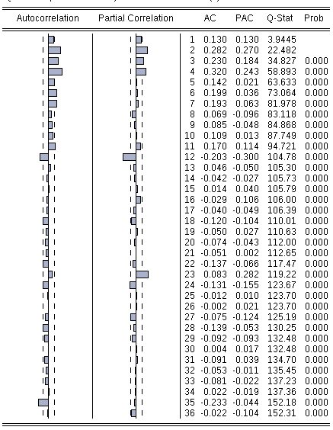 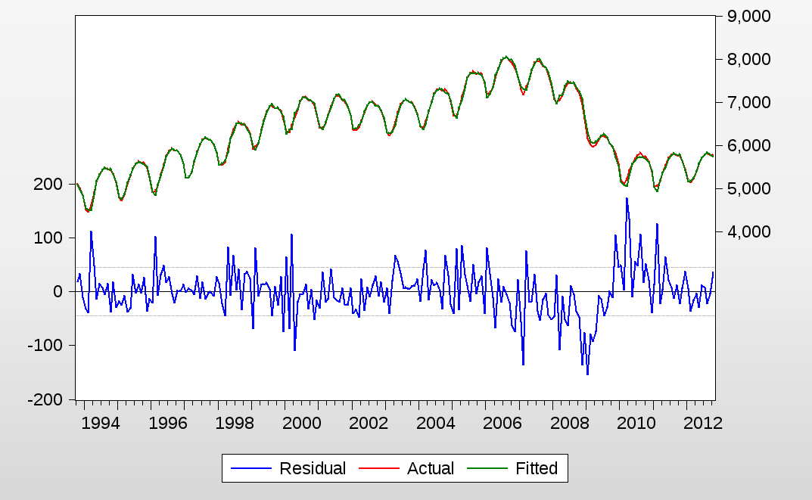

## Model 2: The Kitchen Sink

As an anti-thesis to Model 0, I chose to create a model that included all of the leading indicators listed above then added and removed terms iteratively based on the estimation output and correlogram. Not surprisingly, this was the poorest of the four models I explored.

|  |  |  |  |  |
| --- | --- | --- | --- | --- |
| **Variables** | **Adjusted R-Squared** | **Prob(f-Stat)** | **AIC** | **Durbin-Watson** |
| tcs, ppi, unempl, starts | 0.960912182 | 1.25E-184 | 13.38788963 | 0.365168522 |
| tcs,ppi,unempl,starts, ar1, ar24, ma12 | 0.992657199 | 2.19E-249 | 11.61757 | 1.195041 |

## Model 3: The Difference Model

The unit-root test result shows that we cannot reject the null hypothesis – that EMPL has a unit root – at the 5% confidence level. Considering this, I chose to difference EMPL and then implement a model along the lines of Model 1. Ultimately, this proved to be the best performing of the four models in the hold-out sample forecast.

|  |  |  |  |  |
| --- | --- | --- | --- | --- |
| **Variables** | **Adjusted R-Squared** | **Prob(f-Stat)** | **AIC** | **Durbin-Watson** |
| tcs, dur, unempl, starts, ar(12), ma(12) | 0.961119667 | 1.08E-159 | 9.819111439 | 2.019705157 |

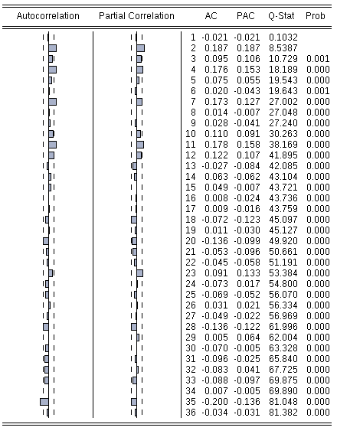 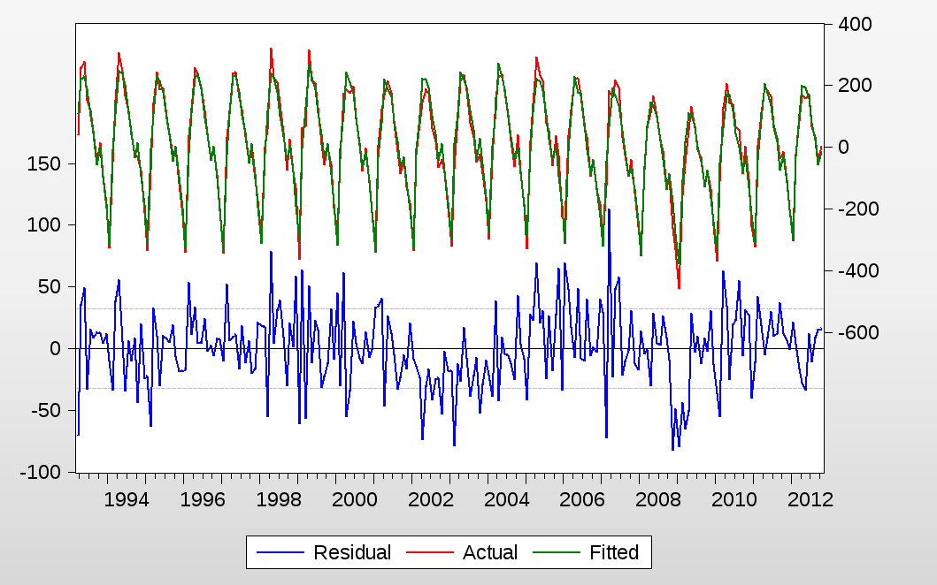

## Comparison of the Models



The contrast in performance of each model is clearest in the above table, with Model 3 best performing. Although the model forecast for September and October was lower than actual, I will not include an add-factor in my final forecast but instead will simply submit what the model produced. My forecast is 5671 and with 2 Standard Errors, the forecast interval is 5605 to 5737.