# Abstract

Our group electrically charged pieces of scotch tape and observed their interactions with each other and with other objects. We then determined the excess charge of one piece of tape

# Data and Data Tables

**Data Sheet #1 Summary**

From Section 3.2 Interaction of Two U-Tapes:

|  |  |  |
| --- | --- | --- |
| **Observation** | **Approach Distance (cm)** | **Deflection Distance (cm)** |
| 1 | 4 | 5 |
| 2 | 4 | 2 |
| 3 | 6 | 8 |
| 4 | 5 | 5 |
| 5 | 6 | 5 |

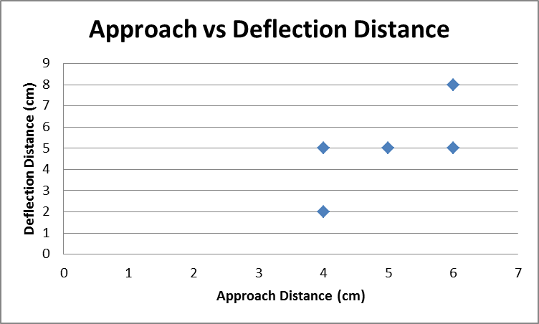

Data Sheet #2 Summary

|  |  |
| --- | --- |
| 1. What was the length of one of your pieces of tape? | 0.21 m |
| 1. What was the mass of one of your pieces of tape? | 0.002 kg |
| 1. What was the distance between your two tapes when one began to float above the others? | 0.02 m |
| 1. What was the magnitude of the gravitational force on the floating piece of tape? | 0.0196 N  9.8 m/s^2 * 0.002 kg |
| 1. What was the magnitude of the electric force on the floating tape? | 0.0196 N  mg=K*Q^2/Dd^2 |
| 1. Ignore air resistance. Assume a long tape as thought it were a point charge, with all the charge concentrated at the center of the long tape. |  |
| * + What was the approximate charge on the floating tape? | 9.3x10^-5C  See attached worksheet |
| * + How many electrons (excess or deficiency does this charge represent? | 5.82x10^14  Number = Q/e |

# Result

Our length of “upper” tape **lost 5.82x10^14 electrons** when pulled up from the “base” tape.

# Discussion

The lab procedure required our group to electrically charge pieces of tape. First, a “base” tape was adhered to the surface of the lab table. A second “upper” tape was then placed on top of the base tape and quickly pulled off. We made two “upper” tapes and adhered one to the lab table in such a way that it was left hanging. We then moved the second “upper” tape progressively closer to the first. When we observed the first moving away we took measurements of the how close the two approached each other and how far the deflection was. The measurements were imprecise because both tapes were attracted to our hands which required moving the metric stick sufficiently away from tape so as not to affect the amount of deflection. Also, either with time or after subsequent charging, the amount of deflection per unit of approach decreased. This phenomenon affects all distance results recorded in this lab and ultimately reduces the quality of the estimate of the number of electrons per charged piece of tape.

We determined whether the pieces of “upper” tape were positively or negatively charged by rubbing a plastic pen on a wool sweater and observing that the tape was attracted, rather than repelled, by the pen. According to lab manual, the pen should be negatively charged. Because negatively and positively charged objects attract each other, the conclusion is that the tape was positively charged.

Next we attempted to estimate the deficiency of the total number of electrons on a piece of “upper” tape. We made two pieces of “upper” tape and draped one over two blocks of wood separated by about 0.15 meters. Then we suspended the second piece of “upper” tape by our fingers starting approximately 0.2 meters above the first and slowly lowered it. The lab procedure in the manual asked us to measure the distance when the electrical force balanced the gravitational force on the second piece – when it was “floating,” in other words. The force exerted by our fingers to keep the tape from “rolling” over the electrical field made feeling or seeing the equilibrium distance difficult, at best. We attempted to estimate this by measuring the distance between the two pieces of tape where the suspended piece began to “roll” or kink. This poor estimation of distance undoubtedly has a substantial impact on our ability to calculate the total electron deficiency in the length of tape.

Finally, we learned to make a length of tape negatively charged instead of positively charged by sandwiching a “lower” piece of tape between the “base” and “upper” pieces during the charging procedure. After pulling the “lower” and “upper” pieces off the “base” together, we neutralized the charge by fingering the back of the non-adhesive side. We repeated this procedure twice so that we had two “upper” and two “lower” tapes. We observed that the “lower” tapes repelled each other as did the “upper” tapes. Because all four pieces exhibited signs of being electrically charged when apart and were electrically neutral when together, at the very least, we must have had sets of both negatively and positively charged tape. Because the “lower” and “upper” pieces repelled each other, we can also conclude that the “lower” and “upper” charges matched. Additionally we observed signs of electric polarization when all four pieces of tape were attracted to electrically neutral objects such as wood and our hands. No measurements were taken during this portion of the experiment.