**Data Sheet #1 Summary**

From Section 3.2 Interaction of Two U-Tapes:

|  |  |  |
| --- | --- | --- |
| **Observation** | **Approach Distance (cm)** | **Deflection Distance (cm)** |
| 1 | 4 | 5 |
| 2 | 4 | 2 |
| 3 | 6 | 8 |
| 4 | 5 | 5 |
| 5 | 6 | 5 |

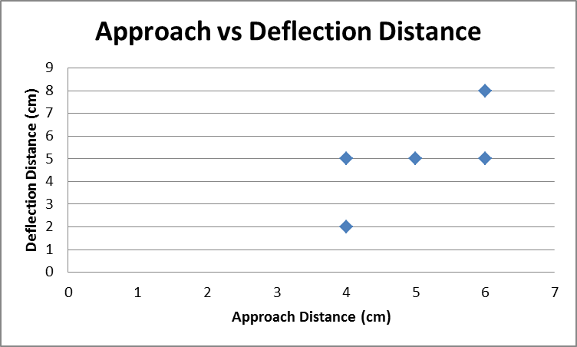

Data Sheet #2 Summary

|  |  |
| --- | --- |
| 1. What was the length of one of your pieces of tape? | 0.21 m |
| 1. What was the mass of one of your pieces of tape? | 0.002 kg |
| 1. What was the distance between your two tapes when one began to float above the others? | 0.02 m |
| 1. What was the magnitude of the gravitational force on the floating piece of tape? | 0.0196 N  9.8 m/s^2 * 0.002 kg |
| 1. What was the magnitude of the electric force on the floating tape? | 0.0196 N  mg=K*Q^2/Dd^2 |
| 1. Ignore air resistance. Assume a long tape as thought it were a point charge, with all the charge concentrated at the center of the long tape. |  |
| * + What was the approximate charge on the floating tape? | 9.3x10^-5C  See attached worksheet |
| * + How many electrons (excess or deficiency does this charge represent? | 5.82x10^14  Number = Q/e |