# Abstract

Our group applied approximately three volts to two types of electrodes, bar and circular, connected by a conductive substrate. Using a voltmeter we mapped the electric field created by the electrodes.

# Data and Data Tables

**Data Sheet #1 Summary**

Data for Bar Electrodes Board ‘E’

|  |  |  |  |  |  |  |  |  |  |
| --- | --- | --- | --- | --- | --- | --- | --- | --- | --- |
| **2.50 V** | | **2.00 V** | | **1.50 V** | | **1.00 V** | | **0.50 V** | |
| **x (cm)** | **y (cm)** | **x (cm)** | **y (cm)** | **x (cm)** | **y (cm)** | **x (cm)** | **y (cm)** | **x (cm)** | **y (cm)** |
| 9.5 | 3 | 11.3 | 10 | 12.5 | 10 | 13.5 | 10 | 14.9 | 10 |
| 8 | 17 | 11 | 3 | 12.5 | 0 | 13.5 | 8 | 15 | 16 |
| 10 | 10 | 10 | 19 | 12.1 | 19 | 13.7 | 6 | 15.5 | 17 |
| 5 | 18 | 11 | 16 | 12.3 | 18 | 13.9 | 4 | 16.5 | 18 |
| 4 | 19 | 9.3 | 13 | 12.4 | 17 | 14.1 | 2 | 17.2 | 19 |
| 5 | 2 | 11.3 | 9 | 12.1 | 20 | 14.7 | 0 | 15.3 | 3 |
| 3 | 1 | 11.3 | 7 |  |  | 14.7 | 17 | 16.3 | 2 |
| 10 | 7 | 10.5 | 2 |  |  | 14.2 | 19 | 16.5 | 1 |
| 10 | 13 | 10 | 1 |  |  | 13.7 | 14 | 18 | 0 |
| 2 | 0 | 10 | 0 |  |  | 13.5 | 12 | 14.9 | 0 |

Data for Circular Electrodes

|  |  |  |  |  |  |  |  |  |  |
| --- | --- | --- | --- | --- | --- | --- | --- | --- | --- |
| **2.50 V** | | **2.00 V** | | **1.50 V** | | **1.00 V** | | **0.50 V** | |
| **x (cm)** | **Y (cm)** | **x (cm)** | **y(cm)** | **x (cm)** | **y (cm)** | **x (cm)** | **y (cm)** | **x (cm)** | **y (cm)** |
| 10.3 | 10 | 11 | 10 | 12.8 | 10 | 14.3 | 10 | 16.3 | 9 |
| 9.6 | 9 | 9.5 | 8 | 11.5 | 0.4 | 14.7 | 9 | 17.5 | 10 |
| 8.6 | 9.6 | 7 | 10 | 11.5 | 16.8 | 16 | 8 | 16 | 11 |
| 9.5 | 10.7 | 9.5 | 11.7 | 11 | 19.6 | 17 | 7.3 | 15.1 | 10 |
| 9 | 9 | 7.8 | 8.4 | 12 | 2.7 | 18 | 7 | 17.1 | 9.1 |
| 8.8 | 10.3 | 7.6 | 11.3 | 12.7 | 8 | 14.8 | 11.5 | 17.3 | 10.7 |
| 10.1 | 10.3 | 10.5 | 11 | 12.5 | 12.5 | 16 | 12.5 | 15.5 | 10.7 |
| 10.2 | 9.3 | 10.8 | 8.7 | 12 | 14 | 17 | 13.3 | 17.5 | 9.6 |
|  |  |  |  |  |  | 24.5 | 10 |  |  |
|  |  |  |  |  |  | 23 | 8 |  |  |
|  |  |  |  |  |  | 23 | 12 |  |  |
|  |  |  |  |  |  | 20 | 13.5 |  |  |
|  |  |  |  |  |  | 20 | 7 |  |  |

Data Sheet 1a

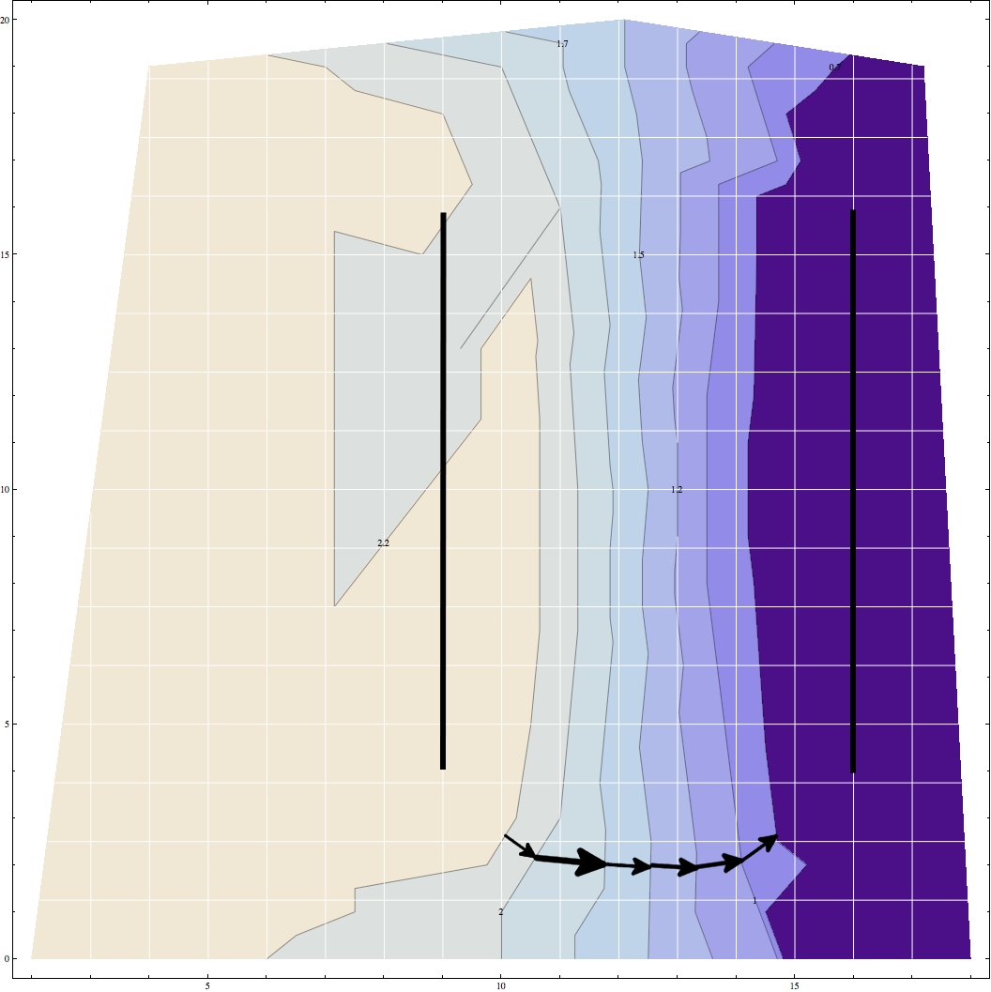

Rendered in Mathematica using PlotContourList.

Data Sheet #1b

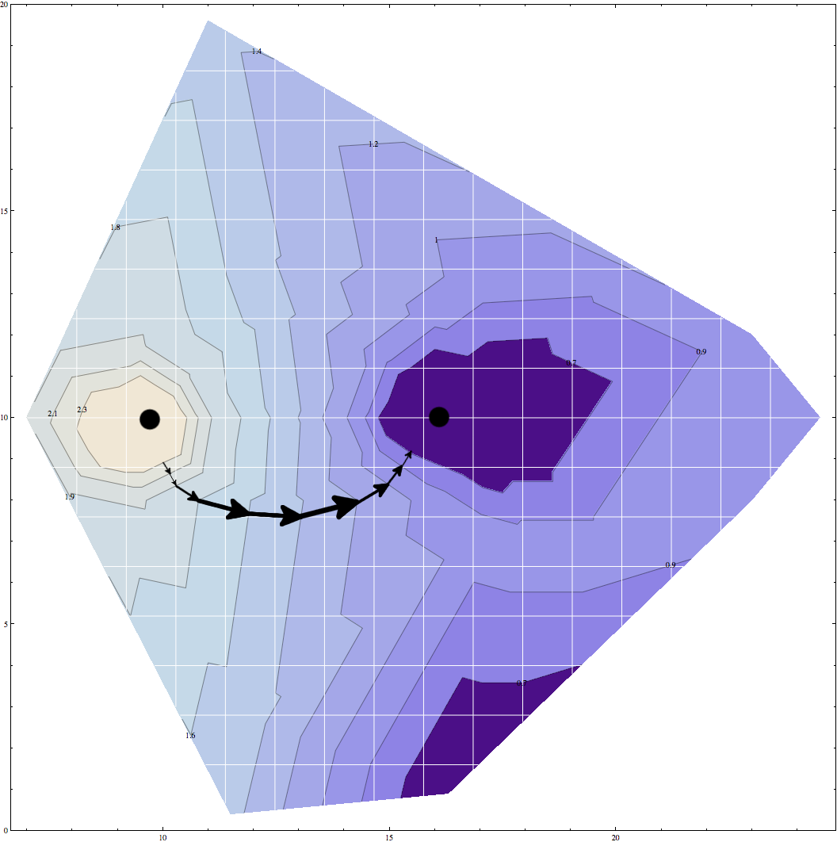

Data Sheet #2 – See attached.

# Result

0.2V / 0.005m = 40 V/m = 40 N/C

# Discussion

We began by connected the bar electrode board to the 3V power supply and then connected a handheld voltmeter to the ground on the power supply. Using a probe on the positive connector we measured the voltage at various points on the conductive carbon substrate on the board. Starting with 2.5 volts and working down to 0.5 volts, we took X and Y readings along the equipotent contours. For 1.50 volts, the contour was essentially a line that ran along x = 12.5 centimeters and so we took only six discrete measurements but verified that it ran continuously by leaving the probe in contact with the board and moving from y=0 to y=20 centimeters. We repeated the procedure for the circular electrode board. On this board the contours for 2.5, 2.0, 1.5 and .5 volts had a small enough radius that eight measurements were sufficient to accurately produce a plot. For 1.0 volts we took twelve measurements.

We attempted to keep our measurements to within +/- 0.02 volts and +/- 0.001 meters, starting the procedure over at one point to attain this accuracy. The larger constraint on the accuracy of our contour maps is probably the number of measurements that we took and our focus on the “key” regions where the contours were more tightly packed.