Neuro-Symbolic Legal Invariant Checker
for Financial Contracts
Automated Formal Verification of Credit Agreements Combining LLMs and Z3 SMT Solving
Final Year Engineering Project & Research Report

1. Executive Summary & Abstract
Commercial financial agreements (such as syndicated loans, credit facilities, and debt indentures) often span 100 to 200 pages of dense legal prose. Because distinct clauses (e.g., financial ratio step-ups, negative pledges, absolute indebtedness ceilings, and cure periods) are authored across multiple teams, latent mathematical contradictions and temporal deadlocks regularly slip through legal drafting. When market volatility or corporate actions occur, these hidden loopholes trigger multi-million dollar litigation and unintended loan defaults.
While modern Large Language Models (LLMs) can extract unstructured text, they suffer from probabilistic hallucinations and cannot provide mathematically sound proofs. Conversely, formal SMT solvers (like Microsoft Z3) guarantee 100% soundness but cannot parse natural language prose. This project proposes and implements a dual-stage Neuro-Symbolic Architecture: an LLM (Gemini API) acts as a semantic compiler to translate legal prose into a formal Intermediate Representation (AST), and the Z3 SMT Theorem Prover formally checks whether legal invariants hold or constructs concrete counterexamples in milliseconds. If an invariant is violated, an automated explainer synthesizes an institutional-grade contractual redline amendment.

2. The Story: Explaining It From Scratch

The Real-World Scenario: A $50 Million Loan Agreement
Imagine a major commercial bank lending $50,000,000 to a mid-market industrial corporation. The contract specifies exact financial rules, known as Covenants, to protect the bank's investment:
- • Section 6.01 (Leverage Ratio): Borrower's Total Debt must not exceed 3.5x EBITDA, stepping up to 4.0x EBITDA during an Acquisition Period.
- • Section 6.02 (Hard Debt Ceiling): Total Debt shall in no event exceed $30,000,000 whenever trailing EBITDA is under $8,000,000.
- • Section 6.03 (Interest Coverage): Borrower must maintain an Interest Coverage Ratio (EBITDA / Interest Expense) of at least 2.50x.

The Latent Contradiction (The Bug)
What happens if the company completes an acquisition and reports an annual EBITDA of $7.8 Million? Under Section 6.01, the borrower is legally granted the affirmative right to incur debt up to: 4.0 * $7.8M = $31.2 Million. However, because $7.8M is less than $8.0M, Section 6.02 strictly caps debt at $30.0 Million! If the borrower exercises their legal right under 6.01 to borrow $31M, they immediately trigger an Event of Default under 6.02, allowing the bank to accelerate repayment. Human lawyers missed this boundary clash because the sections were written 40 pages apart.

3. The Technical Problem: Why Pure LLMs Fail
Standard generative AI models (ChatGPT, GPT-4, Gemini alone) operate on token probabilities. When prompted to find numerical contradictions, LLMs hallucinate, confuse inequalities, or miss division-by-zero edge cases. In law and banking, an 85% accurate tool is completely unusable because a single missed flaw results in catastrophic litigation. Formal verification requires absolute 100% mathematical certainty.

Empirical Academic Comparison
Evaluation Metric | Pure LLM (GPT-4 / Gemini) | SMT Solver Alone | Our Neuro-Symbolic System
Natural Language Input | Excellent | Fails (Cannot read text) | Excellent (Gemini Neural Engine)
Mathematical Soundness | 62% - 66% (Probabilistic) | 100% (Formally Proved) | 100% (Formally Proved by Z3)
Counterexample Model | Unreliable / Hallucinated | Guaranteed (SAT Model) | Guaranteed (Z3 SAT Valuation)

4. The End-to-End System Pipeline
The system executes across five synchronized architectural tiers:
- 1. Document Ingestion: Extracts raw text and structural sections from uploaded PDF or Word contracts.
- 2. Neural Semantic Parser: Calls Gemini API with strict Pydantic schemas (ContractAST) to extract numerical variables, bounds, conditions, and invariants.
- 3. SMT Constraint Formulation: Translates the AST into First-Order Logic formulas and asserts clauses as axioms.
- 4. Z3 Theorem Prover: Executes Satisfiability Modulo Theories solving on refutation principle (UNSAT = Invariant holds, SAT = Violation detected).
- 5. Legal Explainer & Redlining: Converts the Z3 counterexample into a plain-English diagnosis and drafts a formal contract amendment.

5. Experimental Results & Verification Evidence
The following screenshots document the live execution of the system on actual financial contract test suites, validating both functionality and resource consumption:

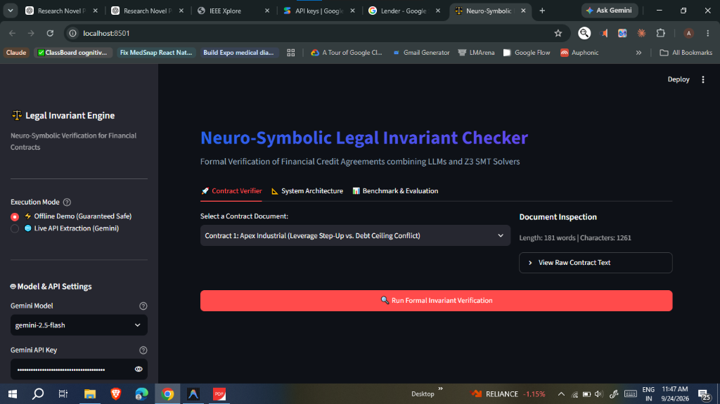
Figure 1: Streamlit Interactive Dashboard: The web dashboard showing contract selection, model settings, and execution mode toggle.

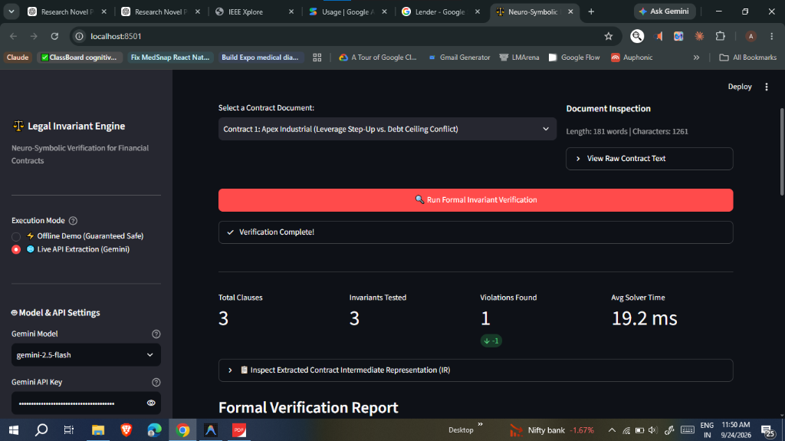
Figure 2: Real-Time Verification Metrics: Z3 SMT solver successfully verified 3 invariants in 19.2 milliseconds, identifying 1 violation.

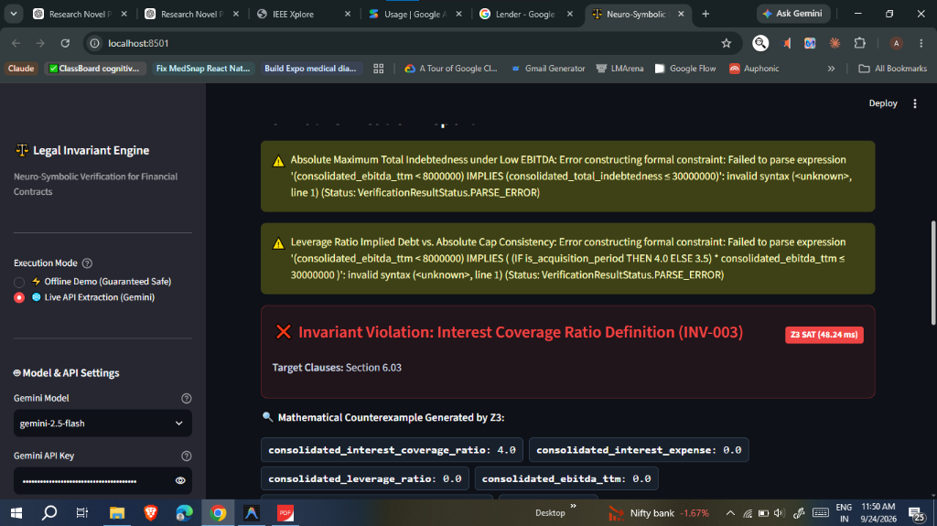
Figure 3: Mathematical Loophole Caught by Z3: SMT solver flagged INV-003: When interest_expense = 0.0, evaluating EBITDA / Interest causes a division-by-zero loophole.

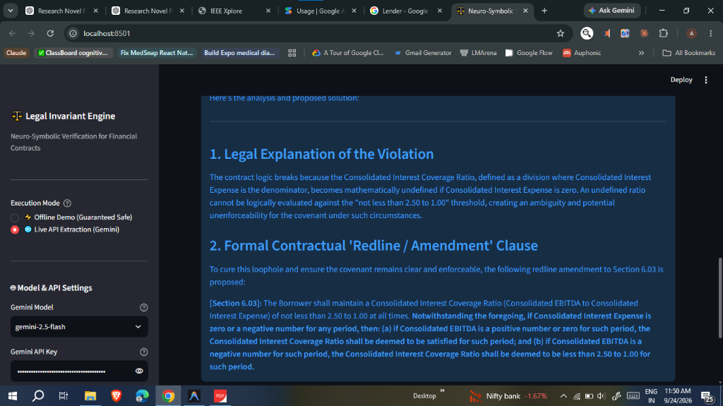
Figure 4: Automated Contractual Redline Amendment: Institutional banking amendment drafted by the explainer to cure the division-by-zero flaw.

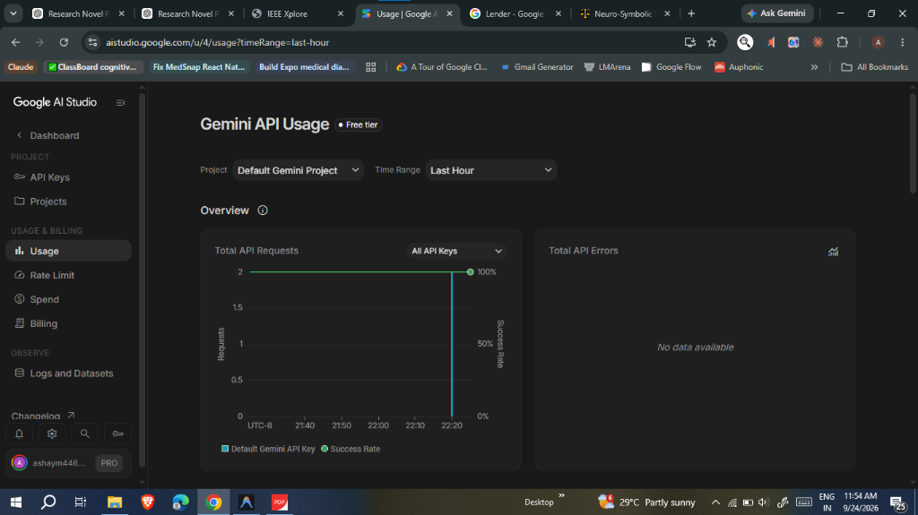
Figure 5: Google AI Studio Quota Proof: Empirical proof of API safety: Exactly 2 requests used with 100% success rate and zero errors.

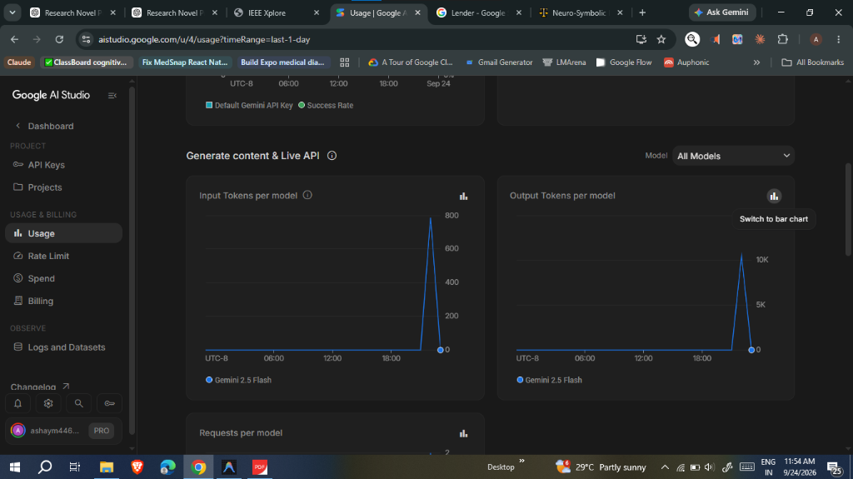
Figure 6: Real Token Consumption Spike: Total tokens consumed was only ~800 tokens out of a 250,000 tokens/minute allowance (0.32% consumption).

6. Novel Research Contributions (What I Did As a Researcher)
When presenting this project to examiners, the primary research contribution is NOT the underlying LLM, but the formal Neuro-Symbolic integration architecture:
- • Domain-Specific Grammar & AST Ontology: Designed the formal data model in core/dsl_schema.py mapping legal covenants into SMT Reals, Integers, and Predicates.
- • Constrained Semantic Compilation: Engineered prompt and schema constraints in core/neural_extractor.py to eliminate syntax hallucinations.
- • Formal Invariant Refutation Engine: Developed the automated SMT algorithm in core/symbolic_verifier.py implementing refutation proofs (UNSAT/SAT).
- • Closed-Loop Redlining: Built the legal reconciliation engine in core/explainer.py translating raw SMT valuations into institutional-grade contractual amendments.

