**KAON 1322**

**Real Time Controller Upgrade Performance Analysis**

C. Correia, P. Wizinowich, S. Ragland

March 18, 2020

**Summary:** This note outlines the expected performance of the Keck I LGS AO system with the new laser and the real-time controller (RTC) upgrade. This performance is first compared to current on-sky performance for the Galactic Center recorded with Keck II LGS AO for which data are available and the results are discussed.

**Contents**

1. Galactic Center Science Performance 1

2. Predictions versus Current Galactic Center Performance 3

2.1. Initial Prediction based on the KAPA Error Budget Tool 3

2.2. Revised H-band Strehl Ratio Prediction 4

2.3. Broadening of the PSF due to High-order Modes Z>4 5

2.4. FWHM and Strehl Ratio versus Tilt Error 6

2.5. Prediction based on Fitting the Data 7

2.6. Analysis of the Tip-tilt Telemetry Data 8

2.6.1. Loop modeling and error breakdown 8

2.6.2. Analysis of telemetry from 2018-03-30 9

2.6.3. Analysis of telemetry from 2018-08-13 11

2.6.4. Analysis of Telemetry from 2018-05-24 12

2.6.5. Analysis of Telemetry from 2018-05-19 14

2.7. Discussion 14

3. Revised Error Budget Tool Predicted Performance 15

3.1. Seeing-limited Quad-cells 15

3.2. Error Budget for Current GC Performance 15

3.3. Predicted Performance for the RTC Upgrade 16

4. Appendix A: PSF broadening models 17

# Galactic Center Science Performance

The data in Table 1 and Table 2 are extracted from Do et al. (Science 365, 2019). This data and results should provide a science anchor for the error budget and impact of tip-tilt.

This paper explained a switch from the Kp filter for 2005 to the H-band filter in 2018: “We switched to a shorter wavelength filter in 2018 in order to avoid astrometric biases due to the infrared source associated with Sgr A*, which is very red.”

Table 1 lists the measured H-band Strehl ratio and FWHM for the listed series of S0-2 observations made with NIRC2 and the Keck II LGS AO system.

Table 1: Galactic center S0-2 performance using NIRC2 with Keck II LGS AO.



A limiting magnitude of Kp = 19.0 mag is reported in Do et al. (2019) for NIRC2 with LGS AO.

Table 2 lists the measured SNR for S0-2 observations with the OSIRIS IFS and Keck I LGS AO. S0-2 is a K = 14.0 mag star ([Ghez et al., 2004](https://ui.adsabs.harvard.edu/abs/2004ApJ...601L.159G/abstract)) with a B0-2 V spectral type. An SNR > 20 is needed to allow the use of the Bracket gamma feature in the radial velocity fit. The radial velocity measurements were reported to have an average uncertainty of 17 km/s using StarKit.

Table 2: Galactic center S0-2 performance using OSIRIS with Keck I LGS

(tint = 900s, Kn3, 35 mas scale).



# Predictions versus Current Galactic Center Performance

## Initial Prediction based on the KAPA Error Budget Tool

This section uses the error budget tool developed for KAPA as discussed in KAON 1303 and maintained as KAON 1321.

Here we use assumptions on the Keck II telescope and its associated error terms as laid out in KAON 716 (and its accompanying spreadsheet) to produce an error budget compatible with the recorded on-sky performance. As shown in Table 3 (printscreen from spreadsheet in KAON 1321), we obtain a Strehl ratio of 12% in H-band which overall compares well to the average measured value of 13±4% in Table 1.

Table : Error budget for median seeing conditions and the Galactic Center science case.

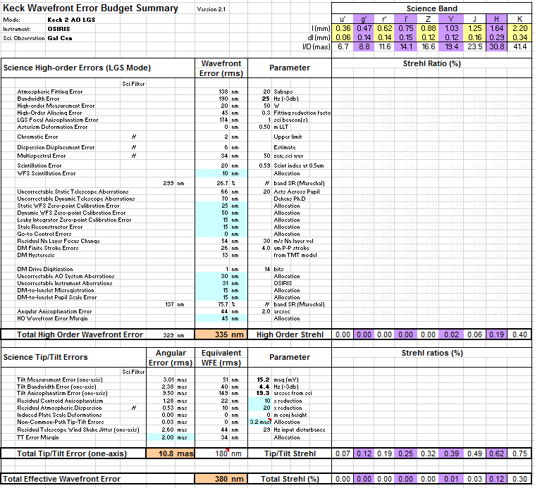

From the above table the high order H-band Strehl ratio is 19% and the single axis tilt error is 11 mas. The validity of these results is evaluated in the following sections and the error budget tool is updated in section 3.2 as a result.

## Revised H-band Strehl Ratio Prediction

The standard Maréchal approximation relates Strehl-ratio (SR) to phase variance as

|  |  |
| --- | --- |
|  | Eq. (1) |

This approximation was used to convert the estimated 335nm rms of high order error in Table 3 into a H-band SR=0.19, where = (335/1650*2*)2 = 1.63 rad2.

For relatively high values of wavefront error the Maréchal approximation underestimates the SR, as shown in Figure 1. For rad2 the underestimation is of the order of 10%.

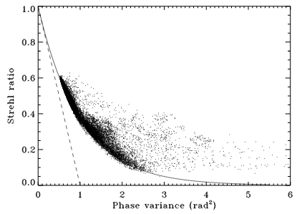

Figure : Maréchal approximation tested on tilt-removed wavefronts. Dots are observations, solid is and dashed is . Figure taken from [Gladysz et al. (2008)](https://iopscience.iop.org/article/10.1086/592787/pdf).

A corrective model that tails off to 5% SR for large variance values (as in Figure 1) is the following

|  |  |
| --- | --- |
|  | Eq. (2) |
| where | Eq. (3) |

Figure 2 compares the two SR approximations. For we get SR=0.19 and SR=0.314 with the original and the corrected Maréchal approximation.

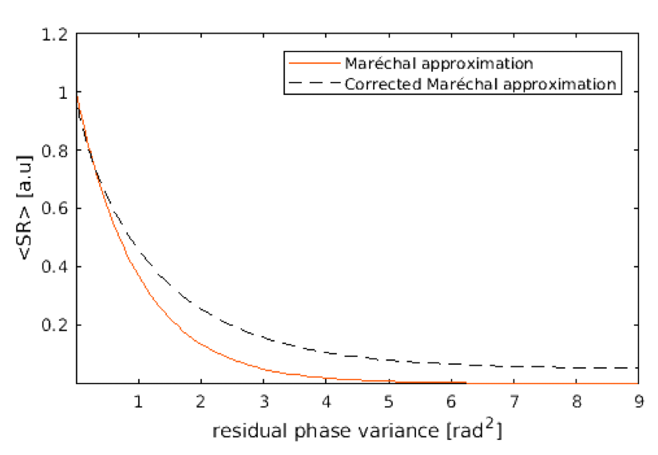

Figure : Comparison of original Maréchal approximation and its corrective approximation.

## Broadening of the PSF due to High-order Modes Z>4

We simulated the Keck PSF due to high-order modes as follows. We produced random draws of wavefront aberration starting at focus up to Zernike j=200 with 335 nm rms (as per Table 3 following a (n+1)-2 power law characteristic of a closed-loop system, where n is the radial order of the Zernike mode. Although we nominally take for granted that high order modes do not change the center of gravity of a PSF, this is not quite true ([Brummelaar (1995)](https://doi.org/10.1016/0030-4018(95)00053-B)). Figure 3 depicts the PSF obtained from 100 independent draws. This experiment allowed us to determine that the FWHM is enlarged by a factor 1.3.

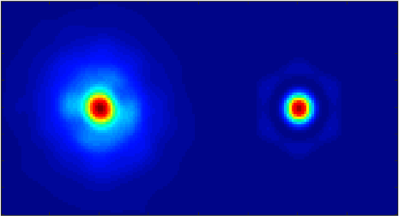

Figure : PSF from the 335 nm rms high-order optical aberration experiment. Right: Diffraction-limited PSF. The FWHM ratio is 1.3.

Figure 4 shows the PSF FWHM broadening due to the first 10 low-order modes evaluated independently, one at a time. They produce no sensible broadening.

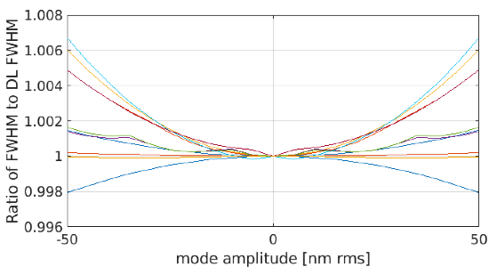

Figure : PSF FWHM broadening due to the first 10 low-order modes starting with focus when evaluated individually.

Figure 5 shows the integrated results of high-order PSF broadening as a function of the residual wavefront error. The polynomial fit is indicated in the plot. In Appendix A: PSF broadening models, we provide the models for the Z, Y & J bands.

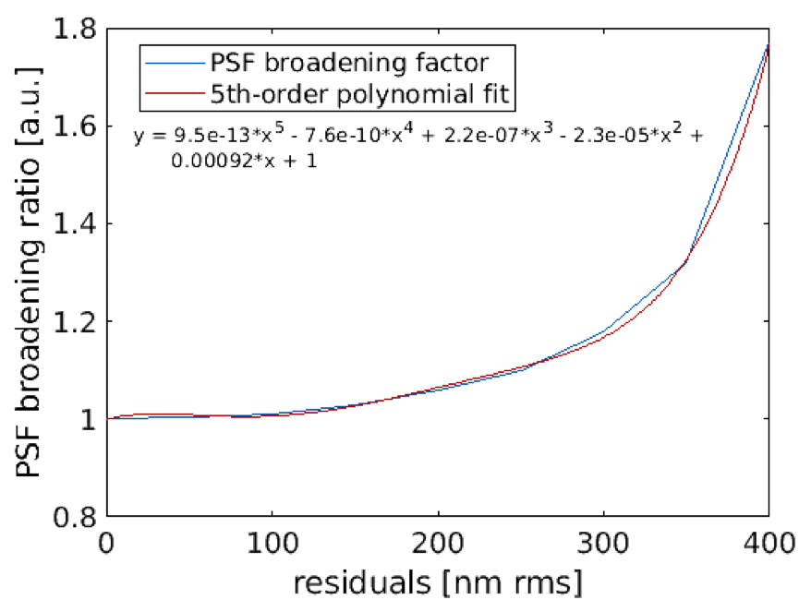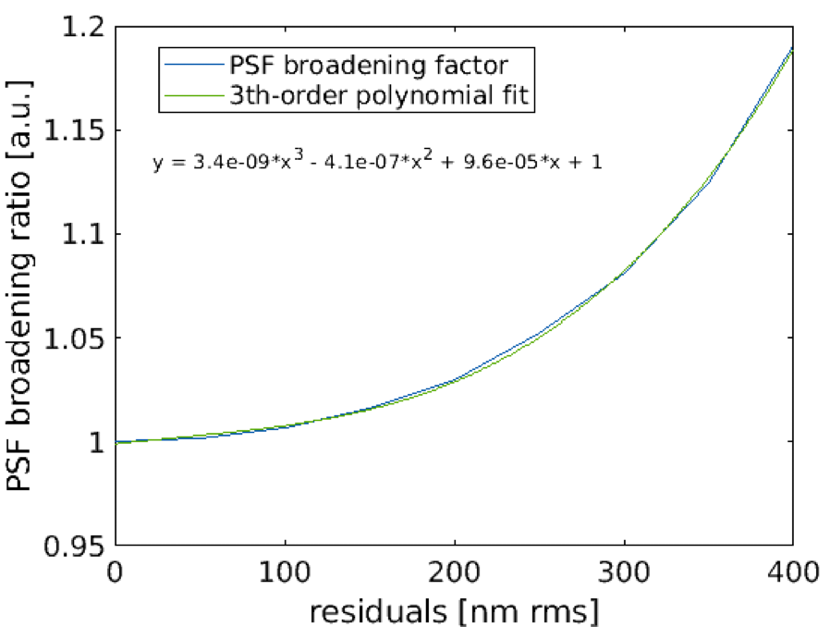

Figure : PSF broadening due to high-order wavefront error. Left: H-band, Right: K-band.

## FWHM and Strehl Ratio versus Tilt Error

The measured FWHM is a combination of the diffraction-limited FWHM (DL; λ/D), and broadening due to tilt (T; σT) and other high order (HO; σHO) terms:

FWHM2 (measured) = FWHMDL2 + FWHMHO2 + FWHMT2

= FWHMHOB2 + FWHMT2

= (λ/D)2 + (σHO/0.44)2 + (σT/0.44)2 Eq. (4)

From section 2.3, (1.3λ/D)2 = (λ/D)2 + (σHO/0.44)2, resulting in (σHO/0.44)2  = 0.69(λ/D)2. We can then solve for σT = 0.44[FWHM2 (measured) – 1.69(λ/D)2]1/2.

The Strehl reduction due to tilt is given by equation 4.60 from Adaptive Optics for Astronomy (Hardy, 1998):

Strehl reduction = σD2 / (σD2 + σT2) where σD = 0.44 λ/D. Eq. (5)

In the case where the FWHM has already been broadened by high orders then this equation becomes:

Strehl reduction = (0.44*FWHMHOB)2 / ((0.44*FWHMHOB)2 + σT2). Eq. (6)

## Prediction based on Fitting the Data

Table 4 is a fit to the Galactic Center data in Table 1. The first three columns are the measurements from Table 1.

An assumption about the FWHM broadening due to high order terms is made in the first column of the next two sections. The first of these two sections uses the FWHM broadening determined in section 2.3. In the last section the FWHM broadening value was selected to obtain the high order Strehl ratio determined in section 2.2.

The FWHM broadening is used to calculate the single axis tilt using Eq. (2) and the reduction due to tilt is calculated using Eq. (4). A value for the high order Strehl ratio is then assumed to calculate a predicted Strehl ratio; this “Assumed HO” value is selected to minimize the Measured-Predicted value calculated in the last column of each section.

For a FWHM broadening of 1.3 (from section 2.3) the single axis tilt is computed to be 22 mas and the high order Strehl ratio is determined to be 0.32. These values are significantly higher than the 11 mas in section 2.1 and the 0.22 Strehl ratio from section 2.2.

In the last section a FWHM broadening value of 1.57 was selected to match the Strehl ratio of 0.22 (from section 2.2). The resultant single axis tilt error of 17 mas is still large compared to the 11 mas in section 2.1.

Table : Fit to the Galactic Center data.



The measured Strehl ratio and the predicted Strehl ratio for the FWHM broadening = 1.3 λ/D case are plotted in Figure 6 versus the measured FWHM. There is a slightly poorer fit when the higher FWHM broadening value is used (as seen by the larger standard deviation).



Figure : Measured and predicted H-band Strehl ratio versus measured FWHM for the Galactic Center data.

## Analysis of the Tip-tilt Telemetry Data

## Loop modeling and error breakdown

To perform an error breakdown, we postulate that the observed residuals contain three terms: measurement noise (photon, read and aliasing), filtered (or propagated) noise through the loop and servo-lag error (or bandwidth error). For a negative-feedback loop these can be written as

|  |  |
| --- | --- |
|  | Eq. (7) |

where

* is the measurement temporal PSD
* is the input tilt temporal PSD
* is the noise temporal PSD
* is the UTT commands temporal PSD
* - the open-loop transfer function
* =is the loop rejection transfer function
* =
* is the noise transfer function
* is the temporal frequency variable

The open-loop transfer function is

|  |  |
| --- | --- |
|  | Eq. (8) |

with

* , is the loop gain, 0.8 a fixed gain scaling (cf. [[van Dam 2004](https://www2.keck.hawaii.edu/optics/aodocs/ApplOptVol43_29oct2004.pdf)])

Eq. (7) can be re-written as

|  |  |
| --- | --- |
|  | Eq. (9) |

which is the formulation provided in [[van Dam 2004](https://www2.keck.hawaii.edu/optics/aodocs/ApplOptVol43_29oct2004.pdf)], Eqs (16-17). Note however that what gets propagated to the science channel is

|  |  |
| --- | --- |
|  | Eq. (10) |

From this system of equations, it is impossible to estimate all the unknowns, i.e. , , . Our approach was thus the following: we postulate a known structure for the IIR filter (parameters in the header). We then estimate the loop gain by fitting the low-frequency model RTF to match

|  |  |
| --- | --- |
|  | Eq. (11) |

where capital letters represent .

The noise level is estimated by minimizing the residual PSD at high-frequencies, where the RTF is assumed to be roughly identical to the identity, by solving

|  |  |
| --- | --- |
|  | Eq. (12) |

where is a frequency threshold above which only noise manifest, i.e. the tilt residual is not dominant.

The servo-lag error is estimated in two ways:

1. It is found from subtracting the noise plus the filtered noise from the residual variance

|  |  |
| --- | --- |
|  | Eq. (13) |

1. It is estimated by first fitting a power law to the low-frequency DTT commands and then performing

|  |  |
| --- | --- |
|  | Eq. (14) |

## Analysis of telemetry from 2018-03-30

We first took the set of observations from March 30, 2018. The Galactic Center image for the example examined here is shown in Figure 7.

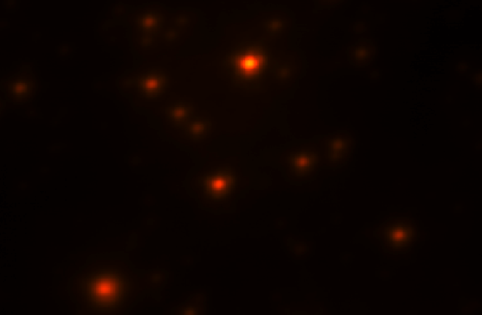

Figure : Galactic Center field observed with NIRC2 on the night of March 30 2018.

For the LGS case, we computed for each j-observation, i.e. the standard deviation of the TT residuals (from keyword DTTCENTROIDS in the telemetry) - Figure 8 – where we also overplot the time-averaged standard deviation and it’s median.

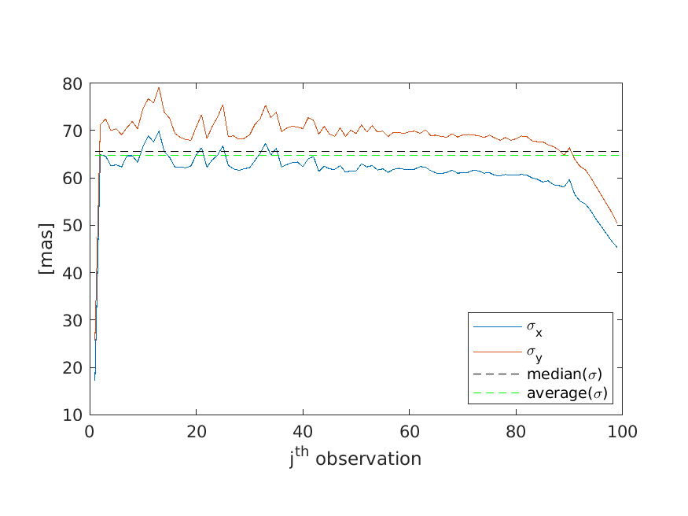

Figure : Time-averaged standard deviation of the tip-tilt centroids.

To have a statistical understanding we repeated the analysis for all the observations in the set. Figure 9 provides the summary with either estimation method. Integrated values are shown in Table 5. When adding quadratically the servo-lag and the filtered noise for the method 1 (Eq. (13)), i.e. the two terms that affect the final PSF, we get (17.12+ 9.22)1/2=19.4 mas rms. This is consistent with the value predicted in Table 4 of 22 mas rms tilt error. Method 2 (Eq. (14)) seems to underestimate the bandwidth error leading to an error breakdown inconsistent with the observations, even when adding the tilt-anisoplanatism term.

Table : Median and average values for all the observations from March 30, 2018.

|  |  |  |
| --- | --- | --- |
|  | **Average (method 1)** | **Average (method 2)** |
| Servo-lag | 17.1 | 2.82 |
| Filtered noise | 9.21 | 9.59 |
| Measurement noise | 57.9 | 60.23 |

|  |  |
| --- | --- |
|  |  |
| Method 1 | Method 2 |

Figure : Error breakdown for all the observations of March 30, 2018.

The signal and noise estimation are shown in Figure 10 for the single instance of image #118 of this night. Here we can see that the model rejection transfer function (RTF) matches well the empirical RTF computed directly from the data – red curves. This means the assumptions on delay and gains are correct. We then scaled the RTF (red solid) and the noise (green) to have the correct units and which we can integrate to obtain values in arcsec on-sky.

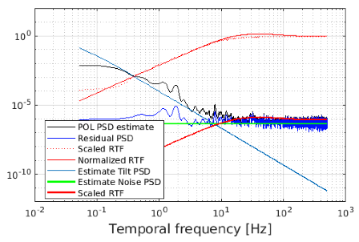

Figure 10: PSDs and RTFs (model and empirical) retrieved from the j=2 (image #118) observation in the set.

## Analysis of telemetry from 2018-08-13

We now conduct the same analysis as previously for the night of 2018-08-13 whose residuals are depicted in Figure 11.

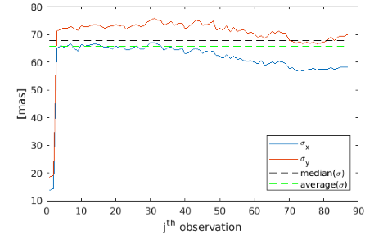

Figure : Time-averaged standard deviation of the tip-tilt centroids.

The error breakdown, shown in Figure 12 for the two estimation methods, now provides 23.0 mas rms for the servo-lag plus filtered noise (see Table 6). In this case method 1 overestimates the single-axis tilt as per the 17 mas value of Table 4.

|  |  |
| --- | --- |
|  |  |
| Method 1 | Method 2 |

Figure : Error breakdown for all the observations of August 13, 2018.

Table : Median and average values for all the observations from August 13, 2018.

|  |  |  |
| --- | --- | --- |
|  | **Average (method 1)** | **Average (method 2)** |
| Servo-lag | 21.27 | 1.39 |
| Filtered noise | 8.99 | 9.59 |
| Measurement noise | 56.44 | 60.23 |

## Analysis of Telemetry from 2018-05-24

A look at the telemetry from May 24, 2018 reveals a more intriguing behavior. Starting with Figure 13, we verified that the tilt residuals measured by STRAP are, as expected (see Table 4), larger than the ones from March 30, 2018. What is puzzling is the form of the temporal PSDs shown in Figure 14, in particular the bump in the high-frequency range, representative of a transfer function with a loop gain higher than the one reported in the header (g=0.1).

The PSDs on Figure 14 were fitted with a g=0.405. This leads to a less effective noise rejection with a factor ~0.5 propagation (in rms values), from which we inspect visually on the order of 80mas rms (single axis Tilt) error. This is much higher than the 30 mas postulated in Table 4 in order to explain the observed SR and FWHM. Table 7 gives the full error breakdown.

We also draw attention to the vibration at ~20Hz that we may want to characterize at a later stage.

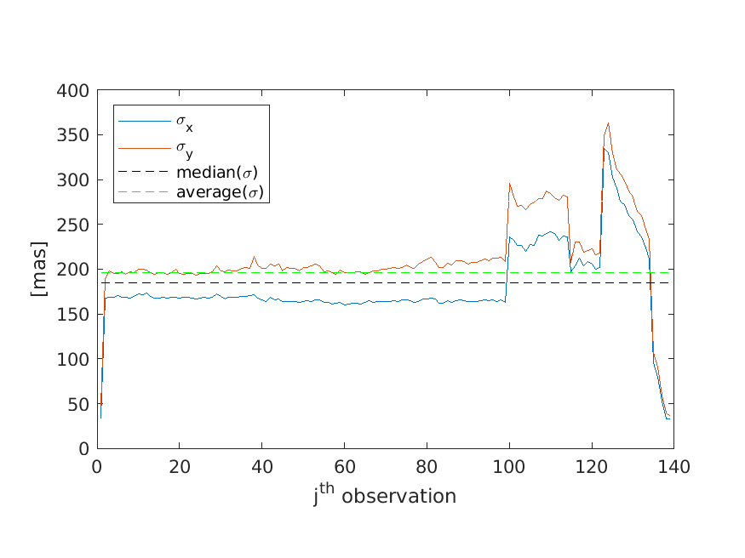

Figure 13: Standard-deviation of the residuals from the telemetry for the night of 2018-05-24.

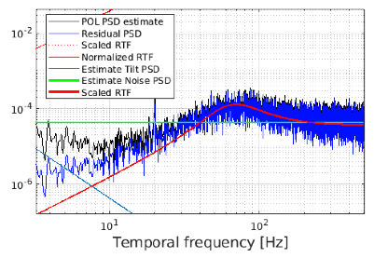

Figure : Sample PSDs for the dataset 'n0012_LGS_trs.sav'.

Figure 15 provides the integrated results from the 3th-90th observations from Figure 13 (i.e. we removed the initial and the ones where tilt literally was higher than the nominal for this set).

|  |  |
| --- | --- |
|  |  |
| Method 1 | Method 2 |

Figure : Error breakdown for all the observations of May 24, 2018.

Table : Median and average values for all the observations from May 24, 2018.

|  |  |  |
| --- | --- | --- |
|  | **Average (method 1)** | **Average (method 2)** |
| Servo-lag | 14.11 | 6.23 |
| Filtered noise | 74.8 | 75.01 |
| Measurement noise | 143.6 | 144.06 |

## Analysis of Telemetry from 2018-05-19

As done for the previous datasets, the standard deviation for the whole set of 2028-05-19 is depicted in Figure 16.

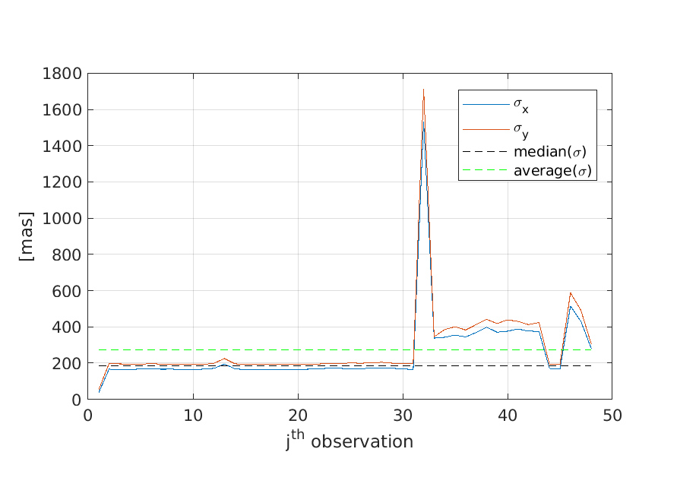

Figure : Standard-deviation of the residuals from the telemetry for the night of 2018-05-19.

This case suffers from the same caveats as the one from May 24, 2018.

## Discussion

Both the measured FWHM and the tip-tilt telemetry data point to more tip-tilt than predicted with the current input to the error budget tool. The error breakdown from STRAP telemetry shown here sheds light into this aspect, pointing to an unexpected large value for the measurement noise of ~60 mas rms, leading to an overall ~19 to 23 mas rms propagated errors onto the observed PSF (nights of March 30 and August 13, 2018). The two May nights showing an excessive 83 and 98 mas FWHM PSFs are harder to interpret on account of the unknown loop gain. A fit to the residuals leads to an inconsistent error breakdown that predicts a too large residual for these nights that is not consistent with the observations.

The tilt inputs to the error budget need to be re-evaluated based on the AO telemetry and updated on the one hand. On the other, the source of the measurement noise must be further investigated (this is a pressing issue) and the TT controller optimized (for instance, employing the Optical Modal Gain Integrator technique).

The Strehl ratio calculation in the error budget tool should take into account the deviation from the Maréchal approximation shown in Figure 1.

It would be useful to have the error budget spreadsheet provide a FWHM estimate. This estimate should take into account the FWMH broadening due to high order wavefront aberrations.

The current performance prediction in section 2.1 and the predicted performance in section 3 will be updated based on these results.

# Revised Error Budget Tool Predicted Performance

## Seeing-limited Quad-cells

The STRAP error model in KAON 1317 was re-evaluated below and no discrepancy was found between what is assumed in the error budget and the analytic formulations provided by Hardy and others.

In the case of STRAP, the spot is effectively seeing-limited. In this case,

|  |  |
| --- | --- |
|  | Eq. (15) |

where

|  |  |
| --- | --- |
|  | Eq. (16) |

[Clare06](https://authors.library.caltech.edu/6856/1/CLAao06.pdf) numerically computes =0.4258. With this definition, we find

|  |  |
| --- | --- |
|  | Eq. (17) |

which is similar to Eq. (18)

|  |  |
| --- | --- |
|  | Eq. (18) |

This means that the original model in Eq. (18) can and should be used for the case of STRAP. Figure 17 compares the Hardy model (provided above) to the one in Thomas et al (2008). We see that for a photon count in the 105+ the single-axis 1-sigma value is ~6 mas rms. One such photon count is what is indicated for the STRAP on the GC observations. This is absolutely in-line with the error budget tool.

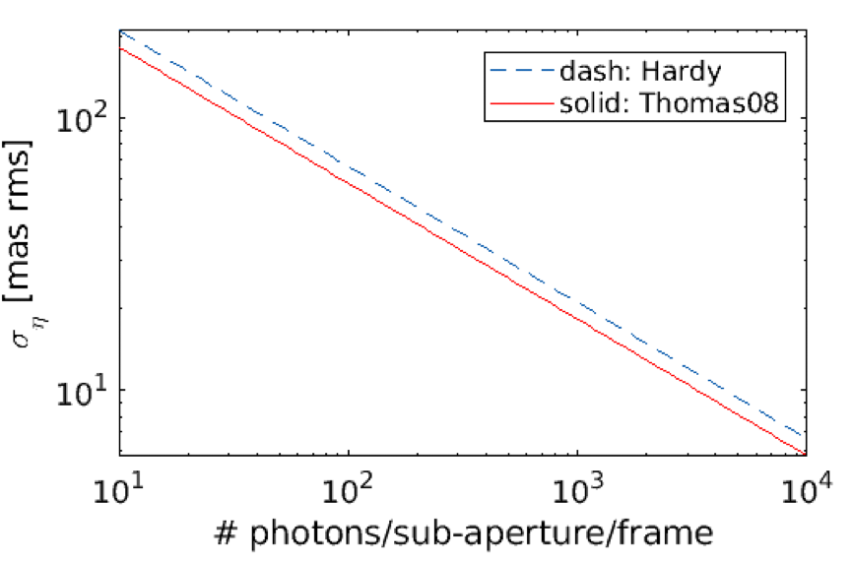

Figure : Analytic model comparison for the case of STRAP (full-pupil aperture) with a seeing-limited spot.

## Error Budget for Current GC Performance

Table 8 shows the error budgets with the new high-order and low-order Strehl-ratio calculations, along with the FWHM model shown in Figure 5 improved to include a diffraction-limited PSF broadening and an artificially inflated TT error total of ~20 mas rms.

Table : Current performance. Note the artificially inflated tip-tilt error to be ~20mas rms.

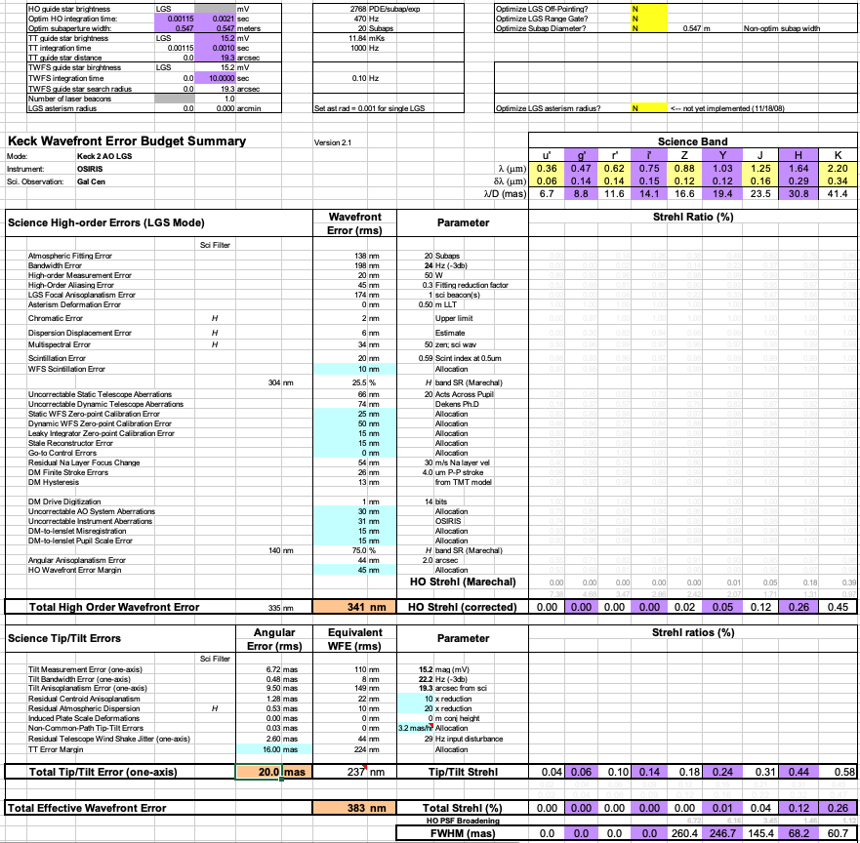

## Predicted Performance for the RTC Upgrade

Table 9 shows the error budget for the Keck I LGS AO system featuring the new RTC and laser. STRAP is used and not TRICK for a fairer comparison to Table 8. The net effect is an increase of the H-band Strehl ratio by 4% (a factor of 1.35). This is the effect of a higher frame rate (here considered 2kHz) which, despite a slight increase in high-order noise (reflecting a higher temporal bandwidth of the rejection transfer function) lowers the bandwidth error from 198nm rms to 89nm rms. The tip-tilt error in this prediction is left unchanged since it appears to be measurement noise limited and is not yet understood. Note also that due to the reduction in high-order wavefront error, the final FWHM is improved by ~10mas (from 68 to 59 mas).

Table : RTC upgrade performance. Note the artificially inflated tip-tilt error to be ~20mas rms.

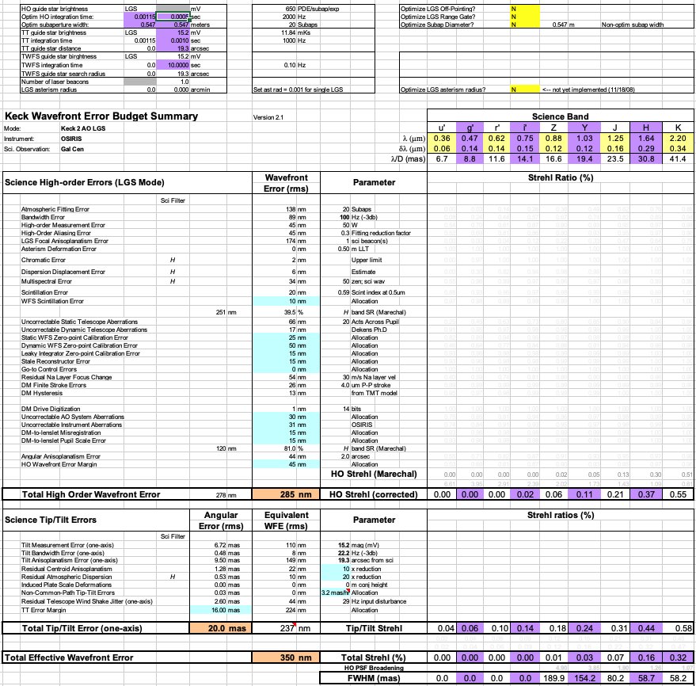

# Appendix A: PSF broadening models

Figure 18 shows the PSF broadening factors and their polynomial fit for the Z, Y and J bands.

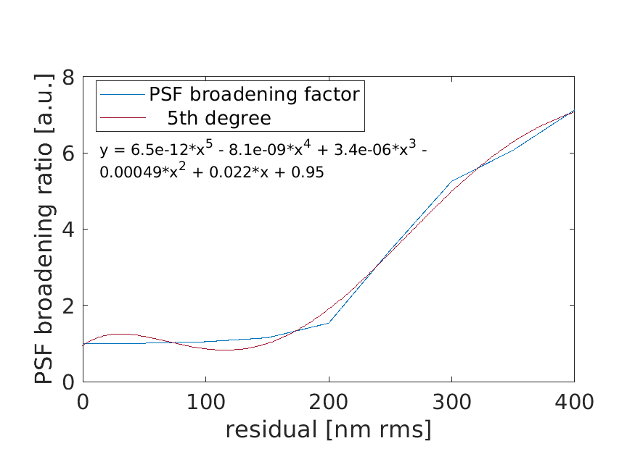

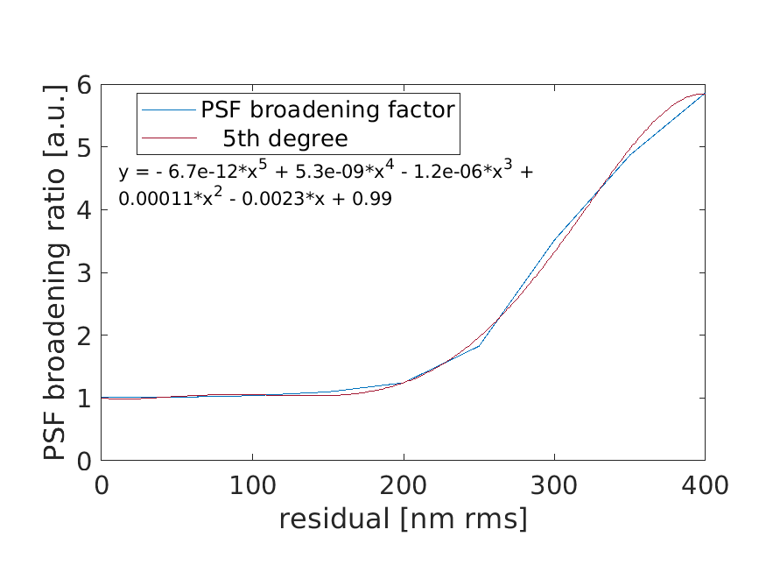

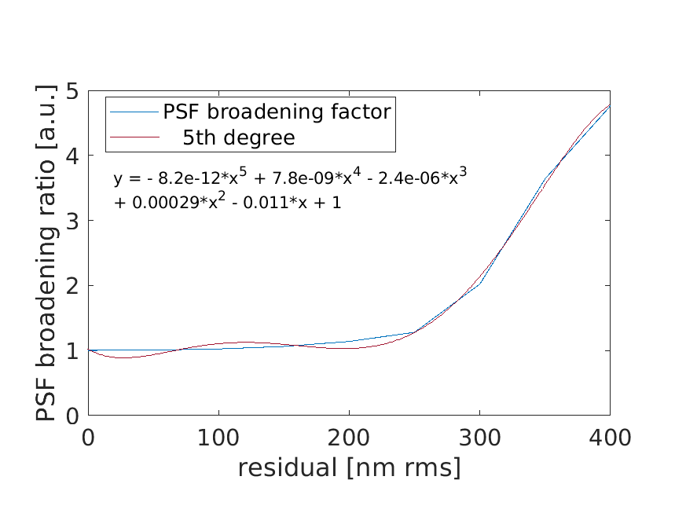

Figure 18: PSF broadening fits for the Z (0.88µm; top), Y(1.03µm) and J (1.25µm) bands.