Shoes Tutorial Note
- For the Shoes App Rookie Creators -
October 18th, 2008
by Satoshi Asakawa
Table of contents

1. Introduction 3
2. Download Shoes 3
3. First step 3
4. Birds-eye view (Survey basic features) 3
4.1 Concept 3
4.2 No.1 para 4
4.3 No.2&3 stack and flow 5
4.4 No.4 button 7
4.5 No.5 image 8
4.6 No.6 edit_line 9
4.7 No.7 link 10
4.8 No.8 background 11
4.9 No.9 Shoes.url 12
4.10 No.10 clear 13
5. Tips for creating our original Shoes apps 15
5.1 Open Shoes built-in manual and Shoes console window 15
5.2 Output messages on the Shoes console window 16
5.3 shoes --help 17
5.4 App object and coding style 20
5.5 Built-in Constants and methods 21
5.6 Scope: A tip of using the YAML file 21
5.7 keypress, mouse and clipboard 23
5.8 the Widget class 25
5.9 shape 26
5.10 mask 27
5.11 Drawing directly on to images 28
5.12 Style 29
5.13 Shoes.setup 30
5.14 Downloader 31
5.15 Assign Shoes URL dynamically 32
5.16 Classes List and Colors List 33
5.17 start, stop and restart 35
5.18 Combination of image objects show/hide and mouse hover/leave 36
5.19 arc and cap 40
5.20 widget with block 41
5.21 text message slide-in 42
5.22 #! shoes 44
5.23 loading widgets from other files? 45
5.24 optional arguments 47
5.25 slot with scrollbar 50
5.26 The :state style 51
6. Hot Topics in the Shoes ML and Shoooes.net 52
6.1 External Fonts 52
6.2 Locking edit_box 52
6.3 Styling Master List 52
7. Assignment 53
7.1 Assignment 1 – twitter client (reader) 53
7.2 Assignment 2 – footracer 54
8. Relevant web sites (Links) 55
9. Appendix 55
9.1 Advanced article 55
9.2 Shoes mailing list in English 55
9.3 Shoes mailing list in Spanish 55
9.4 Shoes IRC channel 55
10. Trivia 56

Introduction
Shoes is a cross-platform tiny graphics and windowing toolkit for the Ruby programming language written by _why. (http://en.wikipedia.org/wiki/Why_the_lucky_stiff)

All sample programs and data files in this tutorial are able to download from here.
(http://github.com/ashbb/shoes_tutorial/tree/master)

Some sample programs are the same in the NKS (The first public manual of Shoes. See chapter 7.)

Download Shoes
Download Shoes from this web site and pick the installer.
(http://shoooes.net/downloads/)
(http://help.shoooes.net/Introducing.html)

We use the latest revision, Shoes-0.r1057, in this tutorial.

First step
There is a tutorial written by _why.
(http://shoooes.net/tutorial/)

Now, copy and paste the whole 16 sample programs and run one by one. No need to understand the code meaning. Just run and look at the app window. This tutorial has screenshots, but be sure to run all 16 samples. Not later. Do it now, before going to the next, please. This is the most important step, I believe.

Birds-eye view (Survey basic features)

4.1 Concept
Shoes is a tiny graphics toolkit. It's simple and was born to be easy! So, Shoes doesn't have many elements (like tabbed controls, toolbars, horizontal scrollbars.) But can be simulated with images.
There are ten essential methods to get going with Shoes.

4.2 No.1 para
banner : Charactor size 48 pixels
title : 34
subtitle : 26
tagline : 18
caption : 14
para (paragraph) : 12
inscription : 10
# sample1.rb
Shoes.app :width => 230, :height => 80 do
para 'Testing, test, test. ',
'Breadsticks. ',
'Breadsticks. ',
'Breadsticks. ',
'Very good.'
end

# sample1.png
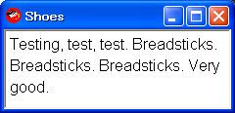

strong : bold
em (emphasized) : italics
code : monospeced font
ins (inserted) : single underline
sub (subscript) : lowering the text by 10 pixels, x-small font
# sample2.rb
Shoes.app :width => 240, :height => 95 do
para 'Testing, test, test. ',
strong('Breadsticks. '),
em('Breadsticks. '),
code('Breadsticks. '),
strong(ins('EVEN BETTER.')),
sub('fine!')
end

# sample2.png
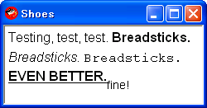

4.3 No.2&3 stack and flow
At first, read the following web page:
http://github.com/why/shoes/wikis/stacksandflows

But use (run) the following sample code instead of the one on the above web page.
Because the method Shoes#text is obsolete and need to correct the path of image file.

# sample3.rb
Shoes.app do
stack do
image "http://hackety.org/images/hackety-org-header.png"
end
stack :width => 200 do
para "column 1"
end
stack :width => -200 do
para "column 2"
end
end

# sample3.png
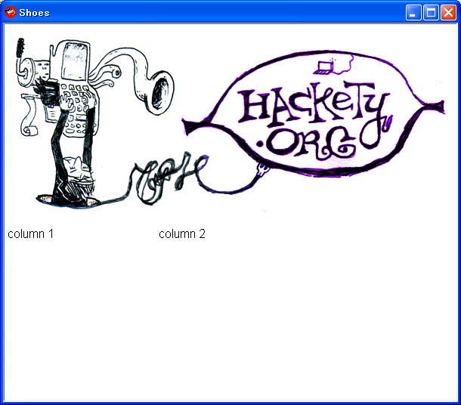

More complex sample code is:
# sample4.rb
Shoes.app :width => 250, :height => 150 do
background gray
flow :width => "90%" do
background brown

flow :width => "70%" do
background purple
stack do
background green
para "stack 0"
end
stack :width => "30%" do
background red
para "stack 1"
end
stack :width => "-30%" do
background blue
para "stack 2"
end
end

stack :width => "20%" do
background yellow
para "stack 3"
end
end
end

# sample4.png
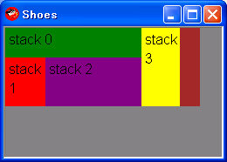

4.4 No.4 button

button("Press Me")
which creates a new button and
button("Press Me"){ alert("clicked")}
how the block fires when clicked and
button("Press Me", :left => 50, :top => 20)
will place the button at coordinates (50, 20).
That's it.

# sample5.rb
Shoes.app :width => 200, :height => 50 do
button("Press Me", :left => 50, :top => 20) do
alert("clicked")
end
end

# sample5.png
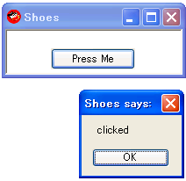

4.5 No.5 image

An image is a picture in PNG, JPEG or GIF format.
We can use the directory path and URL.

# sample6.rb
Shoes.app :width => 680, :height => 460 do
image Dir.pwd + '/loogink.png'
image "http://hacketyhack.net/images/design/Hacky-Mouse-Hand.png"
end

# sample6.png
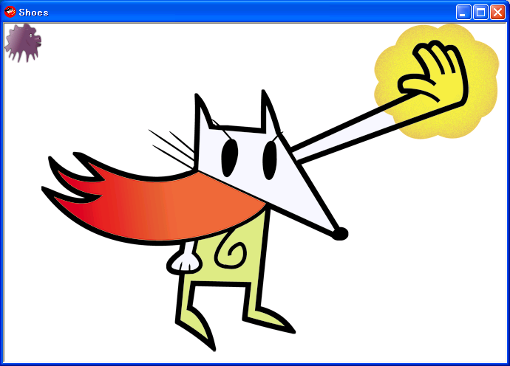

4.6 No.6 edit_line

Edit boxes are wide, rectangular boxes for entering text.
Edit lines are a slender, little box for entering text.

# sample7.rb
Shoes.app :width => 250, :height => 300 do
stack do
@msg = para 'Hello'
@el = edit_line "We love Ruby."
button('ok'){ @msg.text = @el.text}
@eb = edit_box "We love Shoes."
button('ok'){ @msg.text = @eb.text}
end
end

# sample7.png
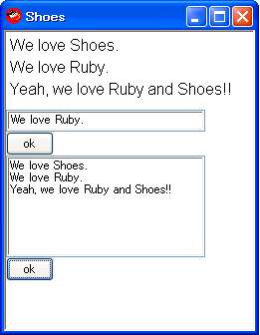

We can use :secret in the edit_line area.

# sample7-1.rb
Shoes.app :width => 235, :height => 80 do
para 'password: '
@el = edit_line :width => 100, :secret => true
button('ok'){@input.replace em(@el.text)}
@input = para ''
end

# sample7-1.png
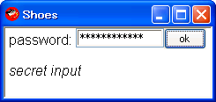

4.7 No.7 link

Hyperlinks. We have three way to write the links.
# sample8.rb
Shoes.app :width => 250, :height => 60 do
para link('RubyLearning.org'){visit "http://www.rubylearning.org/"}
para link('Google', :click => "http://google.com")
image (Dir.pwd + '/loogink.png'), :click => "http://shoooes.net/"
end

# sample8.png
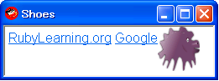

4.8 No.8 background

Backgrounds and borders are both just patterns.
They are actual elements, not styles.
A pattern is made with a color, a gradient or an image.

# sample9.rb
Shoes.app :width => 200, :height => 140 do
background '#FF9900'
background rgb(192, 128, 0), :left => 40
background gray(0.6), :left => 80
background red, :left => 120
background '#FAD'..'#ADD', :left => 160
border Dir.pwd + '/loogink.png', :strokewidth => 15
end

# sample9.png
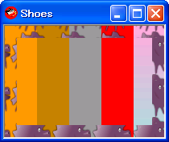

In NKS(Nobody Knows Shoes), just give the background a radius.
Background blue, :radius => 12
But it is obsolete. Now we can use :curve instead of :radius. And can also use :angle for gradient.
# sample10.rb
Shoes.app :width => 200, :height => 70 do
background "#D0A"..darkorange.to_s, :angle => 45, :curve => 30
end

# sample10.png
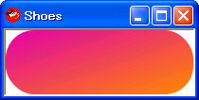

4.9 No.9 Shoes.url

A Shoes App object is a single window running code at a Shoes URL.
When you switch Shoes URLs, a new App object is created.
From the user view point, just seems like a page of the web.
# sample11.rb
class PhotoFrame < Shoes
url '/', :index
url '/loogink', :loogink
url '/cy', :cy

def index
eval(['loogink', 'cy'][rand 2])
end

def loogink
background tomato
image Dir.pwd + '/loogink.png', :left => 70, :top => 10
para "\n" * 3
para strong 'She is Loogink. :)', :stroke => white
para '->', link(strong('Cy'), :click => '/cy')
end

def cy
background paleturquoise
image Dir.pwd + '/cy.png', :left => 70, :top => 10
para "\n" * 3
para strong 'He is Cy. :)', :stroke => white
para ' ->', link(strong('loogink'), :click => '/loogink')
end
end

Shoes.app :width => 200, :height => 120, :title => 'Photo Frame'

# sample11.png
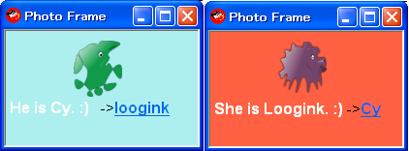

4.10 No.10 clear

The clear method wipes the slot.
It also takes an optional block that will be used to replace the contents of the slot.

# sample12.rb
Shoes.app :title => 'RC', :width => 100, :height => 80 do
def random_creatures
background rgb rand(256), rand(256), rand(256)
name = %w[loogink cy yar kamome shaha][rand 5]
image Dir.pwd + '/' + name + '.png', :left => 30, :top => 10
end

random_creatures

every(5){clear{random_creatures}}
end

# sample12.png
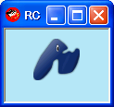

The append and remove methods are also useful.

# sample13.rb
Shoes.app :width => 450, :height => 250 do
stack :margin => 10, :width => 200 do
subtitle 'Shoes ToDoList'
para 'Add a list.'
@add = edit_line
button 'Save' do
@notes.append do
para @add.text, ' ', link('delete'){|e| e.parent.remove}
end
@add.text = ''
end
end
@notes = stack :margin => 10, :width => -200
end

# samples13.png
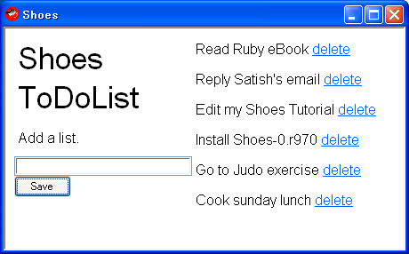

Tips for creating our original Shoes apps

5.1 Open Shoes built-in manual and Shoes console window

To open the Shoes built-in manual,
Type the following on your pc console (terminal window).

shoes -m
or
shoes --manual

Or type Alt + ? on any Shoes app window.
Or select from the menu. See here.
(http://shoooes.net/manuals/)

To open the Shoes console window,
type Alt + / on any Shoes app window.

# sample14.rb
Shoes.app do
background 0..100
end

# shoes_console.png
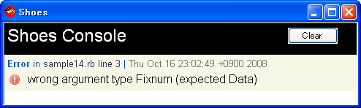

5.2 Output messages on the Shoes console window

We can put the message on the Shoes console window.

# sample15.rb
Shoes.app :width => 150, :height => 40 do
para 'Hello world!'
Shoes.p 'This is a test message.'
debug 'Running Shoes on ' + RUBY_PLATFORM
error 'This is an error message.'
info 'Shoes release name is ' + Shoes::RELEASE_NAME
end

# sample15.png
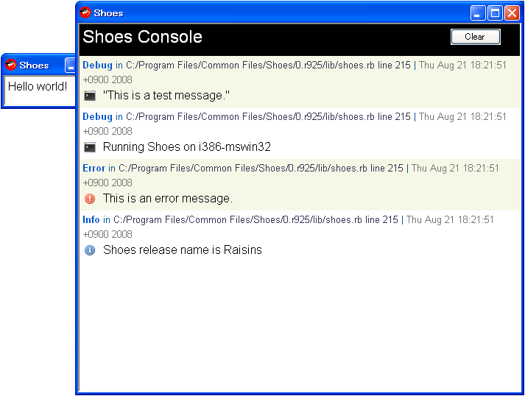

5.3 shoes --help

Type the following on your pc console (terminal window).

shoes -h
or
shoes --help

# shoes_help.png
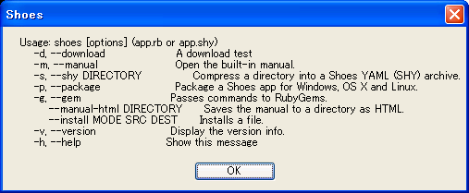

# shoes_version.png
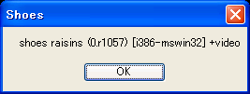

# shoes_download_test.png
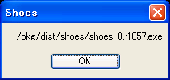

# shoes_gem.png
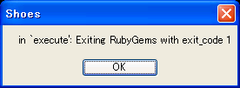
shoes -g install hpricot
Oops, an error will be happen. Perhaps now under construction...

# shoes_shy.png
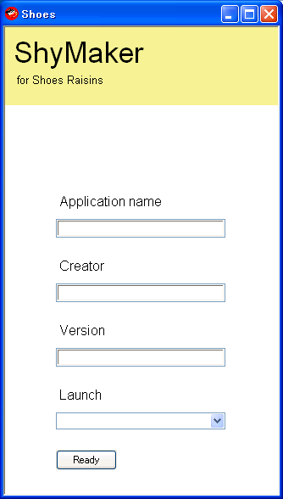
Open the app window, but it doesn't work well. Now under construction...

# shoes_shy-1.png
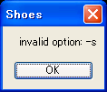
In the case of Shoes-0.r1057,the above message appears
Because this feature is included in ‘shoes --package’.

# shoes_package.png
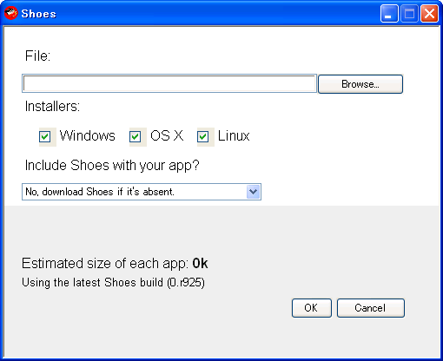
Open the app window, but it doesn't work well. Now under construction...

# shoes_manual-html.png
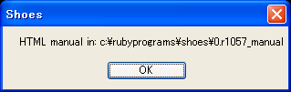
C:\>cd C:\Program Files\Common Files\Shoes\0.r1057
C:\Program Files\Common Files\Shoes\0.r1057>shoes --manual-html C:\rubyprograms\shoes\0.r1057_manual

It works well! Html files were created in my pc. Cool!
# shoes_manual-html2.png
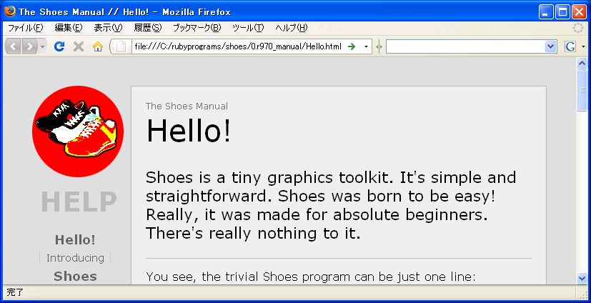

5.4 App object and coding style

A Shoes App object is a single window running code at a Shoes URL. When you switch Shoes URLs, a new App object is created. The App itself is a flow. The Shoes program has three coding style:

# sample16.rb
Shoes.app :width => 150, :height => 40 do
para 'Hello world!', :align => 'center'
end

# sample16.png
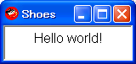

# sample17.rb
class Hello < Shoes
url '/', :index

def index
para 'Hello world!', :align => 'center'
end
end

Shoes.app :width => 150, :height => 40

# sample17.png
is the same as the above sample16.png.

# sample18.rb
class Shoes::Hello < Shoes::Widget
def initialize
para 'Hello World!', :align => 'center'
end
end

Shoes.app :width => 150, :height => 40 do
hello
end

# sample18.png
is the same as the above sample16.png.

5.5 Built-in Constants and methods

Built-in Constants:
Shoes::RELEASE_NAME
Shoes::RELEASE_ID
Shoes::REVISION

Built-in methods:
These methods can be used anywhere throughout Shoes programs:
alert, ask, ask_color, ask_open_file, ask_save_file, confirm, debug, error, exit, gradient,
gray, info, rgb, warn

Read the Built-in manual -> Hello! -> Built-in section.

5.6 Scope: A tip of using the YAML file
# make_sample19_yaml.rb
require 'yaml'

data =<<-EOS
Satoshi Asakawa, Japan
Tom Jonson, Italy
EOS

Gang = Struct.new :name, :country

gangs = []
data.each{|d| gangs << Gang.new( *(d.chomp.split(',')) )}

open('gangs.yml', 'w'){|f| f.puts YAML.dump(gangs)}

# gangs.yml
---
- !ruby/struct:Gang
name: Satoshi Asakawa
country: " Japan"
- !ruby/struct:Gang
name: Tom Jonson
country: " Italy"

# sample19.rb
require 'yaml'

Shoes.app do
Gang = Struct.new :name, :country
gangs = YAML.load_file(Dir.pwd + '/gangs.yml')
gangs.each{|g| para g.name, g.country, "\n"}
end

# sample19.png
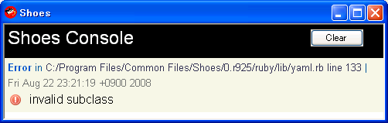

The top-level namespace in any Shoes app is Shoes.
So, in the sample19.rb

Gang = Struct.new :name, :country

It really make a Shoes::Gang struct, not a Gang struct. I
So, change that line to this and it (sample19-1.rb) works well.

::Gang = Struct.new :name, :country

# sample19-1.rb
require 'yaml'

Shoes.app :width => 200, :height => 100 do
::Gang = Struct.new :name, :country
gangs = YAML.load_file(Dir.pwd + '/gangs.yml')
gangs.each{|g| para g.name, g.country, "\n"}
end

# sample19-1.png
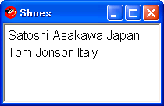

5.7 keypress, mouse and clipboard

We can get mouse events.
We can get a string from the system clipboard and also store a string into the clipboard.
# sample20.rb
Shoes.app :title => 'Sorter', :width => 180, :height => 80 do
background gradient powderblue, royalblue
msg = para '', :size => 8

yar = image(Dir.pwd + '/yar.png', :left => 60, :top => 18).click do
self.clipboard = self.clipboard.sort unless self.clipboard.nil?
yar.transform :center
a = animate(24) do |i|
yar.rotate -15
a.stop if i > 22
end
end
yar.hover{msg.text = strong('Click Yar. She sorts clipboard text!')}
yar.leave{msg.text = ''}
end

# sample20.png
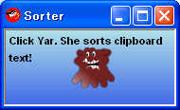

An example of the output.

before:
Creatures name list is:
looginkff
cy
kamome
yar
shaha

Copy the above list into the system clipboard.
Click Yar and she will rotate (*1).
Then paste the clipboard text into the place you want.

*1: With Shoes-0.r925, Yar rotates well expected. But with Shoes-0.r970, Yar rotates when mouse moves out of the Shoes window. This behavior is a bug. It will be fixed in the next Shoes release.

after:
Creatures name list is:
cy
kamome
loogink
shaha
yar

We can get keypress.
# sample21.rb
Shoes.app :width => 250, :height => 40 do
@info = para 'NO KEY is PRESSED.'
keypress{|key| @info.text = "#{key.inspect} was PRESSED."}
end

# sample21.png
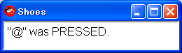

5.8 the Widget class

A custom Shoes widget is setup by inheriting from the Widget class.
And Shoes then creates a method using the lowercased name of the class which is used in your app.

# sample22.rb
class Shoes::Answer < Shoes::Widget
attr_reader :mark
def initialize word
para word
@mark = image(Dir.pwd + '/loogink.png', :width => 20, :height => 20).hide
end
end

Shoes.app :width => 200, :height => 130 do
stack :width => 0.5 do
background palegreen
para '1. apple'
ans = answer '2. tomato'
para '3. orange'
button('Ans.'){ans.mark.toggle}
end
stack :width => 0.5 do
background lightsteelblue
para '1. cat'
para '2. dog'
ans = answer '3. bird'
button('Ans.'){ans.mark.toggle}
end
end

# sample22.png
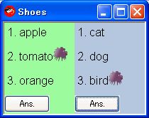

5.9 shape

We can make the arbitrary shape what ever we want.
Beginning at coordinates (left, top).

# sample23.rb
Shoes.app :width => 140, :height => 120 do
fill yellow
shape :left => 30, :top => 30 do
line_to 50, 30
curve_to 100, 100, 10, 20, 100, 50
line_to 20, 100
line_to 30, 30
end
end

# sample23.png
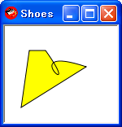
Oops, with Shoes-0.r925, it doesn't work well.
I'm not sure this behavior is the new spec or bug...
The above screenshot is with Shoes-0.r905.

# sample23-1.png
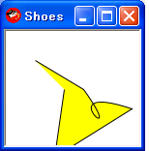
With Shoes-0.r970, it works well. Although be a little bit different from the above pic…
In the case of Shoes-0.r1057, it works as same as Shoes-0.r970.

5.10 mask

We can use a masking layer.
See the following information.
Cut Holes In Shoes And Get A Mask
(http://hackety.org/2007/08/28/cutHolesInShoesAndGetAMask.html)

# sample24.rb
Shoes.app :width => 160, :height => 80 do
def mask_words
strokewidth 4
160.times do |i|
stroke send COLORS.keys[rand COLORS.keys.length]
line i * 4 - 50, 0, i * 4, 80
end
mask :margin => 4 do
title strong 'Shoes'
end
end

mask_words
every 3 do
clear{ mask_words }
end
end

# sample24.png
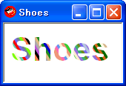

5.11 Drawing directly on to images

We can draw some elements on to the images.
In the below sample app, Cy (green creature) has a star!
# sample25.rb
Shoes.app :width => 250, :height => 76 do
background lightsalmon
icon = image :width => 74, :height => 74 do
oval :width => 70, :height => 70, :fill => lightskyblue,
:stroke => red, :left => 2, :top => 2
end
icon.image Dir.pwd + '/cy.png', :left => 10, :top => 8
icon.star 35, 45, 5, 8, 3, :fill => hotpink, :stroke => nil
msg = para '', :stroke => white

icon.hover do
@a = animate do
button, left, top = self.mouse
msg.replace strong icon[left, top]
end
end
icon.leave do
@a.stop
msg.replace ''
end
end

# sample25.png
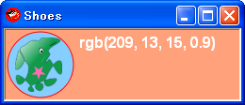

In the case of Shoes-0.r970, you need doing the mouse leaving once. After that it works well.
In the case of Shoes-0.r1057, no need to do that.

5.12 Style

We can change the style of the element with the style method. Calling the style method with no arguments returns a hash of the styles presently applied to the element.

More information is : 6.3 Styling Master List

# sample26.rb
Shoes.app :width => 400, :height => 250 do
def sampling
stack(:width => 1.0){para 'p: pause r: restart'}
#stack(:width => 0.5){@o = oval 0, 0, 50}
stack(:width => 0.5){@r = rect 0, 0, 50, 50, 10}
stack(:width => 0.5){@p = para ''}

@a = every(1) do
@r.style :width => 10 + rand(100), :height => 10 + rand(100),
:curve => rand(20),
:fill => send( COLORS.keys[rand COLORS.keys.length] ),
:strokewidth => rand(10),
:stroke => send( COLORS.keys[rand COLORS.keys.length])
@r.move rand(100), rand(100)
@p.replace @r.style.to_a.map{|e| e.join(': ')}.join("\n")
end
end

sampling
keypress do |k|
case k
when 'p'
@a.stop
when 'r'
@a.stop if @a
clear{sampling}
else
end
end
end

# sample26.png
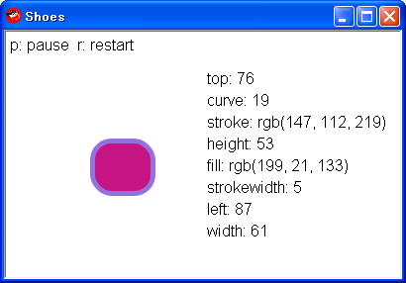

5.13 Shoes.setup

If your Shoes app requires some libraries, this might be useful.
See the following information.
Clearing Up The Whole Shoes And RubyGems Deal
(http://hackety.org/2008/05/08/clearingUpTheWholeShoesAndRubyGemsDeal.html)
# sample27.rb
Shoes.setup do
gem 'something'
end

Shoes.app do
para require 'something'
end

# sample27.png
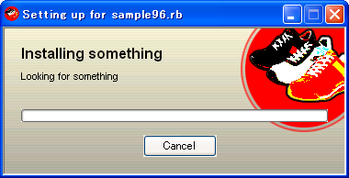
But now, with Shoes-0.r1057, this feature doesn’t work well…

5.14 Downloader

The methods download and progress are so cool.
Although percent and length methods don't work well now, transferred and fraction work well.

# sample28.rb
Shoes.app :width => 450, :height => 100 do
stack :margin => 10 do
url = 'http://shoooes.net/dist/shoes-0.r1057.exe'
status = para "Downloading #{url}"
p = progress :width => 1.0

download url,
:save => Dir.pwd + '/' + File.basename(url),
:start => proc{|dl| status.text = 'Connecting...'},
:progress => proc{|dl|
status.text = "Transferred #{dl.transferred} of #{dl.length} bytes (#{dl.percent}%)"
p.fraction = dl.percent * 0.01},
:finish => proc{|dl| status.text = 'Download finished'},
:error => proc{|dl, err| status.text = "Error: #{err}" }
end
end

# sample28.png
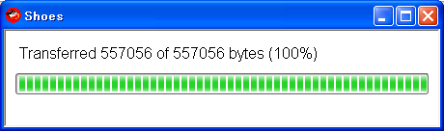

More information about downloader. See the built-in manual.
Shoes includes the Hpricot library for parsing HTML.

5.15 Assign Shoes URL dynamically

We can use regular expressions to assign Shoes URL dynamically.
Shoes passes the match data to the method as the argument.
Show the following sample code revised the above sample11.rb.
# sample29.rb
class PhotoFrame < Shoes
url '/', :index
url '/(.+)', :index

Creature = Struct.new :name, :sex, :wallpaper
@@c = []
@@c << Creature.new('loogink', 'She', 'tomato')
@@c << Creature.new('cy', 'He', 'paleturquoise')

def index n = rand(2)
n = n.to_i
background eval(@@c[n].wallpaper)
image Dir.pwd + '/' + @@c[n].name + '.png', :left => 70, :top => 10
para "\n" * 3
para strong "#{@@c[n].sex} is #{@@c[n].name.capitalize}. :)", :stroke => white
n = n.zero? ? 1 : 0
para '->', link(strong(@@c[n].name.capitalize), :click => "/#{n}")
end
end

Shoes.app :width => 200, :height => 120, :title => 'Photo Frame'

# sample29.png
is almost the same as the above sample11.png.

5.16 Classes List and Colors List

We can see the colors list in the built-in manual.
But we will also be able to see them by the following sample code.
# sample30.rb
Shoes.app :width => 642, :height => 700, :resizable => false do
COLORS.keys.map{|sym|sym.to_s}.sort.each do |color|
flow :width => 160, :height => 20 do
c = send(color)
fill c
rect 0, 0, 160, 20
inscription color, :stroke => c.dark? ? white : black
end
end
end

# sample30.png
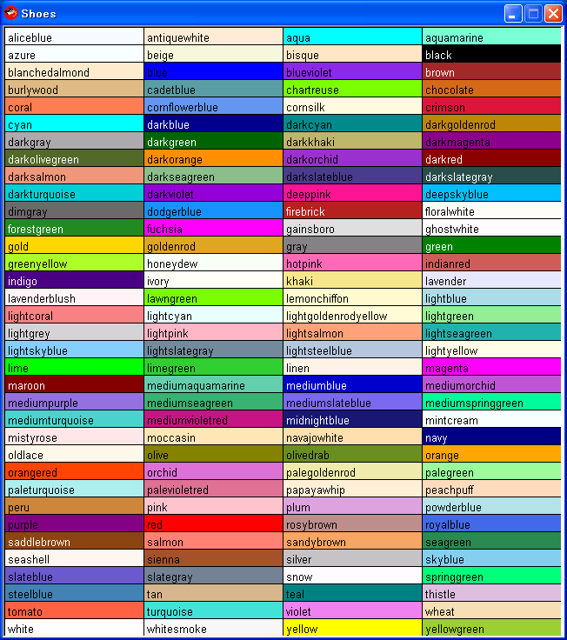

_why is thinking about some more method related colors.
e.g. invert, dark?, light?, black?, white?, opaque?, transparent?
We might be able to get them in the near future.

5.17 start, stop and restart

We can start something with initial condition, then stop and restart the same thing with other condition.
#sample31.rb
Shoes.app :width => 150, :height => 70 do
def number_on_disk
fill eval(@color)
nostroke
oval 0, 0, 30
@l = para ''
animate(3){@l.replace strong @i+=1, :stroke => white}
end

@color = 'blue'
@i = 0
@slot = flow{number_on_disk}

button('chang') do
@slot.clear
@color = %w(green red blue yellow)[rand(4)]
@i = 0
@slot.append{number_on_disk}
end
end

# sample31.png
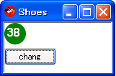

5.18 Combination of image objects show/hide and mouse hover/leave
We've already learned many useful methods like show/hide and hover/leave.
This tiny sample shows us a wonderful combination.
#sample32.rb
Shoes.app :width => 350, :height => 250, :title => 'Menus' do
def menu items
flow do
items.each_with_index do |e, i|
nostroke
nofill
b = image(:width => 100, :height => 21){rect(0, 0, 100, 21)}
f = image(:width => 100, :height => 21){rect(0, 0, 100, 21,
:fill => yellow,:curve => 8)}.hide
b.move 0, i*23
f.move 0, i*23
para i, '. ', e, "\n"
b.hover{f.show; @msg.text = strong(e)}
b.leave{f.hide; @msg.text = ''}
end
end
end

para 'Selected: '
@msg = para '', :stroke => green

flow :left => 50, :top => 50 do
para strong "What?\n"
menu %w(apple tomato orange)
end
flow :left => 200, :top => 50 do
para strong "Who?\n"
menu %w(Satoshi Krzysztof Victor Leticia Mareike)
end
end

# sample32.png
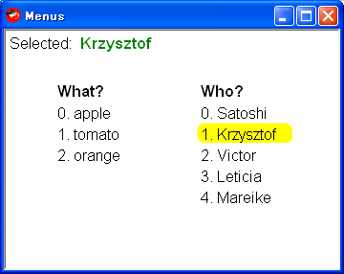

This one is another sample code. It shows the MENUs using many buttons.

#sample33.rb
Shoes.app :title => 'Button MENU', :height => 250 do
def menu title, items, n
button title, :align => 'center', :width => 100 do
if @toggle[n]
items.each{|e| @f[n].append{button(e, :align => 'center',
:width => 100){@msg.text = strong(e)}}}
else
@f[n].clear
@msg.text = ''
end
@toggle[n] = !@toggle[n]
end
end

para 'Selected: '
@msg = para '', :stroke => green

@toggle = true, true
@f = []

flow :left => 30, :top => 50, :width => 100 do
menu 'Who?', %w(Satoshi Vic Mareike Krzysztop Leticia), 0
end
@f << flow(:left => 30, :top => 90, :width => 100)

flow :left => 150, :top => 50, :width => 100 do
menu 'What?', %w(apple banana orange), 1
end
@f << flow(:left => 270, :top => 50, :width => 400)
end

# sample33.png
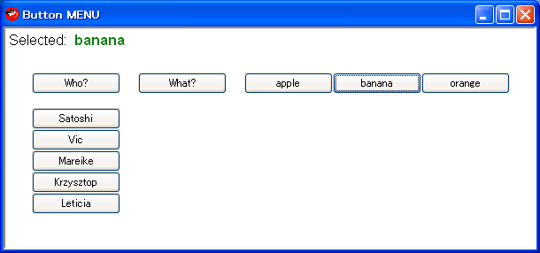

And this one is a combination of sample32 and 33.
#sample34.rb
Shoes.app :title => 'Image MENU', :height => 250 do
background lightskyblue.to_s..lightsalmon.to_s, :angle => 30

def menu title, items, n
nostroke
nofill
tb = image(:left => 0, :top => 0, :width => 100,
:height => 21){rect(0, 0, 100, 21)}
para strong title
@f ||= []
@f << flow do
items.each_with_index do |e, i|
nostroke
nofill
b = image(:width => 100, :height => 21){rect(0, 0, 100, 21)}
f = image(:width => 100, :height => 21){rect(0, 0, 100, 21,
:fill => khaki,:curve => 8)}.hide
yield b, f, i, e
b.hover{f.show}
b.leave{f.hide}
b.click{@msg[n].text = strong(e)}
end
end.hide

tb.click{@f[n].toggle; @msg[n].text = ''}
end

@msg = []
para 'Selected Who?: '
@msg << para('', :stroke => forestgreen)
para 'Selected What?: ', :left => 300
@msg << para('', :stroke => tomato)

flow :left => 30, :top => 50, :width => 100 do
menu 'Who?', %w(Satoshi Vic Mareike Krzysztop Leticia), 0 do |b, f, i, e|
b.move 0, i*23
f.move 0, i*23
para i, '. ', e, "\n"
end
end

flow :left => 150, :top => 50, :width => 400 do
menu 'What?', %w(apple banana orange), 1 do |b, f, i, e|
b.move((i+1)*102 , -32)
f.move((i+1)*102 , -32)
para "#{i}. #{e}", :left => 150 + (i+1)*102, :top => 50
end
end
end

# sample34.png
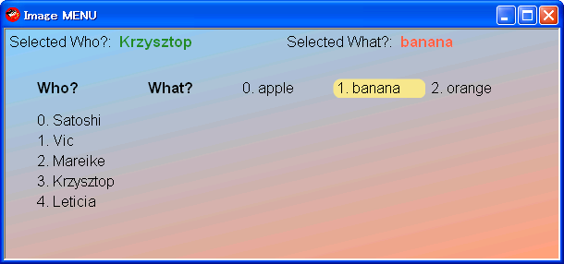

If you want to hide the items when mouse clicks on it, do the following revising and try to run.

Line No.20
b.click{@msg[n].text = strong(e)}
----> b.click{@msg[n].text = strong(e); @f[n].toggle}

Line No.24
tb.click{@f[n].toggle; @msg[n].text = ''}
----> tb.click{@f[n].toggle}

# The edited code is sample34-1.rb and the screenshot is sample34-1.png.

# This MENUs-like user interface original idea was provided by Krzysztop Wicher.

5.19 arc and cap

New arc and cap methods are released in the 970th build.
See the following article:
(http://newwws.shoooes.net/2008/09/10/arcs.html)

And _why shows us a wonderful combination of the animate method.

#sample35.rb
Shoes.app :width => 200, :height => 100, :title => 'Arc' do
fill green.to_s..yellow.to_s, :angle => 45
stroke red.to_s..blue.to_s, :angle => 90
strokewidth 10
cap :round

a = animate 12 do |i|
@c.remove if @c
r = i * (PI * 0.01)
@c = arc 100, 50, 180, 60, 0, i * (PI * 0.01)
a.stop if r >= TWO_PI
end
end

# sample35.png
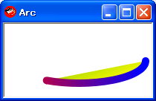
Started….

# sample35-1.png
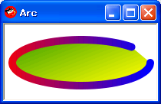
Almost finished….

5.20 widget with block

It’s good using the widget object with block in the case of getting the keypress or the mouse event smoothly.

#sample36.rb
class Shoes::Creature < Shoes::Widget
def initialize
msg = para '', :stroke => white
c = image Dir.pwd + '/yar.png'
yield c, msg
end
end

Shoes.app :width => 140, :height => 70 do
flow :left => 10, :top => 10 do
background blue.to_s..green.to_s, :width => 100, :height => 30
creature do |c, msg|
c.click do
msg.text = 'Uhhhh...'
a = animate(20){|i| c.rotate(-15); a.stop if i > 22}
end
c.hover{msg.text = 'hello'}
c.leave{msg.text = ''}
end
end
end

# sample36.png
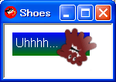

5.21 text message slide-in
_why gave us his one thousandth commit of Shoes on 24th Sep. And a new sample code simple-slide.rb: testing slide-in slide-out animation, too. This is the screenshot.
# simple-slide.png
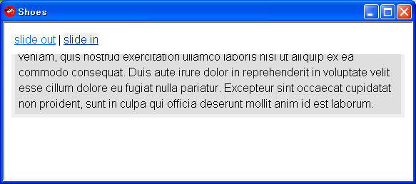
Next sample code, sample37.rb, which works almost similar behavior of the text message slide-in by using mask and animate methods.
#sample37.rb
episode1 =<<-EOS
Episode I
THE PHANTOM MENACE Turmoil has engulfed the Galactic Republic. The taxation of trade routes to outlying star systems is in dispute. \
Hoping to resolve the matter with a blockade of deadly battleships, the greedy Trade Federation has stopped all shipping to the small planet of Naboo. \
While the Congress of the Republic endlessly debates this alarming chain of events, the Supreme Chanccellor has secretly dispatched two Jedi Knights, the guardians of peace and justice in the galaxy, to settle the conflict... \
[Quote] http://www.starwars.com/episode-iii/bts/production/f20050126/indexp2.html
EOS

Shoes.app :width => 400, :height => 380, :title => 'Episode I' do
rect 0, 0, 400, 380, :fill => sandybrown
rect 10, 10, 380, 360, :fill => lavender, :curve => 10
stack do
nostroke
rect 10, 10, 380, 360, :fill => lightblue
oval 50, 40, 100, :fill => green
star 250, 245, 5, 100, 40, :fill => deeppink, :angle => 90
mask do
@t = para strong(episode1), :left => 15, :top => 340, :width => 380
end

@a = animate(36) do |i|
@t.left, @t.top = 15, 340 - i
@a.stop if i > 330
end
end
end

# sample37.png
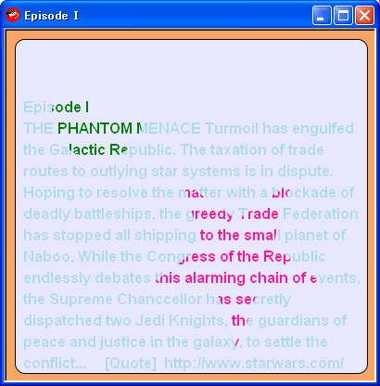

5.22 #! shoes

The sample38.rb has #! shoes on its first line. Shell will see the program file has a #! line and pass it to Shoes.

#sample38.rb
#! shoes
# sample38.rb

Shoes.app :width => 150, :height => 50 do
para strong('Hello World!'), :stroke => red
end

# sample38.png
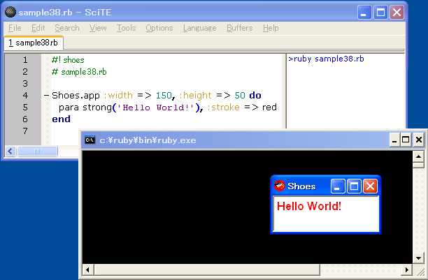

Write code with SciTE and push F5, then kick up Shoes!

And next.
The sample38-1.rb is a Ruby program, not Shoes app. But it’ll launch the Shoes app.

#sample38-1.rb

%x(ruby sample38.rb)

5.23 loading widgets from other files?

The sample39.rb has a require method to load the custom widget class stored in the other file (sample39_creature.rb).

loading widgets from other files?
http://www.mail-archive.com/shoes@code.whytheluckystiff.net/msg01971.html

The Main App and Its Requires
http://help.shoooes.net/Rules.html

#sample39.rb
require 'sample39_creature'

Shoes.app :title => 'go next', :width => 300, :height => 300 do
background moccasin, :margin=> 20, :curve => 20
c = creature(Dir.pwd + '/loogink.png', 50, 100)

routes = [[100, 50], [150, 50], [200, 100], [200, 150], [150, 200], [100, 200],
[50, 150], [50, 100], [150, 50], [100, 200], [50, 100]]
i = -1
para link('go next'){
begin
x, y = routes[(i+=1) % 10]
@msg.text = "#{c.position.inspect}-->[#{x},#{y}]"
c.glide [x, y], :line => true
end unless c.playing?
}

@msg = para ''
end

# sample39.png
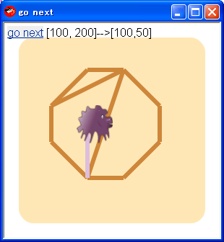

#sample39_creature.rb
class Shoes::Creature < Shoes::Widget
def initialize path, x, y
@path = path
@img = image path
@img.move x, y
end
def glide args, opt = {:line => false}
args << @img.left << @img.top
x1, y1, x0, y0 = args.collect{|e| e.to_f}
a = animate(48) do |i|
@playing = true
case
when x0 < x1
x = x0 + i
y = y0 + (y1 - y0) / (x1 - x0) * i if y0 < y1
y = y0 if y0 == y1
y = y0 - (y0 - y1) / (x1 - x0) * i if y0 > y1
max = x1 - x0
when x0 == x1
x = x0
y = y0 + i if y0 < y1
y = y0 - i if y0 > y1
y = y0 if y0 == y1
max = (y1 - y0).abs
when x0 > x1
x = x0 - i
y = y0 + (y1 - y0) / (x0 - x1) * i if y0 < y1
y = y0 if y0 == y1
y = y0 - (y0 - y1) / (x0 - x1) * i if y0 > y1
max = x0 - x1
else
end
@l.remove if @l
strokewidth 6
@l = line(x0 + 15, y0 + 15, x.to_i + 15, y.to_i + 15,
:stroke => thistle) if opt[:line]
#@img.move x.to_i, y.to_i
@img.remove
@img = image @path, :left => x.to_i, :top => y.to_i
if i == max
a.stop
@playing = false
line(x0 + 15, y0 + 15, x.to_i + 15, y.to_i + 15, :stroke => peru) if opt[:line]
@img.remove
@img = image @path, :left => x.to_i, :top => y.to_i
end
end
end
def position
[@img.left, @img.top]
end
def playing?
@playing
end
end

5.24 optional arguments

When we create an oval shape, like
oval :left => 50, :top => 50, :width => 30
The :left and :top positions are the top-left corner of the oval.

But we create an star shape, like
star :left => 50, :top => 50, :points => 5, :outer => 15, :inner => 10
The :left and :top positions are the center of the star.
A bit strange behavior…

# This information was provided by Sergio Silva.

# sample40.rb
Shoes.app :width => 330, :height => 150 do
nofill
strokewidth 2
oval 50, 50, 50, :stroke => blue
rect 150, 50, 50, 50, :stroke => green
star 250, 50, 5, 30, 20, :stroke => black
oval 50, 50, 1, :stroke => red, :fill => red
oval 150, 50, 1, :stroke => red, :fill => red
oval 250, 50, 1, :stroke => red, :fill => red
end

# sample40.png
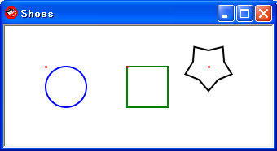

We can use the :center option to specify the coordinates. But it works well only in the case of the oval and rect methods except the star method. If we add undefined option, like :oops, as one of the arguments, no error will occur and nothing will happen, just ignored.

Although I don’t know this behavior is a spec or a bug…

# sample40-1.rb
Shoes.app do
stack :width => 0.3 do
nofill
strokewidth 2
oval 50, 50, 1, :stroke => red, :fill => red
@o = oval 50, 50, 50, :stroke => blue, :center => false, :oops => true
@p1 = para '', :top => 150
end

stack :width => 0.3 do
nofill
strokewidth 2
oval 50, 50, 1, :stroke => red, :fill => red
@r = rect 50, 50, 50, 50, :stroke => green, :center => true, :oops => true
@p2 = para '', :top => 150
end

stack :width => 0.4 do
nofill
strokewidth 2
oval 50, 50, 1, :stroke => red, :fill => red
@s = star 50, 50, 5, 30, 20, :stroke => black, :center => false, :oops => true
@p3 = para '', :top => 150
end

@p1.text = @o.style.map{|e| e.join(': ')}.sort.join("\n")
@p2.text = @r.style.map{|e| e.join(': ')}.sort.join("\n")
@p3.text = @s.style.map{|e| e.join(': ')}.sort.join("\n")
end

# sample40-1.png
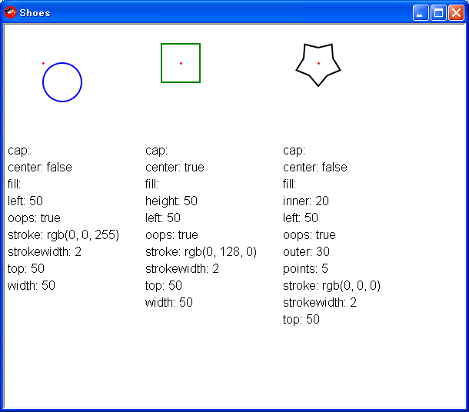

In the above sample40-1, the oval and rect methods accepted :center option, but the star method ignored it as same as the undefined option :oops.

5.25 slot with scrollbar

The :scroll option establishes the slot as a scrolling slot.

# sample41.rb
Shoes.app :width => 240, :height => 161, :resizable => false do
image Dir.pwd + '/jellybeans.jpg'
flow :width => 100, :height => 40, :left => 2, :top => 2, :scroll => true do
background bisque
30.times do |i|
color = COLORS.keys.map{|sym|sym.to_s}.sort_by{rand}
para "colorful jellybeans", :stroke => send(color.first)
end
end
end

# sample41.png
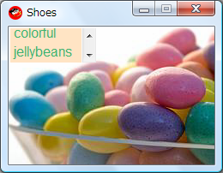

5.26 The :state style
The :state style is for disabling or locking certain controls, if you do not want them to be edited.
# sample42.rb
Shoes.app :width => 400, :height => 410 do
src = IO.read(ARGV[0])
background deepskyblue

stack do
caption strong ":state >> string"
para '# sample42.rb'
end

eb = edit_box :text => src, :width => 1.0, :height => 0.75, :state => 'readonly'

button('edit'){eb.state = eb.state ? nil : 'readonly'}

b1 = button 'save', :state => 'disabled' do
file = ask_save_file
open(file, 'wb'){|f| f.puts eb.text} if file
end

b2 = button 'password' do
pw = ask 'Enter your password: ', :secret => true
(b1.state = nil; b2.state = 'disabled') if pw == 'Ruby&Shoes'
end
end

# sample42.png
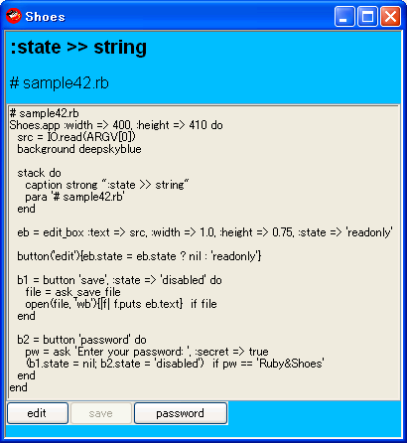

Hot Topics in the Shoes ML and Shoooes.net
Picked up some topics here which were discussed in the Shoes ML nowadays.

6.1 External Fonts
_why added support to Shoes for loading .ttf and .otf files (and others, depending on your platform.)
Can’t wait next build.

+ external font files
(http://www.mail-archive.com/shoes@code.whytheluckystiff.net/msg02092.html)

6.2 Locking edit_box
If Shoes makes the edit_box read-only, we can select (copy) text data from that.

Locking edit boxes
(http://www.mail-archive.com/shoes@code.whytheluckystiff.net/msg02120.html)

6.3 Styling Master List
It's the last big missing piece of the built-in manual.

The Styles Master List
(http://help.shoooes.net/Styles.html)

Assignment

7.1 Assignment 1 – twitter client (reader)

The following spec is an example.
Let's imagine freely and write your own twitter listener.

Example spec:
- Access your twitter homepage: http://twitter.com/home
- Get the friends timeline: /statuses/friends_timeline.xml
- Display the latest 10 twitters.
- User interface image is:

# twitter_listener_snapshot.png
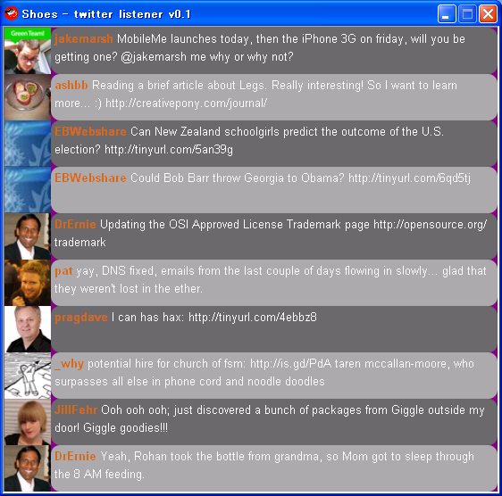
Have fun!

7.2 Assignment 2 – footracer

The following spec is an example.
Let's imagine freely and write your own Foot Race Game.

Example spec:
- Racers run toward the goal.
When the first racer meets the goal line, the game stops and then shows the winner.
- When multiple racers meet the goal line at a time, they are all winners.
- User inputs racers' names.
- Until user selects quit the game, user can play the game repeatedly.
- User interface image is:

# footracer_screenshot.jpg
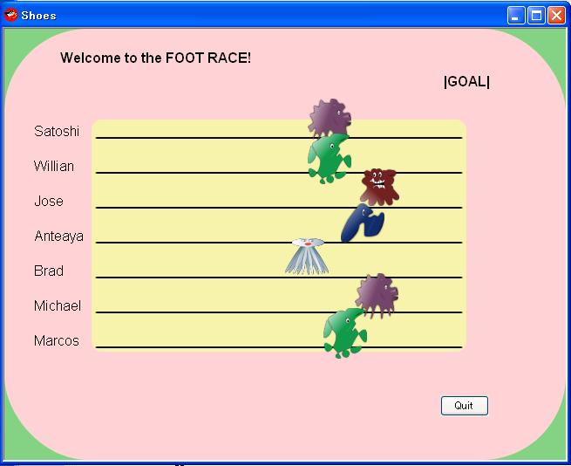
Have fun!

Relevant web sites (Links)

- Three manuals: Nobody Knows Shoes (NKS) and Built-in Manual and Online Reference Manual.
http://shoooes.net/manuals/

- The Shoes Help Desk: The spot for beginners and advanced Shoesers alike.
http://help.shoooes.net/

- The Shoebox
http://the-shoebox.org/

- Rubyinside.com the latest article
Shoes – Rubys Cross Platform GUI App Toolkit - Grows Up
(http://www.rubyinside.com/whys-shoes-grows-up-1014.html)

Appendix

9.1 Advanced article

-- Threaded XMLHttpRequest In Shoes
(http://hackety.org/2008/08/15/threadedDownloadsInShoes.html)
-- Stamping EXEs And DMGs
(http://hackety.org/2008/06/19/stampingExesAndDmgs.html)
-- Martin DeMello's Gooey Challenge
(http://hackety.org/2008/06/12/martinDemellosGooeyChallenge.html)
-- The Image Block At The Bottom Of Shoes
(http://hackety.org/2008/05/22/theImageBlockAtTheBottomOfShoes.html)

9.2 Shoes mailing list in English

To join the mailing list:

Send a message to shoes AT code.whytheluckystiff.net
Cc: why AT whytheluckystiff.net

The archives are available at
http://www.mail-archive.com/shoes@code.whytheluckystiff.net/
or
http://news.gmane.org/gmane.comp.lib.shoes

9.3 Shoes mailing list in Spanish

http://groups.google.com/group/zapatos

9.4 Shoes IRC channel

#shoes on irc.freenode.net

Trivia

- list_box needs to set :height explicitly
# sample91.rb
Shoes.app :width => 300, :height => 60 do
button('OK'){@msg.text = @e.text}
@e = list_box :items => ['blue', 'red', 'yellow'] , :height => 30
@msg = para ''
end

# sample91.png
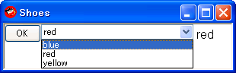
Try to comment out :height => 30 and run.
The list_box doesn't show the items.
But this strange behavior occurs only on Windows. On Mac OS X, it doesn’t.
# This OS X information was provided by George Thompson.

- wonder the mouse event behavior
# sample92.rb
Shoes.app :width => 150, :height => 100 do
@msg = para ''
nostroke

@img = image :width => 20, :height => 20, :left => 30, :top => 30 do
oval :radius => 10, :fill => red
end
@img.hover{ @msg.replace 'hello' }
@img.leave{ @msg.replace '' }

@o = oval :left => 60, :top => 60, :radius => 10, :fill => blue
@o.hover{ @msg.replace 'hi' }
@o.leave{ @msg.replace '' }
end

# sample92.png
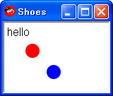
The image (red) oval works the mouse hovering feature but the blue doesn't.
This behavior is a bug. But it is fixed in the latest Shoes-0.r970.

- Shoes Fest
http://shoes.yapok.org/

- Shoes was born July 31st, 2007.
Yes, July 31st is the birthday and now one year old.

- Shoes wiki
New Shoes wiki was launched at Sep 12th, 2008.
(http://github.com/why/shoes/wikis)
Old one was retired. Now linked to the Shoes Official Homepage.
(http://code.whytheluckystiff.net/shoes/)
(http://shoooes.net/)

- Built-in sample apps
See the following directory (in the case of Windows XP and Shoes-0.r970)
There are many sample code. Let’s hack!

C:\Program Files\Common Files\Shoes\0.r970\samples

- Building Shoes
If you have to build Shoes by yourself, this information might be useful.
(http://github.com/why/shoes/wikis/buildingshoes)

- The Rules Of Shoes and UTF-8 Everywhere
Shoes scope makes us a bit confusing…
Shoes supports UTF-8 everywhere. Can’t wait to get the next build.
(http://newwws.shoooes.net/2008/09/22/the-rules-of-shoes.html)

- A very decent intro to shoes for beginners
http://ruby.about.com/od/shoes/Shoes.htm

- Lovely creatures in this tutorial created by Anita Kuno.
Each creature has his/her own name.
* purple is loogink
* brown is Yar
* green is Cy
* blue is kamome
* white is shaha

# sample93.rb
Shoes.app :width => 400, :height => 75, :title => 'Lovely Creaturs' do
background "#D0A".."#F90", :angle => 90
x = 0
creatures = %w(loogink yar cy kamome shaha).collect{|c| image Dir.pwd +
"/#{c}.png", :left => x += 60}

messages =<<-EOS
Thx for reading. :)
See you!
Enjoy Ruby and Shoes!
EOS
messages = messages.to_a

msg = subtitle '', :top => 30, :stroke => white
animate(3) do
creatures.each{|c| c.move c.left, rand(15)}
end

creatures.each do |c|
c.hover{msg.text = strong messages[rand(messages.length)]}
c.leave{msg.text = ''}
end
end

#sample93.png
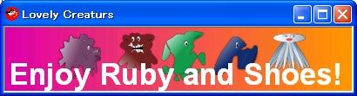
Let’s enjoy Ruby and Shoes with the Lovely Creaturs!

FIN.

