**React Component Structure:**

1. App
   1. ~~BodyWrapper~~
2. BodyWrapper
   1. Header that appears always at the top of the page (?)
   2. ~~Navbar~~
   3. ~~MainBody~~
   4. ~~Footer~~
3. Navbar
   1. GeneralLinks
   2. Link to UserRegistration (sign in / log in / sign out / log out)
   3. UserLinks
   4. EmployeeLinks
   5. ManagerLinks
   6. ShoesLinks

* links to different pages of the website

* should use element <Link> of React Router

* implement a PrivateLink element for link that accessible only to specific users or user that is logged in

* different links should always appear, and some should appear only if the user is logged in.

1. GeneralLinks
   1. Link to Contact
   2. Link to Home
   3. Link to CustomerService
2. UserLinks
   1. Link to UserCart
   2. Link to UserProfile
3. EmployeeLinks
   1. Link to ManageStock
   2. Link to ManageCustomers
4. ManagerLinks
   1. EmployeeLinks
   2. Link to ManageEmployees
5. ShoesLinks
   1. Link to Collection by category

Possible categories:

* + 1. Heels
    2. Wedges
    3. Sandals
    4. Boots
    5. Summer 2019 Collection
    6. etc.

* links to different collections of shoes

* Basically, a Link to the same URL, just a different category every time

1. MainBody
   1. Route to every above Link
   2. UserRoute
   3. EmployeeRoute
   4. ManagerRoute
   5. ItemCollectionRoute
   6. ItemRoute
   7. 404NoMatch

* should use element <Route> of React Router

* Implement PrivateRoute for the links that defined as PrivateLink

* contains within a <Switch> tag of React Router

1. CollectionRoute

* routes to the same component that shows a collection of shoes, just a different category passed as props for every different route

1. ItemRoute

* routes to a specific item

1. 404NoMatch

* a 404 page for URL that was not found with a link back to the home page

1. Collection
   1. List of ItemGalleryMode for every shoe in a collection
   2. Instance of ItemsFilters

* uses Mobx store to manage the shoes and filtering them

* should fill the Mobx store after the component loads (componentDidMount)

1. ItemGalleryMode
   1. Link to ItemPage
      1. Image
      2. Label
      3. Price

* represent a single item when a collection is shown

1. 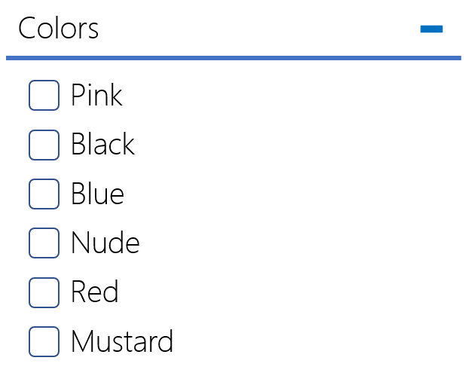ItemsFilters
   1. List of Filter for every possible filter

* should appear as a bar before a Collection component or the side

1. Filter
   1. Header of the filter
   2. List of checkboxes of possible values of the filter

* should be abled to be closed and opened

1. ItemPage
   1. Main image
   2. Additional images
   3. Label
   4. Description
   5. Price
   6. ItemQuantity
   7. AddToCart
   8. AddToWishlist
   9. AlsoViewed (?)

**Important Notes:**

* for every component that is private or specific to a position, should be a check before the component load that the user can access this component
* Style guide used for javascript : <https://github.com/airbnb/javascript>
* Technologies: React Router, Mobx