MY SCREENSHOTS:

Tasks performed:
- WSL installation
- GCC installation
- GCC version check

WSL installation –
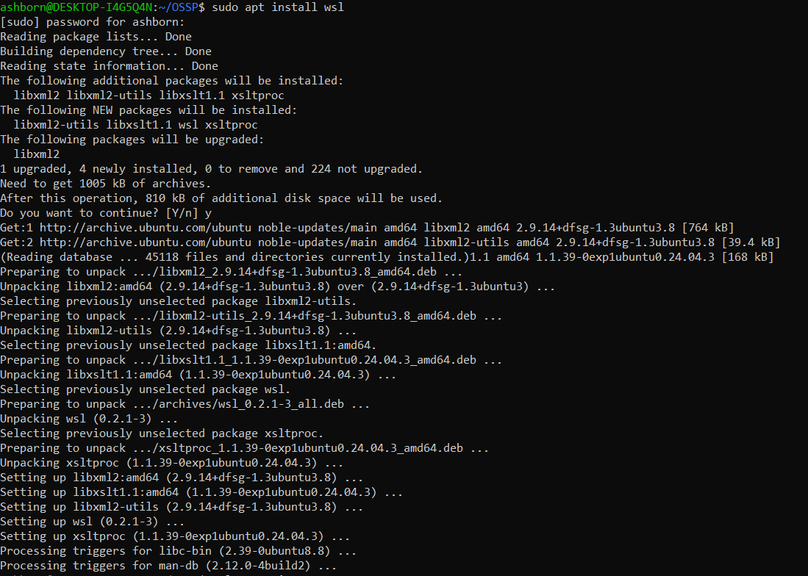

GCC installation –
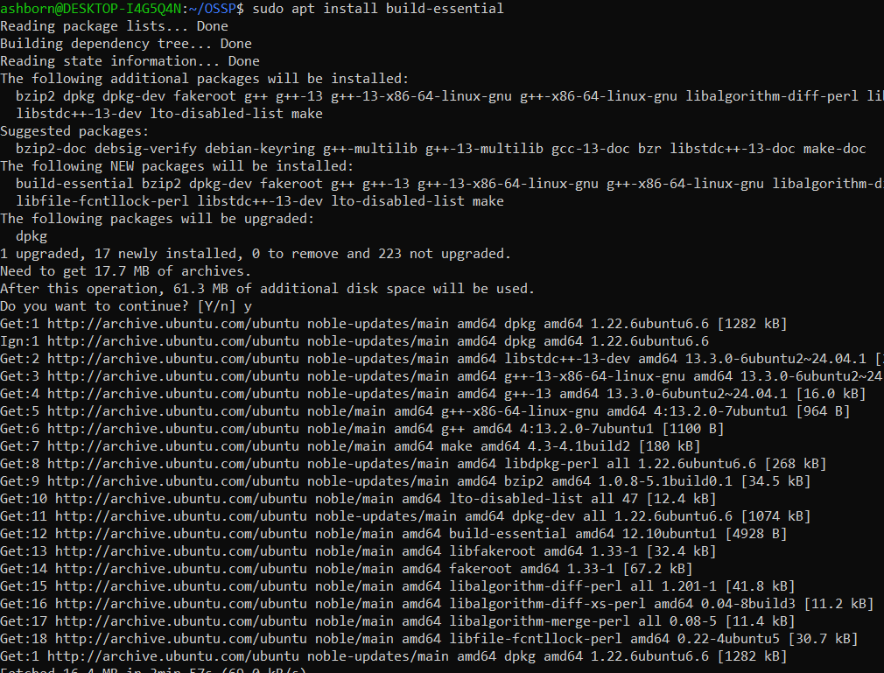
GCC version check –
