- To Install Linux VM, Configure GCC, Setup Git Repository, Create Project Structure, Understand Shell Architecture, Build Initial Makefile.

Task -1: Create Project Structure as follows:

OSSP/
│
├── .git/ # Git repository (created automatically)
├── .gitignore # Files/folders Git should ignore
├── README.md # Project description and instructions
├── LICENSE # Project license (optional)
├── Makefile # Build instructions
│
├── src/ # Source code
│ ├── main.c
│ ├── shell.c
│ ├── parser.c
│ ├── executor.c
│ └── builtin.c
│
├── include/ # Header files
│ ├── shell.h
│ ├── parser.h
│ ├── executor.h
│ └── builtin.h
│
├── obj/ # Object files (.o) (generated)
│
├── bin/ # Executable file (generated)
│ └── my_shell
│
├── docs/ # Documentation
│ ├── design.md
│ └── report.pdf
│
├── tests/ # Test programs
│ ├── test_parser.c
│ └── test_executor.c
│
├── scripts/ # Helper scripts
│ └── run.sh
│
└── assets/ # Images/screenshots
└── architecture.png
Note: For creating this structure use mkdir and touch commands.

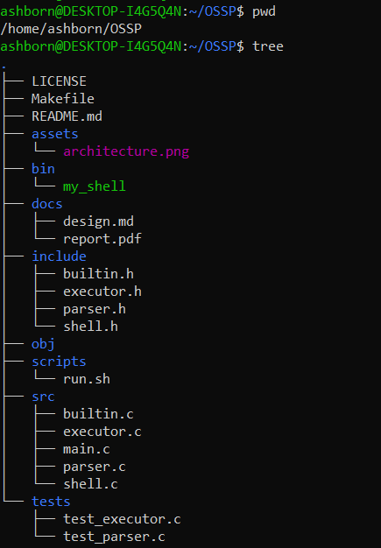

- To Analyze process abstraction, execute fork(), understand exec() family, analyze parent-child relationships, inspect process tree, practice system call tracing.

Task-1: Using a manual command understand the fork() and exec() system calls
Task-2: Write a C program to create a new process and accepting the user commands using fork() and exec() system calls.
Example:
#include <stdio.h>
#include <unistd.h>
int main() {
pid_t pid;
pid = fork(); // Create a new process
if (pid < 0) {
printf("Fork failed!\n");
}
else if (pid == 0) {
// Child Process
printf("This is the Child Process.\n");
printf("Child PID = %d\n", getpid());
}
else {
// Parent Process
printf("This is the Parent Process.\n");
printf("Parent PID = %d\n", getpid());
printf("Child PID = %d\n", pid);
}
return 0;
}

