**Information Retrieval**

**CS4051**

**Assignment 1**

**Boolean Retrieval Model**

**Ashar Usmani 22k-4581**

[**Code Link**](https://github.com/ashboy27/Boolean_Retrieval_Model)

**Query:** image AND restoration

**Output**

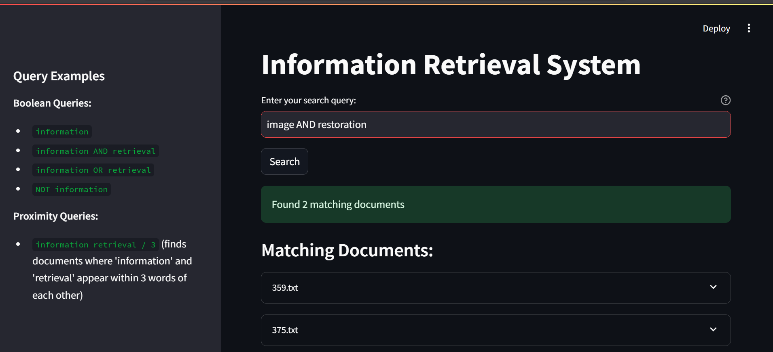

**Query:** deep AND learning

**Output**

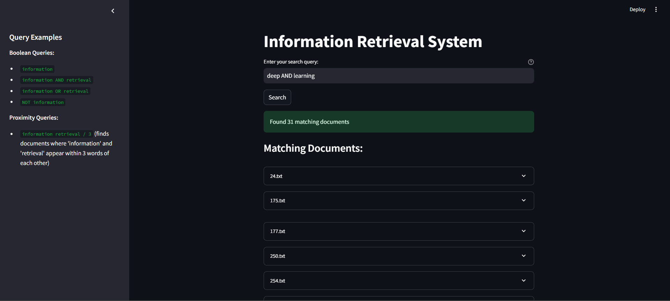

Scroll to view all 45 documents. There are 45 documents. Document 444 also contains both words but is not mentioned in mentioned in example output provided

**Query:** autoencoders

**Output**

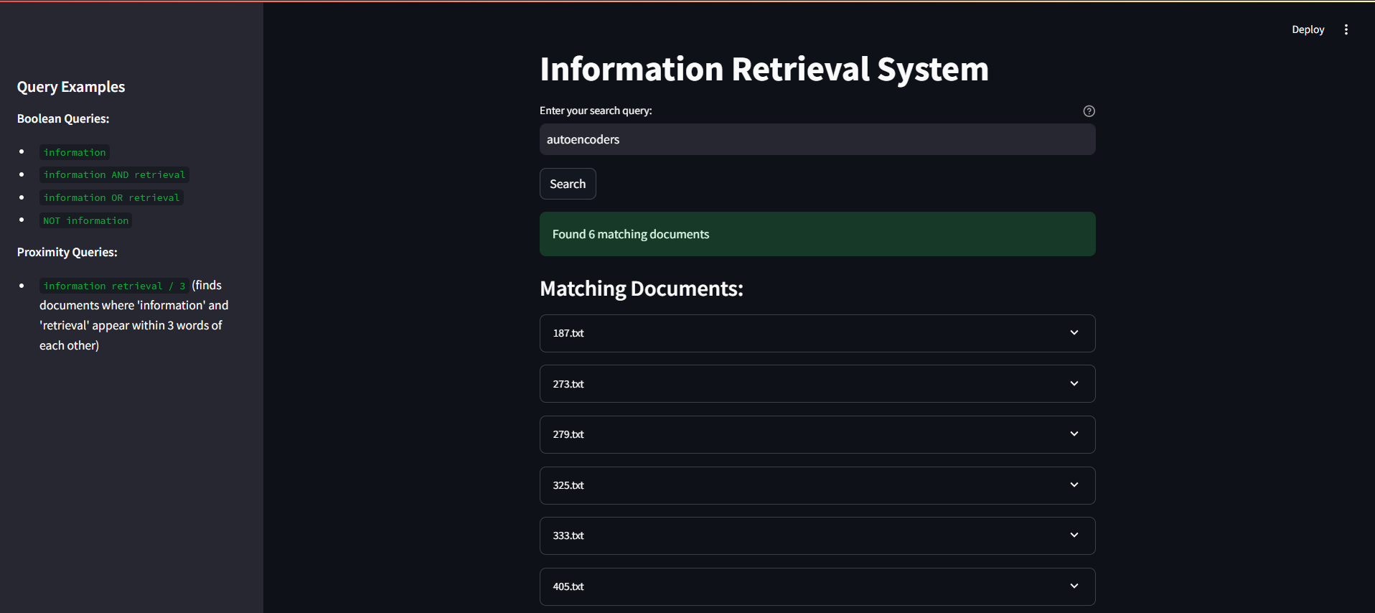

**Query:** temporal AND deep AND learning

**Output:**

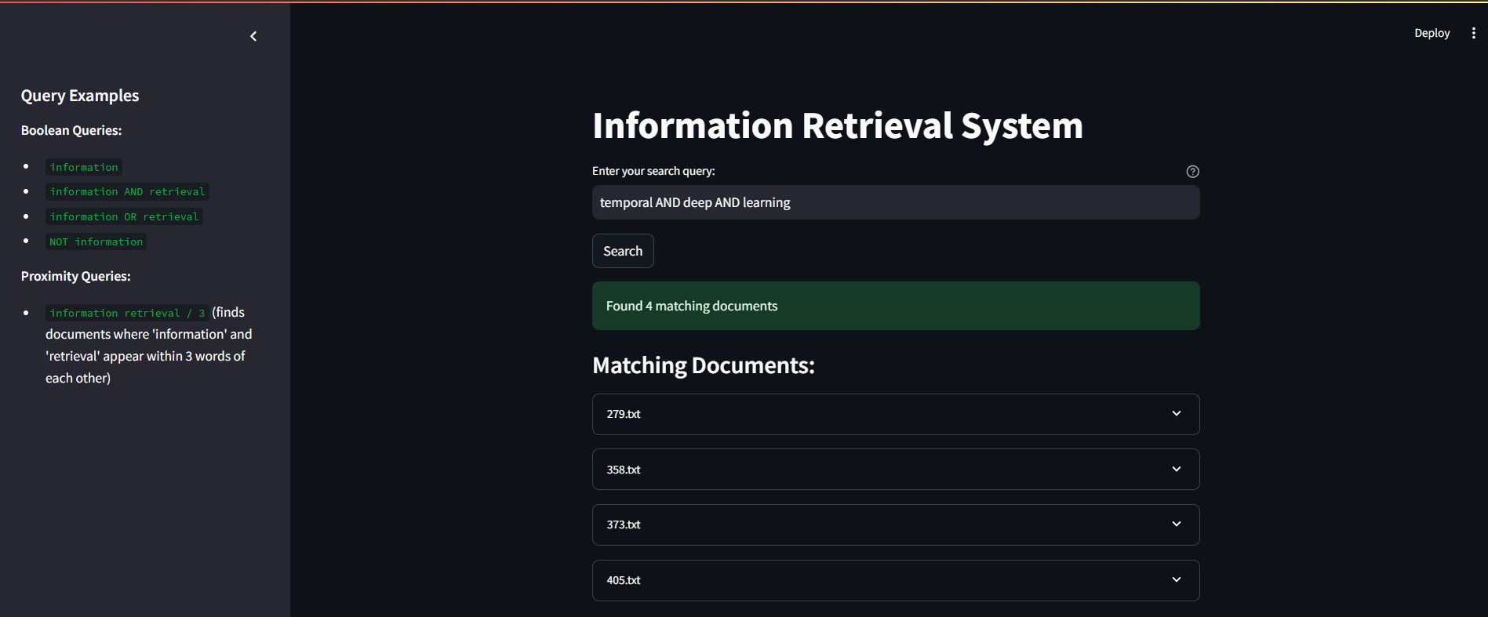

**Query:** time and series

**Output:**

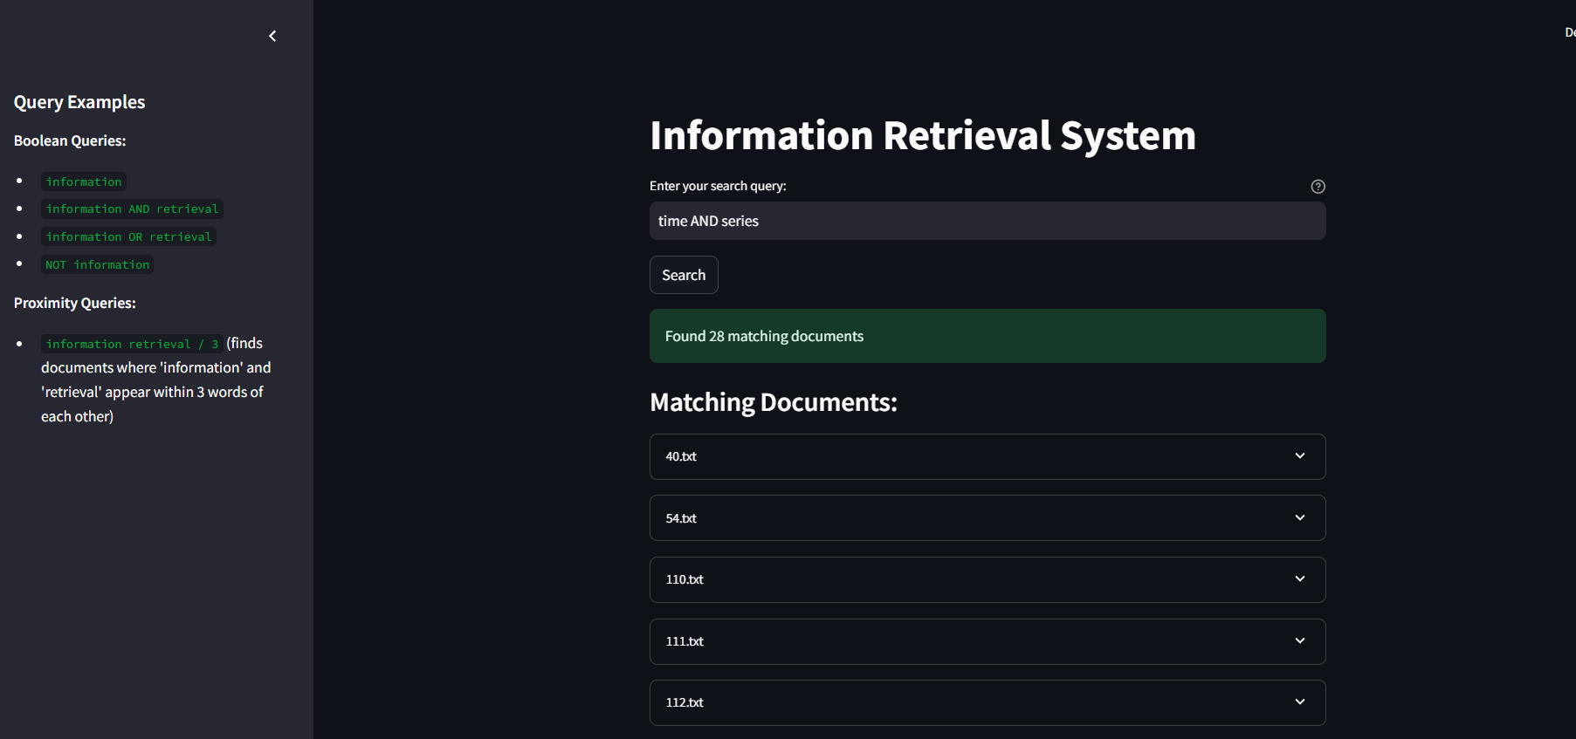

**Query:** time AND series AND classification

**Output:**

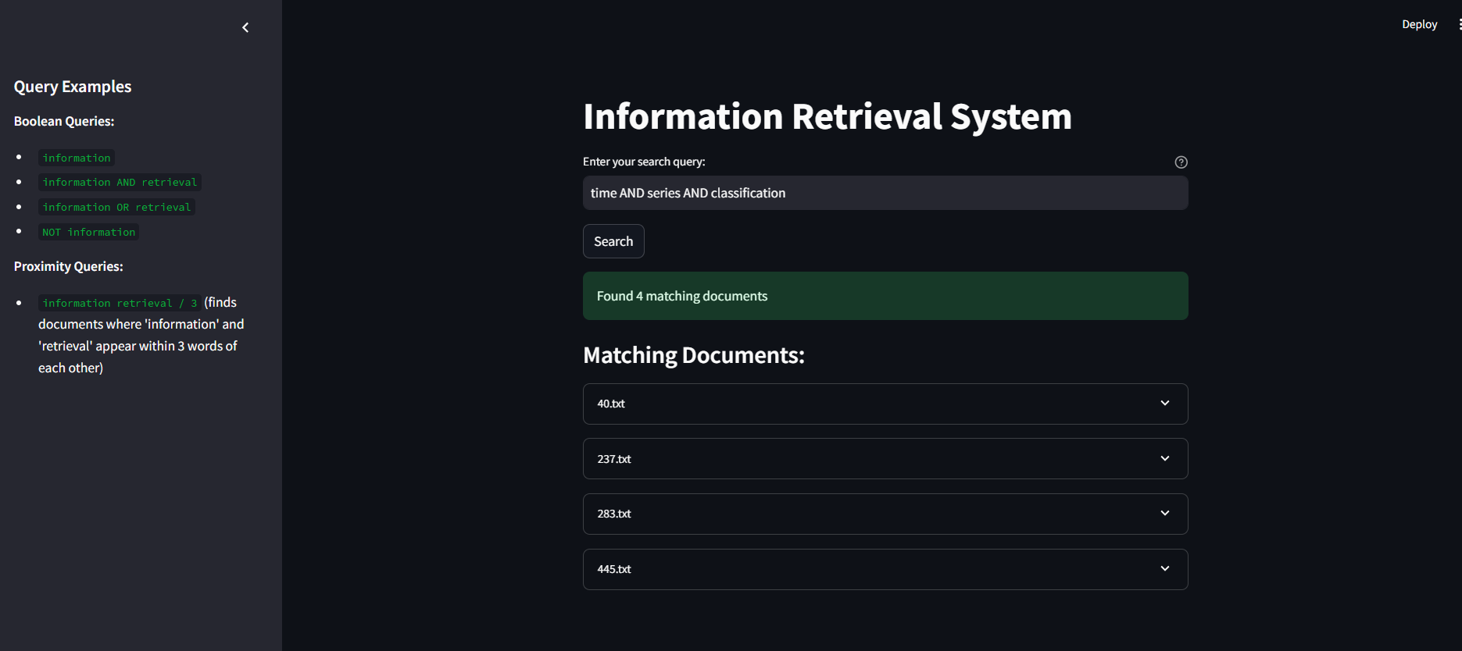

**Query:** time AND series OR classification

**Output:**

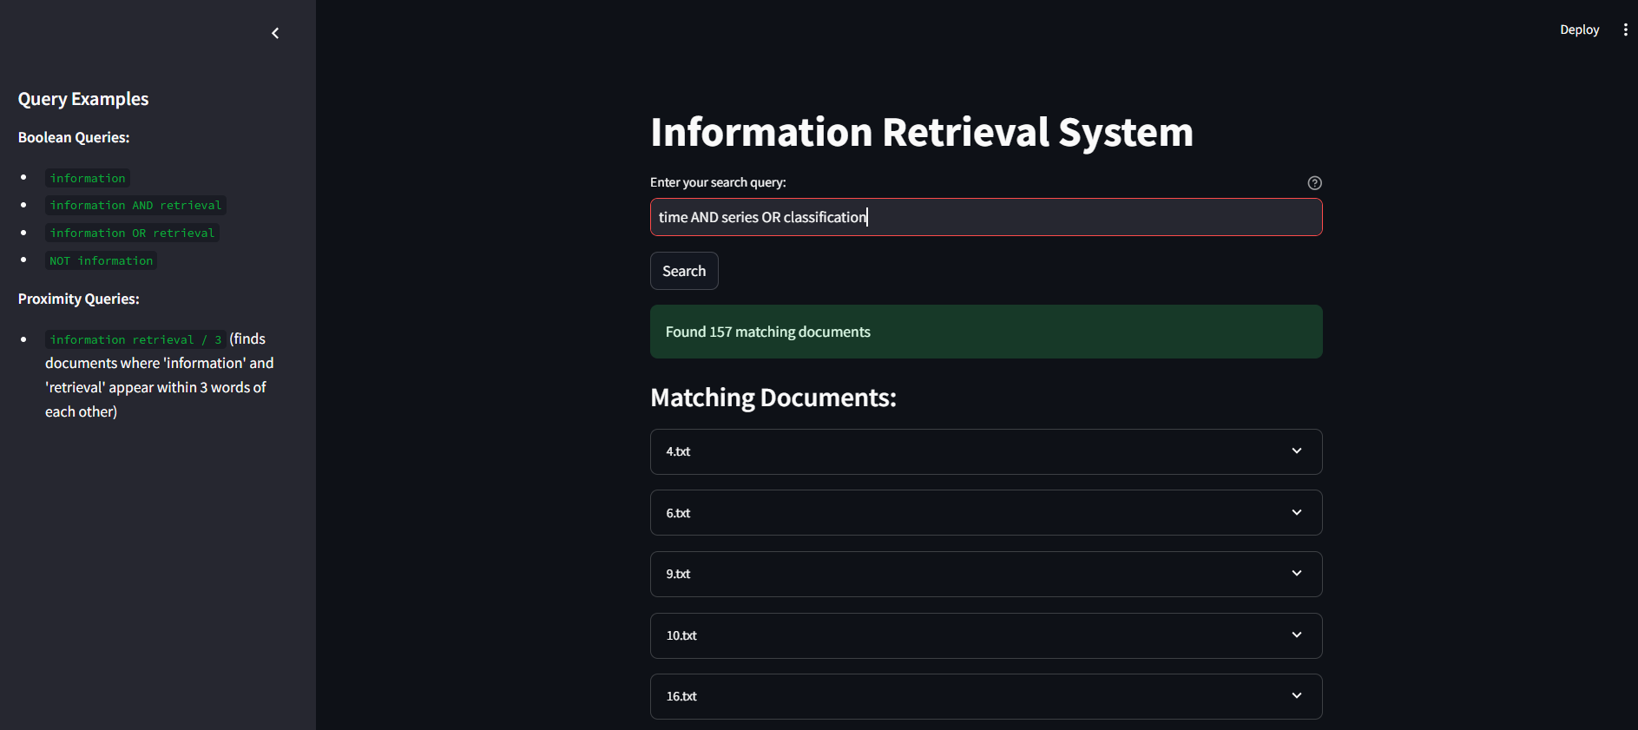

**Query:** pattern

**Output:**

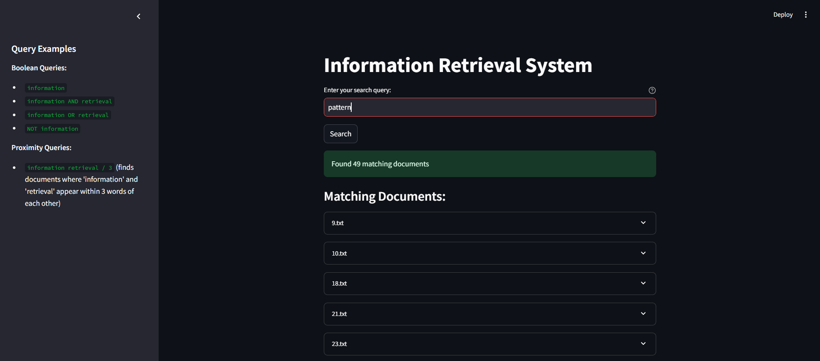

**Query:** pattern and clustering

**Output:**

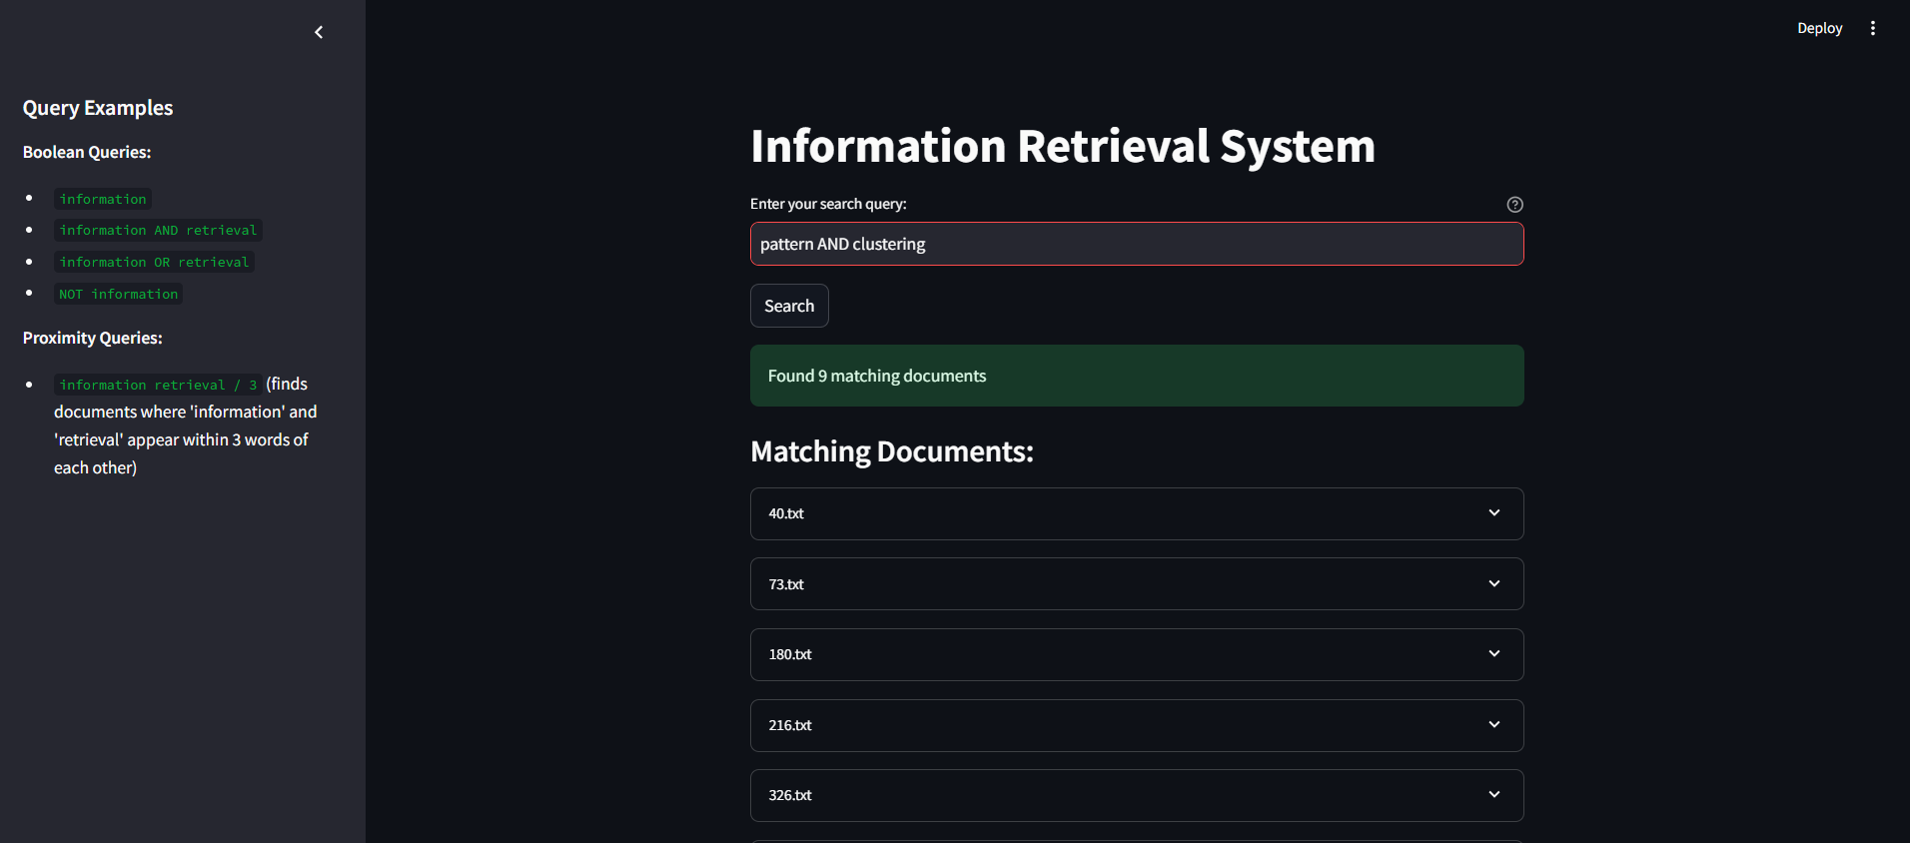

**Query:** pattern AND clustering AND heart

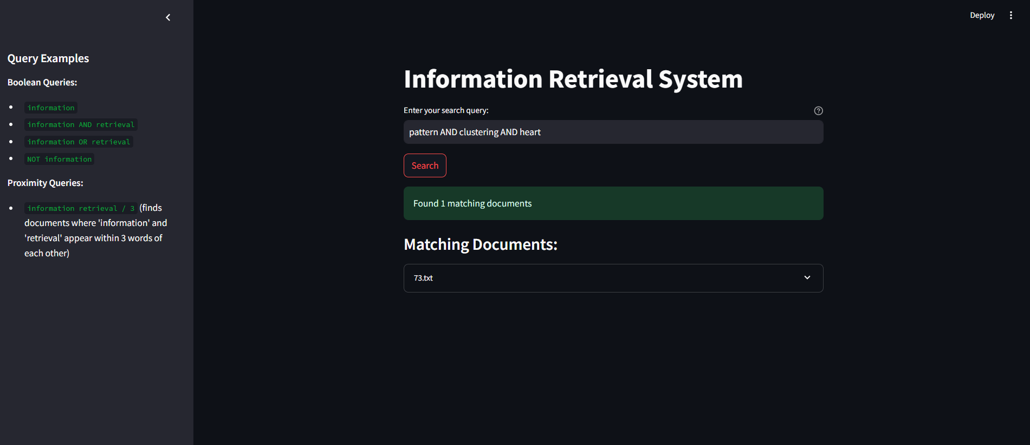

**THE “K” IN PROXIMITY SEARCH MEANS NUMBER OF WORDS BETWEEN QUERIED TERMS**

**Query:** neural information / 2(all documents where neural and information are 2 words apart)

**Output:**

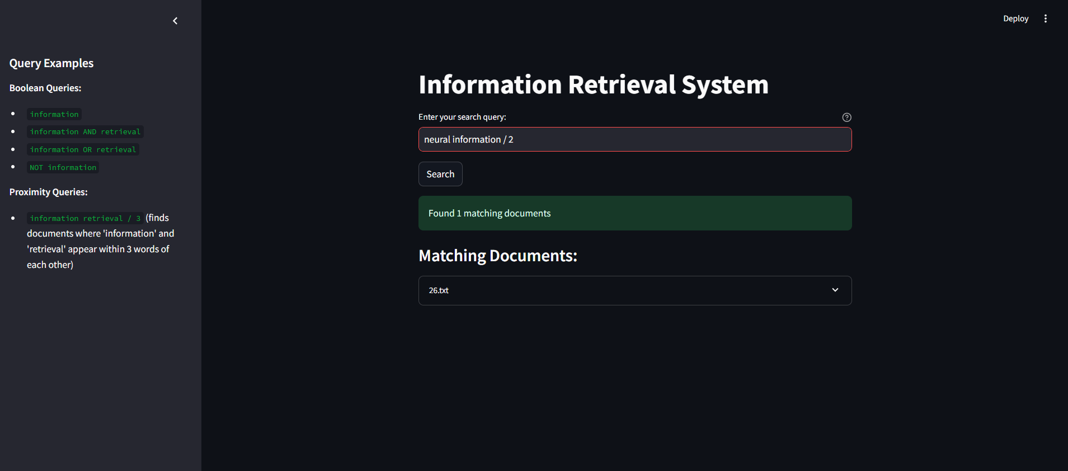

**Query:** feature track / 5

**Output**

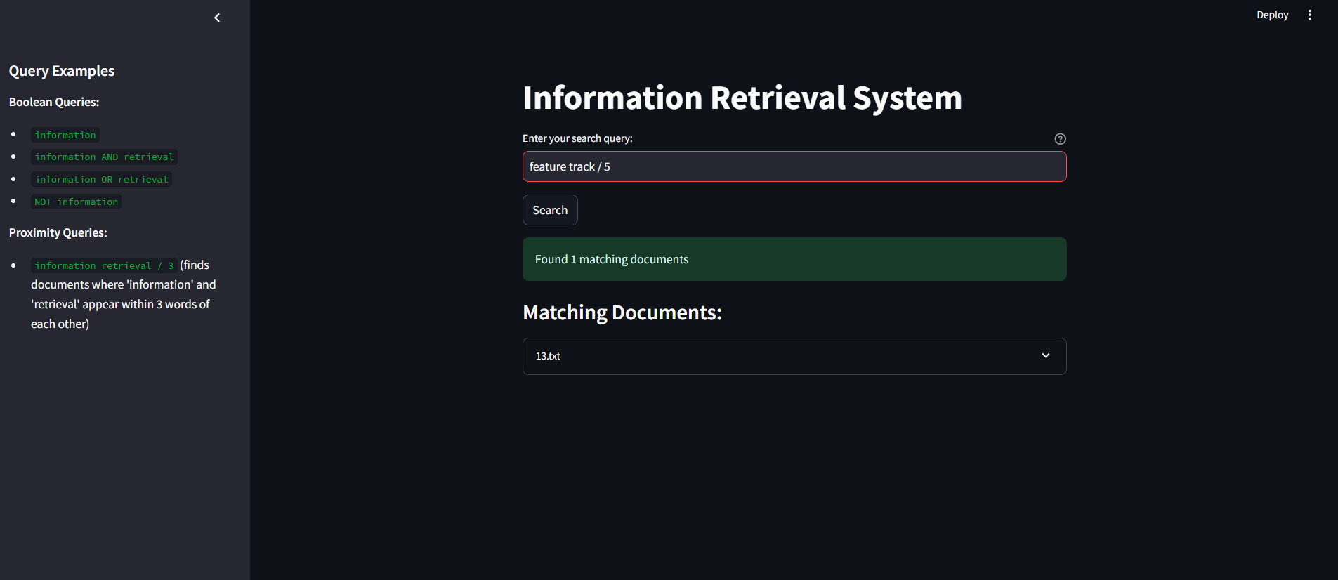

**\***In document 212, both words have 4 words in between them

