Technical Document – Mobile Phone Price Analysis

Business Problem
- Determining the different factors that contribute to Mobile Price.
- How a company launching a mobile phone would determine the mobile phones price.

Dataset Overview
- Price
- Battery Capacity
- Screen Size
- Resolution
- Processor
- RAM(MB)
- Internal Storage(GB)
- Rear Camera
- Front Camera
- Number of SIMs

Analysis
Based off correlation: Resolution, Processing Power(RAM) and Internal Storage are the strongest predictors of price, however the other features are also necessary.
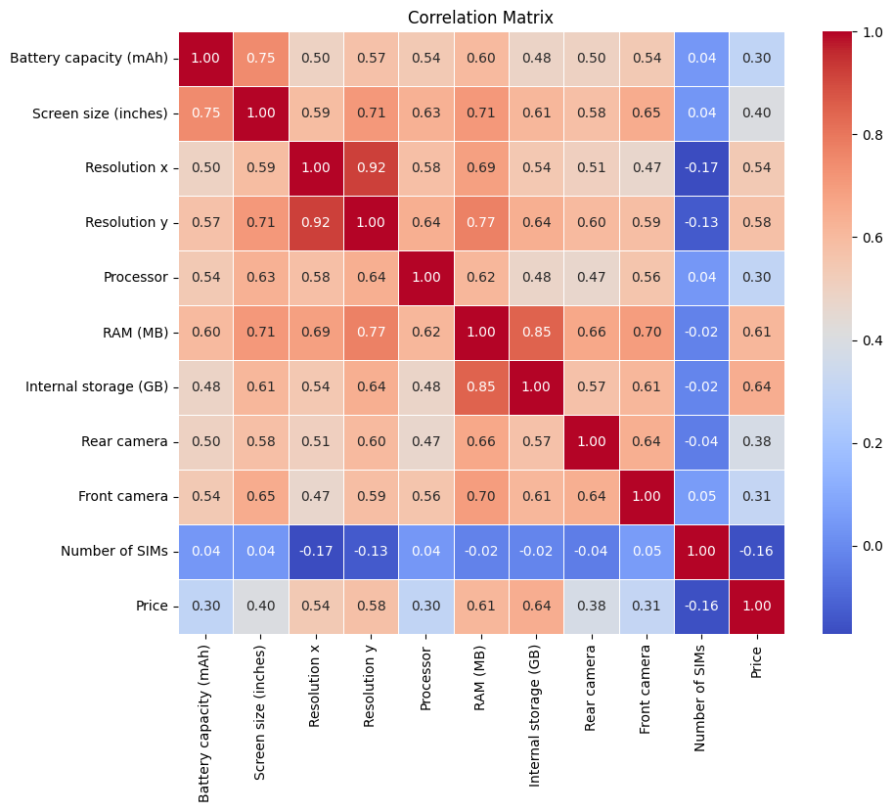
Linear Regression and Random Forest modelling was also done but was not completed.

Linear Regression clustering

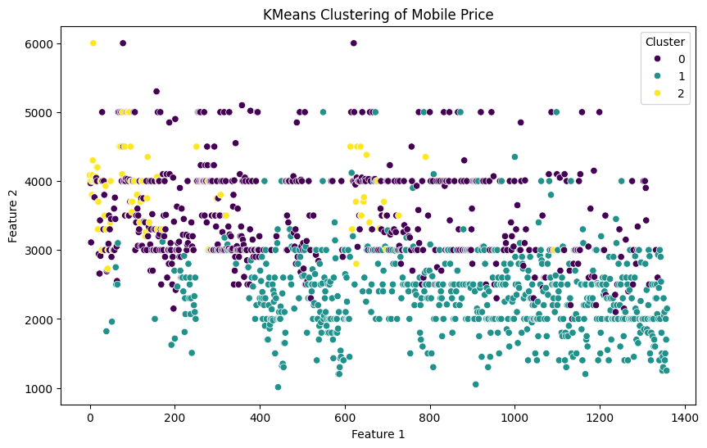

- Linear Regression: Accuracy (F1 Score): 0.02
The low accuracy indicates that the model does not accurately predict the data.

Random Forest Errors
- MAE: 4530.669148030211
- MSE: 86488417.52384362
- RMSE: 9299.914920247584
The large errors indicates the large scale of the data.

Conclusion
A price predictor would be made to predict price: based off a different combination of features.

