Box-Jenkins

After examining the ACF and PACF graph of the original data and the log transformed data, the graphs appear to follow a sin-like function. Various combinations of seasonality and ordinary was attempted to create a stationary process. The data with one difference on seasonality and ordinary is the closest to a stationary process. Plotting the ACF and PACF graph shows exponential decay. We suggest the following possible models for both the original data and the log transformed data: SARIMA (2,1,2)(0,1,1), SARIMA (2,1,1) (0,1,1), SARIMA (1,1,1) (0,1,1), SARIMA(1,1,2) (0,1,1).

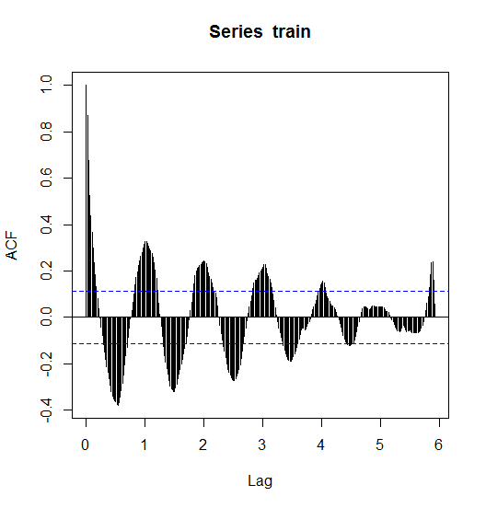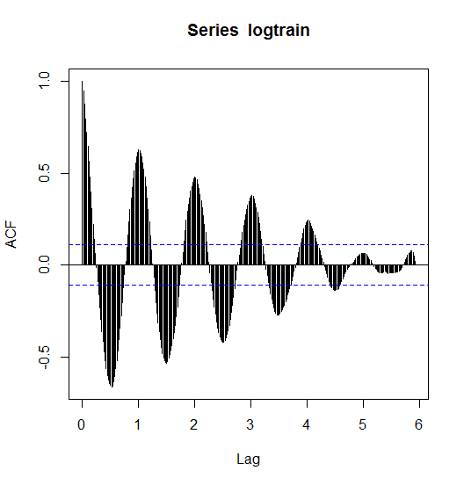

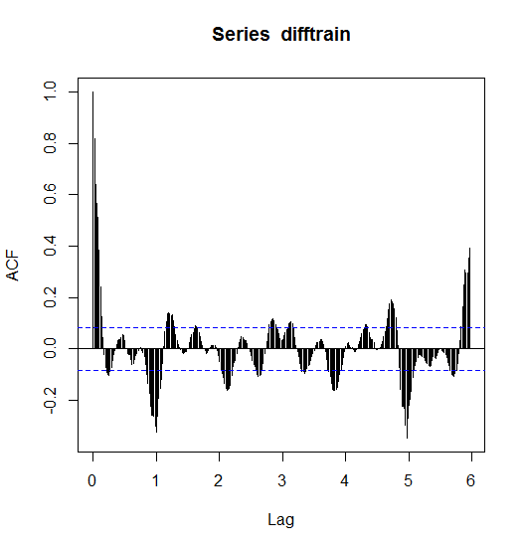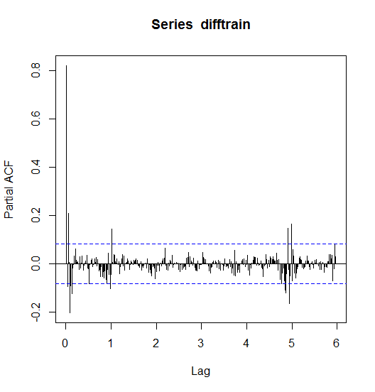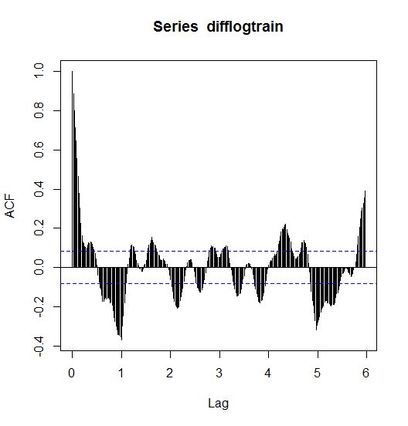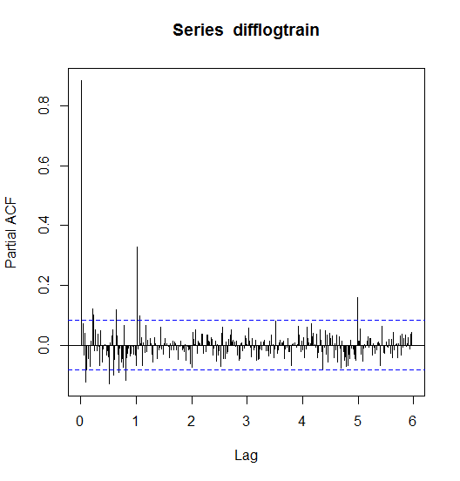

The original data is fitted with the four potential models and the PRESS and AIC is outputted in Table 1. Model 1 outperforms with the smallest AIC while Model 4 outperforms with the smallest PRESS. The log transformed data is fitted with the four potential models and the PRESS and AIC is outputted in Table 2. Model 3 has the smallest PRESS and AIC value so it outperforms the other 3 models. Comparing Table 1 and Table 2, it appears that using the log transformed data provides a better fit than the original data. Predicted value plots, QQ-plots, ACF and PACF were only created for the log transformed data since it appears to be the better fit. None of the models’ prediction intervals contain all the actual values, the first few weeks of actual value is not within the prediction interval. Comparing the actual values to the predicted values, Model 3 does the best job of predicting the seasonality of the actual data. The ACF and PACF of all the residuals appear to be very similar with spikes every now and then. Overall, Model 3 is the best candidate model for Box-Jenkins method.

|  |  |  |  |  |
| --- | --- | --- | --- | --- |
|  | SARIMA (2,1,2)(0,1,1) | SARIMA (2,1,1)(0,1,1) | SARIMA (1,1,2)(0,1,1) | SARIMA (1,1,2)(0,1,1) |
| PRESS | 3033437349 | 3624151583 | 2060589902 | 869736407 |
| AIC | 3899.665 | 3909.311 | 3916.082 | 3914.507 |

Table 1. Comparison between 4 Models with Original Data

|  |  |  |  |  |
| --- | --- | --- | --- | --- |
|  | SARIMA (2,1,2)(0,1,1) | SARIMA (2,1,1)(0,1,1) | SARIMA (1,1,2)(0,1,1) | SARIMA (1,1,2)(0,1,1) |
| PRESS | 2331461430 | 2313577185 | 812949481 | 862593613 |
| AIC | -161.1932 | -161.9326 | -164.7747 | -162.8304 |

Table 2. Comparison between 4 Models with Log Transform Data

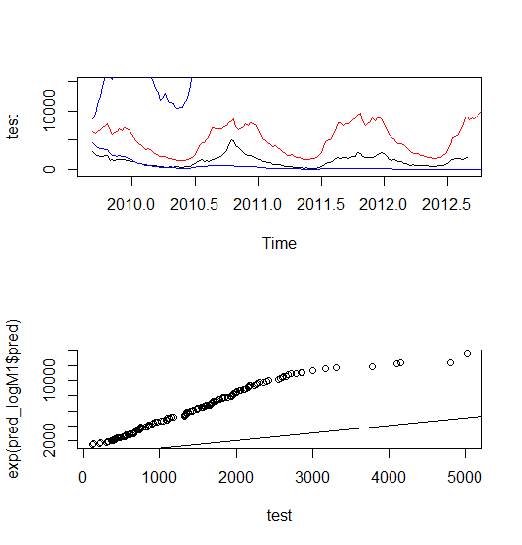

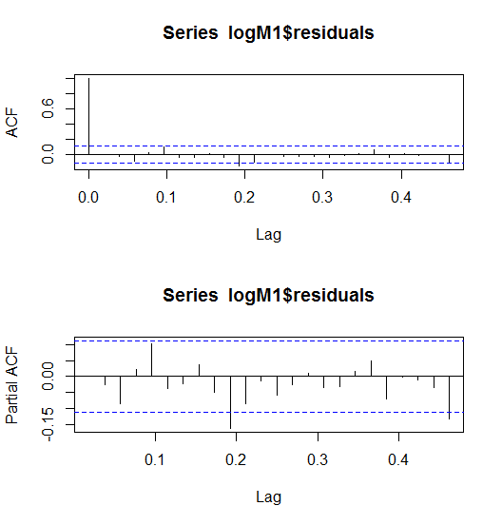

Figure 1. Model 1 Plots

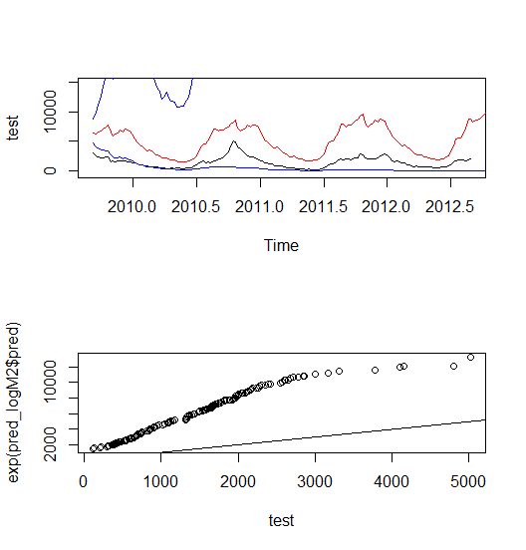

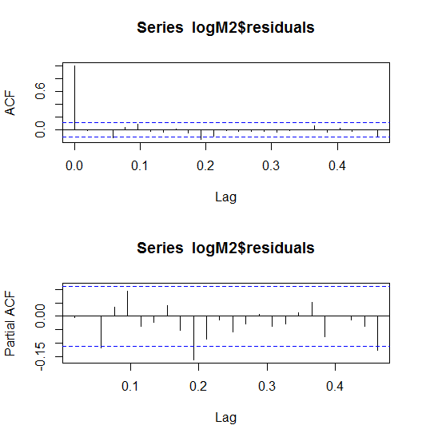

Figure 2. Model 2 Plots

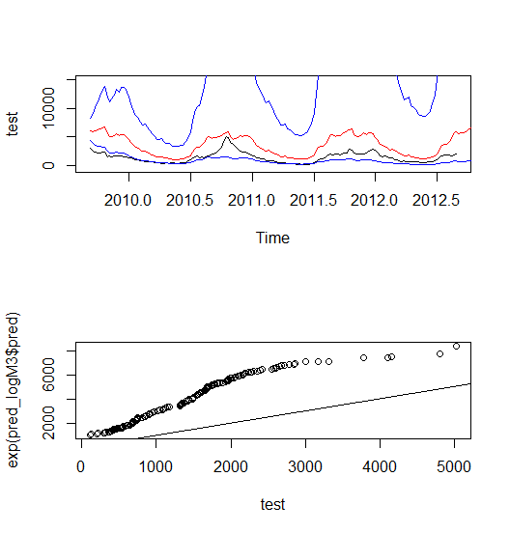

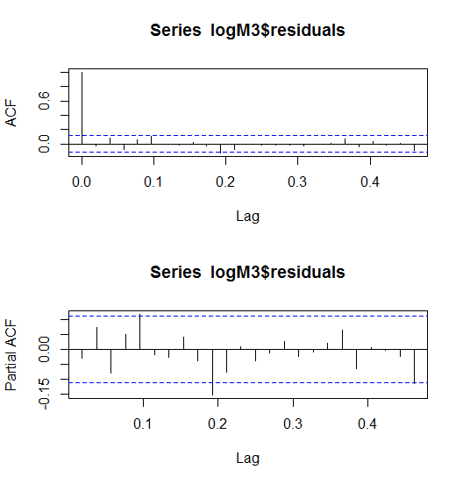

Figure 3. Model 3 Plots

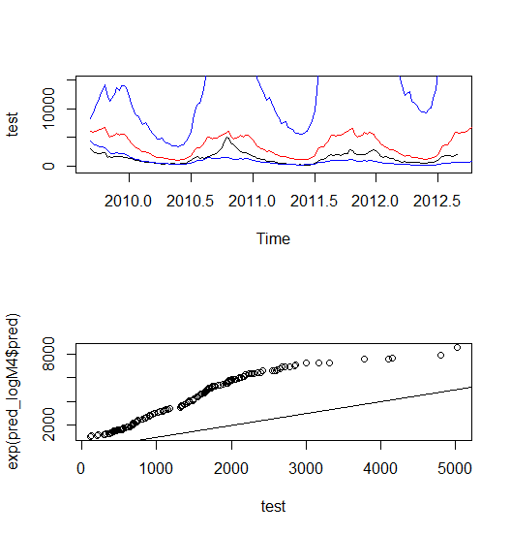

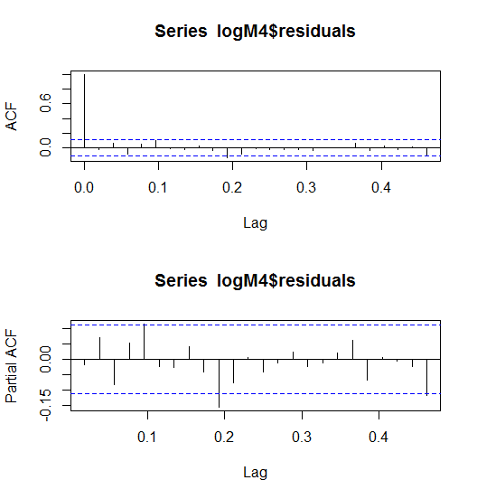

Figure 4. Model 4 Plots