Retail Payments Test Strategy
  - Quality Kiosk Engineering Practice
QK/ENG/TS/2019/014 · Version 3.2 · 12 March 2019 · Owner: Test Manager
This strategy covers the retail payments release for the gateway, the mobile checkout, and the settlement file. It was written for the 2019 programme and is still the document teams open when they join the work. The pages below keep that original voice, type, and header.

Contents
1. Background 1
2. Scope 1
3. Approach 2
3.1 Entry criteria 2
3.2 Execution 2
4. Environments 2
5. Delivery flow 2
6. Exit criteria 2

1. Background
The retailer is moving checkout off a batch window and onto an always-on gateway. Failures now show up as abandoned baskets rather than as a file that can be rerun overnight. The test effort has to prove the payment journey, the timeout behaviour, and the settlement totals together.
Earlier cycles treated the gateway, the app, and finance as three projects. This strategy treats them as one path: a shopper pays, the issuer responds, and finance can still reconcile the day.

2. Scope

In scope
- Card, wallet, and net-banking journeys on the mobile checkout.
- Timeouts, duplicate submits, and issuer declines.
- The nightly settlement file and the finance reconciliation report.
- Peak-hour load at the volumes agreed with the retailer.

Out of scope
- Store POS hardware.
- Chargeback operations after the money has settled.
- The loyalty ledger, except where a payment total depends on it.

3. Approach

3.1 Entry criteria
- The build is deployed to the integration environment with the release notes attached.
- Test accounts and issuer stubs are funded for the cycle.
- Open severity-1 defects from the previous cycle are listed, even if they are accepted.

3.2 Execution
Functional cases run first on a quiet environment. Load starts only after the payment path is stable enough that a failure can be told apart from a capacity problem. Settlement is checked the morning after each load run, not at the end of the whole cycle.

4. Environments
Environment | Use | Data | Owner
INT | Daily functional runs | Masked cards | Checkout squad
PERF | Peak-hour load | Synthetic shoppers | Performance
UAT | Business sign-off | Retailer sample day | Test manager

5. Delivery flow
The figure below is part of the original strategy. It is an image, so a later template change should leave it exactly where the author placed it.
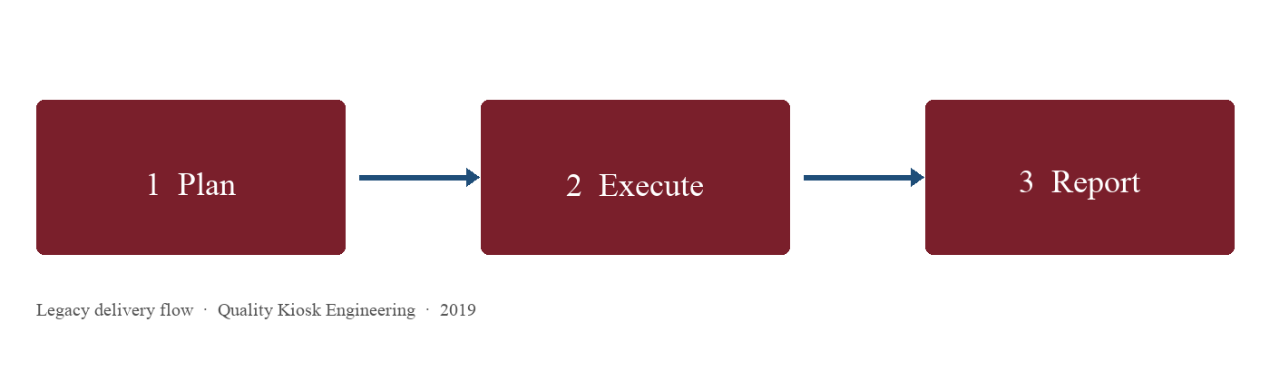
Figure 1. Plan, execute, and report — the 2019 delivery flow.

6. Exit criteria
- No open severity-1 defect on pay, decline, or settlement.
- Peak test held the agreed orders per minute for a full hour.
- Finance signed the sample-day reconciliation.
- The residual risk list is attached to the release note.
Prepared by Quality Kiosk Engineering Practice. Distribution is internal to the programme.

