**Working of the Connect4**

**Model:**

* The model module consists of all the backend of the game. It contains the methodsCheckIfPiecesCanBeDroppedIn, toString, dropPieces,didLastMoveWin , isItADraw and theinit methods.
* The model is completely isolated form the view.
* The human vs Computer Interface consists of an extra method which has the logic of the computer move.

**View:**

* The View Module consists of the board which is displayed to the user.
* The User input is taken and the game piece is displayed.
* The User inputs the column number and the piece corresponding to the user is displayed in that column
* The View is completely isolated from the Model
* In the Human vs Computer Interface, the computer will not prompt the second player for dropping a piece . The computer automatically displays its move in the view

**Controller:**

* The controller Connects The Model and the view
* The controller contains the dropTest and the startGame methods.
* The startGame method is invoked from the main method of the controller class
* The column number is taken as the input form the user in the view and sent to the Model by the controller
* Once the Model performs its operations, and drops the piece into the board, it will return the new board to the controller which will be displayed by the view .

**UML 6.2.1:**

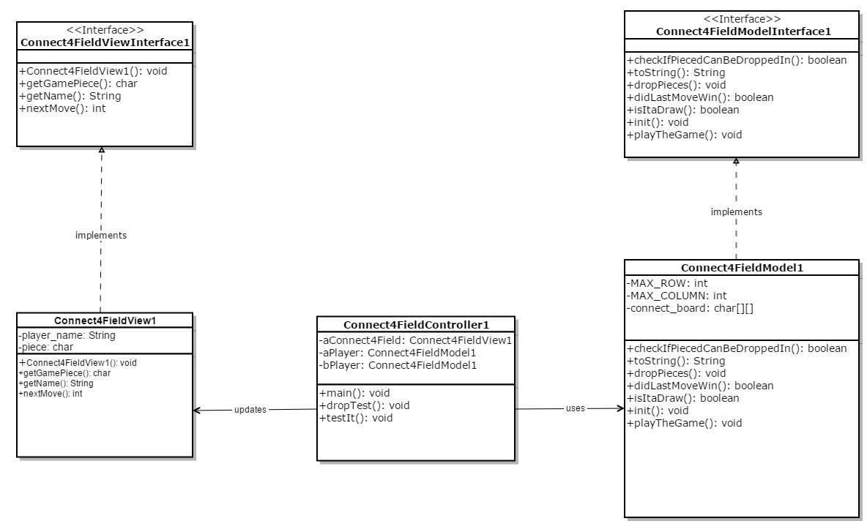

**UML 6.2.2:**

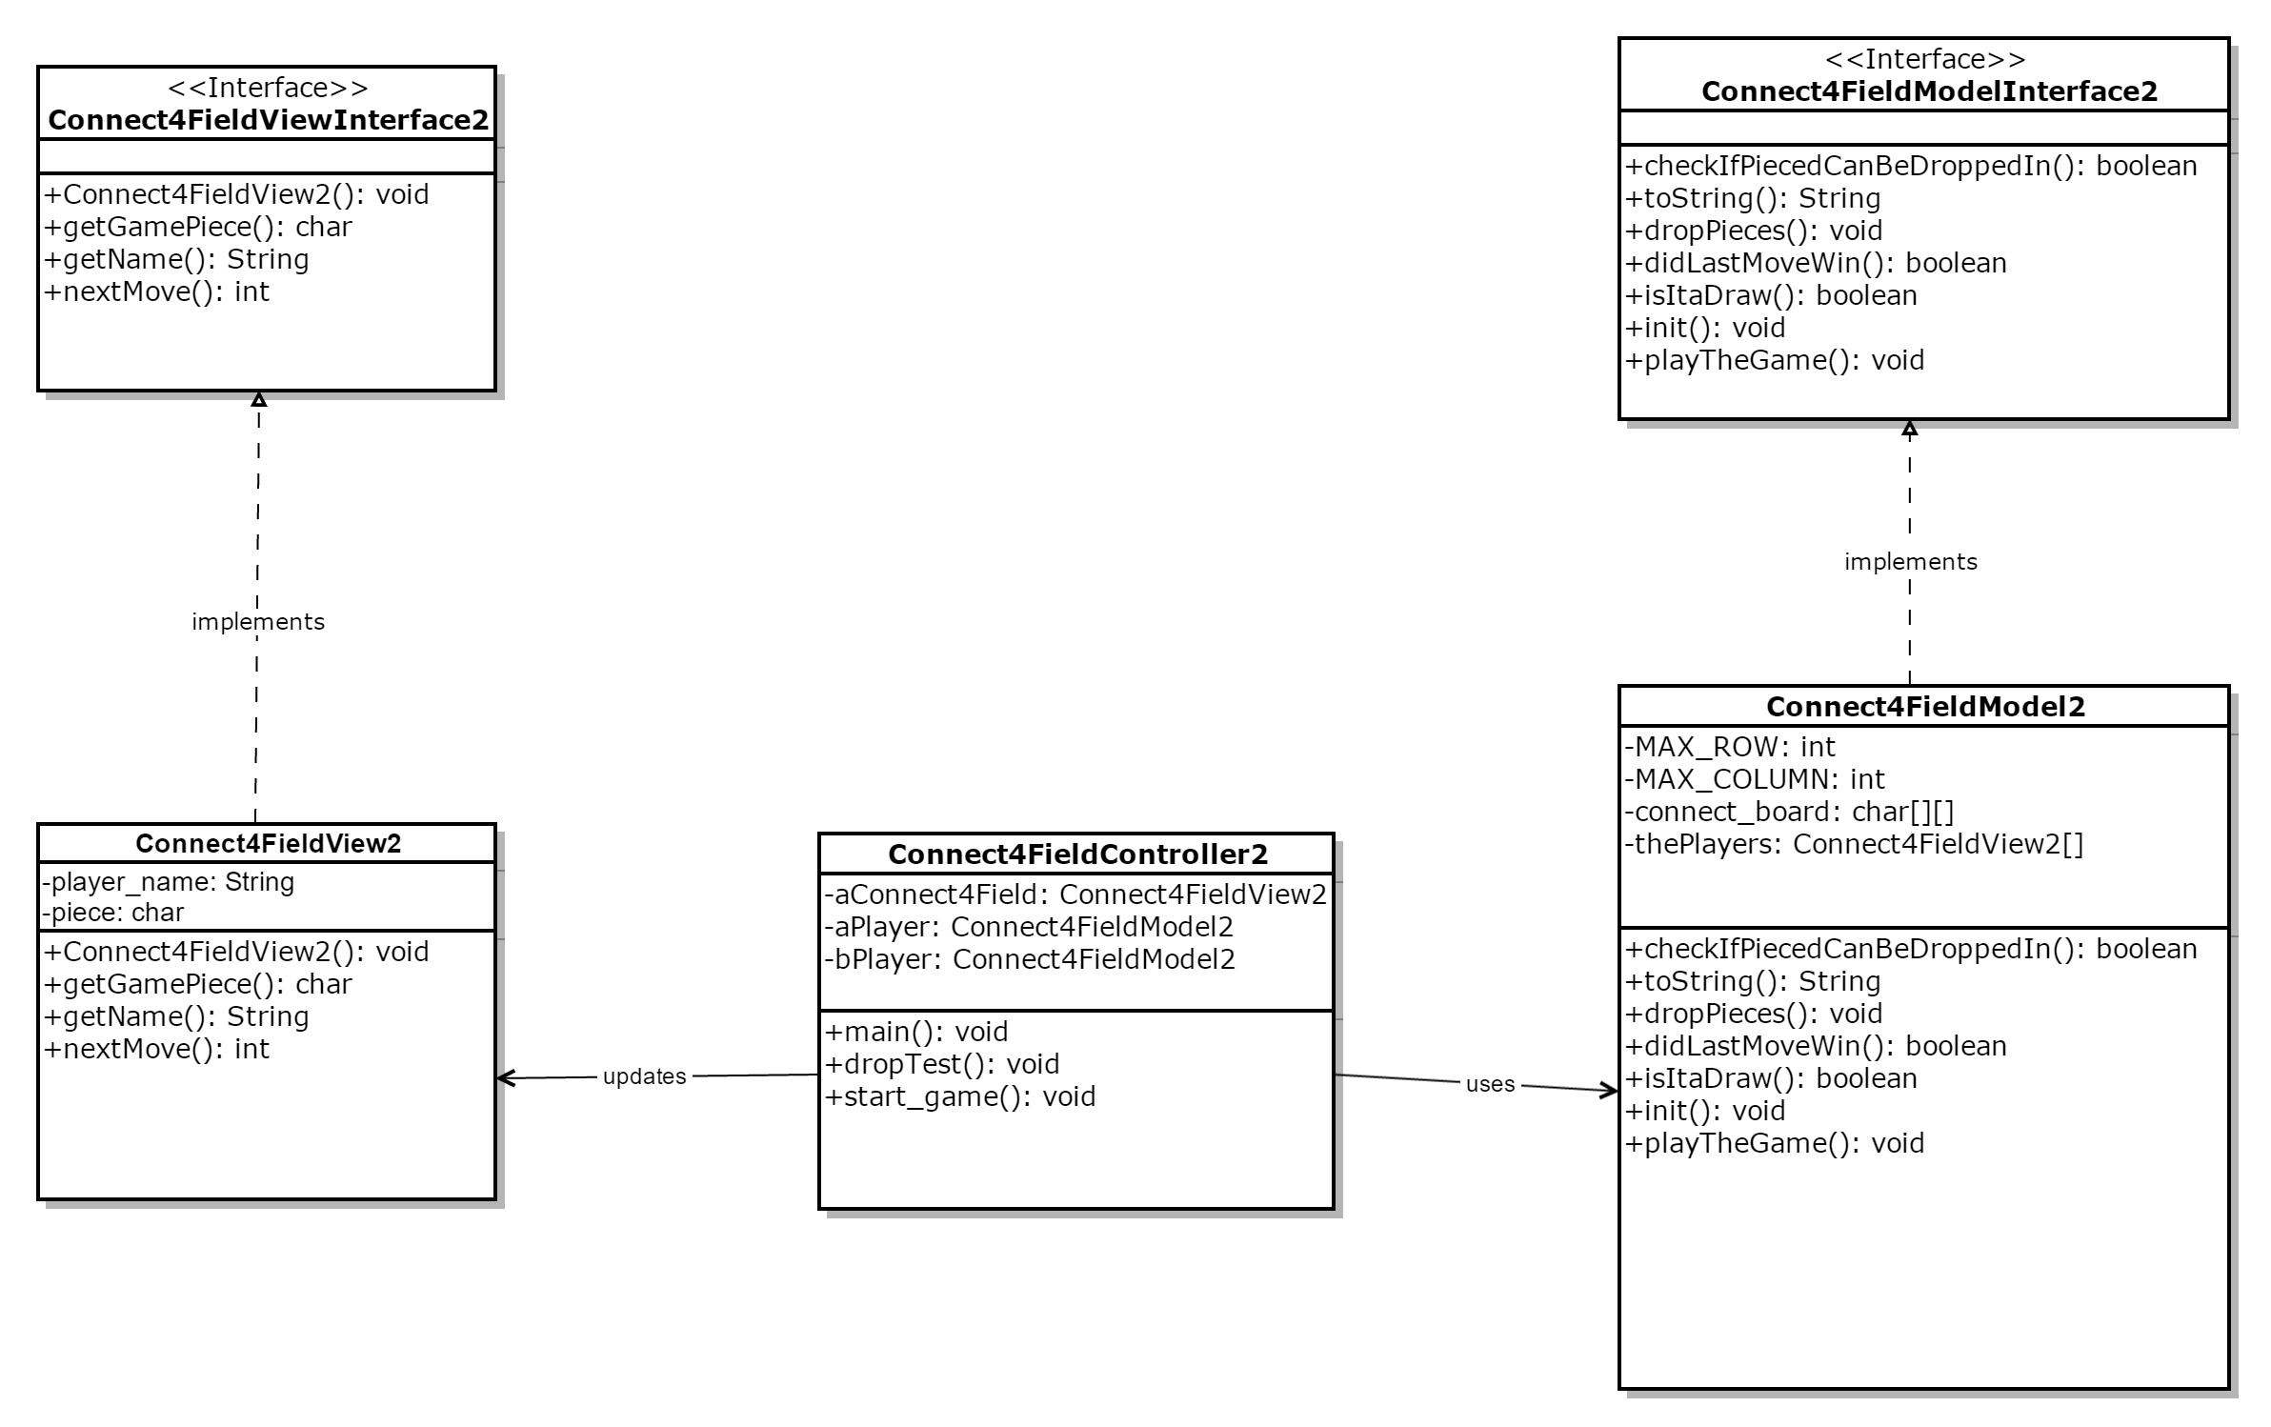

**UML 6.2.3:**

