Aug 29

* Made a repo, we’ll be collaborators on the same repository so we can both push to it
* Pair programming is probably a good idea to avoid interfacing issues (even with git)
* Since we’re essentially integrating our 2 A2s, the first few meetings will definitely be together

Sep 1

* Have to set up git.
* Tried with a test repo so make sure we know it works
* Planning on tablet with diagrams of how it’s going to look
* Will be essentially adding on to A2
* We essentially have the same infrastructure so we’ll stick with it
* We’ll be using Swing, since we both did in A2 and there are plenty of resources online to help us
* Rewrite the backend data structure first. Can just use A2 quizzing logic and a similar GUI unless there’s something we really want to change
* Planning took less time than we thought, so start with simplest class
* Festival pretty independent, so we start with that. Added SwingWorker, but not tested as coding on Windows (VM lags)
* Read through A3 specs and planned out some files
* Stats file will be laid out like Theo’s A2
* Decided to play with making a yes/no JOptionPane in Abby’s A2 into a level chooser – it worked just as expected
* Some more playing with git .metadata getting a bit annoying, but it looks like history so is probably useful. Best to leave it in then before we break the project, but keep an eye out if any of our peers find out something
* we initialised git repo inside the project instead of just src because our png and files will be in a resources folder on the same level as the src
* 5th September
* Met up again because File I/O requires a lot of thought and is probably easy to get wrong.
* Decided to use ArrayList of ArrayLists (one for each level)
* Will have 0th index empty so the index of the data structure lines up with the levels
* Tested data structure and input parsing with wordlist – after some debugging it works.
* We’ll be keeping session and persistent stats separately. Stats file should only be holding the persistent stats so read it into persistent all words data structure

7th Sep

* Continue working with FileIO together
* Changed how stats file is read into datastructure because it was causing issues when testing
* Was using temp arrays for each level and offloading them once levelling up
* Now just first initialise all the arrays and add to relevant level
* More robust so levels don’t have to increase from 1..11, could be arbitrary
* Now we have stats, make it into a JTable so it’s easier to check without looking at the local variables we made for debugging
* Do some GUI for a change. Backend had been difficult
* Use Theo’s GUI from A2 and base it off that. So we don’t end up spending too much time on making a gui only to change it later because of new ideas or that we understood the specs wrong (it’s still the break, not may pairs would have started. Might be clarifications once semester starts again)
* Since we were doing reading files, might as well to write files while we’re at it
* Today went really well and we knocked out probably the most difficult stuff\
* Might just pair program since it’s working really well for us and we can take turns being the driver / being the navigator and taking a break from coding

8 Sep

* Plan is to finish off data handling, so do stats by level today
* Made a panel to choose which type of stats
* level and all stats – 2 types. Two classes. Determine persistent or session via constructor argument
* Making up random stuff to populate the stats files is too tedious. Make the post-quiz logic to do this
* This is easy because we just have to make sure to write to the correct data structure and then just lots of loops through our 2D matrix
* Stats by level just broke normal reading in data :O

13th Sep

* Found out that review list index has been shifted…
* Temp arrays don’t seem to be working very well. Completely change all of these to going by the index of the array list
* Little bit of refactoring to get rid of redundant assignments and wiping of temp arrays.
* Took Theo’s A2 code to get the words.
* Because our stats data structures relied on the words keeping the same index, can’t use Collections.shuffle on the arraylist for that level. Have to shuffle the indexes to use
* Quiz keeps an arraylist for each of the types of results. FileIO needs to access this to make level up and video functions after the quiz, so made fields for it in FileIO

September 14

* Got quiz complete panel working
* Changed festival 1 line call to batch execute an scheme ffile
* Tried to make Festival swingworker a singleton so p.waitFor will actually wait because there is only 1 thread. Didn’t work
* Used queue method found on stackoverflow to prevent overlap on festival

Sep 15

* Added Eclipse stuff to gitignore to stop metadata and recommenders from pushing and pulling a million hidden files each time
* So it turn out you have to first rm –cached to delete it from the repo, else git keeps tracking it even though it’s in the git ignore. Git just ignores new ones.
* Added tally of mastered/faulted/failed to quiz complete to show how many words in each column
* Used windowbuilder to lay out settings panel

16th Sep

* Finished settings by putting combo boxes in for festival
* Copied and pasted Nasser’s ACP code for video
* Took a while and finally got vlcj to work
* Video is a JPanel but the video will only work if there was a locally declared JPane to contain it
* Same with JFrame, needed to make a local variable that pointed to the parent fram

Sept 17-18 (Abby)

* Saved festival settings to settings
* Made sure that settings was actually only saving on save and not in the combo box actionlistener
* Disabled the frame close to force closing only with the power button
* changed level up to comply with A3 specs and show level chooser if on highest level
* Considered ReusableComponents class but that required too many arguments being passes because some of the back button action listeners did stuff such as saving settings, in addition to changing the panel
* Added some TODOs for code to double check on
* Laid out video panel

Sept 17-18 (Theo)

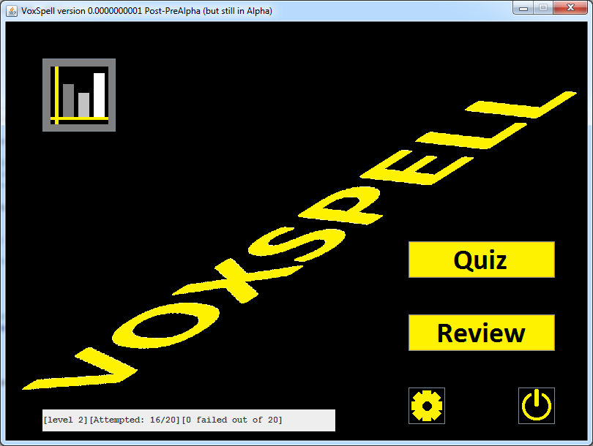

Changed buttons to be images

--> Still need to make background not look like bad.

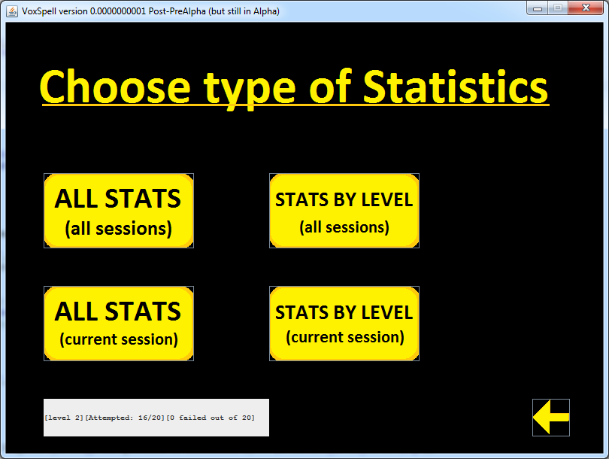

Changed bottom label y co-ords to 500

Changed bottom y label width to 300

Removed Title (commented)

Added background (includes title text)

--> May need to centre buttons

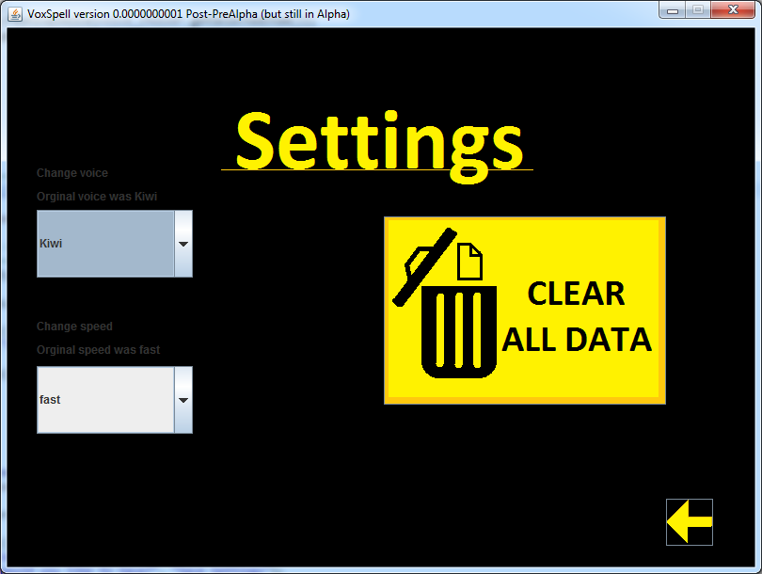

Made background, with settings title

Moved, resized and changed reset button to image

--> Still need to make left hand side not terrible looking

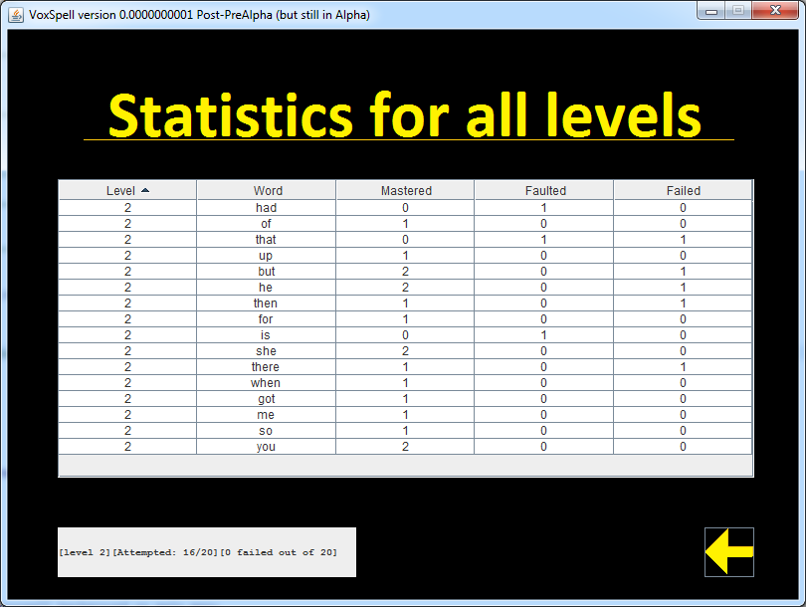

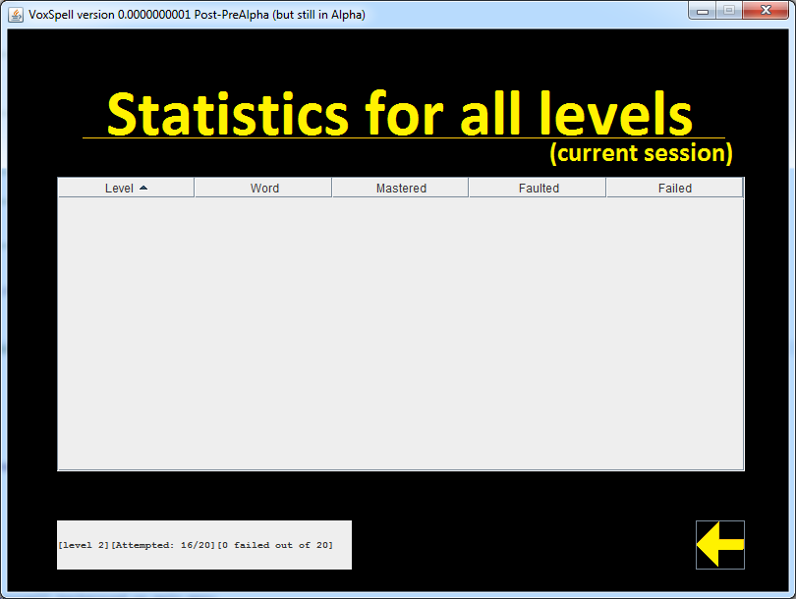

Moved accuracy y=500, width=300

Made background with title

Made it so that background chosen based on type (for extra text noting current session)

--> May decide to make columns not user arrangable.

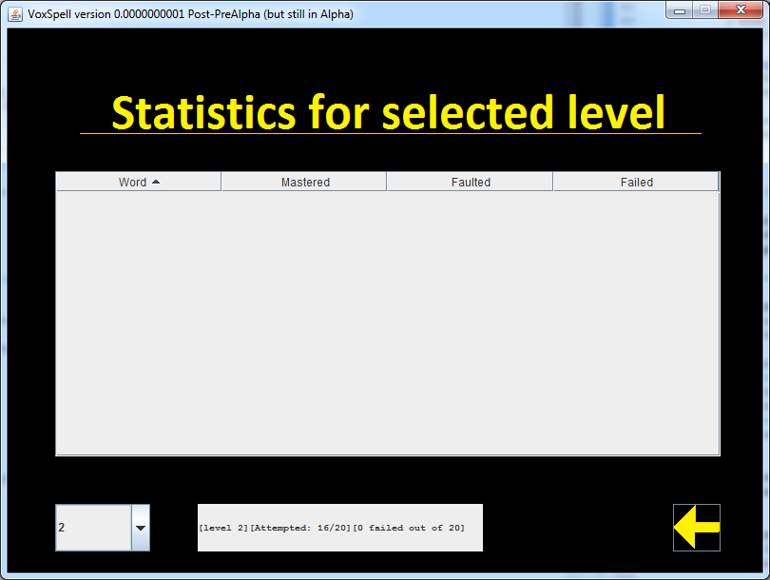

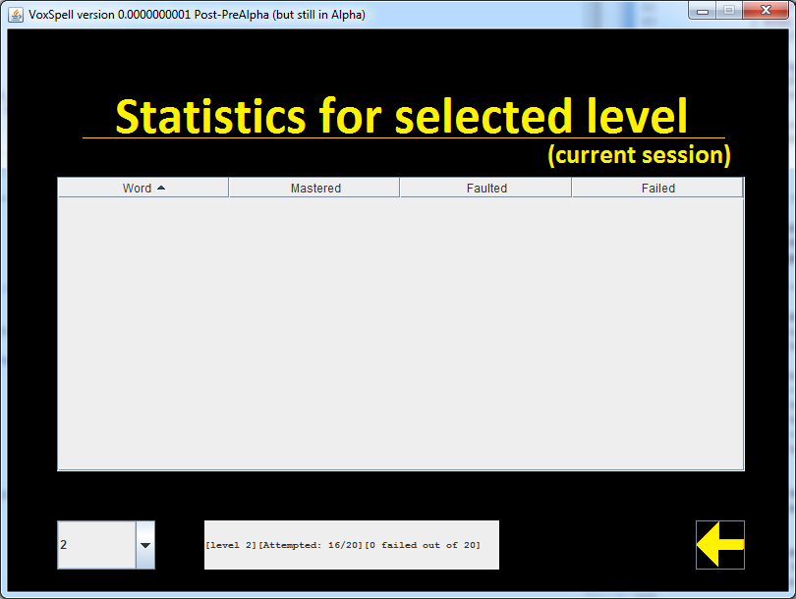

Same as LHS

--> Need to fix bug: When choosing persistent by level, combobox set to current level but (I think) table populated with level 1.

--> Need to sort out label for indicating what combobox does (DISCUSS WITH ABBY)

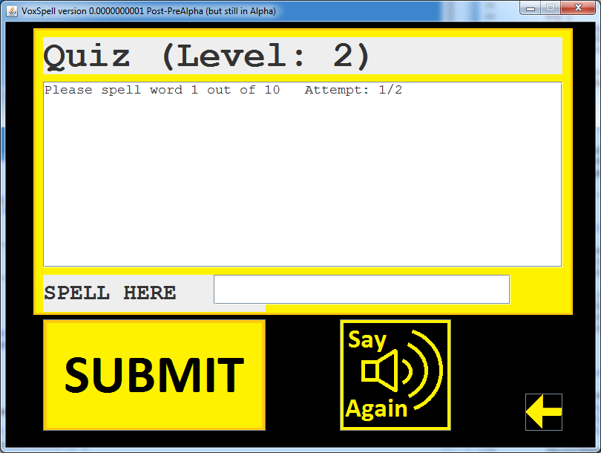

Added background and images to buttons

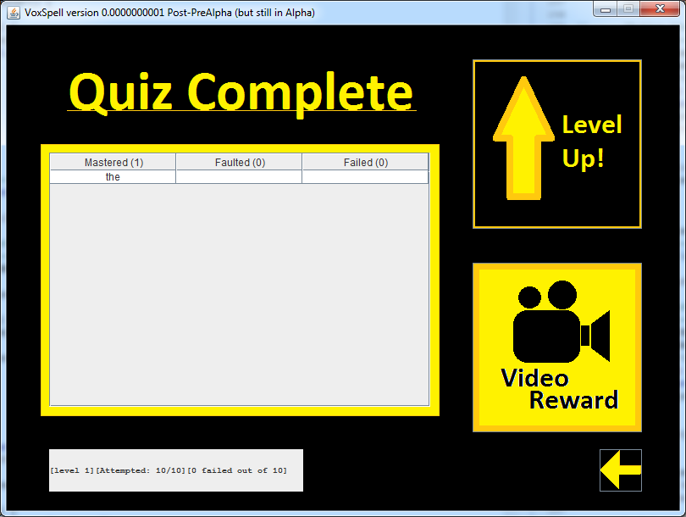

I did things

. Resized and moved accuracy results

. Resized table

. Repositioned two buttons

. Removed Title (put into background)

. Made background

. Added Button Images and removed their text

19th Sep

* Added project and classpath to git ignore. Because it was breaking eclipse project when pulling
* Reason was because /lib with the vlcj libraries weren’t being uploaded to git
* Reason was because they are jars and \*.jar was being ignore
* Used ! to negate the jars. And NOT ignore those that are in /lib
* Integration with Theo’s work on GUI, images, background, and moving components around
* Now have first working version
* Removed project and classpath from git ignore again because without them project hierarchy wouldn’t be recognized.
* Sep 20
* Branched out Release1 for v1 releasable version
* Removed testing and development edits when pushing to release branch
* Made drop down look better
* removed redundant imports
* Added edited FFMPEG video file, program now displays that instead of the original (Original still in resources folder)

21 Sep

* Have both videos used in code. If all correct, plays unedited video. Otherwise if 1 incorrect, play ffmpeg edited video
* JavaDoc commenting
* Made it work on UG4 computers. Required making some local variables references by anon inner class actionlisteners final
* Released version 2 with all working code
* UH OH found bug with user being able to level up again after watching video because the quiz complete panel was being remade each time
* Fixed it by introducing a flag for whether user has already levelled up. If flag set level up button won’t be made.
* Removed completed TODOs
* Released version 3

22 September

* System.exit() strips 30 pixels off bottom of screen on next launch (same as Windows), but otherwise it doesn't happen. Added 30px
* Pretty much copy and pasted readme from A2. And wrote some stuff
* tested the jar again on laptop
* festival doesn't work when it's inside the untitled folder that I copy and pasted from my USB. But it works when I make a new directory and chucks the stuff in. So I noted that if no sound, make a new directory
* The stripping 30px doesn't happen no matter what I do on my VM. So it might just be a UG4 computer thing. Pretty sure we would've encountered cancelling level chooser on your laptop as well but that didn't happen. I mentioned that as a "strange situation"
* When I double click the jar on Windows it actually runs and can find resources. But we've got java -jar so I just said to use command line
* Doesn’t run on the lab computer today because it can’t find Java?? :O
* Festival isn’t making a noise anywhere
* Released version 4 to work with Java 1.7 by making the eclipse project use the 1.7 library instead of 1.8.
* Made a jar with that eclipse project
* Our 1.8 laptops are backwards compatible so it works everywhere
* Zipped up and done!!!!!!!!!