TIPPAAI_AAISD_CV_Q1.ipynb is the main file to run for Q1. The supporting files used are:

1. Analyser.py
2. Image.py
3. ImgManager.py
4. CNNModel.py

The details on

* dataset handling,
* creation of model and
* validation of accuracy

is stated in the comments of TIPPAAI_AAISD_CV_Q1.ipynb

The files and folders generated from Q1 will be used for Q2.

The files and folders are

1. Folder TestImg
2. File: output/model.tflite
3. File output/Labels.txt

In Q2, deployment of model will be via an android application.

To install an run app, , there are 2 ways:

1. Via the given generated apk at \BirdPredictor\APK\BirdPredictor.apk copy and install it in android device and use app
2. Perform the following steps if Q1 has been run

* Copy folder TestImg and its contents, file model.tflite and Labels.Txt to folder \BirdPredictor\app\src\main\assets\
* Open android studio, Build gradle. File -> Sync project with gradle files
* In android studio, menu tab ->Build -> Build Bundle(s)/APK(s) -> Build APK(s)
* The newly generated APK file is located at \BirdPredictor\app\build\outputs\apk\debug\
* copy and install it in android device and use app
* Perform the above or just run the app via Android studio.

Using the app:

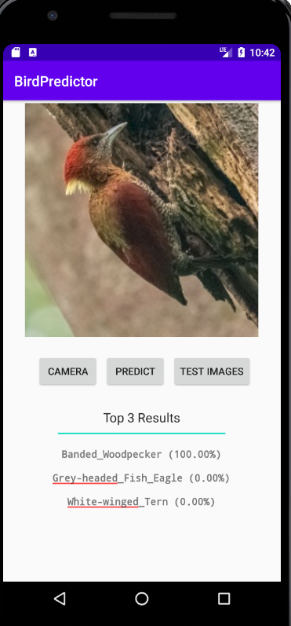

There are 2 ways to get input for model prediction.

1. Via camera
2. Via internal test images(In TestImg folder)

Test Images=> select an image from a list, then press predict button

Camera=> Capture and image from camera, then press predict button

Accuracy of model via camera is dependent on camera quality, lighting and distance between camera and image.

Using the same image and model,results in 2 different confidence outcomes when using the 2 different input methed. Camera input receive lower confidence or totally incorrect prediction