First Congregational Church of Saint Albans, Vermont

United Church of Christ

Sixth Sunday After Epiphany February 14, 2021

We Gather as God's People

CENTERING WORDS: “Love is always open arms. If you close your arms about love you will find that you are left holding only yourself.” ― Leo Buscaglia

THE PREPARATION
The beginning of the prelude is a call to enter into the spirit
of prayer and community.

Prelude: “Have no fear” (from Karol´s Carols) S. Conrady (2019)

Welcome and Announcements

Morning Prayer*
O Holy One,
on mountaintops and valley floors
you reveal to us the light of your love.
Our hearts desire is to bask in the amazing glory
of the divine presence.
With each encounter we are changed and transformed.
Draw us nearer that we might receive a double portion of your Holy Spirit.
Help us, O Holy One, to live our lives as a reflection of divine glory.
May we walk among our siblings and friends as a blessing,
bearing light into dark places,
hope to displace despair,
and love that casts out hate.
Our world is hurting
and we need the followers of Jesus to follow more closely.
Maybe then we will hear your voice speaking to us and saying, … “listen to my Child, the Beloved!” Amen

Opening Hymn
“O’ How Glorious, Full of Wonder” vs 1 & 4 No. 74

Prayer of Confession*
Forgive us, God, when we linger too long by the waters,
and on the mountain tops,
enthralled with the glory that flows from you.
When we fail to listen to your voice, leading and guiding us,
shake us from our contentment
and send us forward endowed with your power. Amen

A moment for personal reflection

Words of Assurance

THE MESSAGE
ANTHEM “Christ, Upon the Mountain Stands”
M. Schwiezer/R. Lehman

A Time for Children of all Ages.
Scripture Reading
2 Kings 2:1-12
Mark 9:2-9
Morning Reflection Wrong End of the Stick

Hymn “For All the Saints” vs 1 & 5 No. 306

THE THANKSGIVING
Sharing Our Joys and Concerns
Choral Call to Prayer “Hear Our Prayer, O Lord” D. Whelpton Prayer of the People ~ Lord’s Prayer (trespasses)
Choral Response to Prayer “Thou wilt keep him in perfect peace, whose mind is stayed on Thee.” Scottish Psalter, 1615

THE DEPARTURE
Benediction
Postlude: “Claudia´s Lullaby”
(Valentine´s day version) S. Conrady (2016)

No matter who you are or where you are on life's journey, you're welcome here.

Our Church Office Hours and Contact Information
Administrative Office- 8 AM to 11 AM weekdays.
Church Office Phone Number- 1-802-524-4555
Pastor Jessica- Office Hours – Tuesdays thru Fridays, 9 AM – 12 PM Email- pastorjessica@firstcongregationalstalbans.org
For urgent, pastoral matters outside of regular office hours, call Pastor Jessica at 207-632-5544

Our worship service is broadcast over the local public access channel 1079 on Sundays at 4 PM. Our Videographer today is Lane McElree.

Music Notes: This morning we bring you an anthem for Transfiguration, composed by American Robert Lehman. Lehman currently serves on the staff of The Church of St. Michael & St. George in St. Louis, Missouri as Organist and Choirmaster, and previously served as organist and choirmaster of Christ Church in New Haven, CT.

*Worship Ways, UCC
Music, Copyright permissions: CCLI #4799426 and SJMP #14586

The First Congregational Church of St. Albans
United Church of Christ

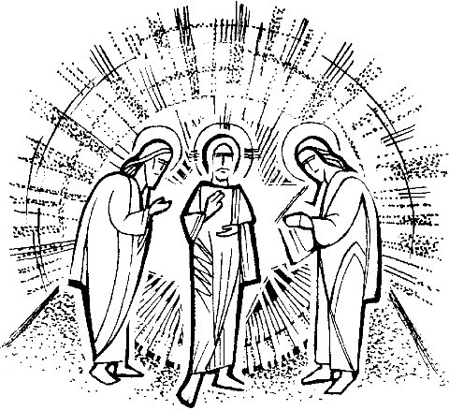

“We welcome you and serve all through faith.”

Jessica Moore, Pastor
Erin Grainger, Music and Choral Director
Stephan Conrady, Organist
Sue Powers, Administrative Assistant
27 Church Street, St. Albans, VT 05478
802-524-4555

first_congregational_church@yahoo.com
www.Firstcongregationalstalbans.org
Facebook: www.facebook.com/1stCongregationalChurchStAlbans
www.vtcucc.org

