First Congregational Church of Saint Albans, Vermont

United Church of Christ

Second Sunday of Lent February 28, 2021

We Gather as God's People

CENTERING WORDS: Perfect humility tends to the annihilation of self. --Meister Eckhart

THE PREPARATION
The beginning of the prelude is a call to enter into the spirit
of prayer and community.

Prelude: “Have no fear” (from Karol´s Carols) S. Conrady (2019)

Welcome and Announcements

Morning Prayer Prayer of St. Francis
Lord make Me an instrument of Your peace
Where there is hatred let me sow love.
Where there is injury, pardon.
Where there is doubt, faith.
Where there is despair, hope.
Where there is darkness, light.
Where there is sadness joy.
Grant that I may
Not so much seek to be consoled as to console
To be understood, as to understand.
To be loved. as to love
For it's in giving that we receive
And it's in pardoning that we are pardoned
And it's in dying that we are born...
To eternal life.

Opening Hymn
“Be Thou My Vision” vs 1 & 4 No. 391

Prayer of Confession*
We are quite open about our successes.
We feel free to boast when we have done well,
but we are not quite so open when things have gone wrong.
We do not praise God anyway.
Instead, we recognize the distance
between me and you
between you and God
between God and me.
Let’s be quite open about it
as we open ourselves
to our Living God in silence. Amen.

A moment for personal reflection

Words of Assurance

THE MESSAGE
ANTHEM “Hymn to Freedom” Oscar Peterson
A Time for Children of all Ages.
Scripture Reading
Psalm 22:23-31
Mark 8:31-38
Morning Reflection

Hymn “Lift High the Cross” vs 1 & 5 Insert/ NCH 198

THE THANKSGIVING
Sharing Our Joys and Concerns
Choral Call to Prayer “Hear Our Prayer, O Lord” D. Whelpton Prayer of the People ~ Lord’s Prayer (trespasses)
Choral Response to Prayer “Thou wilt keep him in perfect peace, whose mind is stayed on Thee.” Scottish Psalter, 1615

THE DEPARTURE
Benediction
Postlude: “

No matter who you are or where you are on life's journey, you're welcome here.

Our Church Office Hours and Contact Information
Administrative Office- 8 AM to 11 AM weekdays.
Church Office Phone Number- 1-802-524-4555
Pastor Jessica- Office Hours – Tuesdays thru Fridays, 9 AM – 12 PM Email- pastorjessica@firstcongregationalstalbans.org
For urgent, pastoral matters outside of regular office hours, call Pastor Jessica at 207-632-5544

Our worship service is broadcast over the local public access channel 1079 on Sundays at 4 PM. Our Videographer today is Lane McElree.

Music notes: Oscar Peterson was a famous Canadian jazz pianist and composer. He wrote Hymn to Freedom in 1962 and it was quickly embraced as an anthem for the Civil rights movement.

*Worship Ways, UCC
Music, Copyright permissions: CCLI #4799426 and SJMP #14586

The First Congregational Church of St. Albans
United Church of Christ

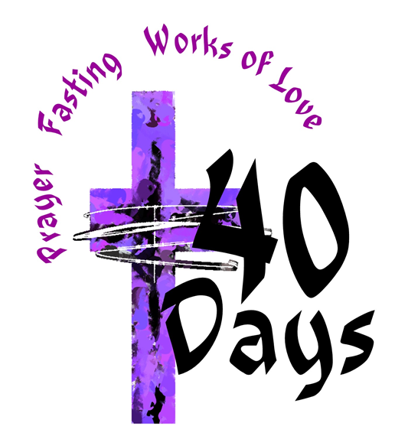

“We welcome you and serve all through faith.”

Jessica Moore, Pastor
Erin Grainger, Music and Choral Director
Stephan Conrady, Organist
Sue Powers, Administrative Assistant
27 Church Street, St. Albans, VT 05478
802-524-4555

first_congregational_church@yahoo.com
www.Firstcongregationalstalbans.org
Facebook: www.facebook.com/1stCongregationalChurchStAlbans
www.vtcucc.org

