First Congregational Church of Saint Albans, Vermont

United Church of Christ

Fourth Sunday of Lent March 14, 2021

We Gather as God's People

CENTERING WORDS: “God’s love has breadth. It is a big love; it’s a broad love . . . God’s love is too big to be limited to a particular race. It is too big to be wrapped in a particularistic garment. It is too great to be encompassed by a single nation. God is a universal God.”—Martin Luther King Jr.

THE PREPARATION
The beginning of the prelude is a call to enter into the spirit
of prayer and community.

Prelude: “Morning Has Broken” Gaelic melody PH 38

Welcome and Announcements

Morning Prayer*
One: Beloved in Christ,
why have you come to worship this morning?
All: We come to celebrate the love of God
in the form of Jesus Christ.
One: This love reaches through the shadows of our lives to embrace us. Our challenge is to trust the light of God’s love in the midst of our struggles.
All: We come to celebrate the light of God in Jesus
who offers love and acceptance,
not judgment and rejection.
One: If only we will trust,
Jesus leads us in the way of light and love.
All: We come to celebrate our God
who loved and loves us so much!

Opening Hymn
“A Mighty Fortress Is Our God” vs 1 & 4 PH 363
Prayer of Confession*
O God of Comfort and God of Challenge,
we come to you this morning the way the Israelites did,
full of complaints and dissatisfaction.
Nothing is enough;
we do not recognize your blessing at work in our day to day lives.
Forgive us.
In our complaints, challenge us as you did the Israelites,
to consider the bigger picture
of oppression, injustice, and inequality around us.
Forgive us when we close our eyes
for fear of what you might show us;
Lift up loving and compassionate leaders
to open our eyes until we see what you see in our world.
Amen.
A moment for personal reflection

Words of Assurance

THE MESSAGE
ANTHEM “You Walk Along Our Shoreline”
arr. B. Britten, text S. Dunstan
A Time for Children of all Ages
Scripture Reading
Numbers 21:4-9
John 3:14-21
Morning Reflection “Big Enough”

Hymn “Immortal Love, Forever Full” verses 1, 3, 6 PH 230

THE THANKSGIVING
Sharing Our Joys and Concerns
Choral Call to Prayer “Hear Our Prayer, O Lord” D. Whelpton Prayer of the People ~ Lord’s Prayer (trespasses)
Choral Response to Prayer “Thou wilt keep him in perfect peace, whose mind is stayed on Thee.” Scottish Psalter, 1615

THE DEPARTURE
Benediction
Postlude: “Londonderry Air” Irish tune Unknown / arr. Conrady

No matter who you are or where you are on life's journey, you're welcome here.

Our Church Office Hours and Contact Information
Administrative Office- 8 AM to 11 AM weekdays.
Church Office Phone Number- 1-802-524-4555
Pastor Jessica- Office Hours – Tuesdays thru Fridays, 9 AM – 12 PM Email- pastorjessica@firstcongregationalstalbans.org
For urgent, pastoral matters outside of regular office hours, call Pastor Jessica at 207-632-5544

Our worship service is broadcast over the local public access channel 1079 on Sundays at 4 PM. Our Videographer today is Lane McElree.

Music notes: We often sing this text to this traditional Irish tune, but not with this accompaniment! This is the piano part arranged by Benjamin Britten, from his six books of British folk song arrangements. We're presenting a variety of Irish tunes today in recognition of the upcoming feast of St. Patrick, patron saint of Ireland.

*Worship Ways, UCC; Rev. Dr. Ginny Brown Daniel, Conference Minister for Missouri Mid-South Conference, UCC.
Music, Copyright permissions: CCLI #4799426 and SJMP #14586

The First Congregational Church of St. Albans
United Church of Christ

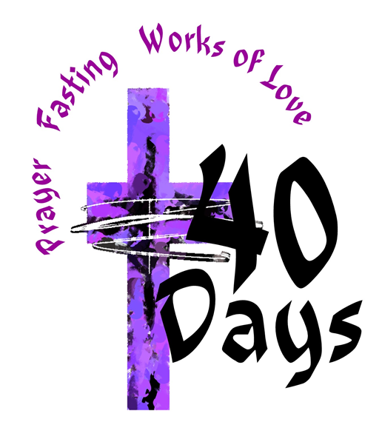

“We welcome you and serve all through faith.”

Jessica Moore, Pastor
Erin Grainger, Music and Choral Director
Stephan Conrady, Organist
Sue Powers, Administrative Assistant
27 Church Street, St. Albans, VT 05478
802-524-4555

info@firstcongregationalstalbans.org
www.firstcongregationalstalbans.org


