First Congregational Church of Saint Albans, Vermont

United Church of Christ

Fifth Sunday of Lent March 21, 2021

We Gather as God's People

CENTERING WORDS:
“The seat of gratitude is the heart.” — Diana Butler Bass

THE PREPARATION

The beginning of the prelude is a call to enter into the spirit
of prayer and community.

Prelude: “If Thou but Suffer God to Guide Thee” PH #83

Welcome and Announcements

Morning Prayer*
God of the journey,
you invite us, the church,
“to accept the cost and joy of discipleship”
and “to be your servants in the service of others.”
In so doing, may your presence be our guide and Jesus our model.
May we respond to you in loving faithfulness. Amen

Opening Hymn

“Immortal, Invisible, God Only Wise” vs 1 & 4 PH 7

Prayer of Confession
God of Mercy,
We struggle.
Guided by the things of this world we have lost our way.
We have not loved our neighbors,
We have wasted opportunities to do good,
and we have looked the other way
when our sisters and brothers have cried out to us in need.
Guide us back to your path.
Forgive us.
Awaken us.
Transform us.
Amen
A moment for personal reflection

Words of Assurance

THE MESSAGE
ANTHEM “Send Lazarus”
Chris Hutchings, text by David Ervin
A Time for Children of all Ages
Scripture Reading
Jeremiah 31:31-34
John 12:20-33
Morning Reflection “Lost & Found”

Hymn
“Breathe on Me, Breath of God” PH # 233

THE THANKSGIVING
Sharing Our Joys and Concerns
Choral Call to Prayer “Hear Our Prayer, O Lord” D. Whelpton Prayer of the People ~ Lord’s Prayer (trespasses)
Choral Response to Prayer “Thou wilt keep him in perfect peace, whose mind is stayed on Thee.” Scottish Psalter, 1615

THE DEPARTURE
Benediction
Postlude: “The God of Abraham Praise” "Yigdal" PH #14

No matter who you are or where you are on life's journey, you're welcome here.

Our Church Office Hours and Contact Information
Administrative Office- 8 AM to 11 AM weekdays.
Church Office Phone Number- 1-802-524-4555
Pastor Jessica- Office Hours – Tuesdays thru Fridays, 9 AM – 12 PM Email- pastorjessica@firstcongregationalstalbans.org
For urgent, pastoral matters outside of regular office hours, call Pastor Jessica at 207-632-5544

Our worship service is broadcast over the local public access channel 1079 on Sundays at 4 PM. Our Videographer today is Lane McElree.

Music notes: the choir selected this piece prior to the pandemic, but we didn’t get a chance to sing it for you last year. In this season of penitence, this song speaks to society’s crimes against the environment and is a call for action on climate change.

*Worship Ways, UCC; Rev. Dr. Ginny Brown Daniel, Conference
Minister for Missouri Mid-South Conference, UCC.
Music, Copyright permissions: CCLI #4799426 and SJMP #14586

The First Congregational Church of St. Albans
United Church of Christ

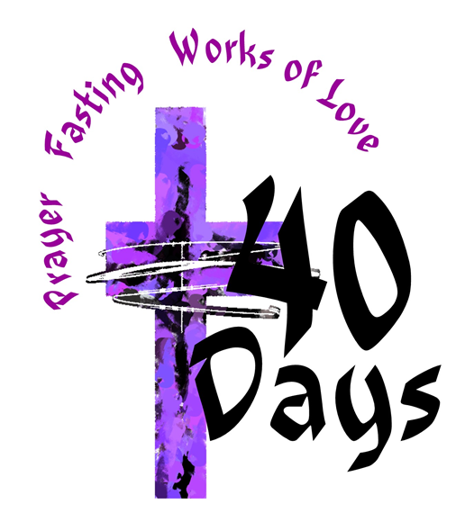

“We welcome you and serve all through faith.”

Jessica Moore, Pastor
Erin Grainger, Music and Choral Director
Stephan Conrady, Organist
Sue Powers, Administrative Assistant
27 Church Street, St. Albans, VT 05478
802-524-4555

info@firstcongregationalstalbans.org
www.firstcongregationalstalbans.org


