First Congregational Church of Saint Albans, Vermont

United Church of Christ

Third Sunday of Easter April 18, 2021

We Gather as God's People

CENTERING WORDS:
“Church is what happens when people are faithful witnesses to the saving action of God, in and for the world, in Jesus Christ.”
— Aaron Miller
THE PREPARATION

The beginning of the prelude is a call to enter into the spirit
of prayer and community.

Prelude “Hope of the World” PH 398

Welcome and Announcements

Morning Prayer*

One: God of love and light,
we come as witnesses of your glory and faithfulness,
amazed to discover your transformative love.
God, we desire for you to abide within us,
and for your grace to be revealed anew daily.
ALL: Be with us
and awaken within us the call to love one another,
in the way it was made real through Jesus the Christ. Amen

Opening Hymn

“Immortal, Invisible, God Only Wise” vs 1 & 4 PH 7

Prayer of Confession
One: Ever-present God,
Forgive us when we stand in disbelief,
and comfort us when our fears outweigh your peace.
God, forgive us when we become too busy to pray.
Help us when we fail to see our neighbors in need.
Abiding God, forgive us when we are overwhelmed
with bad news, and shut down completely.
ALL: In these times, remind us that we are called to be
your love-lived,
your faithful witnesses, and
your humble servants.
Help us to wake up to the work of love,
and to your renewing strength each day, we pray. Amen.

A moment for personal reflection

Words of Assurance

THE MESSAGE
ANTHEM “Christ the Lord is risen again! — Alan Smith
Scripture Reading
Psalm 4
Luke 24: 36-48
Morning Reflection “Can I Get A Witness?”

Hymn
“Lord, Speak to Me, That I May Speak” vs 1 & 4 PH 397

THE THANKSGIVING
Sharing Our Joys and Concerns
Choral Call to Prayer “Hear Our Prayer, O Lord” D. Whelpton Prayer of the People ~ Lord’s Prayer (trespasses)
Choral Response to Prayer “Thou wilt keep him in perfect peace, whose mind is stayed on Thee.” Scottish Psalter, 1615

THE DEPARTURE
Benediction
Postlude “O Holy City, Seen of John” PH 420

No matter who you are or where you are on life's journey, you're welcome here.

Our Church Office Hours and Contact Information
Administrative Office- 8 AM to 11 AM weekdays.
Church Office Phone Number- 1-802-524-4555
Pastor Jessica- Office Hours – Tuesdays thru Fridays, 9 AM – 12 PM Email- pastorjessica@firstcongregationalstalbans.org
For urgent, pastoral matters outside of regular office hours, call Pastor Jessica at 207-632-5544

Our worship service is broadcast over the local public access channel 1079 on Sundays at 4 PM. Our Videographer today is Lane McElree.

*Worship Ways, UCC; Rev. Dr. Sheila Harvey Guillaume
Music, Copyright permissions: CCLI #4799426 and SJMP #14586

The First Congregational Church of St. Albans
United Church of Christ

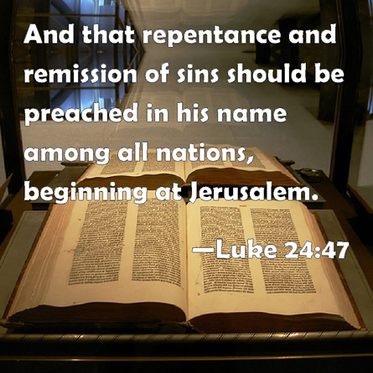

“We welcome you and serve all through faith.”

Jessica Moore, Pastor
Erin Grainger, Music and Choral Director
Stephan Conrady, Organist
Sue Powers, Administrative Assistant
27 Church Street, St. Albans, VT 05478
802-524-4555

info@firstcongregationalstalbans.org
www.firstcongregationalstalbans.org

