First Congregational Church of Saint Albans, Vermont

United Church of Christ

Trinity Sunday May 30, 2021

We Gather as God's People

CENTERING WORDS:
“If you ask me what I came to do in this world, I, an artist, will answer you: I am here to live out loud.” ― Émile Zola

THE PREPARATION

The beginning of the prelude is a call to enter into the spirit
of prayer and community.

Prelude “For George” (variation for keyboards) S. Conrady

Welcome and Announcements

Call to Worship*

One: Come into this household of the living God, the Three in One.
Gather in the wonder of the mystery that God has invited us to share in.
All: We have come as the family of Christ, led by the Spirit of God.
One: Ascribe to the Divine glory and strength; ascribe to God the glory that is due. Worship the Triune God in the Beauty of Holiness. (Adapted from Psalm 29)
All: Our hope is that in this time of worship and learning,
we might embrace what lies beyond our imagination and understanding.

Morning Prayer* (Unison)
O God of Mystery,
Within your very self you model the beloved community.
You are the Wisdom within our hearts,
The Word who dwells among us,
The Spirit who calls us beyond ourselves.
Let us know your presence here today
In a new way, that we might celebrate your love
and go forth rejoicing with the Prophet Isaiah,
saying: “Here am I. Send me.” (Isaiah 6:8b)

Prayer of Confession* (Unison)
Holy One, we acknowledge that too often we try to live
not acknowledging the mystery of your Being.
Even though you have shown us your truth,
we allow ourselves to rest in our own uncertainties.
We find ourselves unable or unwilling to embrace the love
through which you sent Christ to live among us.
We take for granted the grandeur of you as Creator,
of Christ as Redeemer,
and of the Holy Spirit as ever-present sustainer.
We do not live out the beloved community you desire for all.
Forgive us, we pray, and help us give testimony to your love.

A moment for personal reflection

Words of Assurance

THE MESSAGE
ANTHEM “Father, we praise you” A. Bullard
Time For Children of All Ages
Scripture Reading
Isaiah 6:1-8
Morning Reflection “Here I am”

THE THANKSGIVING
Sharing Our Joys and Concerns
Choral Call to Prayer “Hear Our Prayer, O Lord” D. Whelpton Prayer of the People ~ Lord’s Prayer (trespasses)
Choral Response to Prayer “Thou wilt keep him in perfect peace, whose mind is stayed on Thee.” Scottish Psalter, 1615

THE DEPARTURE
Benediction
Postlude “Tichy Pozdrav” Theme composed by my organ teacher,
V. Vobornik

Hymns
Holy, Holy, Holy NCH 277 (Insert)
We Are the Church Binder 59 (Insert)

No matter who you are or where you are on life's journey, you're welcome here.

Our Church Office Hours and Contact Information
Administrative Office- 8 AM to 11 AM weekdays.
Church Office Phone Number- 1-802-524-4555
Pastor Jessica- Office Hours –
Tuesdays, Wednesdays, Fridays, 9 AM – 12 PM;
Thursday 12-3 PM
Email- pastorjessica@firstcongregationalstalbans.org
For urgent, pastoral matters outside of regular office hours, call Pastor Jessica at 207-632-5544

Our worship service is broadcast over the local public access channel 1079 on Sundays at 4 PM. Our Videographer today is Lane McElree.

Music Notes: Most of our solar anthems this year I’ve been solo version of songs that the choir sings. If you had a favorite, let us know! When the choir gets back together we will put together a harmonized version.

*Worship Ways, UCC.
Music, Copyright permissions: CCLI #4799426 and SJMP #14586

The First Congregational Church of St. Albans
United Church of Christ

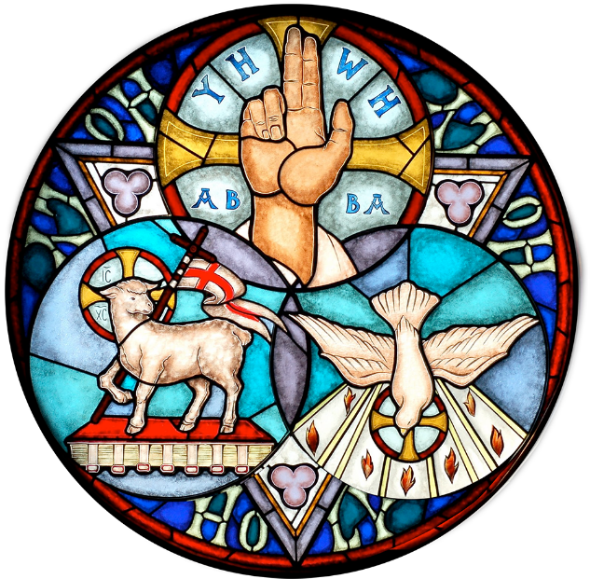

“We welcome you and serve all through faith.”

Jessica Moore, Pastor
Erin Grainger, Music and Choral Director
Stephan Conrady, Organist
Sue Powers, Administrative Assistant
27 Church Street, St. Albans, VT 05478
802-524-4555

info@firstcongregationalstalbans.org
www.firstcongregationalstalbans.org

