First Congregational Church of Saint Albans, Vermont

United Church of Christ

Sixth Sunday of Easter May 9, 2021

We Gather as God's People

CENTERING WORDS:
“Joy is the holy fire that keeps our purpose warm and our intelligence aglow.”
—Helen Keller

THE PREPARATION

The beginning of the prelude is a call to enter into the spirit
of prayer and community.

Prelude “Tekakwitha´s call” S. Conrady

Welcome and Announcements

Morning Prayer* (Unison)
Creating Spirit,
we join with the chorus of all of creation
to celebrate your wonderous deeds.
Fill us with your joy and train our ears for harmony,
so that we may contribute to the world You are already creating.
All this we pray in the name of Jesus,
who revealed what is possible through love. Amen.

PRAYER OF CONFESSION
One: Unwavering God, we keep asking what is it that you most want us to do with our lives in hope you might tell us something easier. Instead, You offer the same answer every time: Love one another as I have loved you.
All: We confess that our love for others is not always what we hope it would be.
One: We are quick to judge and slow to offer grace.
All: We are swift to anger and resistant to make amends.
One: We are prone to suspicion and resistant to build trust.
All: We hear the greatest commandment, and if we are honest, we are filled with hesitation because it means we must change. Unwavering God, in these moments of stillness, hear our struggles with the love you call us to practice…
Amen.

A moment for personal reflection

Words of Assurance

THE MESSAGE
ANTHEM “If ye love me" Malcolm Archer
A Time For Children of All Ages:
Scripture Reading
Psalm 98
John 15: 9-17
Morning Reflection “Love Connection”

THE THANKSGIVING
Sharing Our Joys and Concerns
Choral Call to Prayer “Hear Our Prayer, O Lord” D. Whelpton Prayer of the People ~ Lord’s Prayer (trespasses)
Choral Response to Prayer “Thou wilt keep him in perfect peace, whose mind is stayed on Thee.” Scottish Psalter, 1615

THE DEPARTURE
Benediction
Postlude “Je crie vers Toi, Seigneur Jesus” J. S. Bach

Hymns
What a Friend We Have in Jesus P. H. 335
Holy Spirit, Truth Divine P.H. 243

No matter who you are or where you are on life's journey, you're welcome here.

Our Church Office Hours and Contact Information
Administrative Office- 8 AM to 11 AM weekdays.
Church Office Phone Number- 1-802-524-4555
Pastor Jessica- Office Hours –
Tuesdays, Wednesdays, Fridays, 9 AM – 12 PM;
Thursday 12-3 PM
Email- pastorjessica@firstcongregationalstalbans.org
For urgent, pastoral matters outside of regular office hours, call Pastor Jessica at 207-632-5544

Our worship service is broadcast over the local public access channel 1079 on Sundays at 4 PM. Our Videographer today is Lane McElree.

Music notes: Today's anthem aligns closely with part of today's readings, John 15:10 If you keep my commandments, you will abide in my love, just as I have kept my Father's commandments and abide in his love. The sung text is actually from John 14:15-17, If ye love me, keep my commandments, which is familiar to choral music affectionados from a motet by Reformation composer Thomas Tallis, and it remains one of the more well-known settings of the text. Today's version is one of the two settings the choir has sung in recent years, re-arranged for solo voice.

*Worship Ways, UCC.
Music, Copyright permissions: CCLI #4799426 and SJMP #14586

The First Congregational Church of St. Albans
United Church of Christ

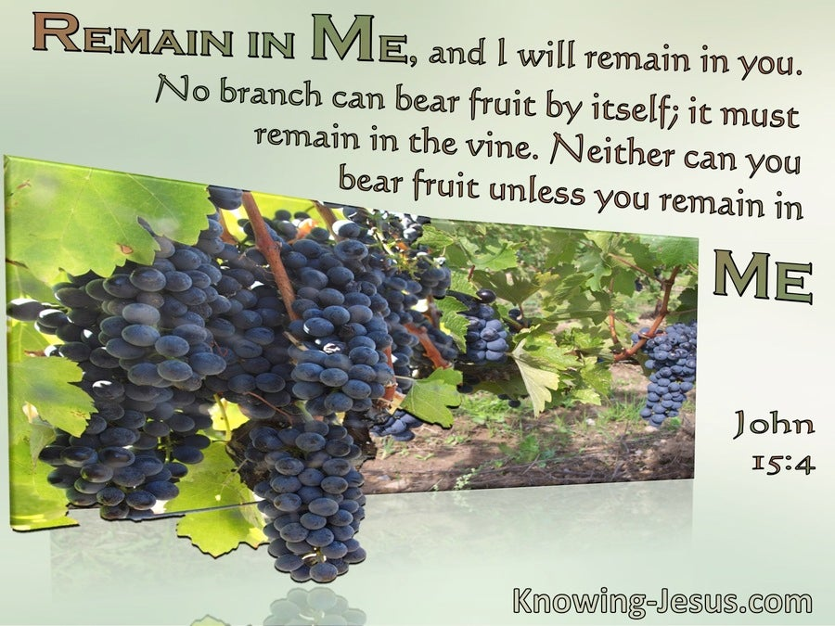

“We welcome you and serve all through faith.”

Jessica Moore, Pastor
Erin Grainger, Music and Choral Director
Stephan Conrady, Organist
Sue Powers, Administrative Assistant
27 Church Street, St. Albans, VT 05478
802-524-4555

info@firstcongregationalstalbans.org
www.firstcongregationalstalbans.org

