First Congregational Church of Saint Albans, Vermont

United Church of Christ

Twelfth Sunday after Pentecost August 15, 2021

We Gather as God's People

CENTERING WORDS:
“Be faithful to the time spent in prayer and make sure that at least half of your prayer is spent in silence. This will bring you closer to Jesus. If you deepen your prayer life you will grow in holiness and obtain many graces for the souls entrusted to your care. Deepen your love for one another by praying for each other and by sharing thoughts and graces you have received in prayer and reading.”
— Mother Teresa

THE PREPARATION

The beginning of the prelude is a call to enter into the spirit
of prayer and community.

Prelude “Grace alone.” BB 14

Welcome and Announcements

Call to Worship¹

One: Come into this household of God
that we might all listen to God’s Word
and discern the wisdom that comes only from God.
All: How can we discover such wisdom?
One: Reverence for God is the beginning of wisdom.
When we choose to live according to God’s will and plan,
God will give to each of us a wise and discerning heart.
All: God fills us with psalms and hymns and spiritual songs!
We have come to praise with music from our hearts.
One: Jesus is here in our midst as living bread.
We want to be nourished and strengthened that we may remain with him.
Jesus is so close to us that we can taste his presence.
All: Praise the Lord! Learn of God’s compassion and mercy.
Praise the Lord with our hearts! Praise the Lord!

*Opening Hymn

Holy, Holy, Holy PH 251

Prayer of Confession¹ (Unison)
All Wise God, we thank you
For giving us this time to look into our words, thoughts and deeds.
We confess that we fool ourselves into believing
that we possess all of the knowledge that we need.
As we go from place to place, we try to block you out.
Even though we say we want to hear your Word and speak with you,
we fail to see that we are always in your presence.
We stray seeking other gods,
whose ways may be easy but cannot show us the ways of love and truth.
We are afraid of being fed with the living bread of Jesus.
Fill us with the Holy Spirit that we might live each day
according to your will and plan for us and for your world.
Help us to discern your wisdom
that we might live eternally with you and Christ.

A moment for personal reflection

Assurance of God’s Unconditional Love.

Passing of the Peace

THE MESSAGE
Special music: “Wedding Waltz” S. Conrady
Time for Children of All Ages
Scripture Reading
Proverbs 9:1-6
John 6:51-58

Morning Reflection “Set the table”

*Hymn

Now Thank We All Our God PH 29
THE THANKSGIVING
Sharing Our Joys and Concerns
Prayer of the People ~
Lord’s Prayer
Our Father who art in heaven hallowed be thy name. Thy kingdom come thy will be done on earth as it is in heaven. Give us this day our daily bread. And forgive us our trespasses, as we
forgive those who trespass against us. And lead us not into temptation, but deliver us from evil. For thine is the kingdom, and the power and the glory, forever, Amen

THE DEPARTURE
*Hymn
Lord Dismiss Us with Thy Blessing PH 63

*Benediction
Postlude “Toccata” BWV 565 arr. Conrady

*You are invited to stand.

No matter who you are or where you are on life's journey, you're welcome here.

Our Church Office Hours and Contact Information
Administrative Office- 8 AM to 11 AM weekdays.
Church Office Phone Number- 1-802-524-4555
Pastor Jessica- Office Hours –
Tuesdays, Wednesdays, Fridays, 9 AM – 12 PM;
Thursday 12-3 PM
Email- pastorjessica@firstcongregationalstalbans.org
For urgent, pastoral matters outside of regular office hours, call Pastor Jessica at 207-632-5544

Our worship service is broadcast over the local public access channel 1079 on Sundays at 4 PM. Our Videographer today is Lane McElree.

¹Worship Ways, UCC.
Music, Copyright permissions: CCLI #4799426 and SJMP #14586

The First Congregational Church of St. Albans
United Church of Christ
Open & Affirming

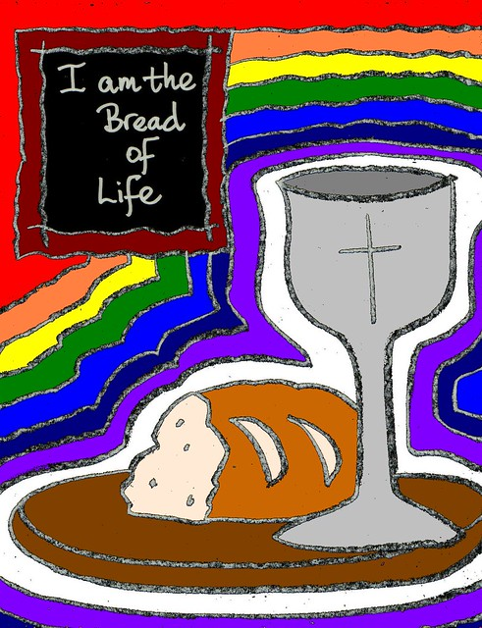

“We welcome you and serve all through faith.”

Jessica Moore, Pastor
Erin Grainger, Music and Choral Director
Stephan Conrady, Organist
Sue Powers, Administrative Assistant
27 Church Street, St. Albans, VT 05478
802-524-4555

info@firstcongregationalstalbans.org
www.firstcongregationalstalbans.

