First Congregational Church of Saint Albans, Vermont

United Church of Christ

Eleventh Sunday after Pentecost August 8, 2021

We Gather as God's People

CENTERING WORDS:
“When I was a boy and I would see scary things in the news, my mother would say to me, ‘Look for the helpers. You will always find people who are helping.'” — Fred Rogers

THE PREPARATION

The beginning of the prelude is a call to enter into the spirit
of prayer and community.

Prelude “Something Beautiful” B B 46

Welcome and Announcements

Call to Worship¹

One: Out of the depths I cry to you, O God:
Many: We hunger for the bread of life, O Jesus,
and we thirst for you, O God.
One: O God, hear my voice! Let your ears be attentive to the voice of my supplications!
Many: We hunger for the bread of life, O Jesus,
and we thirst for you, O God.
One: There is forgiveness with you and I wait for you O God, my soul waits, for
Many: We hunger for the bread of life, O Jesus,
and we thirst for you, O God.
One: In your words I hope. My soul waits for you, God,
more than those who watch for the morning,
more than those who watch for the morning:
Many: We hunger for the bread of life, O Jesus,
and we thirst for you, O God.

Morning Prayer¹ (unison)
God of Healing and Transformation,
we hunger and thirst for your abundant life.
we bring you our sorrow and ask for the bread of joy;
we bring you our despair and ask for the bread of hope;
we bring you our weariness and ask for the bread of inspiration.
Meet us here. We need the bread of heaven to sustain us for our journey to find our way, that we may we be one with you. Amen.

*Opening Hymn

God Is Here (vs. 1 & 4) Insert

Prayer of Confession (Unison)
Holy One, We confess that we continue wars in our holy human family
even though we know they cause unspeakable suffering.
Like David, who wept for Absalom, his lost son,
we are filled with sorrow for all the children
in our human family who die in war.
We see our advanced weapons kill and maim children
and yet still we do not find the ways to peace.
Forgive us.
A moment for personal reflection

Assurance of God’s Unconditional Love.

Passing of the Peace

THE MESSAGE
Special music: “Sad Songs” (#1) S. Conrady
Time for Children of All Ages
Scripture Reading
John 6:35, 41-51

Morning Reflection “Grumbling”

*Hymn

Be Thou My Vision (vs. 1 & 2) PH 391
THE THANKSGIVING
Sharing Our Joys and Concerns
Prayer of the People ~
Lord’s Prayer
Our Father who art in heaven hallowed be thy name. Thy kingdom come thy will be done on earth as it is in heaven. Give us this day our daily bread. And forgive us our trespasses, as we
forgive those who trespass against us. And lead us not into temptation, but deliver us from evil. For thine is the kingdom, and the power and the glory, forever, Amen

THE DEPARTURE
*Hymn
Lord Dismiss Us with Thy Blessing (vs. 1 & 3) PH 63
*Benediction
Postlude “When Stephen, Full of Power and Grace” P H 493
*You are invited to stand.

No matter who you are or where you are on life's journey, you're welcome here.

Our Church Office Hours and Contact Information
Administrative Office- 8 AM to 11 AM weekdays.
Church Office Phone Number- 1-802-524-4555
Pastor Jessica- Office Hours –
Tuesdays, Wednesdays, Fridays, 9 AM – 12 PM;
Thursday 12-3 PM
Email- pastorjessica@firstcongregationalstalbans.org
For urgent, pastoral matters outside of regular office hours, call Pastor Jessica at 207-632-5544

Our worship service is broadcast over the local public access channel 1079 on Sundays at 4 PM. Our Videographer today is Lane McElree.

Our scripture reader this morning is Wayne Miller.

¹Worship Ways, UCC.
Music, Copyright permissions: CCLI #4799426 and SJMP #14586

The First Congregational Church of St. Albans
United Church of Christ
Open & Affirming

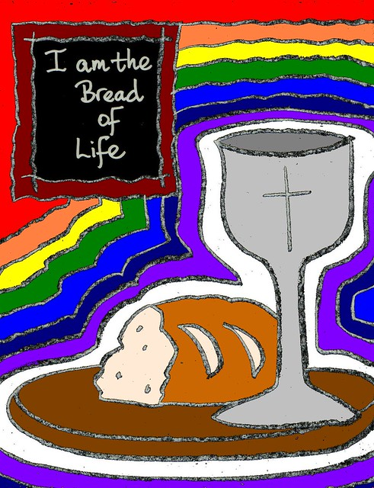

“We welcome you and serve all through faith.”

Jessica Moore, Pastor
Erin Grainger, Music and Choral Director
Stephan Conrady, Organist
Sue Powers, Administrative Assistant
27 Church Street, St. Albans, VT 05478
802-524-4555

info@firstcongregationalstalbans.org
www.firstcongregationalstalbans.org

