First Congregational Church of Saint Albans, Vermont

United Church of Christ

Sixteenth Sunday after Pentecost September 12, 2021

We Gather as God's People

CENTERING WORDS:
“The world as we have created it is a process of our thinking. It cannot be changed without changing our thinking.” ― Albert Einstein

THE PREPARATION

The beginning of the prelude is a call to enter into the spirit
of prayer and community.

Prelude An Angel Unseen P. Edvinsson
Welcome and Announcements

Morning Prayer¹ (unison)
Holy Wisdom of God
You call to us from the depths of our hearts,
where we long for connection with you and with one another.
You call to us from busy streets and neighborhoods,
Where human pain and possibility are most urgent.
You call to us from our sacred stories,
where God, Christ, Spirit create, challenge, comfort.
Guide us, we pray, on an adventure of hope, and
help us see with your eyes
the ways which lead to beloved community
where Christ Jesus is at the center.
Amen.

*Opening Hymn
Abide By Me

Prayer of Confession¹ (Unison)
Christ calls on us to “lose our life in order to save it”;
To “take up our cross and follow”
in the ways of justice and peace.
Like the disciples before us,
we are often amazed and overwhelmed by this command.
We close our ears to such challenge and
our hearts to such risk.
Amen.

A moment for personal reflection

Assurance of God’s Unconditional Love.

Passing of the Peace

THE MESSAGE
Special music: How Can I Keep From Singing? - Traditional
Time for Children of All Ages
Scripture Reading
James 3:1-12
Morning Reflection “Silence is Golden?”

THE THANKSGIVING
Sharing Our Joys and Concerns
Prayer of the People ~
Lord’s Prayer
Our Father who art in heaven hallowed be thy name. Thy kingdom come thy will be done on earth as it is in heaven. Give us this day our daily bread. And forgive us our trespasses, as we
forgive those who trespass against us. And lead us not into temptation, but deliver us from evil. For thine is the kingdom, and the power and the glory, forever, Amen

THE DEPARTURE
*Hymn
All Creatures of Our God and King
*Benediction
Postlude Ivan Sings (“The Adventures of Ivan”) – A. Khachaturian

*You are invited to stand.

No matter who you are or where you are on life's journey, you're welcome here.

Our Church Office Hours and Contact Information
Administrative Office- 8 AM to 11 AM weekdays.
Church Office Phone Number- 1-802-524-4555
Pastor Jessica- Office Hours –
Tuesdays, Wednesdays, Fridays, 9 AM – 12 PM;
Thursday 12-3 PM
Email- pastorjessica@firstcongregationalstalbans.org
For urgent, pastoral matters outside of regular office hours, call Pastor Jessica at 207-632-5544

Our worship service is broadcast over the local public access channel 1079 on Sundays at 4 PM. Our Videographer today is Lane McElree.

Our Scripture Reader this morning is Gerard Sparacino.

¹Worship Ways, UCC.
Music, Copyright permissions: CCLI #4799426 and SJMP #14586

The First Congregational Church of St. Albans
United Church of Christ
Open & Affirming

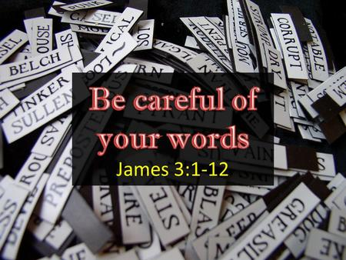

“We welcome you and serve all through faith.”
Worship with us Sundays at 10am

Jessica Moore, Pastor
Erin Grainger, Music and Choral Director
Stephan Conrady, Organist
Sue Powers, Administrative Assistant
27 Church Street, St. Albans, VT 05478
802-524-4555

info@firstcongregationalstalbans.org
www.firstcongregationalstalbans.

