First Congregational Church of Saint Albans, Vermont

United Church of Christ

Eighteenth Sunday after Pentecost September 26, 2021

We Gather as God's People

CENTERING WORDS:
“You are the salt that adds flavor to the earth, and the whole universe is waiting to savor your uniqueness.” ― Michael Bassey Johnson

THE PREPARATION

The beginning of the prelude is a call to enter into the spirit
of prayer and community.

Prelude Catherine´s call
Welcome and Announcements

Call to Worship¹
One: I am the church; you are the church.
All: We are the church together.
One: We depend on our seniors and long-time members
to remember where we came from and where we have been.
All: We are the church together.
One: We depend on our children to retell our sacred stories
as they grow.
All: We are the church together.
One: We depend on our youth and young adults
to ask us why we do things this way
and to suggest something new.
All: We are the church together.
One: We need each other to be the church.
All: We are the church together.

Opening Hymn
All My Hope on God Is Founded PH 339

Prayer of Confession¹
One: Creator of us all,
All: We sometimes forget:
We forget that we are not alone,
We forget that you made us,
We forget that we have had help along the way,
We forget to ask for what we need.
One: Embodied God,
Remind us that we are surrounded.
We are surrounded by the people you have created,
And by the many gifts you have given them to share.
Remind us of our own gifts,
And the ways we may use them in community.
All: Suffering Savior,
We confess that in our own struggle to survive,
We have ignored other communities.
We have forgotten that they too have the right to survive.
Make us mindful. Make us compassionate.
Help us to see you in one another.
Amen

A moment for personal reflection

Assurance of God’s Unconditional Love.

Passing of the Peace

THE MESSAGE
Special music: Under a Tree (for piano) S. Conrady
Time for Children of All Ages
Scripture Reading
Mark 9:38-50
Morning Reflection “Season to Taste”
Hymn
We Would Be Building PH 494

THE THANKSGIVING
Sharing Our Joys and Concerns
Prayer of the People ~
Lord’s Prayer
Our Father who art in heaven hallowed be thy name. Thy kingdom come thy will be done on earth as it is in heaven. Give us this day our daily bread. And forgive us our trespasses, as we
forgive those who trespass against us. And lead us not into temptation, but deliver us from evil. For thine is the kingdom, and the power and the glory, forever, Amen

THE DEPARTURE
Hymn
Lord Dismiss Us with Thy Blessing PH 63
Benediction
Postlude Grace alone (for organ) B.B. 17

No matter who you are or where you are on life's journey, you're welcome here.

Our Church Office Hours and Contact Information
Administrative Office- 8 AM to 11 AM weekdays.
Church Office Phone Number- 1-802-524-4555
Pastor Jessica- Office Hours –
Tuesdays, Wednesdays, Fridays, 9 AM – 12 PM;
Thursday 12-3 PM
Email- pastorjessica@firstcongregationalstalbans.org
For urgent, pastoral matters outside of regular office hours, call Pastor Jessica at 207-632-5544

Our worship service is broadcast over the local public access channel 1079 on Sundays at 4 PM. Our Videographer today is Lane McElree.

Our Scripture Reader this morning is Sandy Christman.

¹ Worship Ways

The First Congregational Church of St. Albans
United Church of Christ
Open & Affirming

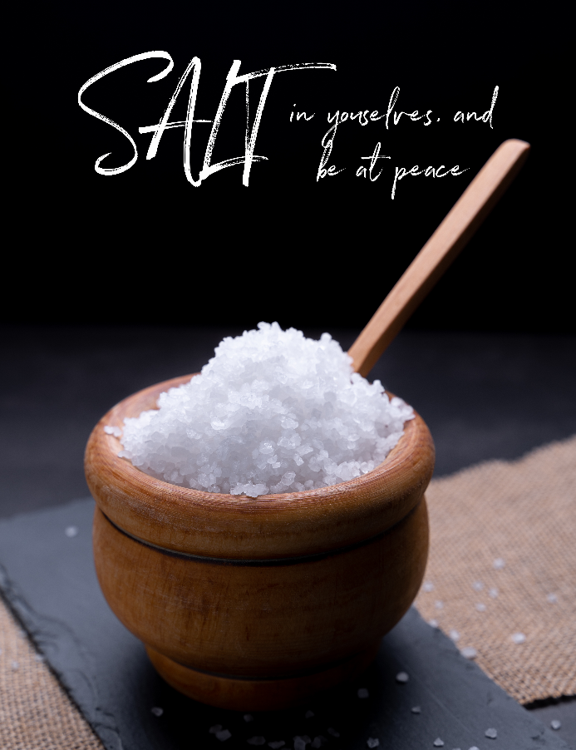

“We welcome you and serve all through faith.”
Worship with us Sundays at 10am

Jessica Moore, Pastor
Erin Grainger, Music and Choral Director
Stephan Conrady, Organist
Sue Powers, Administrative Assistant
27 Church Street, St. Albans, VT 05478
802-524-4555

info@firstcongregationalstalbans.org
www.firstcongregationalstalbans.

