First Congregational Church of Saint Albans, Vermont

United Church of Christ

Forth Sunday After Epiphany January 30, 2022

We Gather as God's People

CENTERING WORDS:
“All of creation teaches us some way of prayer” –Thomas Merton

THE PREPARATION

The beginning of the prelude is a call to enter into the spirit
of prayer and community.

Prelude Morning has broken (Bunessan) Composer unknown

Welcome and Announcements

Morning Prayer ¹
One: O God of Change and Stillness, of Wounds and Repair,
All: in you we find our sense of balance—a place to land and to breathe.
One: May we grow our attention towards that which gives life,
All: and cultivate connections of community and care.
One: May grace touch all that changes us,
All: and all that we hold unfold with peace.
One: May we gather in this space claiming healing as our birthright,
All: and bring with us the medicines of service and compassion.
One: Let us come together to transform ourselves to transform the world,
All: and move like living water—ever adapting, ever faithful,
ever full of all that can be. Amen.

Opening Hymn

God of Grace and God of Glory NCH 436

Prayer of Confession¹
One: O God of Becoming, we claim ourselves as your beloved,
and name the messy reality of being human.
All: In your presence, we do not shy away from our struggles, failings, or regrets.
One: By your invitation, we come to you not in shame, but with courage, seeking right relationship,
All: with you, with ourselves, each other, and all of creation.
One: Guide us in your ways of accountability,
All: with remedies of repair and reconciliation
One: May our sense of self be vast enough for our faults and deep enough to let go,
All: to make space to learn from our wrongdoing, without spiraling into self-hate.
One: Spirit of Creation, teach us the grace of generative conflict,
All: that we may be open to the tension underneath authentic connection.
One: Help us to believe change is possible, in ourselves and others,
All: so our healing can ripple outwards
and our shared power can break forth anew.

A moment for personal reflection

Assurance of God’s Unconditional Love.

Passing of the Peace

THE MESSAGE
Anthem Some Glad Morning (I'll Fly Away) - A. Brumley
A Time for Children of All Ages
Scripture Reading
Luke 4:21-30
Morning Reflection Hello, I must Be Going

Hymn
Spirit of the Living God NCH 283
THE THANKSGIVING
Sharing Our Joys and Concerns
Coral Call to Prayer Hear Our Prayer, O Lord D. Welpton
Prayer of the People ~
Lord’s Prayer
Our Father who art in heaven hallowed be thy name. Thy kingdom come thy will be done on earth as it is in heaven. Give us this day our daily bread. And forgive us our trespasses, as we
forgive those who trespass against us. And lead us not into temptation, but deliver us from evil. For thine is the kingdom, and the power and the glory, forever, Amen

Choral Response to Prayer “Thou wilt keep him in perfect peace, whose mind is stayed
on Thee.” Scottish Psalter, 1615

THE DEPARTURE
Hymn
Carry the Light
Benediction
Postlude Sometimes i feel like a motherless child
arr. Conrady S. Coleridge-Taylor

No matter who you are or where you are on life's journey, you're welcome here.

Our Church Office Hours and Contact Information
Administrative Office- 8 AM to 11 AM weekdays.
Church Office Phone Number- 1-802-524-4555
Pastor Jessica- Office Hours –
Tuesdays, Wednesdays, Fridays, 9 AM – 12 PM
Email- pastorjessica@firstcongregationalstalbans.org
For urgent, pastoral matters outside of regular office hours, call Pastor Jessica at 207-632-5544

Our worship service is broadcast over the local public access channel 1079 on Sundays at 4 PM.
Our Scripture Reader this morning is Nancy Holland.

¹ Worship Ways

The First Congregational Church of St. Albans
United Church of Christ
Open & Affirming

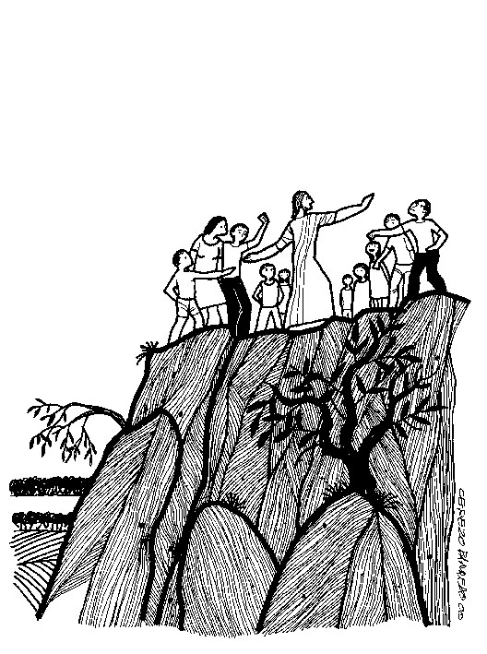

“We welcome you and serve all through faith.”
Worship with us Sundays at 10am

Rev. Jessica Moore, Pastor
Erin Grainger, Music and Choral Director
Stephan Conrady, Organist
Sue Powers, Administrative Assistant
27 Church Street, St. Albans, VT 05478
802-524-4555

info@firstcongregationalstalbans.org
www.firstcongregationalstalbans.org

