First Congregational Church of Saint Albans, Vermont

United Church of Christ

Sixth Sunday After Epiphany February 13, 2022

We Gather as God's People

CENTERING WORDS:
“They joined hands.
So the world ended.
And the next one began.” ― Sarah J. Maas

THE PREPARATION

The beginning of the prelude is a call to enter into the spirit
of prayer and community.

Prelude Canon in D J. Pachelbel

Welcome and Announcements

Morning Prayer ¹
O God of many blessings, be with us in our joy and in our sorrow.
Help us to reach out with your love to those in need,
that we may not be satisfied until all are fed.
Bless each of us here, and all who cannot be present with us today.
Shower your blessings on our worship, as we pray all this through Jesus the Christ,
our teacher and our guide.
Amen.

Opening Hymn

Praise to the Living God NCH 8

Prayer of Confession¹
We try to care for each other, especially when there is pain and sorrow,
and when we witness injustice.
But we cannot find blessing in poverty and hunger.
Sometimes it feels just too hard to offer relief or to work for change.
We prefer to stay in our comfortable spaces or choose to walk past those in need.
Sometimes we are afraid.
Forgive us when we serve ourselves more often than we serve you, O God.
We come to you with humble hearts.
Amen.
A moment for personal reflection

Assurance of God’s Unconditional Love.

Passing of the Peace

THE MESSAGE
A Time for Children of All Ages
Anthem
Scripture Reading
Luke 6:17-26
Morning Reflection
Blessings

Hymn
Blessed Assurance NCH 473

THE THANKSGIVING
Sharing Our Joys and Concerns
Coral Call to Prayer Hear Our Prayer, O Lord D. Welpton
Prayer of the People ~
Lord’s Prayer
Our Father who art in heaven hallowed be thy name. Thy kingdom come thy will be done on earth as it is in heaven. Give us this day our daily bread. And forgive us our trespasses, as we
forgive those who trespass against us. And lead us not into temptation, but deliver us from evil. For thine is the kingdom, and the power and the glory, forever, Amen

Choral Response to Prayer “Thou wilt keep him in perfect peace, whose mind is stayed
on Thee.” Scottish Psalter, 1615

THE DEPARTURE
Hymn
Carry the Light
Benediction
Postlude How long will I love you Ellie Goulding

No matter who you are or where you are on life's journey, you're welcome here.

Our Church Office Hours and Contact Information
Administrative Office- 8 AM to 11 AM weekdays.
Church Office Phone Number- 1-802-524-4555
Pastor Jessica- Office Hours –
Tuesdays, Wednesdays, Fridays, 9 AM – 12 PM
Email- pastorjessica@firstcongregationalstalbans.org
For urgent, pastoral matters outside of regular office hours, call Pastor Jessica at 207-632-5544

Our worship service is broadcast over the local public access channel 1079 on Sundays at 4 PM.
Our Scripture Reader this morning is Lane McElree.

¹ Worship Ways

The First Congregational Church of St. Albans
United Church of Christ
Open & Affirming

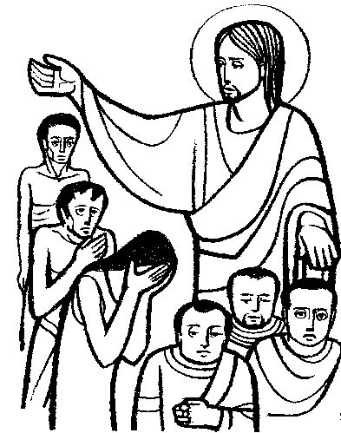

“We welcome you and serve all through faith.”
Worship with us Sundays at 10am

Rev. Jessica Moore, Pastor
Erin Grainger, Music and Choral Director
Stephan Conrady, Organist
Sue Powers, Administrative Assistant
27 Church Street, St. Albans, VT 05478
802-524-4555

info@firstcongregationalstalbans.org
www.firstcongregationalstalbans.org

