First Congregational Church of Saint Albans, Vermont

United Church of Christ

Transfiguration Sunday February 27, 2022

We Gather as God's People

CENTERING WORDS:
“God places us in the world as his fellow workers-agents of transfiguration. We work with God so that injustice is transfigured into justice, so there will be more compassion and caring, that there will be more laughter and joy, that there will be more togetherness in God's world.” ― Desmond Tutu

THE PREPARATION
The beginning of the prelude is a call to enter into the spirit of prayer and community.

Prelude For George S. Conrady

Welcome and Announcements

Opening Prayer ¹ (unison)
O God, you are beyond words and description,
your love is beyond knowledge and explanation.
Make our hearts ready to receive you.
Change us, we pray, that our lives may reflect the glory of your transfiguration.
We rejoice in the power of your Holy Spirit. Amen.

Opening Hymn
A Mighty Fortress Is My God NCH 439

Prayer of Confession¹ (unison)
God of glory and light,
forgive us when we are complacent and comfortable
with keeping the riches of your love to ourselves.
Keep calling us down from our mountains of privilege.
Keep expecting more of us as your disciples.
Keep reminding us to listen to your Son,
in whose name we pray. Amen.
A moment for personal reflection

Assurance of God’s Unconditional Love.

Passing of the Peace

THE MESSAGE
A Time for Children of All Ages
Anthem When Israel was in Egypt’s land – Spiritual
Scripture Reading
Luke 9:28-43(a)
Morning Reflection
“Transformed Through Community”

Hymn
We Have Come at Christ’s Own Bidding NCH 182

THE THANKSGIVING
Sharing Our Joys and Concerns
Coral Call to Prayer Hear Our Prayer, O Lord D. Welpton
Prayer of the People ~
Lord’s Prayer
Our Father who art in heaven hallowed be thy name. Thy kingdom come thy will be done on earth as it is in heaven. Give us this day our daily bread. And forgive us our trespasses, as we
forgive those who trespass against us. And lead us not into temptation, but deliver us from evil. For thine is the kingdom, and the power and the glory, forever, Amen

Choral Response to Prayer
“Thou wilt keep him in perfect peace, whose mind is stayed on Thee.” Scottish Psalter, 1615

THE DEPARTURE
Hymn
Carry the Light
Benediction
Postlude Go Down, Moses Spiritual

No matter who you are or where you are on life's journey, you're welcome here.

Our Church Office Hours and Contact Information
Administrative Office- 8 AM to 11 AM weekdays.
Church Office Phone Number- 1-802-524-4555
Pastor Jessica- Office Hours –
Tuesdays, Wednesdays, Fridays, 9 AM – 12 PM
Email- pastorjessica@firstcongregationalstalbans.org
For urgent, pastoral matters outside of regular office hours, call Pastor Jessica at 207-632-5544

Our worship service is broadcast over the local public access channel 1079 on Sundays at 4 PM.
Our Scripture Reader this morning is Mara Vijups.

¹ Worship Ways




An Open & Affirming Community

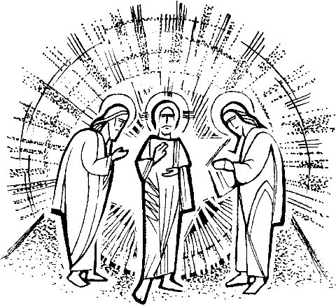

“We welcome you and serve all through faith.”

Worship with us Sundays at 10am

Rev. Jessica Moore, Pastor
Erin Grainger, Music and Choral Director
Stephan Conrady, Organist
Sue Powers, Administrative Assistant
27 Church Street, St. Albans, VT 05478
802-524-4555

info@firstcongregationalstalbans.org
www.firstcongregationalstalbans.org

