First Congregational Church of Saint Albans, Vermont

United Church of Christ

Fifth Sunday after Epiphany February 6, 2022

We Gather as God's People

CENTERING WORDS
“Don’t ask what the world needs. Ask what makes you come alive, and go do it. Because what the world needs is people who have come alive.”
-- Howard Thurman

THE PREPARATION
The beginning of the prelude is a call to
enter into the spirit of prayer and community.

Prelude Alleluja for piano S. Conrady
Welcome and Announcements

Morning Prayer¹
Holy One, you are ready to meet us
wherever we are in our lives,
offering vision, interruption, hope
where we may least expect it.
Surprise us here at worship today
With some grace unexpected
that will change something in us
—large or small—
and send us into the world
inspired and impassioned to do your work.
In Jesus’ name we pray, Amen.

Opening Hymn
“Holy, Holy, Holy” NCH 277

Prayer of Confession¹
One: You call to us through the voices of the poor and the powerless,
But we close ourselves off from their need:
All: God have mercy
One: You call to us through the cries of those who struggle
to change structures of oppression, but we turn away from their challenge:
All: Christ have mercy
One: You hint, you invite, you surround us with calls to love you more fully, and follow you more faithfully, but we cling to comfort and safety:
All: God have mercy

A moment for personal reflection

Assurance of God’s Unconditional Love.

Passing of the Peace

THE MESSAGE
Anthem Hymn to Freedom O. Peterson

Scripture Readings
Luke 5:1-11
Morning Reflection: Rip Tide
Hymn
“Help Us Accept Each Other NCH 388

THE COMMUNION
Celebration of Holy Communion Insert

THE THANKSGIVING
Sharing Joys and Concerns
Choral Call to Prayer Hear Our Prayer, O Lord D. Whelpton
Prayer of the People ~
Lord’s Prayer

Our Father who art in heaven hallowed be thy name. Thy kingdom come thy will be done on earth as it is in heaven. Give us this day our daily bread. And forgive us our trespasses, as we forgive those who trespass against us. And lead us not into temptation, but deliver us from evil. For thine is the kingdom, and the power and the glory, forever, Amen

Choral Response to Prayer “Thou wilt keep him in perfect peace,
whose mind is stayed on Thee.” Scottish Psalter, 1615

THE DEPARTURE
Hymn
Carry the Light
Benediction
Postlude Under a Tree (from: Nocturnal Rainbows) S. Conrady

No matter who you are or where you are on life's journey, you're welcome here.
We invite you to worship with us each Sunday at 10:00 AM.

Welcome to all visitors. We are delighted that you chose to worship
with us today and are strengthened by your participation in our service! If you are new to our church, please sign the guest book in the narthex.
If you are looking for a new church home, consider this family of faith.

Our Church Office Hours and Contact Information
Administrative Office- 8 AM to 11 AM weekdays.
Church Office Phone Number- 1-802-524-4555
Pastor Jessica- Office Hours –
Tuesdays, Wednesdays, Fridays, 9 AM – 12 PM
Email- pastorjessica@firstcongregationalstalbans.org
For urgent, pastoral matters outside of regular office hours, call Pastor Jessica at 207-632-5544
Our worship service is broadcast over the local public access channel 1079 on Sundays at 4 PM.
Our Scripture Reader this morning is Stephen McLaughlin.

¹ Worship Ways

The First Congregational Church of St. Albans
United Church of Christ
Open & Affirming

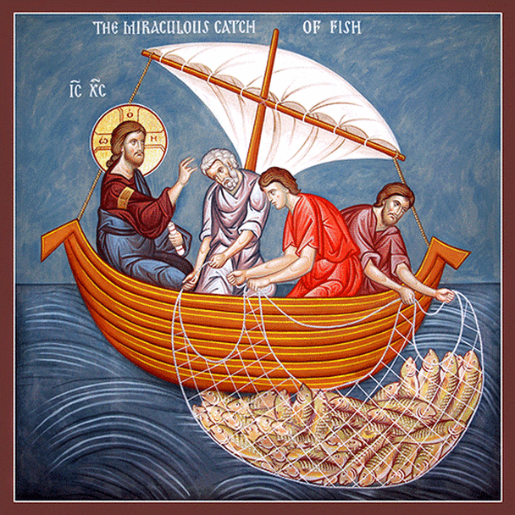

“We welcome you and serve all through faith.”
Worship with us Sundays at 10am

Rev. Jessica Moore, Pastor
Erin Grainger, Music and Choral Director
Stephan Conrady, Organist
Sue Powers, Administrative Assistant
27 Church Street, St. Albans, VT 05478
802-524-4555

info@firstcongregationalstalbans.org
www.firstcongregationalstalbans.org

