First Congregational Church of Saint Albans, Vermont

United Church of Christ

Second Sunday in Lent March 13, 2022

We Gather as God's People

CENTERING WORDS:
“The secret is not following the right path, it’s following that right path to the end. Don’t quit, my friend, until you’ve arrived.” ― Toni Sorenson
THE PREPARATION
The beginning of the prelude is a call to enter into the spirit of prayer and community.

Prelude Gymnopédie #1 (for piano & mellotron) E. Satie

Welcome and Announcements

Opening Prayer ¹ (as a litany)
One: God desires to gather us
Many: She gathers us together
One: Her wings spread out before us
Many: Her presence, all around us
One: To nurture is her nature
Many: To mother is her gift
One: For our safety, she reaches
Many: For our good, she moves
One: Sheltering over us
Many: She is our fortress
One: Deep in her underwing
Many: She is our strength
One: In her, we find our justice
Many: In her, we find our peace

Opening Hymn
Great Is Your Faithfulness NCH 423

Prayer of Confession¹ (unison)
O Wounded Healer, Mighty and Merciful,
Nothing we say can undo the damage we have done.
As you wept over Jerusalem, we now weep over our world.
You see what we have done with the gifts you have freely given us.
You sought to gather us, but we were not willing.
Your prophets spoke, but we did not have ears to hear.
Now their blood is on our hands.
We have stoned those you have sent.
Now, in our desperation, we pray.
Our lives are in chaos, but we long for your joy.
Beyond our rationalized violence, we yearn for a peace that makes no sense.
Forgive us, God of mercy and grace.

A moment for personal reflection
Assurance of God’s Unconditional Love.
Passing of the Peace

THE MESSAGE
A Time for Children of All Ages
Anthem You Walk Along Our Shoreline - Trad. Irish/text:
S. Dunstan

Scripture Reading
Luke 13:31-35
Morning Reflection
“Gathered Together”
Hymn
Christ Is Made the Sure Foundation NCH 182

THE THANKSGIVING
Sharing Our Joys and Concerns
Coral Call to Prayer Hear Our Prayer, O Lord D. Welpton
Prayer of the People ~
Lord’s Prayer
Our Father who art in heaven hallowed be thy name. Thy kingdom come thy will be done on earth as it is in heaven. Give us this day our daily bread. And forgive us our trespasses, as we
forgive those who trespass against us. And lead us not into temptation, but deliver us from evil. For thine is the kingdom, and the power and the glory, forever, Amen

Choral Response to Prayer
“Thou wilt keep him in perfect peace, whose mind is stayed on Thee.” Scottish Psalter, 1615

THE DEPARTURE
Hymn
Carry the Light
Benediction
Postlude Under a Tree (for piano & mellotron) S. Conrady

No matter who you are or where you are on life's journey, you're welcome here.

Our worship service is broadcast over the local public access channel 1079 on Sundays at 4 PM.
Our Scripture Reader this morning is Stephen McLaughlin.
¹ Worship Ways



An Open & Affirming Community

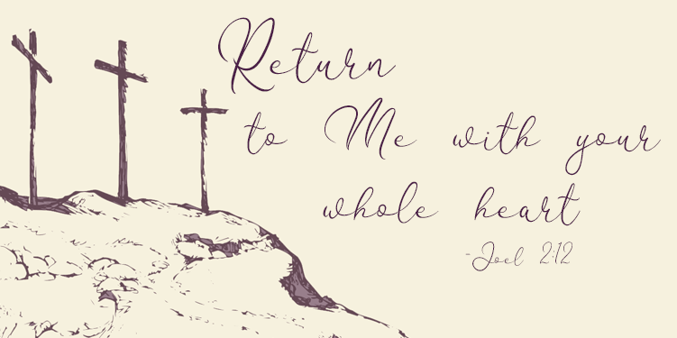

“We welcome you and serve all through faith.”

Worship with us Sundays at 10am

Rev. Jessica Moore, Pastor
Erin Grainger, Music and Choral Director
Stephan Conrady, Organist
Sue Powers, Administrative Assistant
27 Church Street, St. Albans, VT 05478
802-524-4555
info@firstcongregationalstalbans.org www.firstcongregationalstalbans.org

