First Congregational Church of Saint Albans, Vermont

United Church of Christ

Third Sunday in Lent March 20, 2022

We Gather as God's People

CENTERING WORDS:
“The secret is not following the right path, it’s following that right path to the end. Don’t quit, my friend, until you’ve arrived.” ― Toni Sorenson
THE PREPARATION
The beginning of the prelude is a call to enter into the spirit of prayer and community.

Prelude Catherine's call S. Conrady

Welcome and Announcements

Opening Prayer ¹ (unison)
Author of abundance, God of change, we come into this hour with holy expectations. As we travel on our journey of transformation this Lenten season, we know that you are with us. You walk beside us. Your presence surrounds us. Help us to bear fruit as we walk this road. Remind us that you will never leave us nor forsakes us, that your rod and your staff comfort us, that you have prepared a feast for us when all can come and eat. Keep us forever in the path as we worship you in spirit and in truth. Amen.

Opening Hymn
God Our Help in Ages Past NCH 25

Prayer of Confession¹ (unison)
One: God, you call us to step more deeply into ourselves
as we amend and awaken to who you desire us to be.
Let us acknowledge our transgressions in stillness and in silence so that may prepare our hearts for change.
Moment of silence
All: We confess that we have not always brought forth good fruit. In the midst of chaos and frenzy, we have often lost our way. Our feet have strayed from the place where we met you.
Our egos have kept us from seeing our missteps;
Yet, with you, we know there’s another chance for change.
There is another opportunity to bear good fruit
In a world full of spoiled and rotten produce, and systems designed to kill
We are called to be the change that sustains generations.
Let us lean with you into this chance for transformation.

A moment for personal reflection
Assurance of God’s Unconditional Love.
Passing of the Peace

THE MESSAGE
A Time for Children of All Ages
Anthem Prayer for Ukraine Mykola Lysenko

Scripture Reading
Luke 13:1-9
Morning Reflection
“Fruit Salad”
Hymn
Let There Be Peace on Earth BB 35
THE THANKSGIVING
Sharing Our Joys and Concerns
Coral Call to Prayer Hear Our Prayer, O Lord D. Welpton
Prayer of the People ~
Lord’s Prayer
Our Father who art in heaven hallowed be thy name. Thy kingdom come thy will be done on earth as it is in heaven. Give us this day our daily bread. And forgive us our trespasses, as we forgive those who trespass against us. And lead us not into temptation, but deliver us from evil. For thine is the kingdom, and the power and the glory, forever, Amen

Choral Response to Prayer
“Thou wilt keep him in perfect peace, whose mind is stayed on Thee.” Scottish Psalter, 1615

THE DEPARTURE
Hymn
Carry the Light
Benediction
Postlude Danny Boy unknown

No matter who you are or where you are on life's journey, you're welcome here.

Our worship service is broadcast over the local public access channel 1079 on Sundays at 4 PM.
Our Scripture Reader this morning is Sandy Cristman.
¹ Worship Ways





An Open & Affirming Community

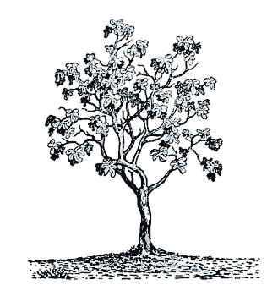

“We welcome you and serve all through faith.”

Worship with us Sundays at 10am

Rev. Jessica Moore, Pastor
Erin Grainger, Music and Choral Director
Stephan Conrady, Organist
Sue Powers, Administrative Assistant
27 Church Street, St. Albans, VT 05478
802-524-4555
info@firstcongregationalstalbans.org
www.firstcongregationalstalbans.org

